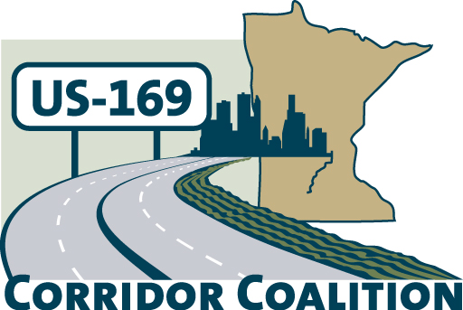
US Hwy 169 Corridor Coalition
Working together to enhance safety, reduce congestion and maximize economic development along the US Highway169
inter-regional corridor.
www.us169corridorcoalition.com

Technical Committee Agenda

Scott County Government Center
Board Conference Room

June 28, 2012
1:30 p.m. – 3:30 p.m.

AGENDA

- Project Prioritization & CIMS interface
- August Event Logistics
  - New Sweden Dairy-Lew G.
- July Executive Committee meeting – Corridor Advocate review
- 2012 Meeting Schedule-Sept-December
  - Jim Gates-Chamber meeting
  - Beard/Gimse meeting
  - Update on State Transportation Finance Task Force

