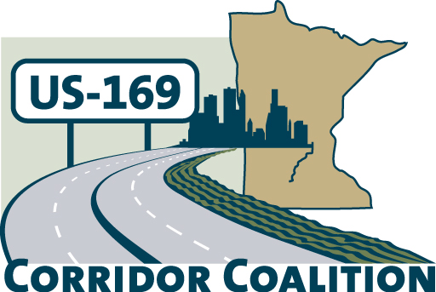
US Hwy 169 Corridor Coalition
Working together to enhance safety, reduce congestion and maximize economic development along the US Highway169 inter-regional corridor.

BOARD MEETING AGENDA
June 14, 2012
7:00 P.M.

Ridges Sand Creek Country Club
Jordan, MN

- Welcome/Introductions – James Hovland, Chair, City of Edina
- Adoption of Agenda
- Educational Programs:
Mileage Based User Fee study – Cory Johnson, MnDOT and James Hovland, Mayor, City of Edina

- Adoption of May 10, 2012 Minutes
- Financial Report for May 2012

- CIMS meetings

- Corridor Advocate Update
- Technical Committee Report
- 2012 Board Meeting Schedule

- Other Items:
- Next Meeting, August 9, 2012, 7:00-9:00 p.m.
New Sweden Dairy tour, St. Peter, MN

- Adjournment

