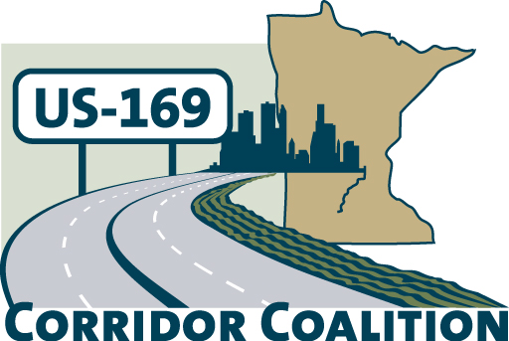
US Hwy 169 Corridor Coalition
Working together to enhance safety, reduce congestion and maximize economic development along the US Highway169 inter-regional corridor.

Executive Committee Meeting
June 14, 2012
5:30 p.m. – 7:00 p.m.

Ridges Sand Creek Country Club
Jordan, MN

AGENDA

- Welcome/Introductions – James Hovland, Chair, City of Edina
- Adoption of May 10, 2012 minutes

- Financial Reports for May 2012

- Technical Committee Report
- Project Priority Matrix
- 2012 Board meeting schedule

- CIMS meetings
- Corridor Advocate Report
- Other Items
- Next Meeting – August 9, 2012, 5:30 – 7:00 p.m.
New Sweden Dairy tour, St. Peter, MN

- Adjournment

