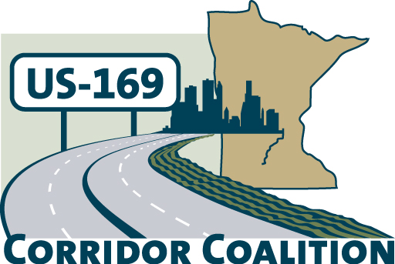
US Hwy 169 Corridor Coalition
Working together to enhance safety, reduce congestion and maximize economic development along the US Highway169
inter-regional corridor.
www.us169corridorcoalition.com

Technical Committee Agenda

Scott County Government Center
Board Conference Room

March 22, 2012
1:30 p.m. – 3:30 p.m.

AGENDA

- Project Prioritization – summary of ranking process
- Transit Study
- Member Recruitment
- April Coalition meeting Agenda & Speaker
- 2012 Meeting Schedule

