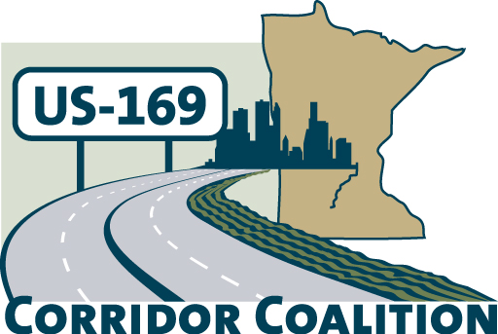
US Hwy 169 Corridor Coalition
Working together to enhance safety, reduce congestion and maximize economic development along the US Highway169 inter-regional corridor.

Membership Board Meeting
Minutes

March 8, 2012

The meeting was called to order at 7:00 p.m. by Vice Chair, Commissioner Ulrich.

Members Present:

Name | Title | Agency
Jon Ulrich | Commissioner | Scott County
Lezlie Vermillion | Deputy County Administrator | Scott County
Tom Hulting | Council Member | City of Bloomington
Jim Gates | Deputy Director Public Works | City of Bloomington
Ed Shukle | City Administrator | City of Jordan
Jeff Johnson | City Engineer | City of Mankato
Mike Laven | Council President | City of Mankato
Jane Kansier | Assistant City Administrator | City of Prior Lake
Ronda Allis | Comm & Economic Dev Director | Region 9 Development Commission
Gene Abbott | Council Member | City of Savage
John Powell | Public Works Director | City of Savage
Mark McNeill | City Administrator | City of Shakopee
Lewis Giesking | Director of Public Works | City of St. Peter
Doug Weiszhaar | Corridor Advocate | WSB & Associates

- Welcome/Introductions

Jon Ulrich, Vice Chair, welcomed the Board members and guests. Members and guests provided introductions to the group.

- Adoption of Agenda

A motion was made by Jim Gates to approve the agenda. Jane Kansier seconded the motion, which the Board passed by unanimous vote.

- Educational Program:
Mary Safgren, Mn/DOT District 7 Planning Director

Ms. Safgren discussed the current planning process underway at the state level to update the Statewide Multi-modal plan. Once the statewide multi-modal plan is updated, then District 7 will begin the annual update of the 20-year highway investment plan.

Ms. Safgren also discussed the Corridor Investment Management Strategy (CIMS) that MnDOT will be undertaking in the near future. Coalition members will be invited to these meetings, which will be held in the various MnDOT Districts.

The final topic discussed by Ms. Safgren involved an update of the various projects along the Highway 169 Corridor that fall within District 7 boundaries. Mn/DOT and the City of St. Peter have been in discussion on the Highway 22 intersection, on the north end of St. Peter, but the two parties have not been able to come to any resolution. Mn/DOT is willing to look at access issues on the Le Sueur Hill, but they want this to be locally led, and at this point, neither the city nor the county is willing to take the lead. The final project that Mary addressed was the TH14/Lind/Webster interchange. Mn/DOT is planning an acceleration lane for traffic moving east on Highway 14 to northbound Highway 169.

- Adoption of February 9, 2012 Minutes

Council Member Gene Abbott motioned for the approval of the February 9, 2012 meeting minutes. City Administrator Mark McNeill seconded the motion, which the Board passed by unanimous vote.

- Financial Report for February

Ms. Lezlie Vermillion presented financial statements for February 2012.

Council Member Tom Hulting motioned for approval. Jim Gates seconded the motion, which the Board passed by unanimous vote.

- Project Priority Matrix activity

Janie Kansier led members through an activity which will help the coalition identify priority projects. Over the course of the past few years, members have identified various projects along the corridor that they considered priorities. The Technical Committee has worked through a process that assigned points to each project based on their technical merit. Members in attendance were each given three dots and were asked to place a dot on the top three projects. Those communities not represented at the meeting will be asked to complete a similar process using Survey Monkey©. The Technical Committee will then combine the two results and share the results with members at the April meeting.

- Corridor Advocate Update

Doug Weiszhaar, Corridor Advocate, distributed a “169 Coalition Membership Recruitment Log” to members. The log identified who had been contacted and any follow-up that was made. Doug will continue to provide a recruitment log at future meetings.

- Technical Committee Report

• 2012 Board Meeting Schedule

Members received an updated 2012 Board meeting schedule. It was noted that the Commissioner of DEED (Department of Employment and Economic Development), Mr. Mark Phillips, will be our speaker at the April meeting. USDA Rural Development Director for Minnesota, Colleen Landkamer, will be our speaker in May.

Members were asked to provide other guest speaker ideas to the Technical Committee.

- Other Items:

No other items were brought forward.

- Next Meeting Date

The next meeting will be on April 12, 2012 at 7:00 pm at the Scott County Government Center.

- Meeting adjourned at 8:12 p.m.

Respectfully submitted by Ronda Allis, Region Nine Development Commission

