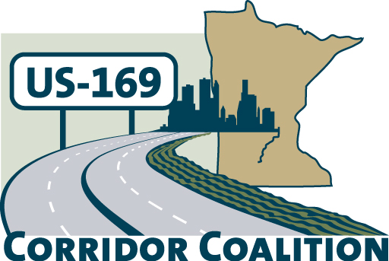
US Hwy 169 Corridor Coalition
Working together to enhance safety, reduce congestion and maximize economic development along the US Highway169 inter-regional corridor.

Membership Board Meeting
Minutes

May 10, 2012

The meeting was called to order at 7:00 p.m. by Vice Chair, Commissioner Ulrich.

Members Present:

Name | Title | Agency
Jon Ulrich | Commissioner | Scott County
Lisa Freese | Transportation Manager | Scott County
Lisa Schickedanz | Associate Planner | Scott County
Vance Stuehrenberg | Commissioner | Blue Earth County
Ed Shukle | City Administrator | City of Jordan
Bob Oberle | Mayor | City of Le Sueur
Seth Greenwood | Public Works Director | Nicollet County
Ronda Allis | Comm & Economic Dev Director | Region 9 Development Commission
Gene Abbott | Council Member | City of Savage
John Powell | Public Works Director | City of Savage
Mark McNeill | City Administrator | City of Shakopee
Matt Lehman | Council Member | City of Shakopee
John Schmitt | Citizen Representative | City of Shakopee
Kathy Nielsen | Clerk | Spring Lake Township
Russ Wille | Community Development Dir. | City of St. Peter
Doug Weiszhaar | Corridor Advocate | WSB & Associates
Khani Sahebjam | Program Manager | HDR Engineering

- Welcome/Introductions

Vice Chair Jon Ulrich welcomed the Board members. Members provided introductions to the group.

- Adoption of Agenda

A motion was made by Ed Shukle to approve the agenda. Jon Schmitt seconded the motion, which the Board passed by unanimous vote.

- Educational Program:
Colleen Landkamer, State Director, USDA Rural Development presented to the Board.

Ms. Landkamer discussed the mission of USDA Rural Development: Building strong communities in rural Minnesota; and provided an overview of the various programs offered by USDA Rural Development
Colleen noted that it takes a strong ro9adway network and transit systems to make their programs successful.
- Adoption of April 12, 2012 Minutes

Council Member Gene Abbott motioned for the approval of the April 12, 2012 meeting minutes. City Administrator Ed Shukle seconded the motion, which the Board passed by unanimous vote.

- Financial Report for April 2012

Lisa Freese presented financial statements for April 2012. Council Member Lehman moved to approve the April financial report. The motion was seconded by Mayor Oberle and passed.

- CIMS meetings

Lisa Freese provided an overview of the CIMS meetings and took a “hand count” of those who were planning on attending the meeting in Mankato on May 14th as well as the meeting in Edina on May 29th. Lisa will send information to the Board members so they speak with a unified voice at both meetings.

- Corridor Advocate Update

Doug Weiszhaar, Corridor Advocate, distributed a “169 Coalition Membership Recruitment Log” to members. The log identified who had been contacted and any follow-up that was made. Doug also shared with Board members that Brandi Popenhagen has accepted a position with a different firm and is no longer at WSB & Associates.

Doug provided an update to the Board on his recruitment efforts during the month of April:
- Land to Air has requested membership information
- Greater Mankato Growth will be presenting the request to the Executive Committee in the near future
- Visited the Jordan Chamber of Commerce
- Is planning to follow up with Cambria, Canterbury, and state legislators
- He will follow up with Valleyfair now that a new Director has been hired

- Technical Committee Report
2012 Board Meeting Schedule

The Board reviewed the 2012 US 169 Coalition Meeting Schedule. Lisa Freese is working on inviting Representative Beard and Senator Gimse to the June meeting. If they are unable to attend, we may have a presentation mileage based user fee study. There was also a reminder that the July meeting has been cancelled.

- Other Items:

No other items were brought before the Board.

- Next Meeting Date

The next meeting will be on June 14, 2012 at 7:00 pm at the Ridges Sand Creek Country Club, Jordan

- Meeting adjourned at 8:27 p.m.

Respectfully submitted by Ronda Allis, Region Nine Development Commission

