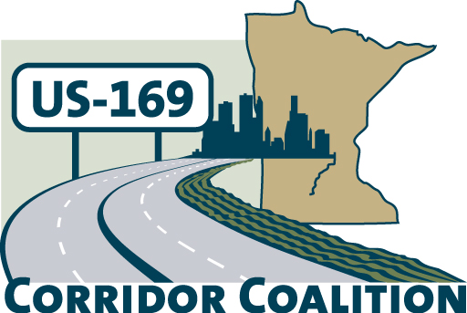
US Hwy 169 Corridor Coalition
Working together to enhance safety, reduce congestion and maximize economic development along the US Highway 169
inter-regional corridor.

Executive Committee Meeting Minutes

May 10, 2012

Name | Title | Agency
Jon Ulrich | Commissioner | Scott County
Bob Oberle | Mayor | City of Le Sueur
Vance Stuehrenberg | Commissioner | Blue Earth County
Lisa Schickedanz | Associate Planner | Scott County
Ronda Allis | Comm & Ec Dev Dir | Region 9 Dev Comm
Ed Shukle | City Administrator | City of Jordan
Doug Weiszhaar | Corridor Advocate | WSB

The meeting was called to order at 5:40 p.m. by Vice Chair, Commissioner Jon Ulrich.

- Commissioner Ulrich welcomed Executive Committee members.

- Adoption of April 12, 2012 minutes – Vance Stuehrenberg made a motion to approve the April 12th minutes. The motion was seconded by Bob Oberle and approved.

- Financial Reports for April 2012 – The financial report for April 2012 was distributed and reviewed. Lisa Schickedanz provided an overview of the financials. Bob Oberle made a motion to approve the financial reports. The motion was seconded by Vance Stuehrenberg and approved.

- Technical Committee Report:

Project Priority Matrix – Lisa Schickedanz provided an update/overview on the project priority ranking process. The Technical Committee is following up with the directives from the Executive Committee:

The Executive Committee would like the Technical Committee to review the list again and focus on:
- Identify “next steps” for each project – do they need funding? Further study? Etc..
- Categorize as “short term” (0-5 years) or “medium term” (6 – 10 years), or “long term” (10+ years).
- Review low cost, high impact options
- Create a list of potential funding sources

The Technical Committee is still working on the project priority ranking process. They have identified some potential funding sources.

The Executive Committee also reviewed the 2012 US 169 Coalition Meeting Schedule. Lisa Freese is working on inviting Representative Beard and Senator Gimse to the June meeting. If they are unable to attend, we may have a presentation mileage based user fee study. There was also a reminder that the July meeting has been cancelled.

- CIMS meetings – Executive Committee members received a “one-pager” providing an overview of the CIMS process. Doug Weiszhaar attended the first CIMS meeting in southwestern MN on May 8th. The focus of the meeting was on low cost, high benefit improvements. The next meeting will be in Mankato on May 14th.

- Corridor Advocate Update
Doug Weiszhaar reported that Brandi Popenhagen accepted a position with a different firm and is no longer with WSB & Associates. Doug is in the process of recruiting an assistant for the work on the Highway 169 Corridor Coalition. Doug provided an update to the Executive Committee on his recruitment efforts during the month of April:
- Land to Air has requested membership information
- Greater Mankato Growth will be presenting the request to the Executive Committee in the near future
- Visited the Jordan Chamber of Commerce
- Is planning to follow up with Cambria, Canterbury, and state legislators

- Other Items:

- Next Executive Committee Meeting, June 14, 2012, 5:30 – 7:00 p.m.
at the Ridges Sand Creek Country Club, Jordan

- Executive Committee adjourned at 6:40 p.m.

Respectfully Submitted by Ronda Allis – Region Nine Development Commission.

