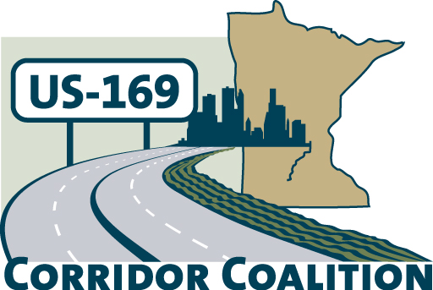
US Hwy 169 Corridor Coalition
Working together to enhance safety, reduce congestion and maximize economic development along the US Highway169 inter-regional corridor.

Executive Committee Meeting
October 11, 2012
5:30 p.m. – 7:00 p.m.

Canterbury Paddock Conference Room
Track Level/1st Floor
1100 Canterbury Road
Shakopee, MN 55379

AGENDA

- Welcome/Introductions – James Hovland, Chair, City of Edina
- Adoption of August 9, 2012 Minutes
- Financial Reports for August 2012 and September 2012
- Technical Committee Report-did not meet in September
- 2013 Budget
- Corridor Advocate Report
- Other Items
- Next Meeting – November 8, 2012, 5:30 – 7:00 p.m.
  - Host SMSC
- Adjournment

