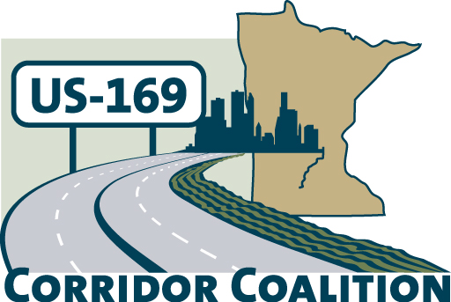
US Hwy 169 Corridor Coalition
Working together to enhance safety, reduce congestion and maximize economic development along the US Highway169 inter-regional corridor.

BOARD MEETING AGENDA
October 11, 2012
7:00 p.m.

Canterbury President’s Suite
Club House Level/3rd Floor
1100 Canterbury Road
Shakopee, MN 55379

- Welcome/Introductions – James Hovland, Chair, City of Edina
- Adoption of Agenda
- Educational Programs: Canterbury Operations
Randy Sampson, President and CEO of Canterbury Park

- Adoption of September 13, 2012 Minutes
- Financial Report for September 2012
- September 2012 Executive Committee Report

- Corridor Advocate Update
- Technical Committee Report

- Next Meeting, November 8, 2012, 7:00-9:00 p.m.
Host SMSC

- Adjournment

