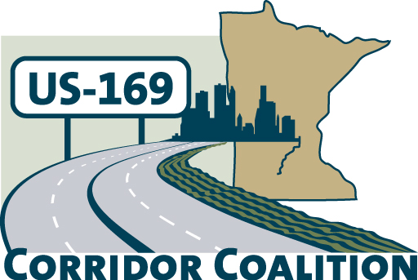
US Hwy 169 Corridor Coalition
Working together to enhance safety, reduce congestion and maximize economic development along the US Highway169 inter-regional corridor.

BOARD MEETING AGENDA
September 13, 2012
7:00 p.m.

Bloomington Council Chambers of Civic Plaza
1800 West Old Shakopee Road
Bloomington, MN

- Welcome/Introductions – James Hovland, Chair, City of Edina
- Adoption of Agenda
- Educational Programs: 169 Corridor Discussion Panel
- Commissioner Mark Phillips, Dept. of Employment and Economic Development (DEED)
- Director Will Schroeer, Minneapolis/Bloomington Chamber of Commerce
Infrastructure for Economic Development
- Division Director Tim Henkel, Minnesota Dept. of Transportation
Modal Planning and Program Management

- Adoption of August 9, 2012 Minutes
- Financial Report for August 2012
- August Executive Committee Report – No Meeting or Report

- Corridor Advocate Update
- Technical Committee Report-No Meeting or Report

- Next Meeting, October 11, 2012, 7:00-9:00 p.m.
Scott County Government Center, County Board Room

- Adjournment

