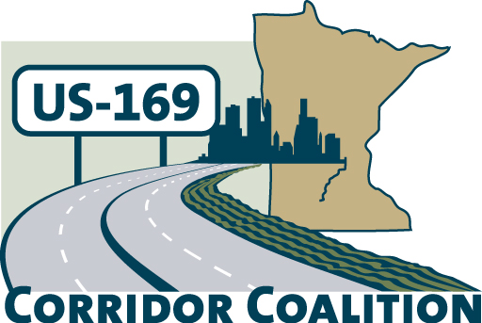
US Hwy 169 Corridor Coalition
Working together to enhance safety, reduce congestion and maximize economic development along the US Highway169 inter-regional corridor.

Executive Committee Meeting
September 13, 2012
5:30 p.m. – 7:00 p.m.

Dakota Conference Room of Civic Plaza
1800 West Old Shakopee Road
Bloomington, MN

AGENDA

1. Welcome/Introductions – James Hovland, Chair, City of Edina
2. Adoption of August 9, 2012 minutes
3. Financial Reports for August 2012
4. Technical Committee Report-did not meet in August
5. MnDOT and Metro Council Plans
6. Corridor Advocate Report
7. Other Items
8. Next Meeting – October 11, 2012, 5:30 – 7:00 p.m.
Any Ideas?
9. Adjournment

