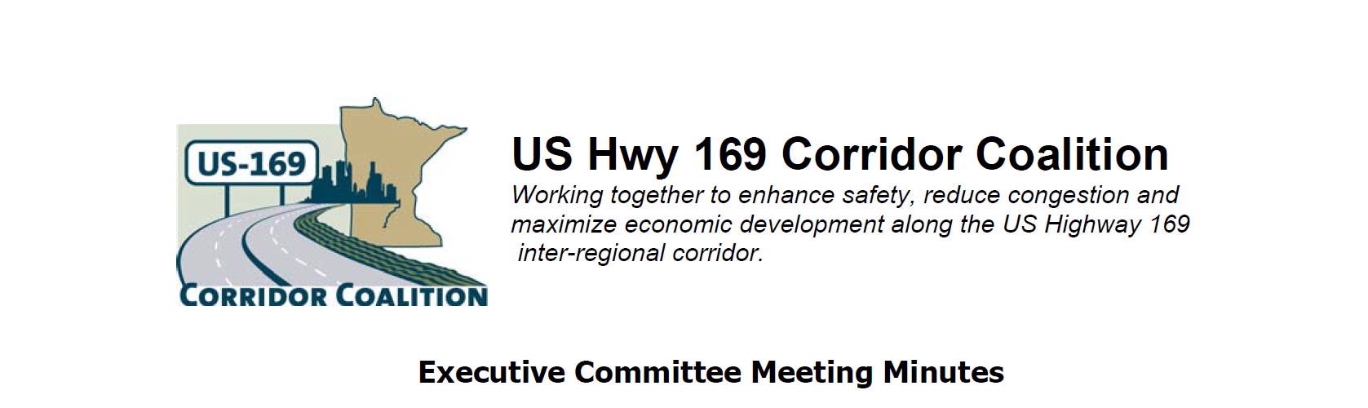
September 13, 2012
Name | Title | Agency
Jon Ulrich | Commissioner | Scott County
Lisa Freese | Transportation Manager | Scott County
Jim Gates | Deputy Director of Public Works | City of Bloomington
Vance Stuehrenberg | Commissioner | Blue Earth County
Ed Shukle | City Administrator | City of Jordan
Doug Weiszhaar | Corridor Advocate | WSB & Associates

- Welcome and Introductions
Jon Ulrich, Vice Chair, Scott County welcomed the group.

A quorum was not present so no official actions took place.
- Adoption of August 9, 2012 minutes
No Action
- Financial Reports for August 2012
No Action

- Technical Committee Report-
No meetings in August or September

- MnDOT and Metro Council Plans
Lisa distributed a list of upcoming MnSHIP District Stakeholder Meetings Of interest to the coalition are the D7 meeting in Mankato on October 10, and the Metro meeting in Minneapolis on October 16.

Lisa also distributed a summary of the CIMS meeting comments. There was no major discussion of either one.
- Corridor Advocate Report
The Corridor Advocate report was distributed. There was general disappointment with the effort made over the last month. There were several suggestions on contacts to make in the coming month. These included:
- Southwest Transit (the Park & Ride at Pioneer Trail has been removed from the Metro Transit improvements list)
- City of Eden Prairie
- Volk Transfer in Mankato
- Get a list of Grater Mankato Growth members to pursue
- Talk to the Mayor of LeSueur to talk to Cambria
- Contact Shakopee Chamber
- Ask Leslie for help with Ames

There was a suggestion that the Coalition conduct an open house by invitation including a buffet lunch to raise interest in the coalition efforts and increase membership. They would like to see 3 per year in the various areas of the corridor (south, middle, north). The corridor advocate is to prepare a plan to conduct these and present the plan at the next Executive Committee meeting

- Other Items

- Next Meeting – October 11, 2012, 5:30 – 7:00 p.m.
- Any Ideas?
- Invite Canterbury to discuss their operations. Meet at Canterbury or Prior Lake?
- Discuss Transit Highways (small starts BRT) Study. Meet in Prior Lake?
It was suggested that the Executive Committee invite the Tech Committee to hold a joint meeting to discuss direction.
- Adjournment.

