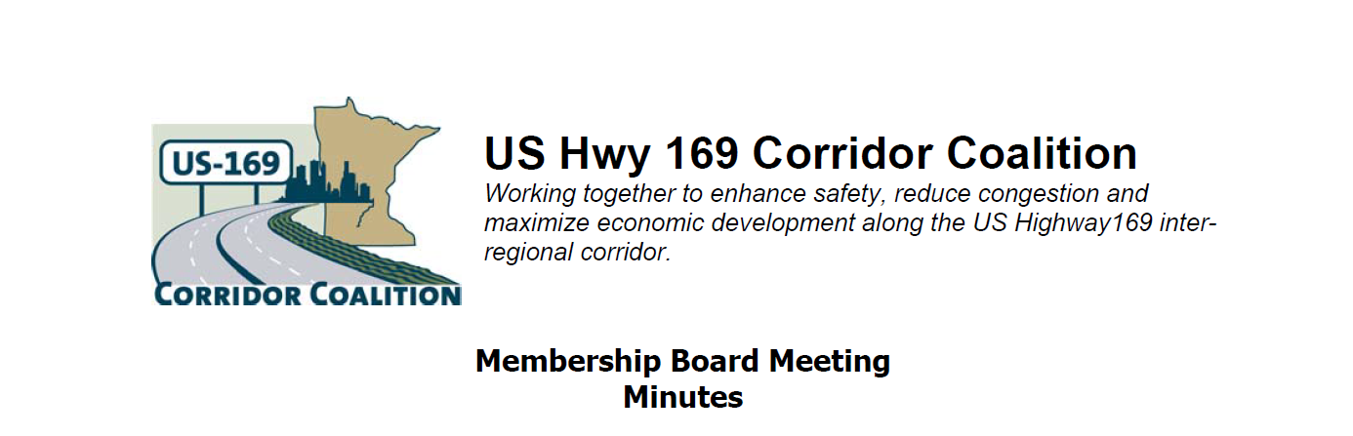
September 13, 2012
The meeting was called to order at 7:15 PM by Board Vice Chairman, Commissioner Jon Ulrich.
Members Present:
Name | Title | Agency
Jim Hovland | Mayor | City of Edina
Jon Ulrich | Commissioner | Scott County
Lisa Freese | Transportation Manager | Scott County
Jim Gates | Deputy Director of Public Works | City of Bloomington
Vance Stuehrenberg | Commissioner | Blue Earth County
Ed Shukle | City Administrator | City of Jordan
Terry Genelin | R-9 ACT | Region 9 Development Commission
Janet Williams | Mayor | City of Savage
Lewis Giesking | Director of Public Works | City of St. Peter
Doug Weiszhaar | Corridor Advocate | WSB & Associates
John Schmitt | Citizen Representative | City of Shakopee
Tim Henkel | Division Director | Minnesota Dept. of Transportation
Mark Phillips | Commissioner | Minnesota Dept. of Employment and Economic Development (DEED)
Will Schroerer | Director | Minneapolis/Bloomington Chamber of Commerce

1) Welcome/Introductions
Vice Chair Jon Ulrich welcomed the Board members. Members provided introductions to the group.

2) Adoption of Agenda
A motion was made by to approve the agenda. A second to the motion was made and the motion passed.

3) Educational Program: 169 Corridor Discussion Panel
Director Will Schroeer, Minneapolis / Bloomington Chamber of Commerce:
- Transit is the issue that has brought The Minneapolis and St. Paul Chambers of Commerce together.
- 93% of members want this as the Chambers #1 public priority.
- The single day record of 497,000 riders on the Twin Cities system was set on September 2, 2011.
- United Health is adding 6500 jobs in their new campus, but only adding 2400 parking stalls
- Other major Metro areas are far ahead of us in providing transit opportunities, primarily by using a local sales tax. Dallas is the largest system nationally.
- Transit is a necessary component of a thriving region.

Commissioner Mark Phillips, Dept. of Employment and Economic Development:
- SW Light Rail received funding from the recent grant cycle just to keep it moving towards completion.
- Litchfield Milk Producers invested in sewer expansion which will serve a large increase in jobs in the region.
- Duluth parking garage brings $80 Million office tower with it and associated jobs building and occupying that tower.
- 170,000 people are out of work in Minnesota, 150,000 of them in construction.
- Interest rates are at historic lows.
- This is the first recession to be led in recovery by large companies.
- Small businesses are unable to obtain start up loans. Home equity is missing which in turn can be used to develop entrepreneurial jobs.
- Minnesota is coming out of the recession faster than much of the country.
- A Tech Company from India will announce the opening of a major office in Bloomington.
- Return on Investment is of huge importance in decisions on where to put resources.

Division Director Tim Henkel, Minnesota Dept. of Transportation:
- MnDOT is working in partnership with Corridor Coalitions through what it calls its Corridor Management Investment System (CIMS).
- US169 is and Interregional Corridor (IRC) of great importance as our web site has presented.
- Our coalition should explore the Frac Sand freight issue in our corridor.
- CIMS is a competitive program in corridors.
- An Advisory Committee will select projects to be funded in upcoming grant programs.
- Transportation Finance Advisory Committee will be discussing obtaining addition input from outside sources at their 9/14 meeting.
- Minnesota State Highway Investment Program (MnSHIP) meetings will be occurring in October, watch for their opportunities.
- MAP21 (Federal Authorization Bill) Was passed as a 2 year bill. It combined 140 federal programs into 6 categories. MnDOT will host a seminar on Monday 9/17 to explain these changes.

4) Adoption of August 9, 2012 Minutes
The minutes of the August 9, 2012 Board Meeting were amended to reflect that John Powell was in attendance. Member Freese moved to approve the Minutes; the Motion was seconded by Member Stuehrenberg and passed.

5) Financial Report for August 2012
Lisa Freese presented the financial statement for August 2012. A copy is included at the end of these minutes. The current account balance is $68,165.97. Member Stuehrenberg moved to approve the Budget. The motion was seconded by Member Schmitt and passed.

6) September Executive Committee Report – No Report

7) Corridor Advocate Update
The Corridor Advocate report was presented by Doug Weiszhaar. The monthly contacts were distributed. Mr. Weiszhaar discussed a proposal of the executive Committee to host a series of open houses by invitation including a buffet lunch to raise interest in the coalition efforts and increase membership. They would like to see 3 per year in the various areas of the corridor (south, middle, north). The corridor advocate is to prepare a plan to conduct these and present the plan at the next Executive Committee Meeting.

8) Technical Committee Report – No meeting or Report
No update provided as there was no meeting.

9) Other Items:

10) Next Meeting Date
It was announced that ideas for the next meeting were to invite Canterbury Park to discuss the facility and the operations involved with keeping it profitable. Location will be announced. The next meeting will be 7:00 p.m. October 11, 2012.

11) Meeting adjourned about 8:50 p.m.
Respectfully submitted by Doug Weiszhaar & Janelle Borgen, WSB & Associates

