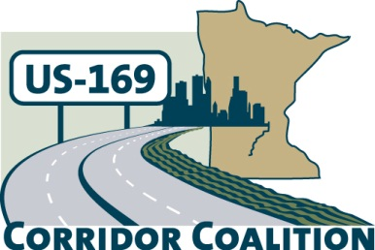
US Hwy 169 Corridor Coalition
Working together to enhance safety, reduce congestion and maximize economic development along the US Highway169 inter-regional corridor.

BOARD MEETING AGENDA
November 10, 2016
7:00 P.M.

Location: Scott County Government Center
Second Floor Board Conference Room
200 Fourth Avenue West
Shakopee, MN 55379

- Welcome/Introductions – Vance Stuehrenberg, Chair, Blue Earth County Commissioner

- Adoption of Agenda

- Adoption of September 8, 2016 Minutes

- Financial Report – September/October 2016
- Project Updates Presentations
  - Flood Mitigation Project – 35 minutes
    - Presentation
    - Q & A
  - US169 Mobility Study Decision -20 minutes - Lisa Freese, Scott County

- Upcoming Meeting Agenda & Schedule Discussion
  - 2017 meeting dates/locations
  - Future presentation suggestions
- Other Items

- Adjournment

