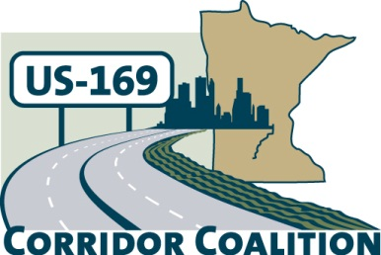
US Hwy 169 Corridor Coalition
Working together to enhance safety, reduce congestion and maximize economic development along the US Highway169 inter-regional corridor.

AGENDA: Joint Executive and Technical Committee Meeting
November 10, 2016
6:00 p.m. – 7:00 p.m.

Location: Scott County Government Center
Second Floor Board Conference Room
200 Fourth Avenue West
Shakopee, MN 55379

- Welcome/Introductions – Vance Stuehrenberg, Chair, Blue Earth County Commissioner

- Adoption of Agenda

- Financial Report – September/October 2016

- Adoption of September 8, 2016 Minutes

- Map Book – Safety Map
  - Next steps

- Fall Newsletter Review

- Social Media Strategy
  - Schedule meeting to discuss next steps

- Upcoming Meeting Agenda & Schedule Discussion
  - 2017 meeting dates suggestions
    - Thursday, January 12th
    - Thursday, March 9th
    - Thursday, September 14th
    - Thursday, November 9th
  - 2017 Legislative Event date
    - February 9, 2017
    - February 16, 2017

- Other Items
  - Reinstate monthly calls with HDR and Lisa/Vance for material review

- Adjournment

