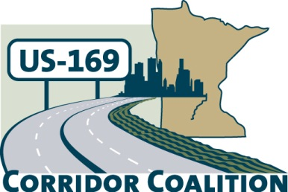
US Hwy 169 Corridor Coalition
Working together to enhance safety, reduce congestion and maximize economic development along the US Highway169 inter-regional corridor.

AGENDA: Joint Executive and Technical Committee Meeting
August 20, 2015
6:00 p.m. – 7:00 p.m.

Location: Scott County Government Center
Second Floor Board Conference Room
200 Fourth Avenue West
Shakopee, MN 55379

- Welcome/Introductions – Jon Ulrich, Chair, Scott County Commissioner

- Adoption of Agenda

- Adoption of May 2015 Minutes

- Financial Report – June 2015

- Project Update – TH 41 / US 169

- Agenda Planning – upcoming coalition meetings:
  - Executive and Technical Committee Meetings – frequency and timing
  - Board Meeting – September 17, 2015
  - Board Meeting – November 19, 2015
  - Board Meeting – January 21, 2015

- Other Items

- Adjournment

