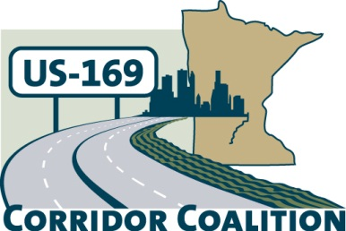
US Hwy 169 Corridor Coalition
Working together to enhance safety, reduce congestion and maximize economic development along the US Highway169 inter-regional corridor.

Joint Executive and Technical Committee Meeting Minutes
May 21, 2015
6:00 p.m. – 7:00 p.m.

Location: Scott County Government Center

First Name | Last Name | Title | Agency
Bob | Broeder | Mayor | City of LeSueur
Andrew | Carlson | Councilmember | City of Bloomington
Lisa | Freese | Transportation Program Director | Scott County
Jim | Gates | Deputy Director of Public Works | City of Bloomington
Dana | Petersen | Public Involvement Coordinator | HDR
Vance | Stuehrenberg | Commissioner | Blue Earth County
John | Ulrich | Commissioner | Scott County

- Welcome/Introductions – Jon Ulrich, Chair, Scott County Commissioner

- Adoption of Agenda
Lisa Freese requests that an addition to the agenda be made to include the transitway study invoice topic. Mayor Broeder makes a motion to approve the agenda. Commissioner Stuehrenerg seconds the motion, and it is approved.

- Adoption of January 2015 Minutes
Commissioner Stuehrenberg makes a motion to approve the minutes. Councilman Carlson seconds the motion, and they are approved.

- Financial Report – April 2015
- Note: WSB joined as an affiliate member
- Mankato’s dues are still out, Lisa to connect with Jeff
- Dispersements to HDR and League of MN Cities
- Balance of $141,792.95
- Commissioner Stuehrenberg makes a motion to approve the report. Councilman Carlson seconds the motion and it is approved
- 169 Transitway Study Invoice
- Coalition originally agreed to contribute $25,000 for the study
- Scott County will be the conveyer of the money
- Lisa Freese indicates that Scott County will issue an invoice to the Coalition for the $25,000 and it will be paid to the County. It will then be dispersed to MnDOT
- Partners in the study is to include: City of Prior Lake, City of Shakopee, Scott County, District 7, MnDOT, Met Council, and the Coalition

- Legislative Session Wrap Up – Coalition Members Perspective
- Transportation seems to be the same as last year; no tax bill because of transportation
- May have a special session called in June due to work undone
- Two successes on the corridor:
  - Scott County applied for regional money for Hwy 41 and received $7M
  - Another award contributed about $1M for active traffic management system on 169
  - Combine with instrumentation effort by MnDOT to get signs up on this side of the corridor
  - Attempting to get TIGER funding
- Legislative Open House
  - Most attendees understood importance of the corridor and specific areas with high needs
  - Next steps may include getting funding and specific initiatives as a topic of discussion

- Upcoming Meeting Agenda & Schedule Discussion
- Joint Executive and Technical Meeting Agenda – August 20, 2015
  - Strategic funding opportunities
  - Discuss approach and main call to action
- Board Meeting Agenda – September 17, 2015
  - SWLRT Presentation
  - Kicking off transitway study and introduction of the consultant team in the fall

- Adjournment

