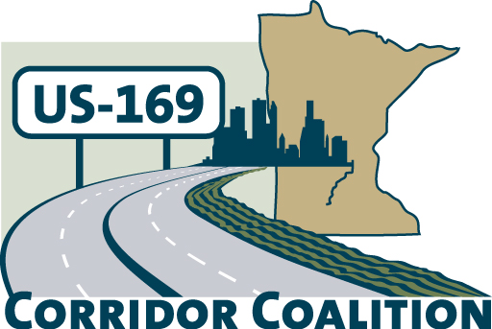
US Hwy 169 Corridor Coalition
Working together to enhance safety, reduce congestion and maximize economic development along the US Highway169 inter-regional corridor.

Executive Committee Meeting
September 12, 2013

Saint Peter Community Center, Senior Center
600 South 5th Street St Peter, MN 55436

First Name | Last Name | Title | Agency
Jan | Callison | Commissioner | Hennepin County
Jim | Gates | Deputy Director Public Works | City of Bloomington
Jim | Hovland | Mayor | City of Edina
Lewis | Giesking | Director of Public Works | City of St Peter
Lisa | Freese | Transportation Program Director | Scott County
Tom | Hulting | Council Member | City of Bloomington
Vance | Stuehrenberg | Commissioner | Blue Earth County
Emily | Hyland | Public Involvement Manager | HDR

The meeting was called to order at 5:58 PM by Vice-Chairman, Commissioner Vance Stuehrenberg.

- Welcome/Introductions – Vance Stuehrenberg, Vice-Chair, Commissioner
- Adoption of Agenda

Member Mayor Jim Hovland made a motion to approve the agenda with the modification of moving the item six, Corridor of Commerce Project Priority Discussion to item eight. The motion was seconded by Council Member Tom Hulting and approved.

- Adoption of Minutes from August 8, 2013

Member Council Member Tom Hulting Jim made a motion to approve the financial report. The motion was seconded by Mayor Jim Hovland and approved.

- Financial Report for June and July 2013

Member Commissioner Jan Callison made a motion to approve the financial report. The motion was seconded by Council Member Tom Hulting and approved.

- Meeting Data Adjustment Discussion

Mayor Jim Hovland made a motion to change the executive committee meetings and board meetings to the third Thursday starting November 2013 through August 2014. The motion was seconded by Council Member Tom Hulting.

- Upcoming Corridor Coalition Events – Planning Discussion
  - Outreach Meeting - The Executive Committee discussed the approach for the tentatively schedule October Business Outreach Meeting in the northern corridor. Mayor Jim Hovland suggested a breakfast meeting from 7:30 – 9:00 am at the Braemar Golf Course. Deputy Director of Public Works Jim Gates volunteered to assist with the planning and organization of the event. Speaker suggestions included Mayor Jim Hovland and Former Mayor John Schmidt. Commissioner Jan Callison suggested personal outreach to commissions and chambers instead of hosting the meeting in October. Jan Callison suggested outreach to Edina, Twin West, and Eden Prairie Chambers. HDR will revise the US 169 Corridor Coalition PowerPoint presentation and benefits handout for review at the next Executive Meeting. These materials will be finalized and used for personal outreach by Board members throughout the corridor.
  - 2014 Legislature Breakfast – The Executive Committee requested Khani Sahebjam to review the current legislative strategy and provide feedback to review during the next Executive Board Meeting. The Executive Committee suggested HDR identify the start of the 2014 legislative session begins and identify when the Minnesota League of Cities facility is available once the session begins. Emily Hyland, HDR, will contact City Administrator Ed Shukle for assistance reserving the facility.

- Studies: With time limitations, it was suggested Lisa Freese provides an update on the Board Meeting
  - Long Haul Study
  - Highway Transitway Study

- Other Items:
  - Member Commissioner Vance Stuehrenberg made a motion to cancel the Joint Executive and Technical Committee meeting scheduled for Thursday, October 10, 2013 and have the Thursday, November 21, 2013, Joint Executive and Technical Committee Meeting to start at 6:00 pm. The motion was seconded by Commissioner Jan Callison and approved.
- Materials to review during the November Executive Meeting will include:
  - Legislative workplan 2014
  - Legislative breakfast planning update
  - Review business outreach materials
  - Discuss Technical Committee Guidance
- Mayor Jim Hovland mentioned that all Board meetings do not require an educational speaker.
- HDR will email out the 2013-2014 Work Plan for review and input from the Executive Committee to provide guidance and direction for the Technical Committee

- Next Meetings – Hosted in Shakopee on November 21
  - Joint Executive Committee Board Meeting at 6:00 pm
  - Board Meeting at 7:00 pm

- The meeting was adjourned at 6:58 PM

Respectfully submitted by Emily Hyland, HDR

