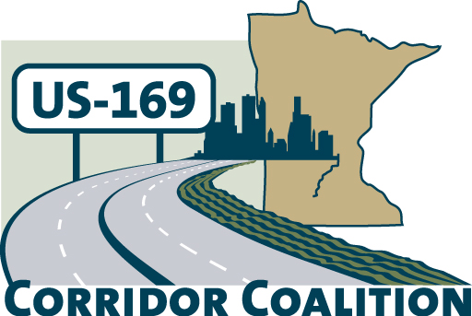
US Hwy 169 Corridor Coalition
Working together to enhance safety, reduce congestion and maximize economic development along the US Highway169 inter-regional corridor.

BOARD MEETING AGENDA
March 8, 2012
7:00 P.M.

Verizon Wireless Center
1 Civic Center Plaza
Mankato, MN 56001

- Welcome/Introductions – James Hovland, Chair, City of Edina
- Adoption of Agenda
- Educational Programs:
District 7 update – Mary Safgren, District 7 Planning Director

- Adoption of February 9, 2012 Minutes
- Financial Report for February 2012

- Project Priority Matrix activity

- Corridor Advocate Update
- Technical Committee Report
- 2012 Board Meeting Schedule

- Other Items:
- Next Meeting, April 12, 2012, 7:00-9:00 p.m.
Shakopee, MN

- Adjournment

