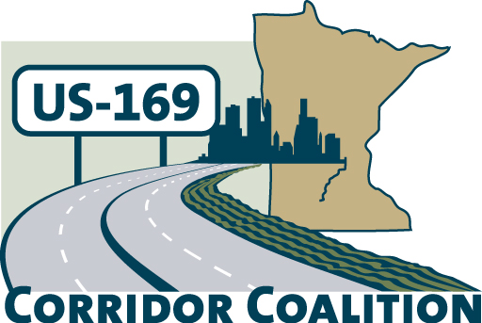
US Hwy 169 Corridor Coalition
Working together to enhance safety, reduce congestion and maximize economic development along the US Highway169 inter-regional corridor.

Membership Board Meeting
Minutes

February 9, 2012

The meeting was called to order at 7:00 p.m. by Vice Chair, Commissioner Ulrich.

Members Present:

Name | Title | Agency
Jon Ulrich | Commissioner | Scott County
Lisa Freese | Transportation Manager | Scott County
Troy Beam | Transit Manager | Scott County
Timothy Lies | Mayor | City of Belle Plaine
Scott Schneider | City Council | City of Belle Plaine
Jim Gates | Deputy Director Public Works | City of Bloomington
Vance Stuehrenberg | Commissioner | Blue Earth County
Alan Forsberg | County Engineer | Blue Earth County
Ed Shukle | City Administrator | City of Jordan
Joe Thill | City Council | City of Jordan
John Weckman | Chair | Louisville Township
Jeff Johnson | City Engineer | City of Mankato
Mike Laven | Council President | City of Mankato
Seth Greenwood | Public Works Director | Nicollet County
Warren Erickson | Council Member | City of Prior Lake
Ronda Allis | Comm & Economic Dev Director | Region 9 Development Commission
Gene Abbott | Council Member | City of Savage
Mark McNeill | City Administrator | City of Shakopee
Matt Lehman | City Council | City of Shakopee
John Schmitt |  | City of Shakopee
Lewis Giesking | Director of Public Works | City of St. Peter
Doug Weiszhaar | Corridor Advocate | WSB & Associates

- Welcome/Introductions

Jon Ulrich, Vice Chair, welcomed the Board members and guests. Members and guests provided introductions to the group.

- Adoption of Agenda

A motion was made by Jim Gates to approve the agenda. Council Member Gene Abbott seconded the motion, which the Board passed by unanimous vote.

- Educational Program:
Charlie Zelle, President and CEO, Jefferson Lines, and
Bonnie Buchanan, Senior Advisor Special Projects, Land To Air

Ms. Lisa Freese provided brief biographies on the two speakers. Charlie Zelle began the presentation by providing an overview of Jefferson Lines. They are a third-generation family owned business that has been around for 93 years. They operate in thirteen states and interline with Greyhound.

The 3-5 year vision for the company places a heavy focus on the metro-ring area of Minnesota. They are very interested in the Highway 169 corridor.

Bonnie Buchanan discussed the Land To Air service that is currently running along the Highway 169 corridor. There are presently seven trips that run from Mankato to the Minneapolis/St. Paul airport on a daily basis, using Highway 169 as the main route. They have also recently implemented a route from Mankato to Rochester, via Albert Lea and Austin. They are also establishing a route from Mankato to the State Capitol.

Land To Air is also interested in looking at the communities along the Highway 169 corridor to see what their needs are and how Land To Air can help meet those needs.

- Adoption of January 12, 2012 Minutes

Council Member Scott Schneider motioned for the approval of the January 12, 2012 meeting minutes. Mayor Tim Lies seconded the motion, which the Board passed by unanimous vote.

- Financial Report for January

Ms. Lisa Freese presented financial statements for January 2012.

Council Member Matt Lehman motioned for approval. Jim Gates seconded the motion, which the Board passed by unanimous vote.

- Corridor Advocate Update

Doug Weiszhaar, Corridor Advocate, distributed a “169 Coalition Membership Recruitment Log” to members. The log identified who had been contacted and any follow-up that was made. Doug will continue to provide a recruitment log at future meetings.

- Legislative Breakfast debriefing

Board members received a summary of the Legislative Breakfast event, which was held at the League of MN Cities building in St. Paul on Wednesday, February 1, 2012.

The overall consensus was that there was great turnout and the event was a success. Those who participated agreed that we may want to start the event earlier, since many of the Legislators had to leave for early morning committee meetings. Board members also discussed the possibility of doing a brief presentation about the Corridor at the beginning of the event so the Legislators are aware of who we are and what our mission is. It was also discussed that this is something that we should consider doing prior to our “educational program” so that the speakers are also aware of the mission of the coalition.

- Technical Committee Report

• 2012 Board Meeting Schedule

Ms. Lisa Freese distributed an updated meeting schedule for 2012, which included more potential topics for the educational component. Members should review the potential topics and let the Technical Committee know which ones they are most interested in.

- Other Items:

Ms. Lisa Freese distributed a “Linkage Study – An Analysis of Transit Potential for the Highway 169 Corridor”. This one-page document outlined the work that would need to be completed in order to describe the current transit markets for passenger movement on the Highway 169 Corridor from Mankato to the Twin Cities.

- Next Meeting Date

The next meeting will be on March 8, 2012 at 7:00 pm in Mankato.

- Meeting adjourned at 9:00 p.m.

Respectfully submitted by Ronda Allis, Region Nine Development Commission

