OS Simulation

Jamie Westrick

Alex Latunski

Evan Dembo

We choose simulation 2. Our deallocation function removes the earliest inserted process.

First Fit: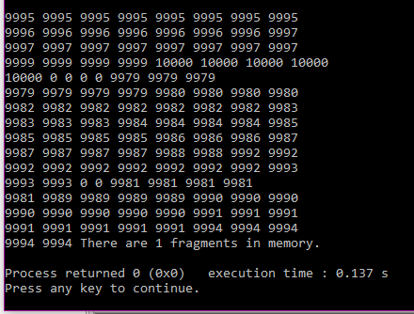

Next fit: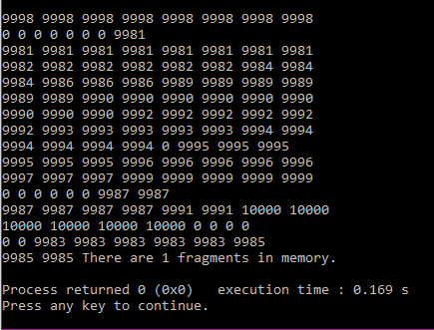

Best fit: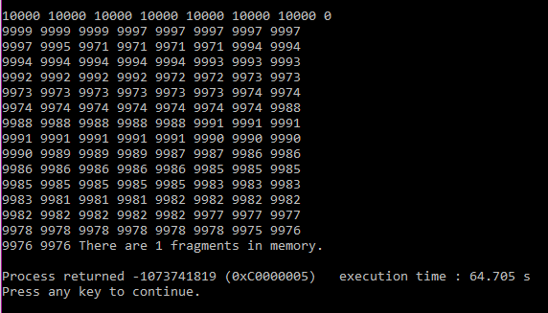

Worst fit: 