**COSC3596 Assignment 4**

*Michael Buffone, December 1st, 2020*

**Mobile App Requirements:**

* Create at least 2 activities.
  + What does each activity do?
    - LoginActivity is the login page for the employee app.
    - HomeActivity is the home screen for the successful login which has three options for the user to choose.
    - DisplayUserActivity is the hosting activity used to create a bundle and pass it to the EmployeeList fragment
    - EmployeeList is a fragment that is created when the user presses the “show all” button, which shows all users in the SQLite database
* Create at least 1 fragment.
  + What does the fragment do?
    - The fragment is used to list all employees within the SQLite database
* Use the SQLite Database.
  + What data is stored in the database?
    - There are two databases
      * The first database is the login database which holds credentials for logging into the app
        + The username and password types are both type varchar
      * The second database holds all the employee’s names
        + The name is type varchar
  + How is the data used in the app?
    - When an admin logs into the app, they can add or remove employees from the database. To view this, they can press the show all button which takes all the employees’ names out of the database, puts it into a string array, and sends it to the fragment.
* Ensure that the application works well in both portrait and landscape orientations.
  + Rotating the phone does not mess up the app and is fully functional in both portrait and landscape orientations.

**The app should include at least two of the following components:**

* **Contain at least one dialog.**
  + Two dialogs are used for adding and deleting employees in which the user is prompted to enter a name to add or delete.
* Include at least one menu (options/context/popup).
* **Define your style and theme. (will be discussed in Module 11)**
  + The style “EmployeeAppTextInfo” is declared in the themes.xml page. It declares textColor for plain and edit texts, hint color, and text background.
* Support more than 1 locale. (will be discussed in Module 11)

**Portrait Demonstration:**

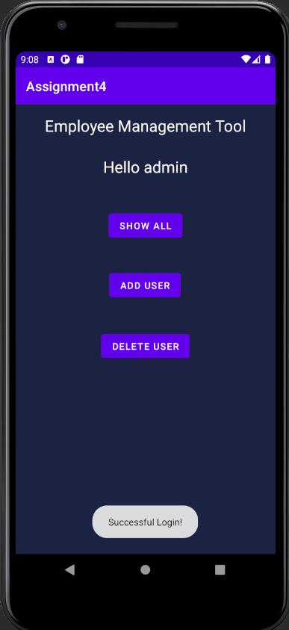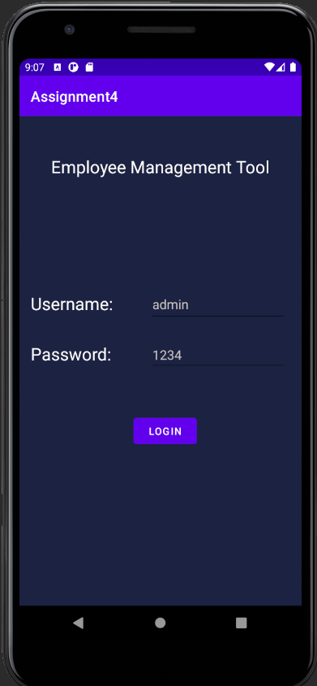 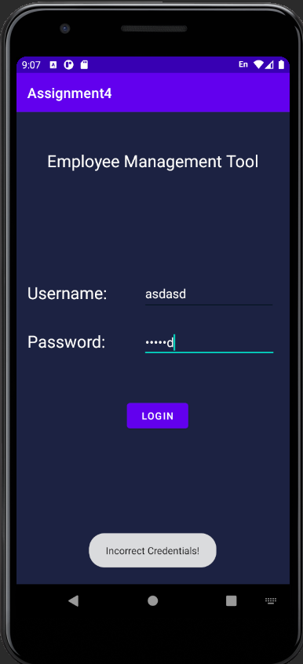

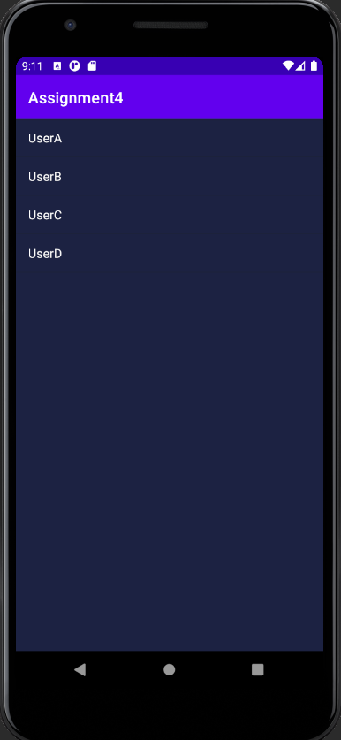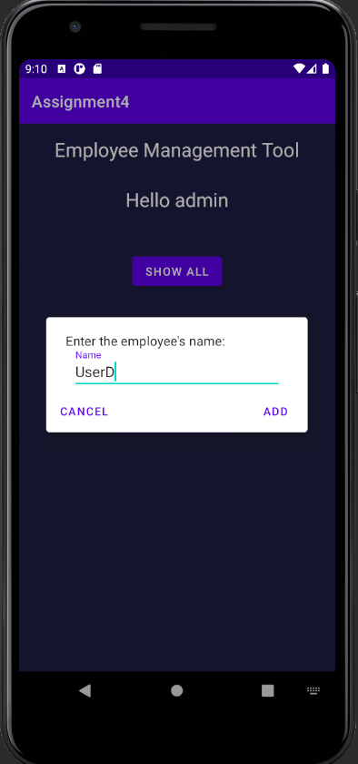 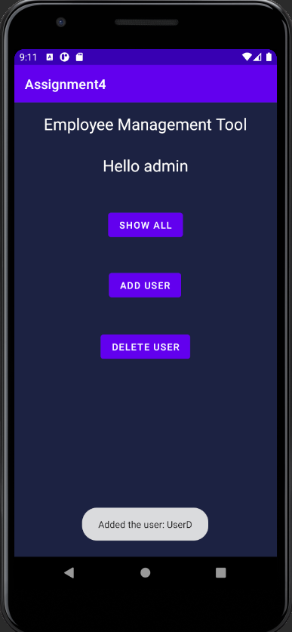

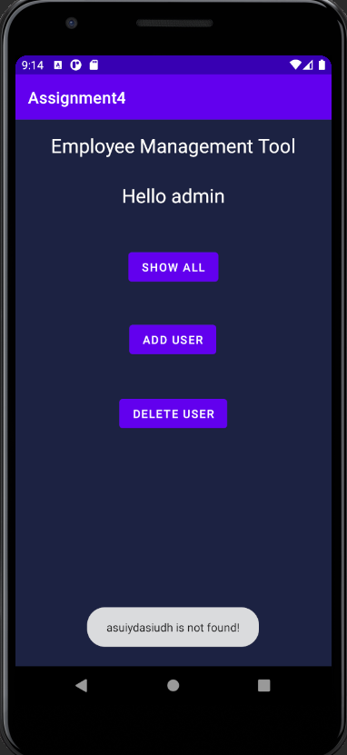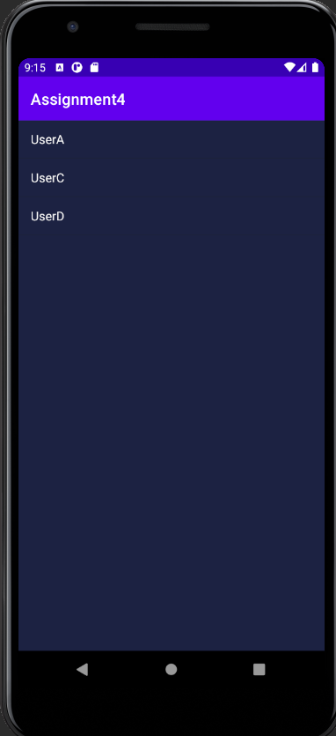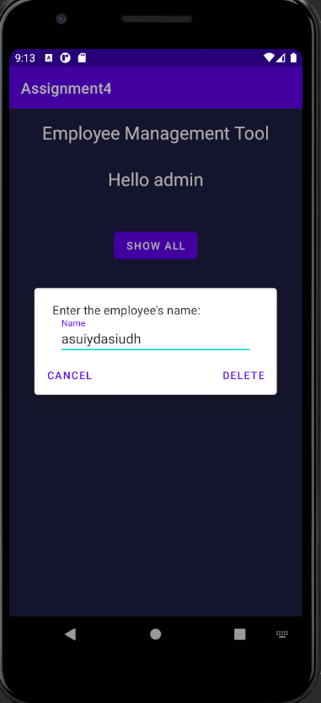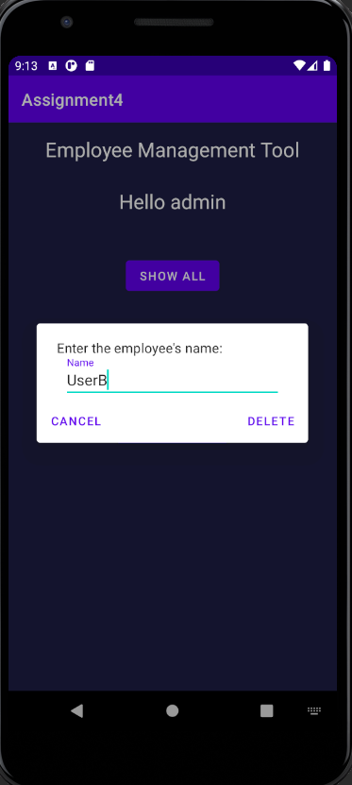 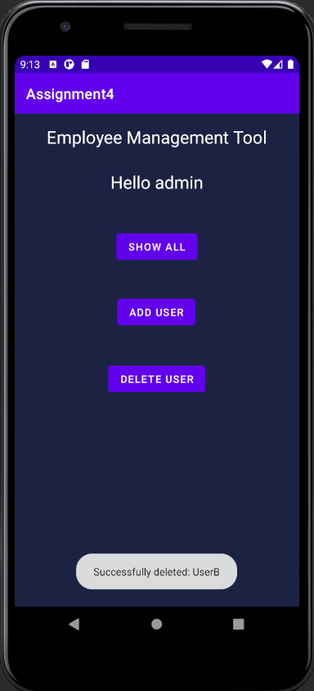

**Landscape Demonstration:**

