Study Project – Phase 3 Document
(Implementation Readiness & Validation)

Cover Page
Course Title: Study Project
Project Title: Storyplex — AI-Powered Visual Novel Engine
Student Name(s): Suryansh , Abhinav, Sudarshan, Saksham
Team ID: 87
Team Name: HawksLab
Student ID(s): 2023ebcs698, 2023ebcs618, 2023ebcs658, 2023ebcs652,
Project Advisor / Supervisor: Swapnil Saurav
Date of Submission: 3 March 2026

1. Introduction
1.1 Purpose of Phase 3
The objective of Phase 3 is to demonstrate that Storyplex — an AI-powered visual novel engine — has reached implementation readiness. This phase focuses on:
- • Demonstrating a fully functional system capable of generating complete visual novels from user prompts, including AI-generated stories, character sprites, scene backgrounds, and interactive gameplay.
- • Validating the design choices made in earlier phases — specifically the selection of Google Gemini as the AI backbone, sql.js for in-app persistence, and a lightweight vanilla JS frontend — through a working implementation.
- • Assessing system reliability under real usage conditions, identifying performance bottlenecks in the AI generation pipeline, and evaluating the system's potential for future enhancement and scalability.

1.2 Summary of Work Completed So Far
Phase 1 (Problem Definition & Planning): Identified the core problem — creating visual novels requires a rare combination of writing, art, and programming skills, making it inaccessible to most people. Defined the project scope as an AI-powered engine that generates all content dynamically. Planned the system architecture as a client-server application with AI integration.
- Phase 2 (Design & Proof of Concept): Designed the system architecture with three layers — a Vite-based SPA frontend, an Express.js REST API backend, and a Google Gemini AI engine. Built a proof of concept demonstrating that Gemini could generate structured story content (JSON), character sprites with consistent art styles, and scene backgrounds. Validated the feasibility of real-time dialogue generation and automatic background removal for sprite transparency.

2. Implementation Overview
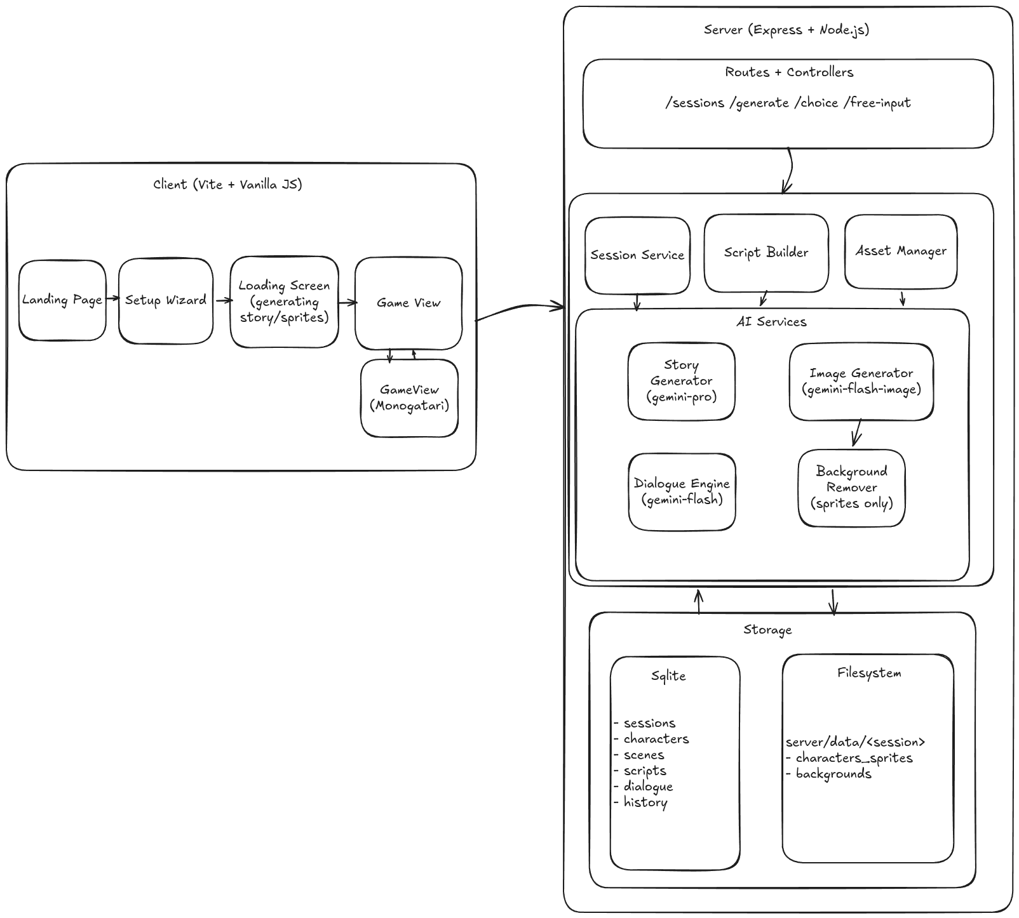
2.1 Implementation Status
The system has reached full implementation across all planned modules. Current status:
- Fully implemented modules:
— Frontend SPA with custom hash router, 5 views (Landing, Setup Wizard, Loading, Game, Sessions)
— Backend REST API with 14 endpoints across 4 route groups (Sessions, Generation, Gameplay, Assets)
— AI story generation pipeline (world building, character creation, plot arc construction)
— AI image generation pipeline (character sprites with 10 expressions, scene backgrounds)
— Real-time dialogue engine with full context awareness and free-form player input
— SQLite database layer with 5 tables (sessions, characters, scenes, script_labels, dialogue_history)
— Asset management system with automatic background removal for character sprites
- Partially implemented modules:
— Session resume/continuation (functional but lacks full state replay on reconnection)
— Error recovery during generation (basic retry logic; no checkpoint-based resume)
- Planned but not implemented components:
— User authentication and multi-user support
— Save/load game state at arbitrary points during gameplay
— Audio/music generation or integration
— Export visual novel as standalone package

2.2 Implemented Features
Core Application Functionality:
— Complete visual novel generation from a 7-field setup form (genre, art style, setting, protagonist, personality, tone, premise)
— 5-step content generation pipeline with real-time progress tracking via Server-Sent Events (SSE)
— Interactive game view with typewriter dialogue, character expression changes, and scene transitions
— Branching story with player choice system and free-form text input for open-ended player agency
- Data Handling and Persistence:
— sql.js (SQLite compiled to WebAssembly) for zero-dependency in-app database
— 5-table schema: sessions, characters, scenes, script_labels, dialogue_history
— Generated assets (sprites, backgrounds) stored on filesystem with structured directory layout
— Dialogue history tracking (last 40 messages) for AI context continuity
- User Interaction Flows:
— Landing page with new story creation and session resumption
— Setup wizard with genre selection, art style picker, and character configuration
— Loading screen with SSE-powered real-time progress bar and step indicators
— Game view with dialogue box, character sprites, scene backgrounds, choice buttons, and free-input field
— Session management page for browsing, resuming, and deleting saved games
- Integration with External Services:
— Google Gemini 2.5 Pro for story and world generation (structured JSON output with schema validation)
— Google Gemini 2.5 Flash for real-time dialogue generation during gameplay
— Google Gemini 2.5 Flash Image for character sprite and scene background generation
— @imgly/background-removal-node for automatic transparent sprite cutouts
— Sharp for image processing, resizing, and format conversion

3. System Validation and Testing
3.1 Testing Strategy
The testing strategy combines manual exploratory testing with structured validation of each pipeline stage:
- Manual / Exploratory Testing: Primary testing approach — each feature was tested through end-to-end user flows. Multiple story configurations were generated across all supported genres (Fantasy, Sci-Fi, Horror, Romance, Mystery) and art styles (Anime, Cartoon, Realistic, Fiction) to validate output quality and consistency.
- Integration Testing: The full generation pipeline was tested as an integrated system — from session creation through story generation, image generation, script building, and gameplay interaction. API endpoints were validated using direct HTTP requests to verify correct request/response handling, error codes, and SSE streaming behavior.
- Component-Level Validation: Individual services (script builder, asset manager, background remover, dialogue engine) were tested in isolation by feeding them controlled inputs and verifying outputs. AI prompt templates were iteratively refined based on output quality — particularly for JSON schema compliance and image consistency.

3.2 Test Cases and Results
Key test cases executed and their outcomes:
Test Case 1 — Session Creation & Setup:
Feature: Create new session via setup wizard with all 7 fields
Expected: Session stored in database with status 'created'
Result: Session created successfully with all parameters persisted
Status: Pass
- Test Case 2 — Full Story Generation Pipeline:
Feature: Generate complete visual novel content from session parameters
Expected: World lore, 3-5 characters, 5 scenes, opening script with choices produced
Result: All content generated successfully; JSON schema validation passes; character count and scene count within range
Status: Pass
- Test Case 3 — Character Sprite Generation & Background Removal:
Feature: Generate 10 expression sprites per character with transparent backgrounds
Expected: Consistent character appearance across expressions; clean background removal
Result: Sprites generated with good consistency using neutral anchor approach; background removal produces clean cutouts in ~90% of cases; occasional artifacts on complex hair/clothing edges
Status: Partial Pass
- Test Case 4 — Interactive Gameplay with Player Choice & Free Input:
Feature: Player selects choices or types free-form actions; AI generates story continuation
Expected: Coherent narrative continuation with appropriate character responses and scene changes
Result: Dialogue engine maintains context effectively; free-form inputs produce creative and relevant responses; new characters and scenes introduced dynamically when story warrants it
Status: Pass
- Test Case 5 — SSE Progress Streaming:
Feature: Real-time generation progress updates via Server-Sent Events
Expected: Client receives incremental progress updates (0-100%) with step labels
Result: Progress events stream correctly; loading screen updates in real time; connection resilient to brief interruptions
Status: Pass

3.3 Validation Summary
The system meets the defined requirements as follows:
- Requirement Compliance: The system successfully generates complete visual novels from user specifications — including AI-written stories, AI-generated character sprites (10 expressions each), AI-generated scene backgrounds, and interactive gameplay with branching dialogue. All core user flows (create, generate, play, manage sessions) function as designed. The REST API serves all 14 endpoints correctly with appropriate error handling.
- Deviations from Expected Behavior: Background removal occasionally produces artifacts on complex character designs (roughly 10% of sprites). Very long generation pipelines (5+ characters) can take 3-5 minutes due to sequential image generation. Gemini API occasionally returns malformed JSON requiring retry logic. Free-form player inputs that are extremely off-topic may produce less coherent continuations.

4. Performance and Reliability Analysis
Responsiveness: The frontend SPA loads instantly via Vite's optimized bundling. API responses for session CRUD operations complete in <50ms. Gameplay interactions (choice/free-input) return AI-generated continuations in 2-5 seconds depending on response complexity. The initial full generation pipeline takes 2-5 minutes depending on character count.
- Stability: The Express.js server runs reliably under single-user load. The sql.js database handles all CRUD operations without issues. SSE connections maintain stable streaming throughout the generation process. The application gracefully handles API errors with retry logic and user-facing error messages.
- Resource Usage: Memory footprint is moderate — the server process consumes ~150-300MB during image generation due to background removal processing. The sql.js in-memory database is lightweight (~5MB even with multiple sessions). Generated image assets (sprites + backgrounds) consume ~2-5MB per session on disk.
- Performance Bottlenecks Observed:
— Sequential sprite generation is the primary bottleneck (10 expressions × N characters)
— Background removal processing is CPU-intensive (~3-5 seconds per sprite)
— Gemini API rate limits can slow generation during peak usage
— Large dialogue histories (40+ messages) increase token usage and response latency

5. Risk Analysis and Mitigation Review
5.1 Identified Risks (Revisited)
Key risks identified in earlier phases and revisited:
- Technical Complexity: Building a multi-stage AI pipeline that generates consistent, high-quality content across text (stories), images (sprites/backgrounds), and interactive scripting (dialogue engine) — with all components working together seamlessly.
- Dependency on External APIs: The entire generation pipeline depends on Google Gemini API availability, rate limits, and output quality. API changes, outages, or pricing changes could directly impact system functionality.
- Time and Scalability Concerns: Image generation is inherently slow and sequential. Generating 10 sprites per character for multiple characters creates a significant time bottleneck. The system currently supports single-user operation only.

5.2 Mitigation Effectiveness
Assessment of mitigation strategies:
- Successfully Mitigated Risks:
— Technical complexity was managed through modular architecture (separate services for story gen, image gen, dialogue engine, script builder) allowing independent development and testing of each component.
— Character sprite consistency was achieved through the 'neutral anchor' approach — generating the neutral expression first and using it as a reference image for all subsequent expressions.
— JSON output reliability was improved through strict schema definitions in AI prompts and retry logic for malformed responses.
— Background removal quality was addressed by using @imgly/background-removal-node, which provides ML-based segmentation superior to simple color-keying approaches.
- Remaining Risks:
— Gemini API dependency remains — no fallback AI provider is implemented. An API outage would render the generation pipeline non-functional.
— Image generation speed has not been fully mitigated — parallel generation is used where possible, but the neutral anchor requirement enforces some sequential processing.
— Scalability to multiple concurrent users has not been addressed — the sql.js in-memory database and single-process Node.js server would require architectural changes for production deployment.

6. Limitations and Constraints
Current limitations, assumptions, and constraints of the system:
- Current Limitations:
— Single-user system with no authentication or authorization
— No audio or music support — visual novels are silent
— Cannot save/load game state at arbitrary points during gameplay
— Background removal produces occasional artifacts (~10% of sprites)
— No export functionality — generated novels can only be played within the application
— Limited to English language content generation
- Assumptions Made During Development:
— Users have a stable internet connection for AI API calls
— The Google Gemini API remains available and maintains current capabilities
— Single-user local deployment is the primary use case
— Users are comfortable with a web-based interface for gameplay
- Constraints Due to Time, Resources, or Technology:
— AI image generation quality is bounded by Gemini's capabilities — no fine-tuning or custom models
— Generation time is constrained by API rate limits and sequential processing requirements
— In-memory SQLite (sql.js) limits database size and concurrent access
— No dedicated GPU available — background removal runs on CPU
— Project timeline limited implementation of automated testing suite

7. Future Enhancements and Scope Extension
Realistic future improvements for the system:
- Feature Enhancements:
— User authentication and profiles with personal story libraries
— Save/load game state with branching timeline visualization
— AI-generated background music and sound effects
— Multi-language support for story generation
— Character voice synthesis using text-to-speech APIs
— Community sharing — publish and play stories created by other users
- Performance Optimizations:
— Parallel sprite generation with batched API calls
— Image caching and CDN integration for faster asset delivery
— Preemptive generation — start generating the next scene while the player is reading
— Optimized background removal using GPU acceleration (WebGPU)
- Scalability Improvements:
— Migration from sql.js to PostgreSQL for multi-user production deployment
— Horizontal scaling with worker processes for generation pipeline
— Queue-based generation system (e.g., Bull/Redis) for handling concurrent requests
— Cloud deployment with auto-scaling (AWS/GCP)
- Additional Use Cases:
— Educational tool — generate interactive history lessons or language learning scenarios
— Therapeutic applications — AI-guided narrative therapy sessions
— Game prototyping — rapidly prototype visual novel concepts before full production
— Export to standalone formats (Electron app, mobile, or Monogatari-compatible package)

8. Learning Outcomes and Reflections
Reflections on the development process:
- Technical Skills Gained:
— Practical experience with generative AI integration — prompt engineering, structured output parsing, and image generation pipelines using Google Gemini's multi-modal capabilities.
— Full-stack JavaScript development — building a complete SPA frontend without frameworks, designing RESTful APIs with Express.js, and working with in-app SQLite databases.
— Real-time web technologies — implementing Server-Sent Events for live progress streaming.
— Image processing techniques — automated background removal, sprite consistency management, and asset pipeline design.
- Design and Problem-Solving Insights:
— The 'neutral anchor' approach for sprite consistency was a key design insight — generating a reference image first and using it to guide all subsequent expressions dramatically improved visual coherence.
— Structured JSON prompts with strict schemas proved essential for reliable AI output — free-form text generation was too unpredictable for a pipeline that required programmatic processing.
— Modular service architecture paid dividends — isolating AI services, asset management, and script building allowed independent iteration on each component without cascading failures.
- Challenges Faced and Lessons Learned:
— AI output reliability was the biggest challenge — Gemini occasionally produces malformed JSON or inconsistent character appearances, requiring robust validation and retry mechanisms.
— Balancing generation quality vs. speed required pragmatic trade-offs — we chose sequential sprite generation for consistency over parallel generation for speed.
— Prompt engineering is an iterative art — prompts were refined through dozens of iterations to achieve consistent, high-quality output across different genres and art styles.
— Keeping the frontend framework-free was both a constraint and a learning opportunity — it deepened understanding of DOM manipulation, routing, and state management fundamentals.

9. Final Deliverables
Deliverables submitted as part of Phase 3:
- github: https://github.com/HawksLab/visual-novels/tree/v0
- ppt: https://docs.google.com/presentation/d/1I3QemCbMeZ6lP8CH1DH2RFcsVt_3LzpWn5u-7y7XmDc/edit?usp=sharing

10. Conclusion
In conclusion:
- Project Readiness: Storyplex has achieved full implementation readiness. All core modules — frontend SPA, backend API, AI generation pipeline, image processing system, and interactive game engine — are functional and integrated. The system successfully generates complete visual novels from simple user specifications.
- Achievement of Objectives: The primary objective — making visual novel creation accessible to anyone without requiring writing, art, or programming skills — has been met. Users can generate a unique visual novel by filling out a simple form, and then play through an interactive story with AI-generated dialogue, characters, and artwork. The system supports multiple genres and art styles, free-form player input, and dynamic story evolution.
- Preparedness for Evaluation: The system is ready for demonstration and evaluation. It can be run locally with a single command, requires minimal setup (only a Gemini API key), and produces visually compelling results within minutes. While limitations exist (single-user, no audio, API dependency), the core value proposition — AI-powered visual novel generation — is fully realized and demonstrable.

11. Supervisor Review and Approval
Advisor Feedback:
Supervisor Comments:
Recommendations:
Signature: ___________________________
Date: _______________________________

