Multiple Choice
Identify the letter of the choice that best completes the statement or answers the question.

____ 1. The phases of the SDLC are

a. | inception, elaboration, construction, transition | c. | inception, analysis, design, transition
b. | planning, analysis, design, implementation | d. | inception, elaboration, design, implementation

____ 2. The SDLC is the

a. | Standard Development Life Cycle | c. | Software Development Life Cycle
b. | Structured Development Life Cycle | d. | Systems Development Life Cycle

____ 3. Which of the following is usually a responsibility of the Business Analyst

a. | Ensuring the system conforms to infrastructure standards d | c. | Identifying how technology can improve business processes
b. | Developing and monitoring the project plan | d. | Analysing the key business aspects of the system

____ 4. Which of the following is the odd one out

a. | method | c. | behaviour
b. | class | d. | Process

____ 5. In object-oriented development which of the following is a description of a class

a. | the general template we use to define and create specific occurences | c. | a location where information about specific occurrences of things e.g. people, telephone numbers, transaction serial numbers, are held
b. | a specific person, place, or thing about which we wish to capture and hold information | d. | a specification of what an object can do

____ 6. In object-oriented development which of the following is a description of an attribute

a. | the general template we use to define and create specific occurences | c. | a location where information about specific occurrences of things e.g. people, telephone numbers, transaction serial numbers, are held
b. | a specific person, place, or thing about which we wish to capture and hold | d. | a specification of what an object can do

____ 7. Which of the following is not a facet of Economic Feasibility

a. | Development Costs | c. | Intangible Costs & Benefits
b. | Annual Operating costs | d. | Project Size

____ 8. Which of the following would normally be considered an Operational Cost

a. | Software Licensing Fees | c. | Increased Market Share
b. | Vendor Installation | d. | Reduction in Inventory

____ 9. A which of the following is not regarded as an operational non-functional requirement

a. | the system should fit in a pocket or small handbag | c. | it should display reports in the currency appropriate to the origin of the enquiry
b. | it should integrate with the organisation’s inventory system | d. | it should work on any browser

____ 10. Which of the following makes the least amount of change to the current system

a. | Business Process Automation | c. | Business Process Reengineering
b. | Business Proeess Improvement

____ 11. Which of the following might deploy root cause analysis

a. | Business Process Automation | c. | Business Process Reengineering
b. | Business Proeess Improvement

____ 12. Which of the following is not associated with Business Process Reengineering

a. | Outcome Analysis | c. | Technology Analysis
b. | Informal Benchmarking | d. | Activity Elimination

____ 13. Which of the following is unlikely to be included in a System Proposal document

a. | A system request | c. | A development team staff list
b. | A workplan | d. | A feasibility analysis

____ 14. Which of the following symbols is used for more than one pupose in a UML activity diagram

a. | a rectangle with rounded corners | c. | a filled-in circle
b. | a diamond | d. | a filled in circle inside another circle

____ 15. Which of the following is not true of Use Cases

a. | they describe what the user can do | c. | they describe how the system responds
b. | they are the building blocks for continued design activities | d. | they facilitate functional decomposition

____ 16. A(n) _____ is an instantiation of a class.

a. | attribute | c. | operation
b. | message | d. | Object

____ 17. A systems analyst draws a lifeline with an X at the end. This lifeline represents

a. | a message that cannot be delivered | c. | a message that is delivered at that point in time
b. | an object that is destroyed at a point in time | d. | an object that is complete at that point in time

____ 18. Which of the following are used to create objects?

a. | concrete objects | c. | concrete classes
b. | abstract objects | d. | abstract classes

____ 19. Which of the follow can be described as “A-kind-of” relationship.

a. | generalisation/specialization | c. | vague
b. | association | d. | aggregation

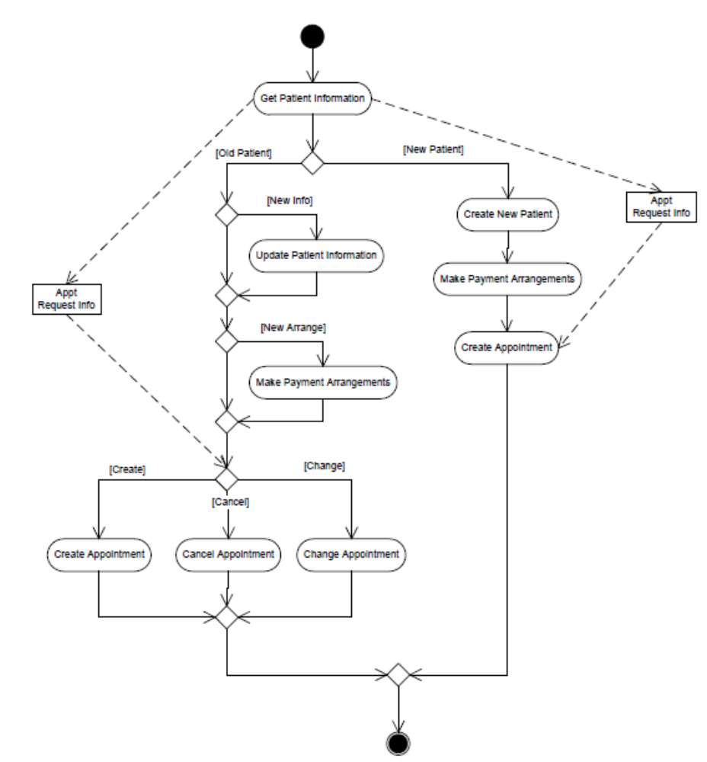

____ 20. In the activity diagram above [Old Patient] is

a. | a class | c. | an object
b. | an activity | d. | a guard condition
Question 21

Class Motors’ main business is selling new vehicles, mostly cars, for a number of manufacturers. When a customer arrives they work with a sales person to purchase a vehicle. Often, but not always, the customer will be trading in their current vehicle. Sometimes the company will buy a trade-in vehicle without selling a vehicle on the same invoice but usually the invoice details the sales of a new vehicle, the purchase of a trade-in vehicle and any options that the customer requests during the transaction. Sales Persons earn commission according to their past performance.

Among the attributes that will be recorded in the system will be Customer Number, Customer Name, Customer Address, Customer Phone Number, Trade-in vehicle number, Purchase value, New Vehicle Number, Sale price, Salesperson Identity Number, Commission rate, Option code, Option Price, Transaction Date/time, Invoice number, Manufacturer, Model, Year of Manufacture.

Develop a class model showing six concrete classes to hold the information for this situation.
[10 marks]

