CHAPTER 5 -- YOUR TURN

  - Appointment System
Using Figure 5-6 as a template, complete the CRC cards for the remaining identified classes in Figure 5-7.

FRONT
Class Name: Person | ID: 1 |  | Type: Abstract, Domain
Description: Base class for all people in the system |  |  | Assoc. Use Cases: none
Responsibilities |  | Collaborators
BACK
Attributes:
lastname
firstname
address
phone
birthdate
age
Relationships:
Generalization (a kind of): none
Aggregation (has parts): none
Other Associations: none

FRONT
Class Name: Medical History | ID: 2 |  | Type: Abstract, Domain
Description: Basic relevant medical data on a patient |  |  | Assoc. Use Cases: none
Responsibilities |  | Collaborators
BACK
Attributes:
heart disease
high blood pressure
diabetes
allergies
Relationships:
Generalization (a kind of): none
Aggregation (has parts): none
Other Associations: is contained in the Patient class

FRONT
Class Name: Bill | ID: 3 |  | Type: Abstract, Domain
Description: Captures the payment process for appointments |  |  | Assoc. Use Cases: none
Responsibilities  Calculate the fees for cancelations. |  | Collaborators
BACK
Attributes:
date
amount
purpose
Relationships:
Generalization (a kind of): none
Aggregation (has parts): none
Other Associations: Appointments lead to Bills

FRONT
Class Name: Appointment | ID: 4 |  | Type: Abstract, Domain
Description: A commitment for a doctor to treat a patient |  |  | Assoc. Use Cases: none
Responsibilities  Handle cancelations. |  | Collaborators  Bill
BACK
Attributes:
time
date
reason
Relationships:
Generalization (a kind of): none
Aggregation (has parts): none
Other Associations: Appointments lead to Bills

  - Campus Housing
In Your Turn 4-4, you created a set of the use cases from the campus housing service that helps students find apartments. Using the same use cases, create a structural model (CRC cards and class diagram). See if you can identify at least one potential derived attribute, aggregation relationship, generalization relationship, and association relationship for the model.

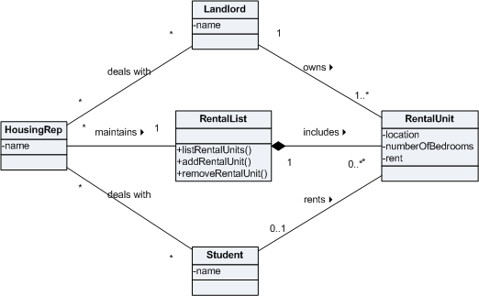

FRONT
Class Name: Housing Rep | ID: 1 |  | Type: Abstract, Domain
Description: Person that manages the rental lists and deals with both landlords and students |  |  | Assoc. Use Cases: None
Responsibilities  None |  | Collaborators  None
BACK
Attributes:
name
Relationships:
Generalization (a kind of): none
Aggregation (has parts): none
Other Associations: Deals with Landlords, deals with Students, maintains Rental List

FRONT
Class Name: Landlord | ID: 2 |  | Type: Abstract, Domain
Description: Person that controls rental units |  |  | Assoc. Use Cases: None
Responsibilities  None |  | Collaborators  None
BACK
Attributes:
name
Relationships:
Generalization (a kind of): none
Aggregation (has parts): none
Other Associations: Deals with Housing Reps, owns Rental Units

FRONT
Class Name: Student | ID: 3 |  | Type: Abstract, Domain
Description: Person that rents Rental Units |  |  | Assoc. Use Cases: None
Responsibilities  None |  | Collaborators  None
BACK
Attributes:
name
Relationships:
Generalization (a kind of): none
Aggregation (has parts): none
Other Associations: Deals with Housing Reps, rents Rental Units

FRONT
Class Name: Rental Unit | ID: 4 |  | Type: Abstract, Domain
Description: A place wherein students may live |  |  | Assoc. Use Cases: None
Responsibilities  None |  | Collaborators  None
BACK
Attributes:
location
number of bedrooms
rent
Relationships:
Generalization (a kind of): none
Aggregation (has parts): none
Other Associations: Owned by a Landlord, rented by a Student, contained in a Rental List

FRONT
Class Name: Rental List | ID: 5 |  | Type: Abstract, Domain
Description: Listing of all available rental units |  |  | Assoc. Use Cases: None
Responsibilities  generate a list of available rental units  add a rental unit  remove a rental unit |  | Collaborators  None
BACK
Attributes:

Relationships:
Generalization (a kind of): none
Aggregation (has parts): Rental Units
Other Associations: Maintained by a Housing Rep

