Multiple Choice
Identify the letter of the choice that best completes the statement or answers the question.

____ 1. The SDLC is the

a. | Software Development Life Cycle | c. | Systems Develoment Life Cycle
b. | Software Deployment Life Cycle | d. | Standard Development Life Cycle

____ 2. The phases of the Unified Process are

a. | planning, analysis, design, implementation | c. | inception, elaboration,construction, transition
b. | planning, elaboration, design, transition | d. | inception, analysis,construction, implementation

____ 3. Which of the following is usually a responsibility of the Systems Analyst

a. | Analysing the key business aspects of the system | c. | Designing new business processes and policies
b. | Ensuring the system conforms to infrastructure standards | d. | Identifying how technology can improve business processes

____ 4. Which of the following is the odd one out:

a. | instance | c. | occurrence
b. | object | d. | class

____ 5. Encapsulation is

a. | the concept of capturing data with a business process | c. | the concept of combining process and data in a single entity
b. | not found in object-oriented systems | d. | none of the above

____ 6. Which of the following is not a facet of Technical Feasibility

a. | Familiarity with the Functional Area | c. | Strategic Alignment of the project with the business goals
b. | Project Size | d. | compatability

____ 7. Which of the following would normally be considered a Development Cost

a. | Software Licensing Fees | c. | Increased Market Share
b. | Vendor Installation | d. | Reduction in Inventory

____ 8. Which of the following is not true

a. | a functional requirement relates directly to a process a systems has to perform | c. | a functional requirement relates directly to information the systems needs to remember
b. | a functional requirement relates directly to the number of cases the system must handle | d. | <<no selection>>

____ 9. The single most critical step in the SDLC is

a. | determining technical feasibility | c. | architecture design
b. | requirements determination | d. | unit testing

____ 10. Which of the following concentrates on improving the efficiency of the current system

a. | Business Process Automation | c. | Business Process Reengineering
b. | Business Proeess Improvement

____ 11. Which of the following is not associated with Business Process Reengineering

a. | Outcome Analysis | c. | Technology Analysis
b. | Informal Benchmarking | d. | Activity Elimination

____ 12. Which of the following is best for revealing the high levels of integrated information required to be documented for the analysis and design of complex organisational information systems.

a. | Joint Application Design | c. | Document Analysis
b. | Questionnaires | d. | Observation

____ 13. Which of the following is a kind of flowchart

a. | the Class diagram | c. | the Use Case diagram
b. | the object diagram | d. | the Activity diagram

____ 14. Which of the following describes the structural perspective of an information system

a. | it models relationships between kinds of things about which values have to be remembered during the enactment of the busines process | c. | it is a model of the states into which particular objects of the classes may get into
b. | it shows how information is passed around parts of the system during the enactment of the business process | d. | it is a model of the users interactions with the system

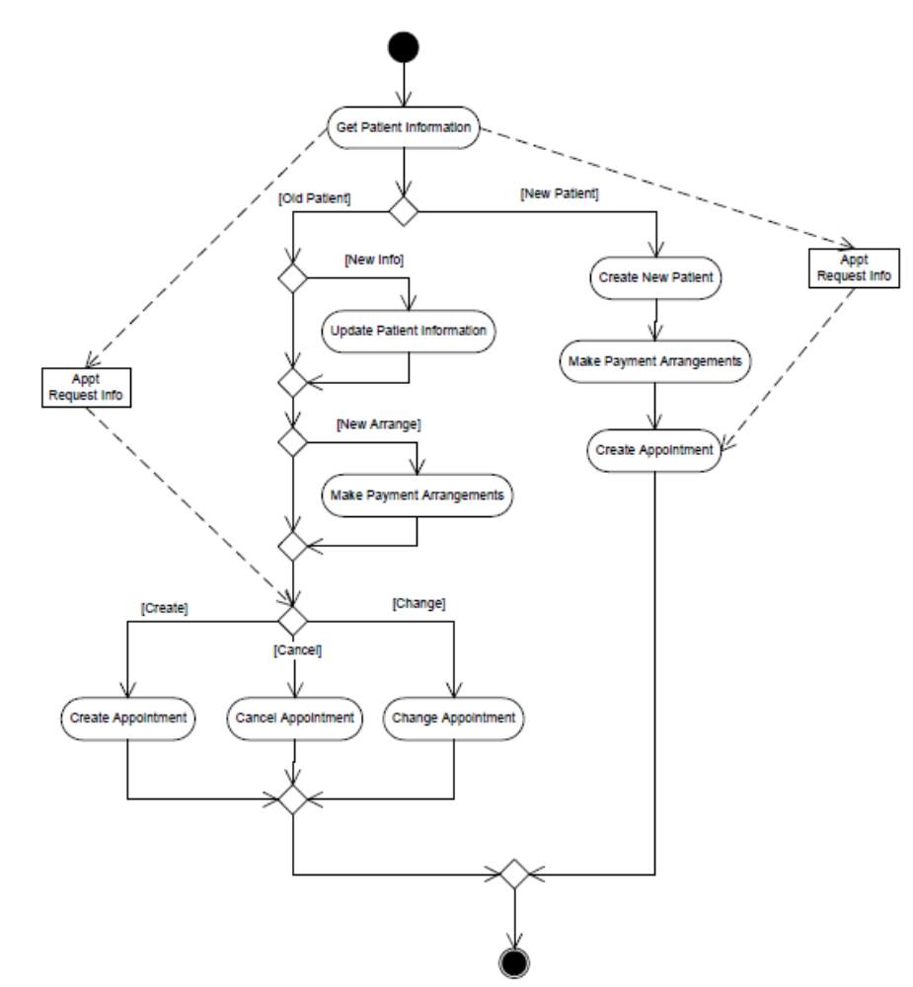

____ 15. In the activity diagram shown the rectangles labelled “appt request info” represent

a. | a class | c. | an activity
b. | an object | d. | a decision

____ 16. Which of the following is not true of Use Cases

a. | they describe what the user can do | c. | they describe how the system responds
b. | they are the building blocks for continued design activities | d. | they facilitate functional decomposition

____ 17. The modeling focus of the interaction diagram is at the_____ level while the modeling focus on the class diagram is at the _____ level.

a. | class, object | c. | class, interaction
b. | interaction, class | d. | object, class

____ 18. When arranging actors and objects on a sequence diagram, it is recommended to list them

a. | in alphabetical order down the side of the diagram | c. | in the order in which they participate in the sequence down the side of the diagram
b. | in alphabetical order across the top of the diagram | d. | in the order in which they participate in the sequence across the top of the diagram

____ 19. The acronym CRUD stands for

a. | create, read, update, delete | c. | collaborate, reference, undo, delete
b. | collaborate, read, update, delete | d. | create, reference, undo, delete

____ 20. Which of the following would most likely not be an example of an attribute?

a. | employee name | c. | ISBN number
b. | stock number | d. | cancel appointment

Question 21

In a University, several housing representatives (housing reps) deal with landlords who own a rental unit (flat or apartments) for renting to students. Each housing rep maintains a list of rental units which students will rent. The list will include details of rental units till they are all let. Students do not deal with the landlord but only deal with the housing rep.

Draw a Class Model showing the five classes involved for a system that would support this situation that incorporates the associations described above. Using UML notation show only concrete classes and the multiplicity for each association and the type of aggregation for any aggregated relationships.

[10 marks]

