Track 3: A World Without Barriers
Project: Smart Anti-Tremor Device

Problem Statement:
People with Parkinson’s disease may experience involuntary hand tremors, rigidity, and difficulty with fine motor movements, making activities such as writing challenging. Tremors can cause shaky pen movements, irregular lines, reduced writing speed, and increased physical effort.
Our project focuses on this specific challenge by developing an assistive device that reduces the effect of involuntary hand movements while allowing the user to maintain control of their intentional movements.

What Are We Building?
We are developing a low-cost, portable, and modular Smart Anti-Tremor Pen that detects involuntary hand movements in real time and mechanically compensates for them.
The pen is mounted inside a 2-axis stabilizing gimbal. An MPU6050 motion sensor tracks the instruments movement, while an Arduino/ESP32 processes the sensor data and controls two servo motors. The servos adjust the gimbal to compensate for unwanted movement and keep the pen tip more stable.
The same stabilization platform can also be adapted for other lightweight instruments such as a spoon or toothbrush, making the system modular.
Working Principle:
- The user holds the whole instrument containing the MPU6050.
- The sensor continuously measures movement of the platform it is mounted on , including pitch and roll.
- The ESP32 processes the incoming motion data.
- The system filters and estimates the unwanted tremor component.
- Corrective signals are generated for the two servo motors.
- The servos adjust the 2-axis gimbal.
- The gimbal compensates for unwanted movement, helping keep the pen tip more stable.
- The user can continue making intentional writing movements.

System Architecture:

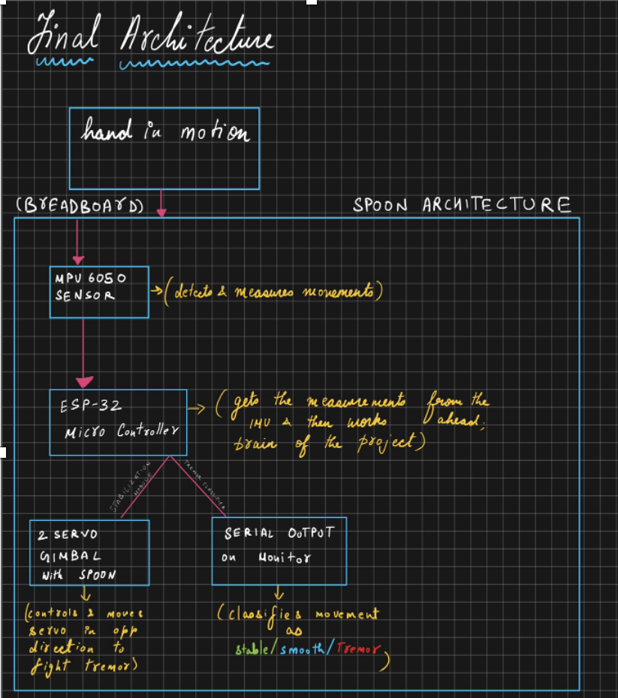
The architecture follows the documented prototype flow from hand movement sensing through processing and tremor detection to servo-based mechanical stabilization.

Components Used:
Component | Role in project | How it is used
ESP32 DevKit | Main controller | Reads MPU6050 over I²C and sends PWM commands to both servos.
MPU6050 | Motion sensing | Mounted on the breadboard; GX/GY angular motion is used by the stabilizer.
2 × SG90 | Actuation | Servo 1 = up/down; Servo 2 = left/right.
Breadboard + jumpers | Rapid prototyping | Holds the MPU6050 and provides temporary wiring between ESP32, sensor and servo signals.
4 x1.5V AA battery pack | Servo power | Powers both servos separately; ground is shared with ESP32 ground.
Acrylic/M3 hardware + spoon | Mechanical system | Forms the DIY 2-axis gimbal and carries the utensil.

1)ESP32
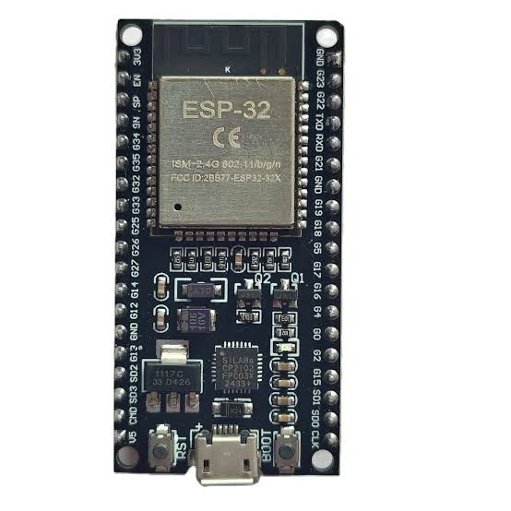

2)MPU6050
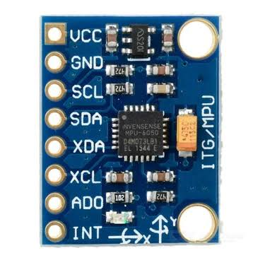

3)SG90 SERVOS
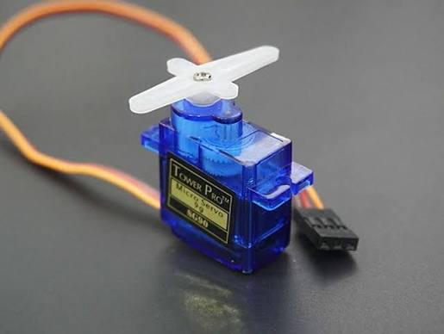

4) 4x1.5V AA Battery Pack


Two Types of Modules:
1)Tremor-detection code: This is a separate program for identifying the character of the motion. It collects a short window of gyroscope readings, removes the bias, measures overall activity and examines the frequency content. Its output is STABLE, SMOOTH or TREMOR.

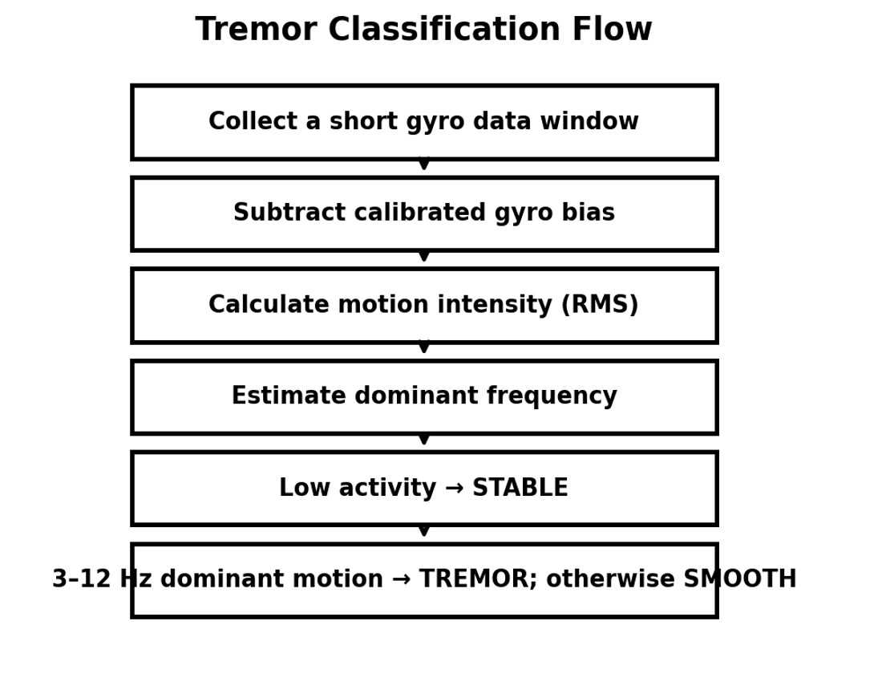

2)Stabilizing code: This is the code used in the physical spoon demonstration. It calibrates the gyroscope, removes small sensor noise, converts GX/GY into opposite servo corrections, constrains the servo range and updates both servos continuously.
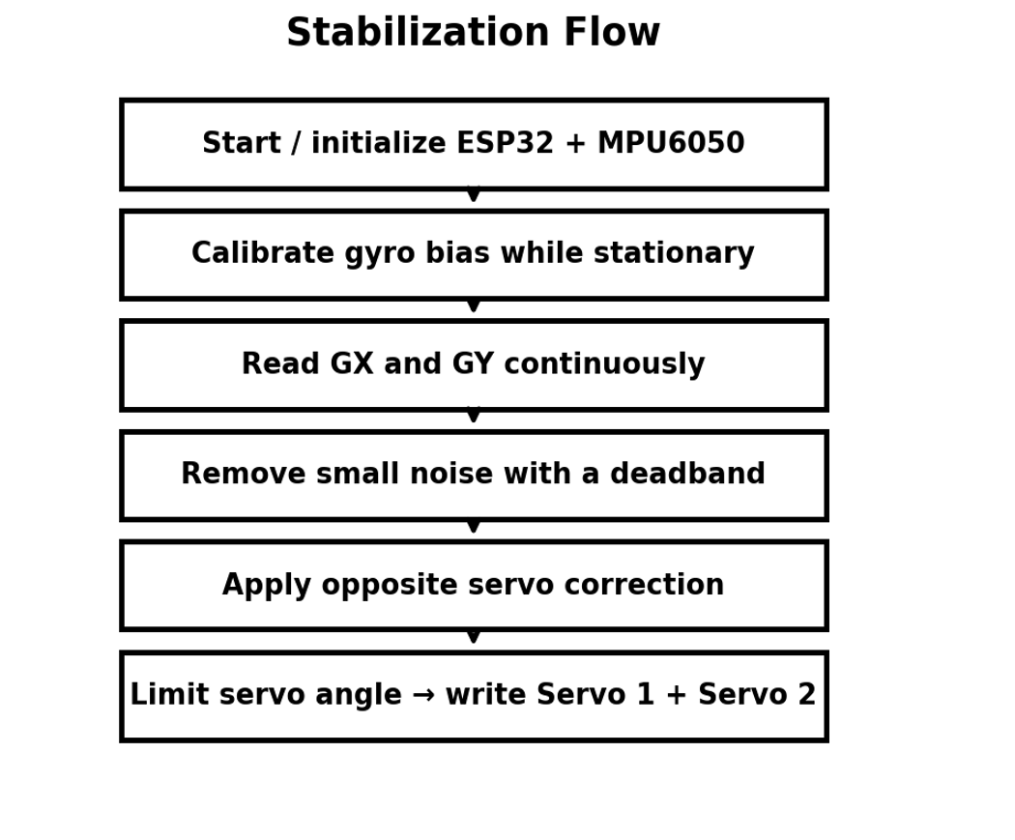

How We Filter/ Detect Tremor:
- Bias calibration: the sensor is kept still at startup, and the average gyro reading is stored as a bias. That baseline is subtracted from later measurements.
- RMS activity filtering: very small motion is treated as stable instead of being called tremor.
- Frequency filtering: the algorithm checks the low-frequency motion range and focuses the tremor decision on approximately 3–12 Hz.
- Decision logic: low activity → STABLE; dominant motion inside the tremor band → TREMOR; other non-stable motion → SMOOTH.

This is a lightweight signal-processing detector, not a clinical diagnosis. A wider 3–12 Hz band is used for the prototype so the system is not dependent on a single fixed tremor frequency.

Why Our Approach Is Different:

The prototype uses tool level stabilization via a two-axis gimbal to stabilize the component itself instead of the entire hand. It features a breadboard-mounted MPU6050 sensor for easy prototyping and separates stabilization from tremor detection for better robustness its frequency aware detection analyses both motion magnitude and frequency to accurately classify real tremors from normal movements.
The target V1 bill of materials is therefore in the low-thousands of rupees, far below the ₹50,000–₹1,00,000 range used as the commercial comparison for the hackathon. The exact final price will change with manufacturing volume, enclosure, battery, PCB and mechanical refinement. The cost advantage comes from commodity electronics, a simple gimbal and a repairable modular design.

Future Aspects:

- PCB integration: move the ESP32, MPU6050, power regulation, battery interface and servo connections from the breadboard to a compact custom PCB.

- Compact mechanical design: replace the temporary acrylic/breadboard arrangement with a lighter enclosed gimbal and interchangeable spoon/pen/tool mounts.

- Data collection: record synchronized accelerometer and gyroscope data for stable, smooth and tremor movements, with appropriate user consent and labels.

- ML-based real-time detection: train a lightweight classifier on collected motion windows and deploy it on the ESP32 to estimate tremor probability continuously.

- Adaptive stabilization: use the classifier output to change stabilization gain/filtering—gentler during intentional movement and stronger when tremor is detected.

- Personal calibration: allow the system to learn a user's normal movement range and tremor characteristics.

Project Conclusion:
This prototype demonstrates a practical low-cost route to active utensil stabilization. The MPU6050 mounted on the breadboard provides motion data, the ESP32 performs real-time control, and two SG90 servos move the spoon in opposition to hand rotation. A separate lightweight signal-processing algorithm classifies motion as STABLE, SMOOTH or TREMOR. The next stage is to combine the proven physical controller with a compact PCB, a larger real-world motion dataset and an embedded ML model for adaptive tremor detection and stabilization.
Our goal is not to stop the user's movement, but to make that movement less of a barrier.

