# Detailed Design Document: ChatSphere

## About ChatSphere:

ChatSphere is a messaging application designed for seamless communication between users. It allows users to create private chats, add contacts, and send messages in real-time. With features like Notification and Video Calling, users can stay connected and engaged effortlessly. ChatSphere ensures a user-friendly interface for an intuitive messaging experience.

## 1. Introduction

### 1.1 Purpose

This document aims to present a comprehensive overview of ChatSphere's design and architecture, encompassing features, functionality, and technical specifications.

### 1.2 Scope

ChatSphere, as a chatting app, endeavors to provide users with a dynamic platform for real-time communication, fostering seamless conversations, multimedia sharing, and interactive features to enhance the overall chatting experience.

### 1.3 Objectives

* Make it easy for users to chat by creating a simple and friendly interface in ChatSphere.
* Keep user information safe with strong security measures.
* Allow ChatSphere to grow and handle more users in the future.
* Let users work together by making it easy to share and collaborate on chats and activities..

## 2. System Overview

### 2.1 System Architecture

ChatSphere employs a client-server architecture with a responsive web-based front end for user interactions and a robust back-end server handling core logic, ensuring an efficient and dynamic chatting experience.

### 2.2 Key Features

* User registration and authentication
* Real-Time Chatting
* Notification System
* Video Calling
* Emoticons and Stickers

### 2.4 Technologies Used

* Front-end: React
* Back-end: Express
* Database: MongoDB
* Authentication: JWT
* Additional tools/libraries as needed.

## 3. Database Design

3.1 Entity-Relationship Diagram

User Entity:

* *UserID (Primary Key):* Unique identifier.
* *Username:* User's chosen name.
* *Email:* User's contact address.
* *Password:* Secure authentication.

Message:

* *Id (Primary Key):* Unique identifier..
* *SenderID:* Sender's UserID.
* *Data:* Message content.
* *SenderID:* Sender's UserID.

Friends:

* *Id(Primary Key):* Unique identifier.
* *UserID (Foreign Key):* Owner of the contact.
* *FriendId(Foreign Key):* UserID of the contact.

## 4. API Details

* **User Authentication and Authorization:**
  + /api/auth/register: Register a new user.
  + /api/auth/login: Log in an existing user.
  + /api/auth/logout: Log out the current user.
  + /api/auth/reset-password: Reset user password.
* **User Profile:**
  + /api/users/{userId}: Retrieve user profile information.
  + /api/users/{userId}/update: Update user profile information.
* **Messaging:**
  + /api/messages/send: Send a new message.
  + /api/messages/{messageId}: Retrieve a specific message.
  + /api/messages/{userId}/inbox: Retrieve the inbox of a user.
  + /api/messages/{userId}/outbox: Retrieve the outbox of a user.
  + /api/messages/{messageId}/delete: Delete a specific message.
* **Contacts:**
  + /api/contacts/add: Add a new contact.
  + /api/contacts/{contactId}/remove: Remove a contact.
  + /api/contacts/{userId}/list: List all contacts of a user.

5. Deployment Process

#### Pre-Deployment Tasks:

* Code Review: Ensure that all code changes are reviewed by team members to maintain code quality and identify any potential issues.
* Testing: Conduct thorough testing of the application to ensure it functions correctly in different environments. This includes unit tests, integration tests, and end-to-end tests.
* Environment Setup: Prepare the deployment environment, including configuring servers, setting up databases, and ensuring necessary dependencies are installed.

#### Deployment Steps:

* Build Artifacts: Generate production-ready artifacts for deployment. This may involve compiling front-end code, bundling dependencies, and preparing server-side code.
* Configure Servers: Set up servers to host the application. This includes provisioning virtual machines or containers, configuring network settings, and installing required software.
* Deploy Code: Deploy the application code to the servers. This can be done manually by copying files or using automated deployment tools like Vercel, AWS CodeDeploy, or Jenkins.
* Configure Services: Configure any additional services required for the application to run, such as databases, caching systems, and messaging queues. Ensure that configurations match the production environment.

4. Database Diagram

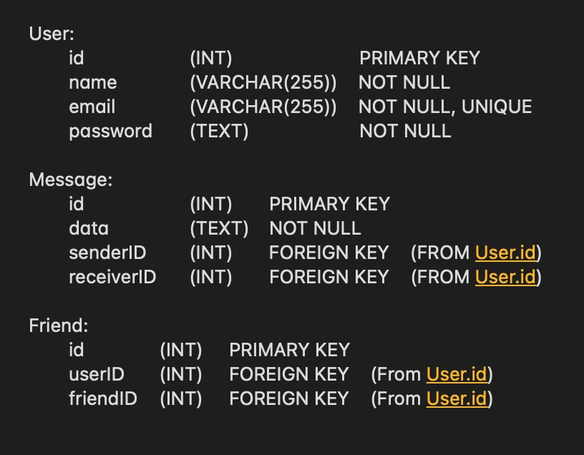

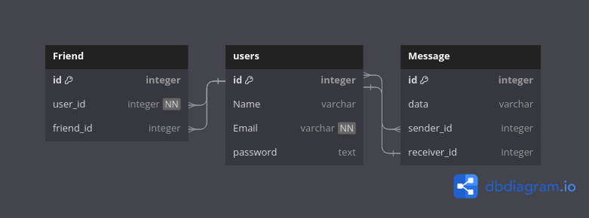

## 5. Flow Diagram



 

 