1. Traning

Search with tinyeye and telegraph.co.uk has county named nevada at https://www.telegraph.co.uk/science/2016/03/12/area-51-and-extra-terrestrial-life-both-exist-says-head-of-nasa/

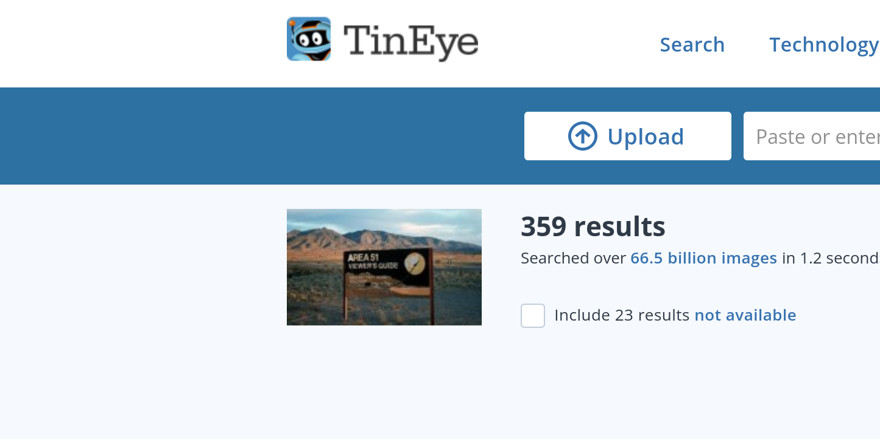

2. Get the light
Cat the file to get binary digits and then convrt it to ascii

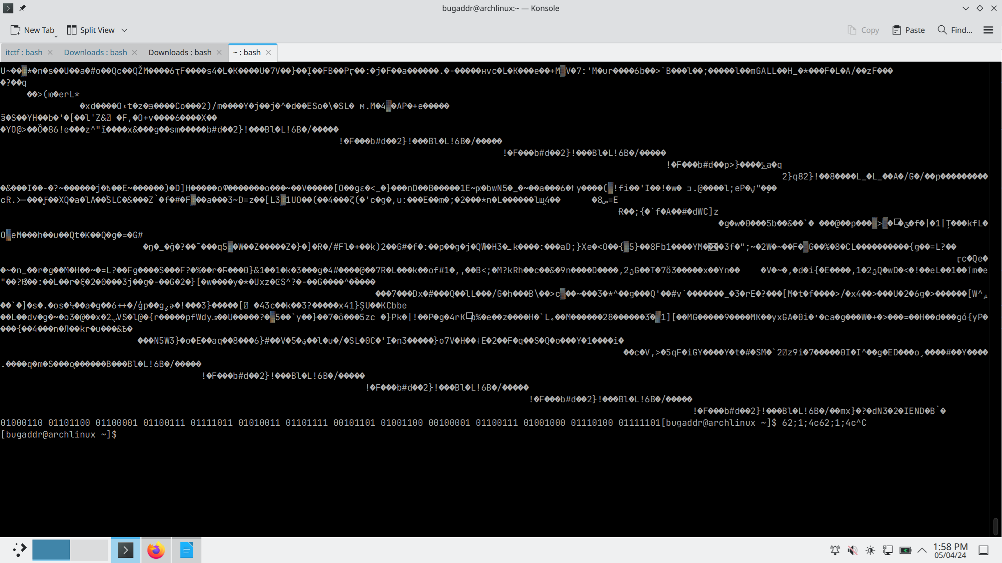

3. Social bird

osint and search account on twitter then download a image in post and it has a movie named wild west whose director is david attwood

4. Look
execute the pyhton file and get cipher then decrypt vigenere_decrypt with decode.fr

