Analytic Plan: Booking Cancellation Risk Model for ABC Hotels

By: Krisha Bugajski
Date: 09/14/25

1. Business Problem Statement

Goal: ABC Hotels wants to identify bookings that have a high risk of cancellation. The objective is to assign a probability, between 0 and 1, where higher values represent a greater risk of cancelation. The high risk bookings will then be targeted with advertisements and offers in an effort to reduce cancellations and improve profits.

Why It Matters: This model is important because cancellations make it harder to predict income and fill rooms. Also, retaining bookings that already exist is usually cheaper than finding new customers. By knowing which bookings are at high risk, ABC Hotels can send advertisements with promotions, reminders, or offers to reduce cancellations, therefore increasing income stability and overall guest satisfaction.

How the Model Will Be Used: This model will be used by the operations and marketing teams at ABC Hotels, where they will be able to identify high-risk bookings and give them a tailored outreach (promotions, reminders, service improvements). Business analysts will also be able to use feature importance insights to understand what factors are driving these cancellations.

2. Supervised Classification Problem Definition

This is a supervised binary classification problem. The target variable is booking_status, encoded as (canceled = 1, not_canceled = 0). The model will output a calibrated probability of cancellation for each booking.

3. Dataset Overview

Data Summary: The Customer dataset contains over 35,000 booking records, with guest demographics, booking details, pricing, and customer history which can all be used to
identify customer cancellation for ABC Hotels.

Dataset Structure:
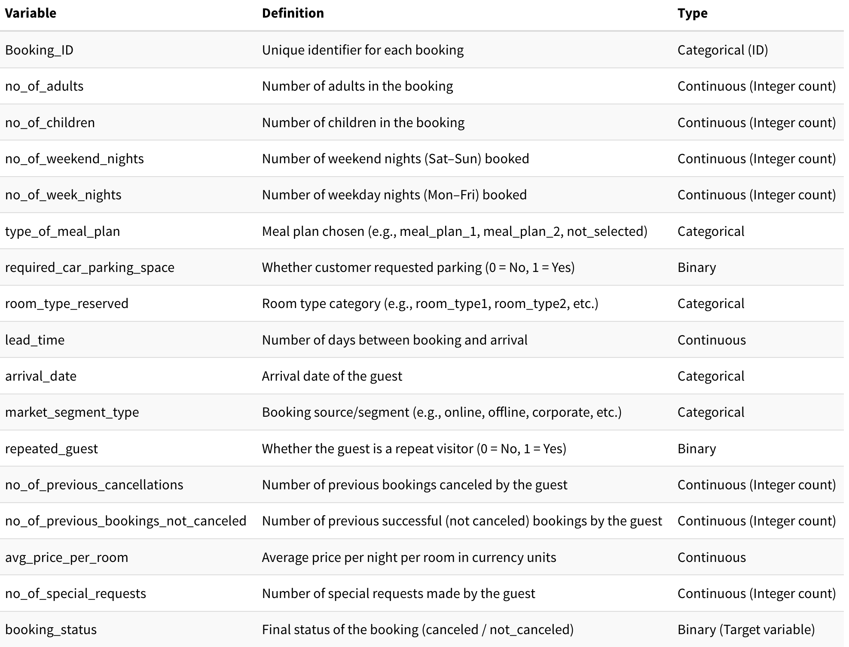

Note: Booking_ID will be the only variable excluded because it is only an identifier and has no predictive value.

3. Data Processing Plan
Missing values:
- Continuous variables: impute with median, since its robust to outliers
- Categorical variables: impute with “Unknown”, preserving the missingness as a possible signal
- If more than 1% is missing, add an indicator variable (feature_missing = 1, else 0), since it still might represent a meaningful pattern or group

Outliers:
- Clip continuous variables at the 0.5th and 99.5th percentiles to reduce extreme influences. This is a great way to still preserve the overall distribution of the data.
Encoding:
- One-hot encode the categorical variables such as meal plan, room type, and market segment. Encode binary variables as 0/1.
Scaling:
- Standardize continuous features (mean=0, std=1) to ensure there is fair comparison across all features.
Leakage check:
- Verify that all features reflect only information available at or before the time of booking and that no variables contain post cancellation information, so there is no risk of data leakage.
Class Imbalance Check
- Measure the proportion of canceled vs not canceled bookings in booking_status.
- Plan for resampling or class weighting if imbalance exists (SMOTE).

3. Feature Engineering Plan

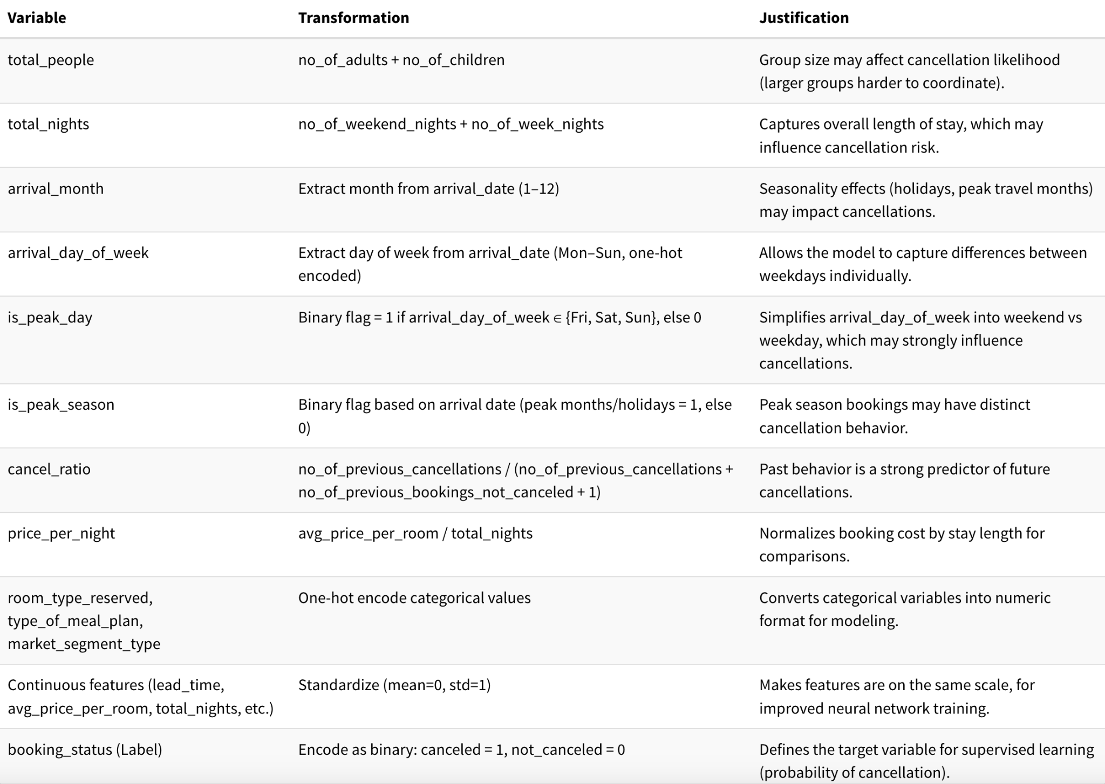

4. Expected Analytic & Informational Outcomes
- Booking-level probability scores of cancellation (0–1). For example, if a booking gets 0.7, that means there is a 70% chance it will be canceled.
- Risk tiers (Low, Medium, High) to help guide targeted interventions. Instead of just probabilities, grouping them into buckets can make it easier for business use.
- Get a performance report using the following tools to see how good the model is:
  - ROC curve / AUC: shows how well the model separates canceled vs. not canceled.
  - PR curve (Precision-Recall): better for imbalanced data, tells us how many true cancellations we catch without too many false alarms.
  - Calibration plots: checks if predicted probabilities match reality. For example, do bookings with a predicted 0.7 probability actually cancel around 70% of the time?
  - Feature importance: this shows which variables matter most.
- Explainability: SHAP-based feature importances using:
  - Global: which features generally influence cancellations the most.
  - Per booking: why a specific booking got a high or low cancellation score.
- Business integration: Threshold-based targeting rules and expected value analysis.
  - Once there are probabilities available, the hotel needs rules for action. For example, if probability greater than or equal to 0.5, they can send a discount email to the customers.
  - Expected value analysis: weigh costs and benefits. For example, if preventing a cancellation saves $500 but offering a discount costs $50, then interventions make more sense.
- Monitoring plan: Models don’t last forever and patterns change through seasonality, promotions, and economic shifts.
  - Drift detection: check if the input data or customer behavior changed at all.
  - Monthly calibration checks: ensure the predicted probabilities still match reality.
  - Retrain often: refresh the model with the newest data often, or right away if performance drops.

5. Anticipated Challenges & Mitigations
