PROJECT PROPOSAL
Design and Development of an Institutional Review Board Management Information System (AWHSC-IRB MIS)
A Web-Based, Workflow-Driven Information System Supporting the AWHSC Institutional Review Board

Prepared for
Asrat Woldeyes Health Science Campus — Institutional Review Board (AWHSC-IRB)
Prepared by
Bogale Shigult · Binyam Eshetu · Behailu Haile · Dereje Chinkil · Eden Damenu
Document reference
AWHSC-IRB-MIS/PROP/2026-01 · Version 1.0
August 2026

Document Control

Project Team
Name | Role
Bogale Shigult | Project Team Member
Binyam Eshetu | Project Team Member
Behailu Haile | Project Team Member
Dereje Chinkil | Project Team Member
Eden Damenu | Project Team Member
Role assignments above are placeholders — update each member's specific role (e.g., Project Lead, Systems Analyst, Backend Developer, Database Designer, QA/Documentation) once responsibilities are finalized.

Revision History
Version | Date | Author | Description of Change
0.1 | — | Project Team | Initial draft outline derived from AWHSC-IRB SOP review
1.0 | August 2026 | Project Team | First complete proposal issued for stakeholder review

Approval
Role | Name | Signature | Date
IRB Chairperson
IRB Secretariat / Administrator
Project Sponsor
Lead Developer / Systems Analyst

Table of Contents
Right-click anywhere in the table below and choose “Update Field” (or press F9) to populate page numbers, then Ctrl+Click any entry to jump straight to that section.

Quick Links — Appendices
Appendix A · Appendix B · Appendix C · Appendix D · Appendix E · Appendix F · Appendix G · Appendix H · Appendix I

Abstract / Executive Summary
The Asrat Woldeyes Health Science Campus Institutional Review Board (AWHSC-IRB) operates under an approved Standard Operating Procedure (SOP) that governs the full lifecycle of research ethics review — from protocol submission and review through continuing review, amendments, safety reporting, monitoring, meetings, records management, confidentiality, and auditing. These activities are currently coordinated through document-based and largely manual processes that place a growing administrative burden on the Secretariat, reviewers, and Committee as the volume and complexity of submissions increases.
This proposal recommends the design and development of the AWHSC-IRB Management Information System (AWHSC-IRB MIS): a secure, centralized, web-based platform that digitally represents the institution's approved SOP as a structured, workflow-driven system. Rather than being conceived as a generic document-management tool, the system is derived directly from the SOP's defined procedures, responsibilities, and records requirements, which gives the proposal a defensible, source-derived foundation rather than an assumed one.
The proposed system is organized into ten functional modules covering user and access management, research and protocol management, protocol review, continuing review and final reports, amendments, safety and adverse-event reporting, monitoring, meetings and communication, study files and archiving, and audit/inspection. It will be built using a UML-driven, iterative software engineering methodology that carries requirements from SOP analysis through use-case and workflow modeling, architecture and database design, implementation, testing, and deployment.
Key deliverables include a full software requirements specification, a complete UML analysis and design package, a layered system architecture with role-based access control and audit logging, a relational database and REST API, and a tested, deployable web application together with user documentation. The project's central and most defensible artifact is a SOP-to-Requirement-to-System traceability matrix that demonstrates, module by module, how each SOP procedure is realized in the software design.
Upon completion, the AWHSC-IRB MIS is expected to provide a single, secure, and auditable environment for managing research submissions, ethical review, committee decision-making, study monitoring, safety reporting, records management, confidentiality, and institutional oversight — improving traceability, turnaround time, and compliance across the entire IRB review lifecycle.

Chapter One: Introduction

1.1 Background
The AWHSC-IRB is governed by an approved Standard Operating Procedure (the “AWHSC-IRB SOP”) that defines the purpose, scope, responsibilities, flow charts, detailed instructions, records, confidentiality requirements, and annexes for all IRB activities. The SOP establishes procedures covering, among others: protocol review, resubmitted protocol review, continuing review, final report review, protocol implementation monitoring, non-compliance and violation intervention, research-participant requests, study termination, safety and adverse-event reporting, site monitoring, review meeting agendas and minutes, emergency meetings, communication records, active study files, archive and retrieval, confidentiality, and auditing and inspection.
This breadth of coverage means that the AWHSC-IRB is not merely a review committee but the custodian of a complete research-oversight lifecycle, generating and depending on large volumes of interrelated records, decisions, and deadlines. As submission volumes grow, sustaining this lifecycle through manual, document-based coordination becomes increasingly demanding on staff time and increases the risk of inconsistency between related activities.

1.2 Problem Statement
The AWHSC-IRB has established procedures covering a broad range of research ethics activities, including protocol review, continuing review, amendments, safety reporting, monitoring, meetings, communication, study-file management, confidentiality, and auditing. Managing these interconnected activities requires systematic coordination of information, documents, responsibilities, decisions, deadlines, and historical records. The absence of an integrated information-management platform can make it difficult to provide a unified view of the complete research review lifecycle and to maintain consistent traceability across related activities.
The SOP itself illustrates the scale of this coordination requirement: it specifically requires that active study files be created, maintained, distributed, and kept secure while remaining readily retrievable when needed. Meeting the intent of this and related requirements consistently, across every open study and every reviewer, is difficult to guarantee without a centralized system of record.

1.3 General Objective
To design and develop a secure, centralized, and workflow-based Institutional Review Board Management Information System that supports the AWHSC-IRB's research ethics review, study monitoring, records management, and oversight activities in accordance with its approved Standard Operating Procedures.

1.4 Specific Objectives
- Analyze the existing AWHSC-IRB SOPs and translate applicable procedures into system requirements.
- Design a centralized system for managing research protocols and submissions.
- Support protocol review and resubmission workflows.
- Support continuing review and final-report processes.
- Manage protocol amendments and related committee decisions.
- Support reviewer assignment and review activities.
- Manage IRB meetings, agendas, minutes, attendance, and decisions.
- Support safety and adverse-event reporting.
- Support monitoring and non-compliance management.
- Manage communication records between the IRB and investigators.
- Maintain active study files and archived records.
- Enforce confidentiality and role-based access control.
- Maintain audit trails for significant system activities.
- Provide reporting and information-retrieval capabilities.
- Develop a maintainable, UML-based software architecture that can be extended in future phases.

1.5 Scope
The system scope is organized into ten functional modules, described fully in Section 2.4. In summary, these cover: user and access management; research and protocol management; protocol review; continuing review and final reports; protocol amendments; safety and adverse events; monitoring; meetings and communication; study files and archive; and audit and inspection.
The scope of this proposal includes requirements analysis, UML-based design, architecture, database and API design, implementation of a web-based application, and testing through to deployment. It excludes procurement of institutional hardware/hosting infrastructure and change-management activities outside the software project itself, both of which are noted under limitations below.

1.6 Significance
- Provides the AWHSC-IRB with a single, authoritative system of record for the entire research-review lifecycle.
- Improves consistency and traceability between related activities — e.g., linking an amendment, a continuing review, and a safety report to the same protocol history.
- Strengthens institutional compliance posture through role-based access, confidentiality controls, and comprehensive audit trails.
- Reduces administrative overhead on the Secretariat and reviewers by automating routine coordination and record-keeping tasks.
- Establishes a defensible, SOP-derived software design that can be validated against the institution's own governing procedures.
- Creates a maintainable technical foundation (UML models, layered architecture) that supports future extension as IRB needs evolve.

1.7 Limitations
- The system reflects the AWHSC-IRB SOP version reviewed at proposal time; subsequent SOP revisions will require corresponding requirement updates.
- The proposal addresses the software system itself; institutional hosting, network, and hardware procurement are treated as a dependency rather than part of this scope.
- Integration with external national or regulatory research-registration systems, if required, is treated as a future extension rather than part of the initial release.
- Full realization of workflow automation benefits depends on institutional adoption and consistent use of the system by all IRB roles.

Chapter Two: System Description

2.1 Existing AWHSC-IRB Procedures
The AWHSC-IRB SOP defines, for each procedure, its purpose, scope, responsibilities, flow chart, and detailed instructions, together with the records it generates. Procedures span protocol review, resubmission, continuing review, final report review, protocol amendments, safety and adverse-event reporting, monitoring, meeting management, communication records, active study file management, archiving, confidentiality, and audit/inspection. Because each procedure is already documented with defined responsibilities and record requirements, the SOP functions as a ready-made requirements source for the proposed system, rather than requiring requirements to be invented from scratch.

2.2 Proposed System
The AWHSC-IRB MIS is a web-based application that represents each SOP procedure as a corresponding system module, workflow, and set of records. Investigators submit and track protocols online; reviewers and Committee members conduct and record reviews and decisions within the system; the Secretariat manages meetings, communications, and study files; and administrators manage users, roles, and system-wide audit oversight. Every action of consequence — submission, review, decision, amendment, safety report, monitoring visit, communication, and archive event — is captured as a structured, timestamped, and traceable record.

2.3 Major Stakeholders
Role | Primary Interaction with the System
Investigator | Submits protocols, amendments, continuing review and final reports, and safety reports; tracks review status and receives communications.
Reviewer | Receives assigned protocols, records assessments and recommendations, participates in meetings.
Secretariat | Verifies submissions, schedules meetings, manages agendas/minutes, maintains study files and archive, issues official communications.
Chair / Committee Members | Chairs or participates in meetings, records committee decisions, approves minutes.
Administrator | Manages users, roles and permissions, oversees audit logs and system configuration.

2.4 Functional Modules

Module 1 — User and Access Management
- Users, roles, and permissions
- Authentication and access control

Module 2 — Research and Protocol Management
- Investigators, research projects, protocols, protocol versions, and submissions

Module 3 — Protocol Review
- Initial protocol review, resubmission, reviewer assignment, review assessment, and review decision

Module 4 — Continuing Review and Final Reports
The SOP explicitly identifies continuing review and final report review as distinct IRB activities, each with its own timing and records.

Module 5 — Protocol Amendments
This is treated as a major module. The SOP describes amendment decisions including approval, modification requests, suspension, requests for additional information, and non-approval — each of which the module represents as a distinct decision outcome and workflow branch.

Module 6 — Safety and Adverse Events
The SOP covers serious adverse events, unanticipated events, and protocol deviations. The corresponding Safety and Adverse Event (SAE) record captures: study, protocol number, sponsor/host institution, report date, participant information, event description, treatment, outcome, seriousness, relationship to study, IRB decision, reviewer, comments, and action — providing detailed, source-derived structure for the module's data model.

Module 7 — Monitoring
- Site monitoring, monitoring visits, findings, and follow-up, as explicitly identified in the SOP

Module 8 — Meetings and Communication
- Agenda preparation, meeting procedure, minutes, emergency meetings, and communication records — all explicitly identified SOP activities

Module 9 — Study Files and Archive
One of the major modules, since the SOP explicitly requires that active study files be securely created, maintained, distributed, and retrievable. Covers document management, archive, retrieval, and confidentiality controls.

Module 10 — Audit and Inspection
Supports the SOP's defined “Auditing and Inspection of the IRB” activity, including audit trail capture and inspection-readiness reporting.

2.5 Main Workflow
The diagram below shows the central protocol lifecycle the system supports, from initial submission through review, approval, ongoing oversight activities, and closure into the archive.
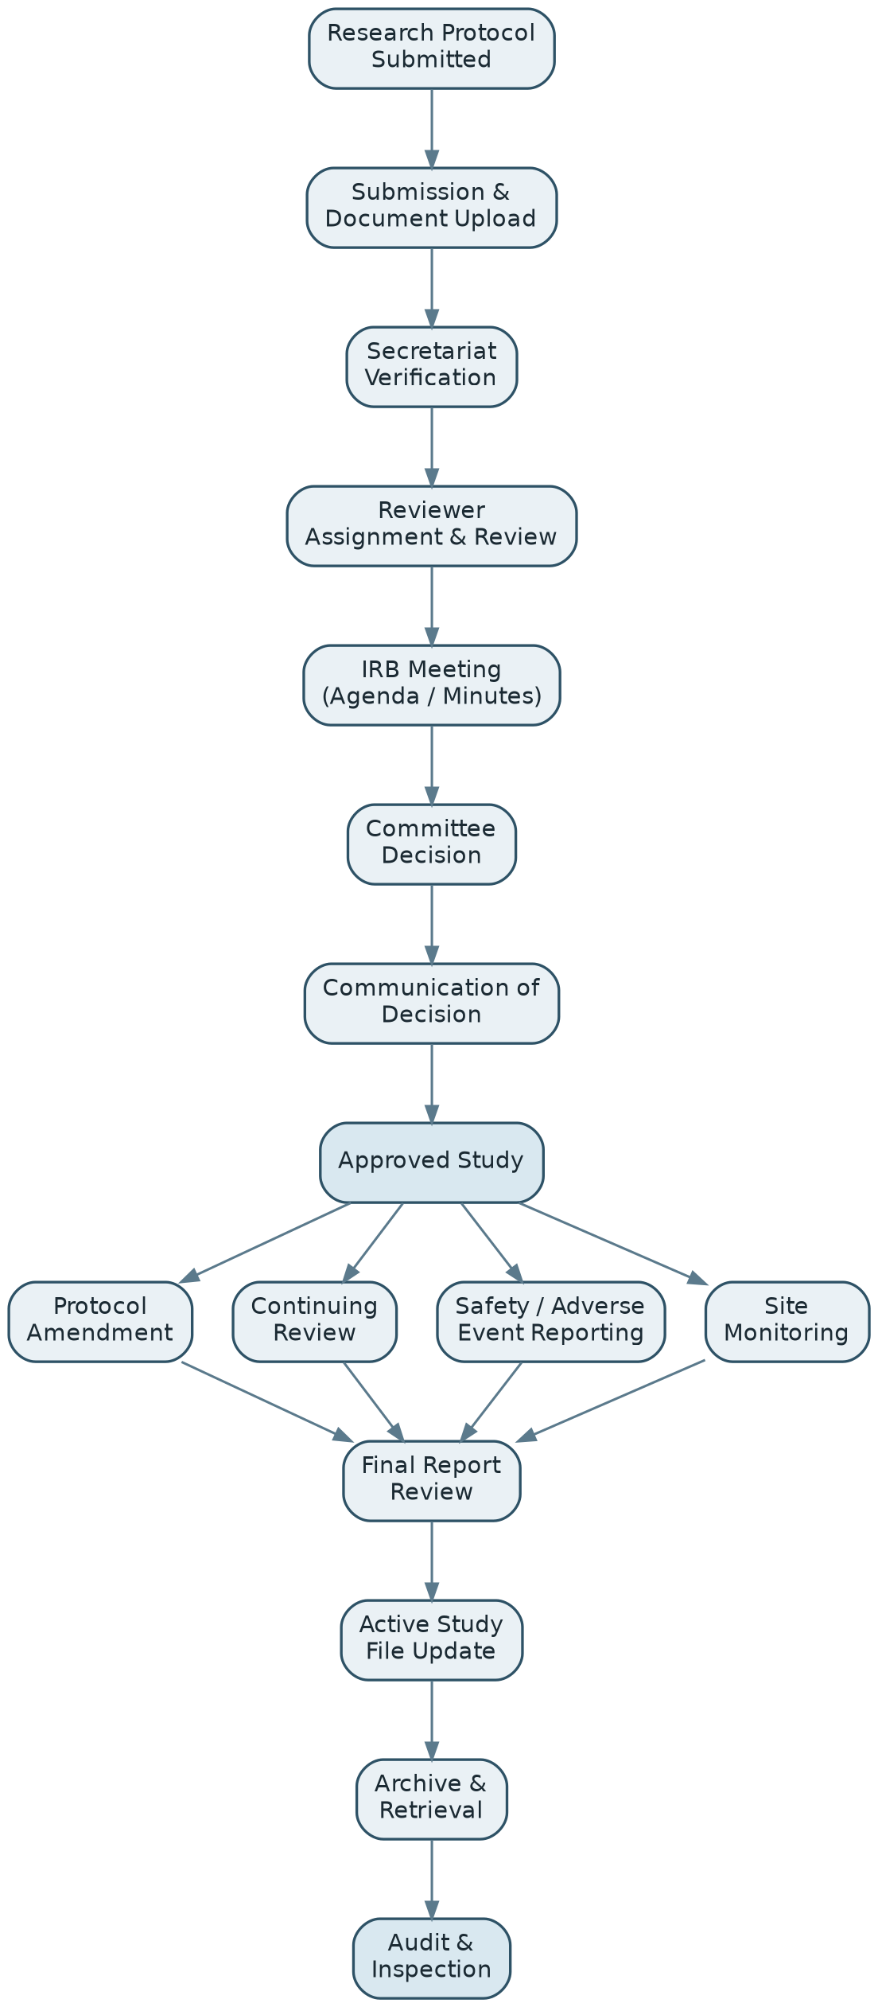
Figure 2.1 — Core protocol lifecycle workflow supported by the AWHSC-IRB MIS

Chapter Three: System Architecture

3.1 Architectural Overview
The AWHSC-IRB MIS follows a layered, web-based architecture. Users access the system through a web application interface; a REST API layer handles authentication, authorization, validation, and audit logging for every request; three application service groupings — Research & Submission Management, Review & Decision Management, and Study Lifecycle Management — implement the business logic for the ten functional modules; and a data and storage layer persists relational data, documents/files, and the audit log.

3.2 General Architecture
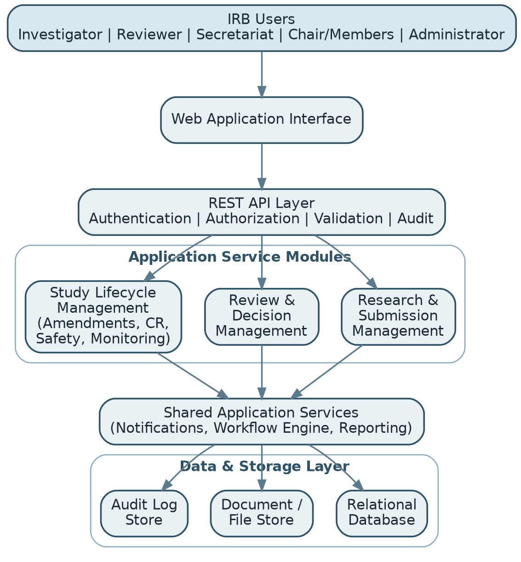
Figure 3.1 — General system architecture (proposal-level view)
This is a proposal-level architecture diagram. Detailed component, deployment, and class diagrams are held in the technical appendices (Appendix E) so that the proposal body remains readable to non-technical stakeholders while the full design detail remains available for technical review.

3.3 Security Architecture
- Role-based access control (RBAC) aligned to the stakeholder roles in Section 2.3, enforced at the API layer.
- Authentication with secure credential storage and session management.
- Confidentiality controls over protocol, participant, and reviewer information, consistent with the SOP's confidentiality requirements.
- Comprehensive audit logging of create, update, decision, and access events to support the SOP's Auditing and Inspection procedure.
- Encryption of data in transit (TLS) and at rest for sensitive documents and records.

3.4 Data Architecture
A relational database stores structured entities — users, protocols, submissions, reviews, decisions, amendments, safety reports, monitoring visits, meetings, and audit records — while a separate document/file store holds uploaded protocol documents, consent forms, and supporting attachments referenced by those entities. This separation keeps the relational schema clean while allowing documents to be managed, versioned, and retrieved independently, in line with the SOP's active-study-file and archive requirements.

3.5 Deployment Overview
The system is designed for deployment as a standard three-tier web application: a browser-based front end, an application/API server, and a database server, deployable on institutional or cloud infrastructure. Environments are separated into development, staging/testing, and production, with the staging environment used for user acceptance testing prior to go-live. Full deployment topology and environment specifications are documented in Appendix E.

Chapter Four: Software Engineering Methodology
The project follows a UML-driven, iterative software development methodology, chosen specifically because the AWHSC-IRB SOP already requires each procedure to identify its purpose, scope, responsibility, flow chart, and detailed instructions — a structure that maps naturally onto requirements engineering and UML workflow modeling.

Methodology flow
- SOP Analysis
- Requirements Engineering
- Use Case Modeling
- Workflow Modeling
- Sequence & State Modeling
- Class & Database Design
- Architecture Design
- Implementation
- Testing
- Deployment
- Maintenance

4.1 Requirements Engineering
Each SOP procedure is analyzed and decomposed into functional and non-functional system requirements, which are recorded in the Software Requirements Specification (Appendix A) and linked back to their source procedure in the SOP-to-Requirement Traceability Matrix (Appendix B).

4.2 UML-Based Analysis
Use case, activity, sequence, state-machine, and class diagrams are produced for each module, translating the SOP's own flow charts and responsibilities into formal software analysis artifacts (Appendix C).

4.3 System Design
The layered architecture described in Chapter Three is elaborated into component and deployment views, and a role-permission matrix is defined for every stakeholder role identified in Section 2.3.

4.4 Database Design
An entity-relationship diagram, data dictionary, and normalized relational schema are derived from the class model and the module data requirements (e.g., the SAE record structure in Module 6), documented in Appendix D.

4.5 API Design
A REST API is specified module by module, with documented request/response contracts, authentication requirements, and error handling, documented in Appendix F.

4.6 Implementation
The application is implemented in iterative increments aligned to the functional modules, allowing early modules (e.g., User and Access Management, Research and Protocol Management) to be validated before dependent modules (e.g., Review, Amendments) are built on top of them.

4.7 Testing
Each module is validated through unit, integration, and user-acceptance testing, with test cases traced back to their originating requirement and SOP procedure (Appendix I).

4.8 Deployment
The system is released first to a staging environment for institutional user acceptance testing, then promoted to production following sign-off, with rollback and backup procedures defined ahead of go-live.

Chapter Five: Deliverables

5.1 Requirements Deliverables
- Project Proposal
- Software Requirements Specification
- Functional Requirements
- Non-functional Requirements
- Business Rules
- Requirements Traceability Matrix

5.2 UML / Analysis Deliverables
- Use Case Diagram and Specifications
- Activity Diagrams
- Sequence Diagrams
- State Machine Diagrams
- Class Diagram
- Package Diagram

5.3 Architecture Deliverables
- General System Architecture
- Component Diagram
- Deployment Diagram
- Security Architecture
- Data Architecture

5.4 Database / API Deliverables
- Entity-Relationship Diagram (ERD)
- Data Dictionary
- Database Schema
- REST API Specification
- API Request/Response Contracts
- Role-Permission Matrix

5.5 Implementation Deliverables
- Web Application (front end)
- Backend / API
- Database
- Document Management
- Authentication / RBAC
- Audit Logging
- Reporting
- Testing (unit, integration, UAT)
- Deployment
- User Documentation

Chapter Six: Implementation Plan

6.1 Development Phases and Milestones
Phase | Activities | Key Milestone | Indicative Duration
1. Initiation & SOP Analysis | Stakeholder engagement, SOP review, requirements elicitation | Approved SRS & traceability matrix (Appendix B) | 3 weeks
2. UML Analysis & Design | Use case, activity, sequence, state, and class modeling | Approved UML design package | 4 weeks
3. Architecture & Data Design | Architecture, ERD, schema, API specification | Approved architecture & data design | 3 weeks
4. Core Module Implementation | User/Access, Research & Protocol, Protocol Review modules | Core modules functional in staging | 6 weeks
5. Lifecycle Module Implementation | Continuing Review, Amendments, Safety, Monitoring | Lifecycle modules functional in staging | 6 weeks
6. Meetings, Records & Audit Modules | Meetings/Communication, Study Files/Archive, Audit modules | Full feature set in staging | 5 weeks
7. Testing & UAT | Unit, integration, security, and user-acceptance testing | UAT sign-off | 4 weeks
8. Deployment & Training | Production deployment, user training, documentation handover | System go-live | 2 weeks

6.2 Testing and Acceptance
Each module undergoes unit and integration testing during implementation, followed by consolidated system testing and a formal User Acceptance Testing (UAT) cycle with representative Secretariat, reviewer, and Chair users. Acceptance criteria are drawn directly from the requirements traceability matrix so that sign-off can be tied back to specific SOP procedures.

6.3 Deployment
Deployment follows a staged approach — development, staging, and production — with data migration (where applicable), backup procedures, and a rollback plan defined before production cutover.

6.4 Training and Maintenance
- Role-based training sessions for Secretariat, reviewers, Committee members, and administrators.
- User manuals and quick-reference guides for each role.
- A defined maintenance and support plan covering bug fixes, minor enhancements, and periodic security updates post-launch.

Chapter Seven: Expected Benefits and Outcomes
The project will deliver an integrated, secure, and traceable IRB Management Information System that digitally represents the AWHSC-IRB's established procedures and supports the management of research submissions, ethical review, committee decision-making, study monitoring, safety reporting, records management, confidentiality, and auditing within a unified information environment.

7.1 Operational Benefits
- Faster, more predictable turnaround for protocol review, continuing review, and amendment decisions.
- Reduced administrative burden on the Secretariat through automated reminders, status tracking, and document handling.
- A single source of truth for the status and history of every protocol, from submission to archive.

7.2 Governance and Compliance Benefits
- Stronger confidentiality and access control aligned to the SOP's confidentiality requirements.
- Complete, tamper-evident audit trails supporting the SOP's Auditing and Inspection procedure.
- Demonstrable, source-derived traceability between institutional procedures and system functionality.

7.3 Strategic Benefits
- A maintainable, UML-documented technical foundation that can be extended as the IRB's needs evolve.
- Improved institutional readiness for external audits, inspections, and accreditation reviews.

Chapter Eight: Conclusion
This proposal presents the AWHSC-IRB Management Information System as an SOP-driven, not generic, software project. Every functional module, workflow, and data structure proposed here is traceable to a specific procedure already defined and approved within the AWHSC-IRB SOP, giving the project a defensible institutional foundation rather than an assumed one.
The recommended chain of work — AWHSC-IRB SOP, requirements, UML analysis, architecture, database/API design, implementation, and testing — is what distinguishes this proposal from a generic “we will build a website” project. It is recommended that the next step be the development of the complete Software Requirements Specification and UML analysis package (Appendices A–C), using the AWHSC-IRB SOP as the primary source, so that detailed system design and implementation can proceed on an approved and traceable basis.

References
AWHSC-IRB. Standard Operating Procedures for the Institutional Review Board (AWHSC-IRB SOP), 2026 edition. Internal institutional document.
[Additional references — national research ethics guidelines, relevant ICH-GCP or WHO IRB guidance documents, and software engineering standards used — to be added during the requirements phase.]

SOP-to-System Traceability
This matrix is one of the strongest elements of the proposal: it shows, procedure by procedure, that the proposed system modules and their UML artifacts are derived directly from the AWHSC-IRB's own approved SOP rather than from generic assumptions about how an IRB should operate.
AWHSC-IRB SOP Procedure | Proposed System Module | Primary UML Artifact
Protocol Review | Protocol Review | Use Case + Activity
Resubmitted Protocol | Resubmission | Activity + State
Continuing Review | Study Lifecycle Management | State + Sequence
Final Report | Study Closure | Activity
Protocol Amendment | Amendment Management | Sequence + State
Safety Report | Safety Management | Class + Workflow
Site Monitoring | Monitoring | Activity
Meeting & Minutes | Meeting Management | Sequence
Communication Records | Communication | Class + API
Active Study Files | Records Management | Class + ERD
Archive / Retrieval | Archive | Activity
Confidentiality | Security / RBAC | Component
Auditing & Inspection | Audit | Class + Component

Appendices
The following technical appendices support this proposal. They are developed in full during the requirements and design phases described in Chapter Four, and are referenced throughout the proposal rather than reproduced in the main body, so that the proposal remains readable to non-technical stakeholders.

Appendix A — Software Requirements Specification (SRS)
Full functional and non-functional requirements derived from the SOP analysis in Section 4.1.

Appendix B — SOP-to-Requirement Traceability
Detailed, requirement-level extension of the traceability matrix above, linking each SOP procedure through to its system requirement, use case, workflow, database entity, API, and test case.

Appendix C — UML Diagrams
- Use Case Diagrams and Specifications
- Activity Diagrams
- Sequence Diagrams
- State Machine Diagrams
- Class Diagram

Appendix D — Database Design
- Entity-Relationship Diagram (ERD)
- Database Schema
- Data Dictionary

Appendix E — Architecture
- General Architecture (see Section 3.2)
- Component Architecture
- Deployment Architecture
- Security Architecture

Appendix F — API Specification
- API catalog
- API request/response contracts
- Error handling conventions

Appendix G — Security
- Role-Based Access Control (RBAC) matrix
- Permission matrix
- Audit architecture
- Confidentiality controls

Appendix H — Business Rules
Consolidated business rules extracted during requirements engineering (see Section 4.1), covering eligibility, timing, and decision rules for each module.

Appendix I — Testing and Traceability
- Test strategy
- Test cases
- Test traceability matrix
- User Acceptance Testing (UAT) results

