Public GIT (Github/Bitbucket/Gitlab) url: https://github.com/Bugarm/DatabaseHome

Public API (Vercel or otherwise) url: database-home.vercel.app

Screenshots
Task 1 Screenshot of your development environment setup:
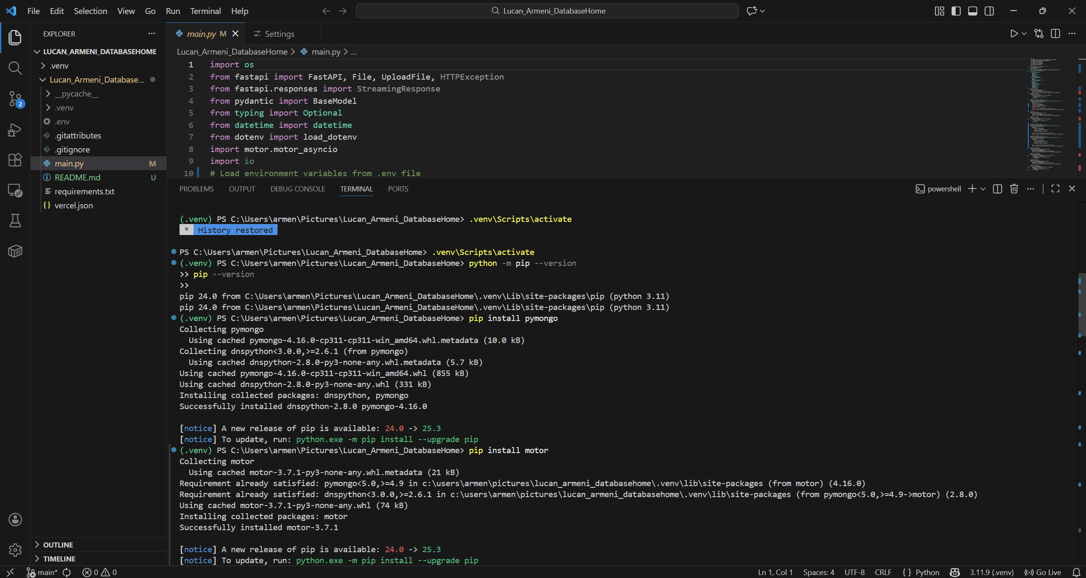
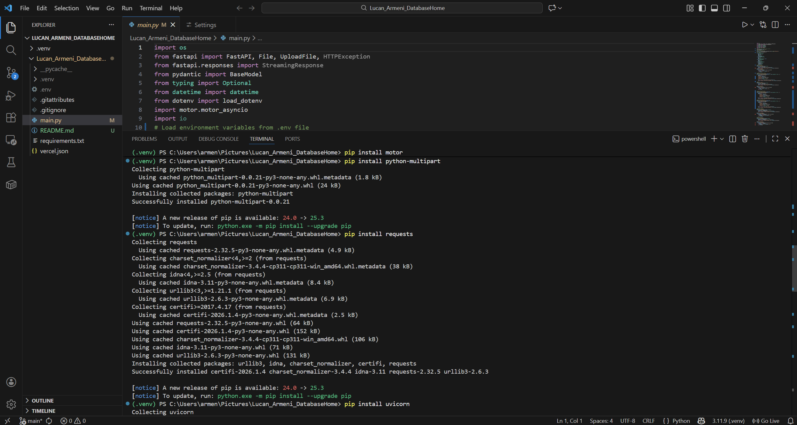
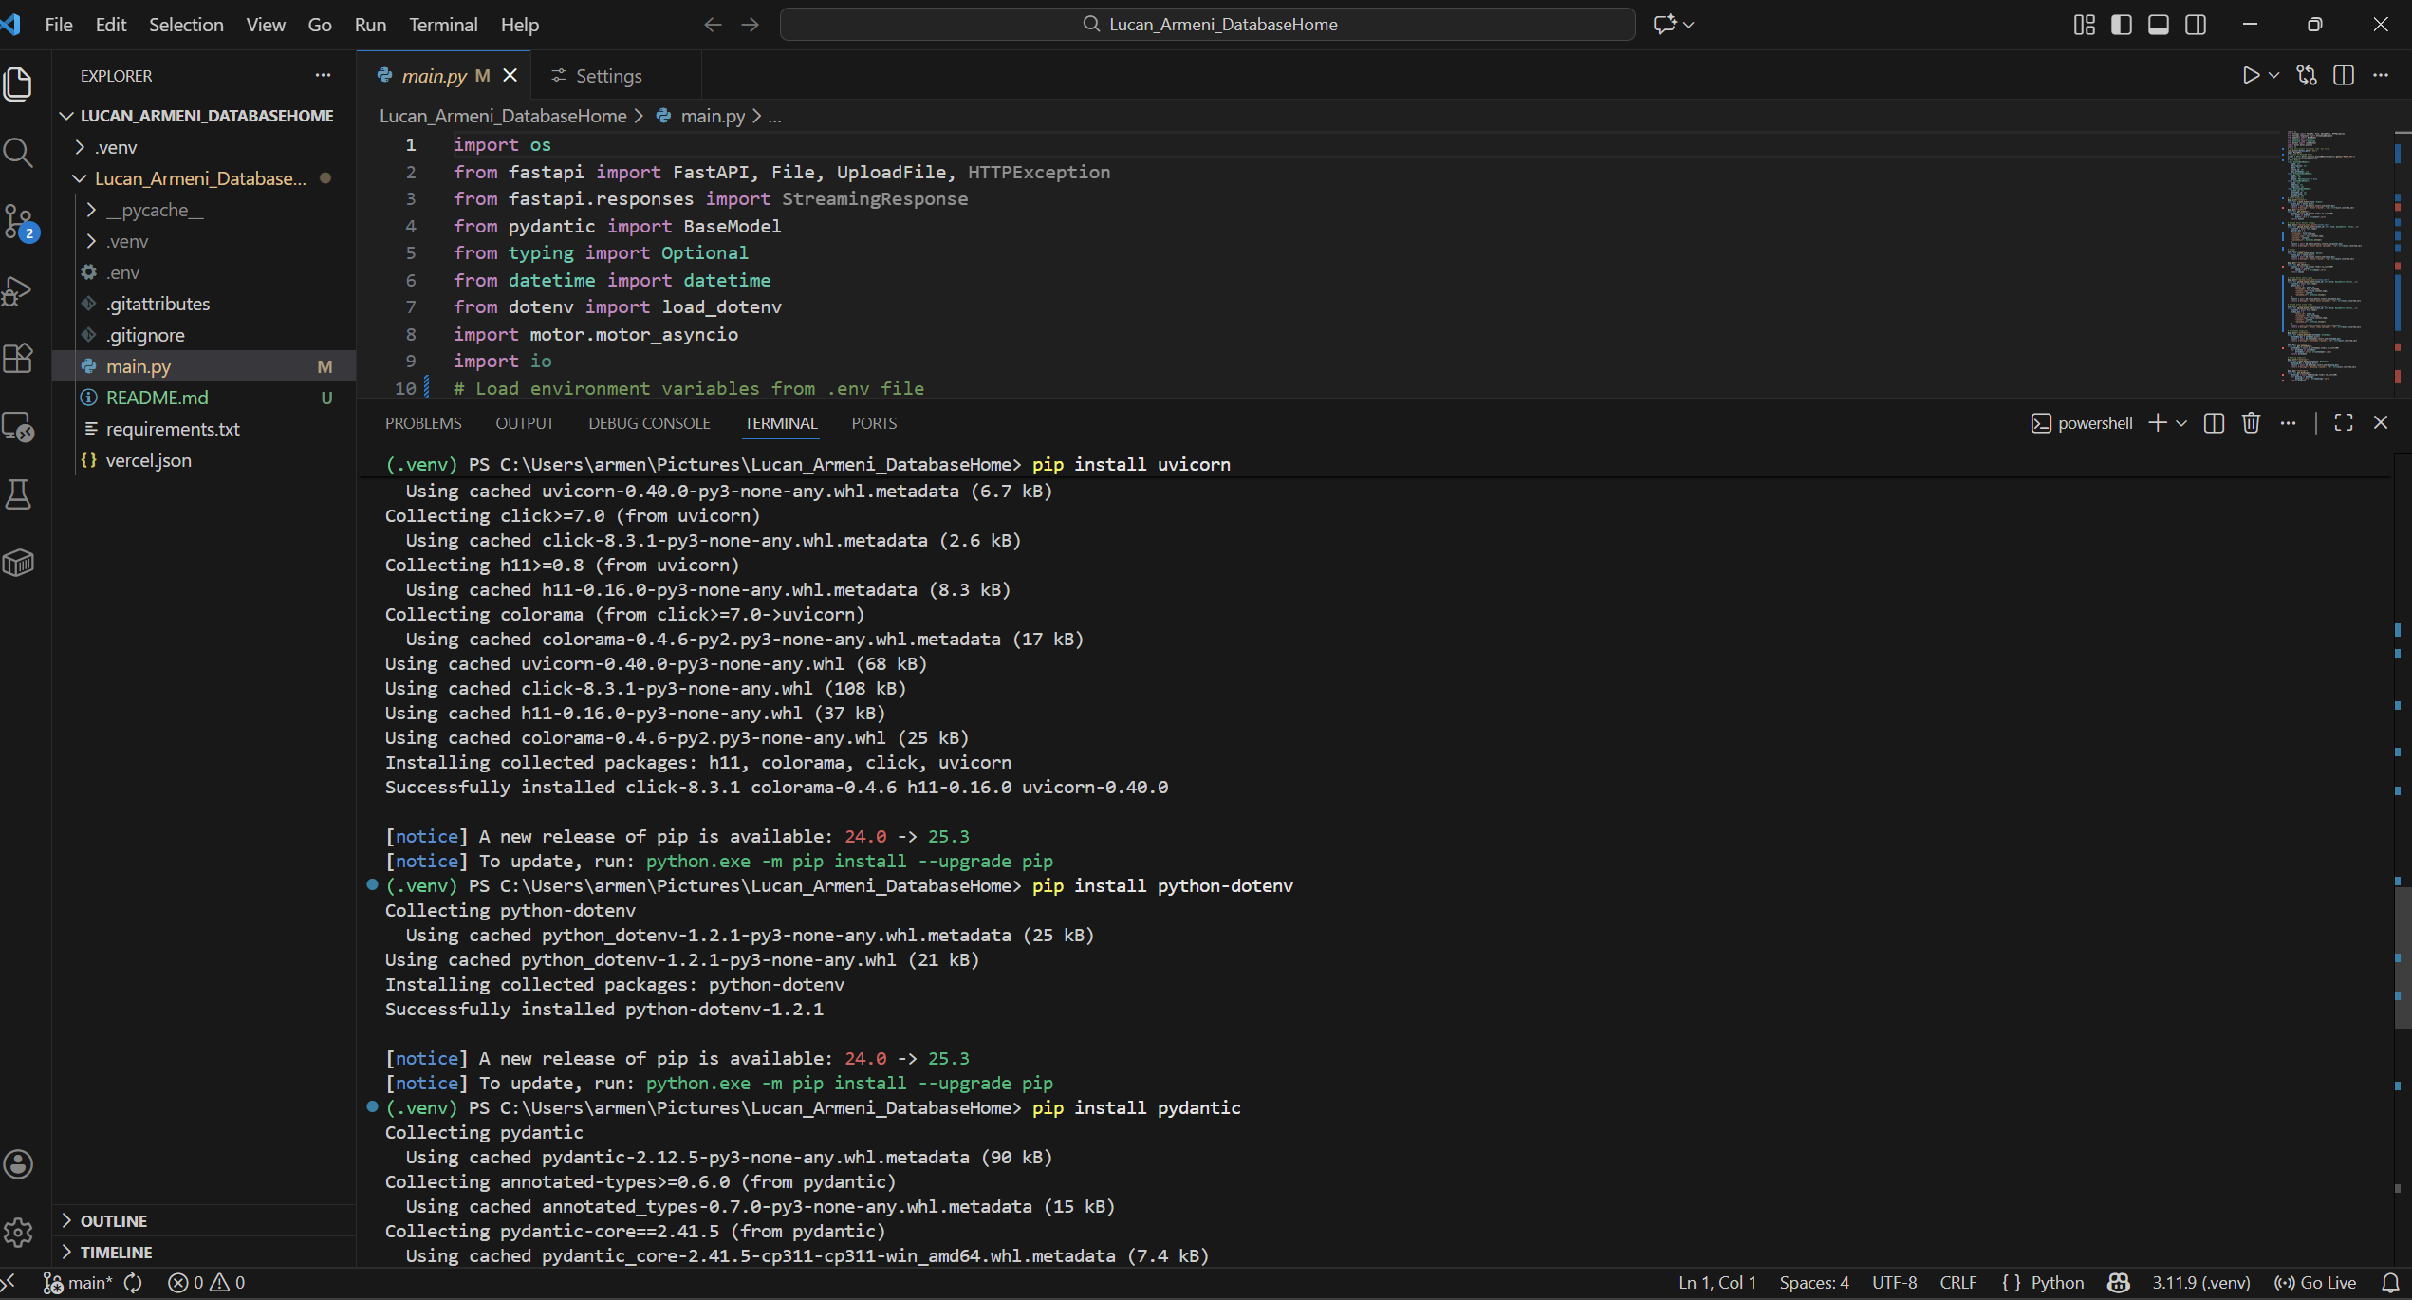
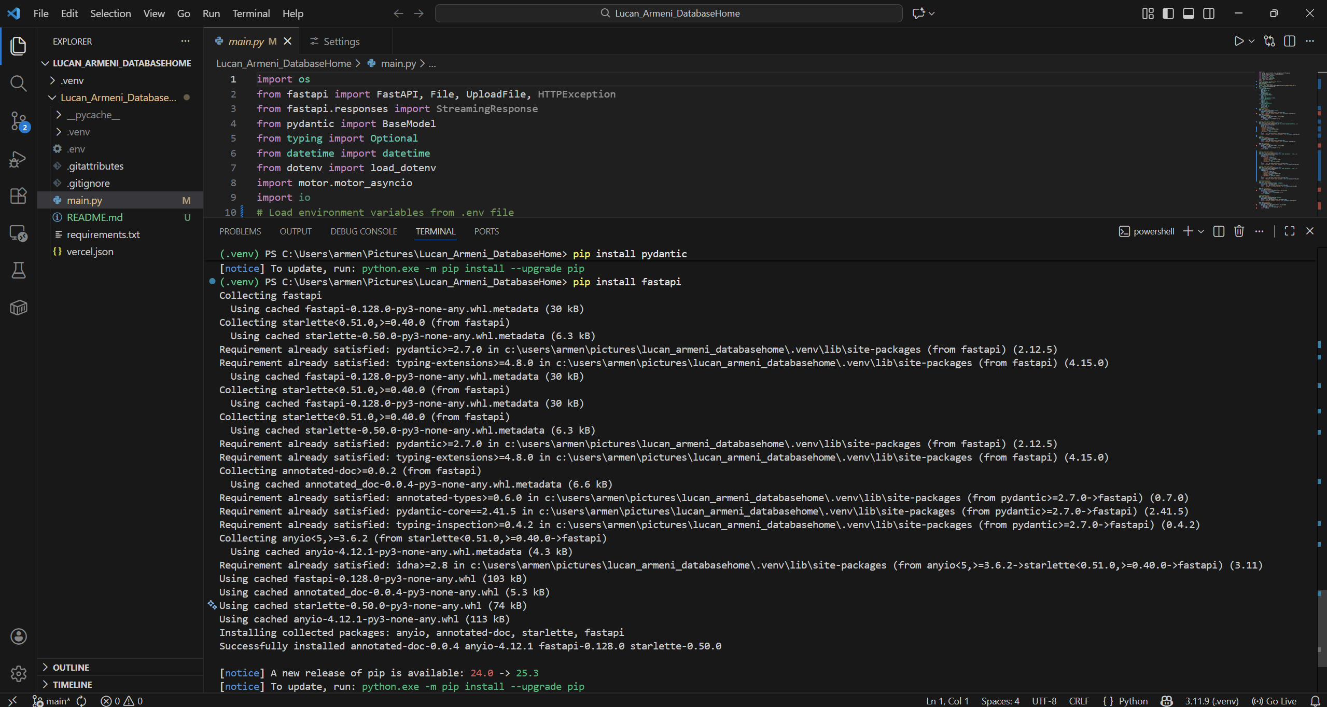

Task 2: Screenshot/s of your Mongo Database on MongoAtlas: 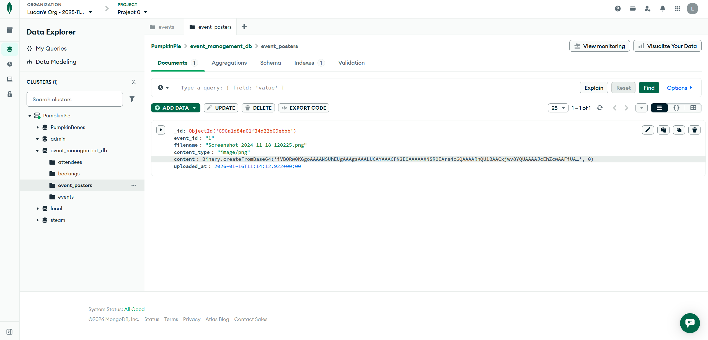

Task 3A: Screenshot of the API running on localhost in your browser: 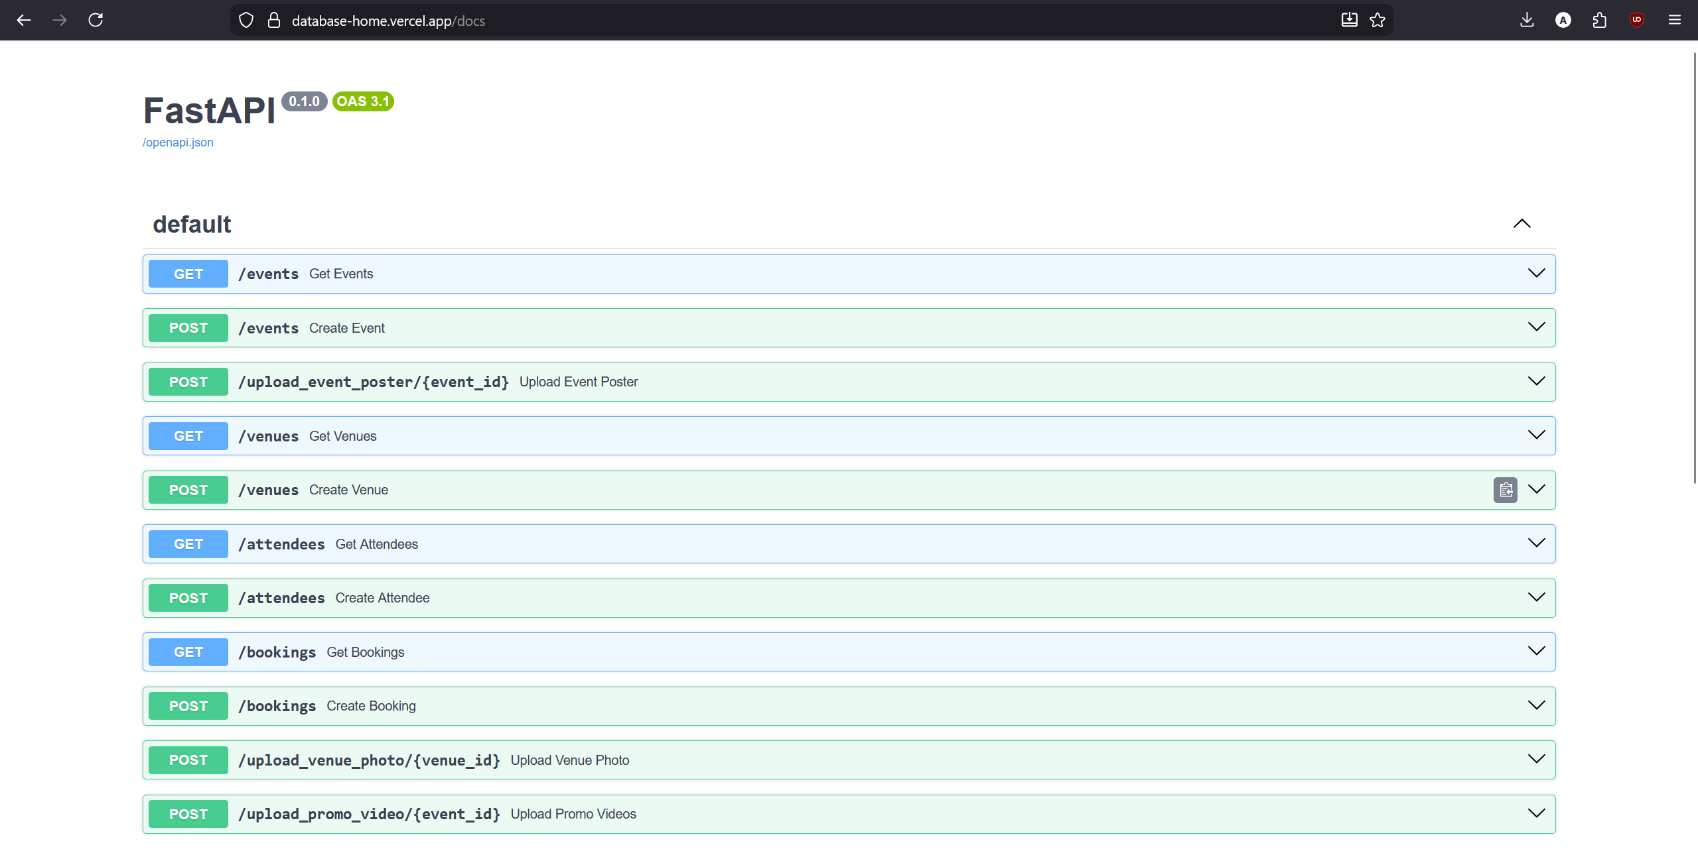
Task 3B: Screenshot of the hosted API running on a public url such as Vercel: 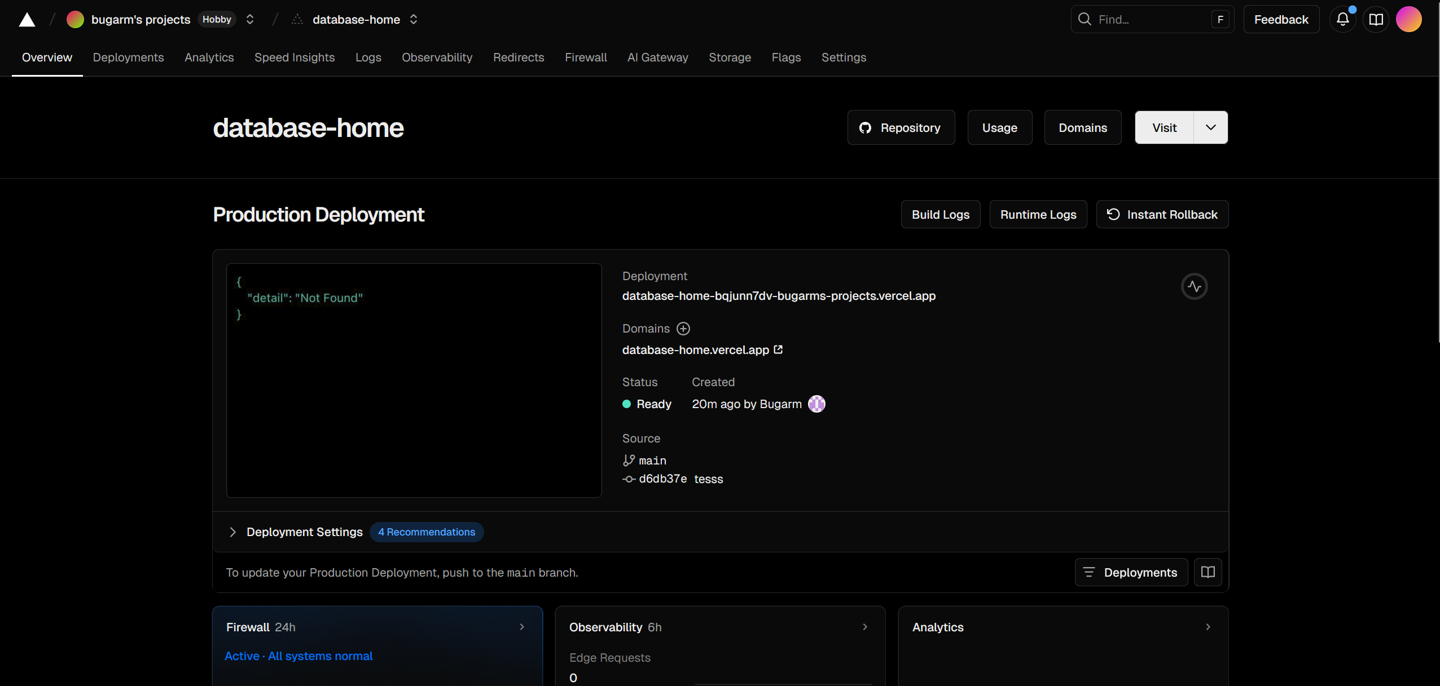

Task 4A: Screenshot showing credential setup.
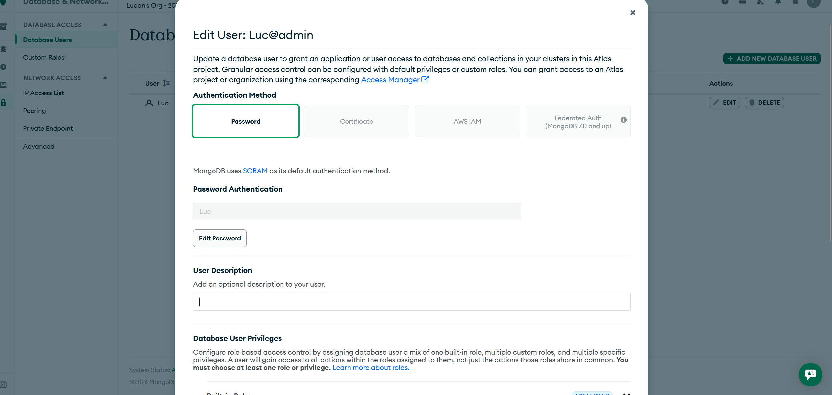

Task 4B: Screenshot showing IP whitelisting.
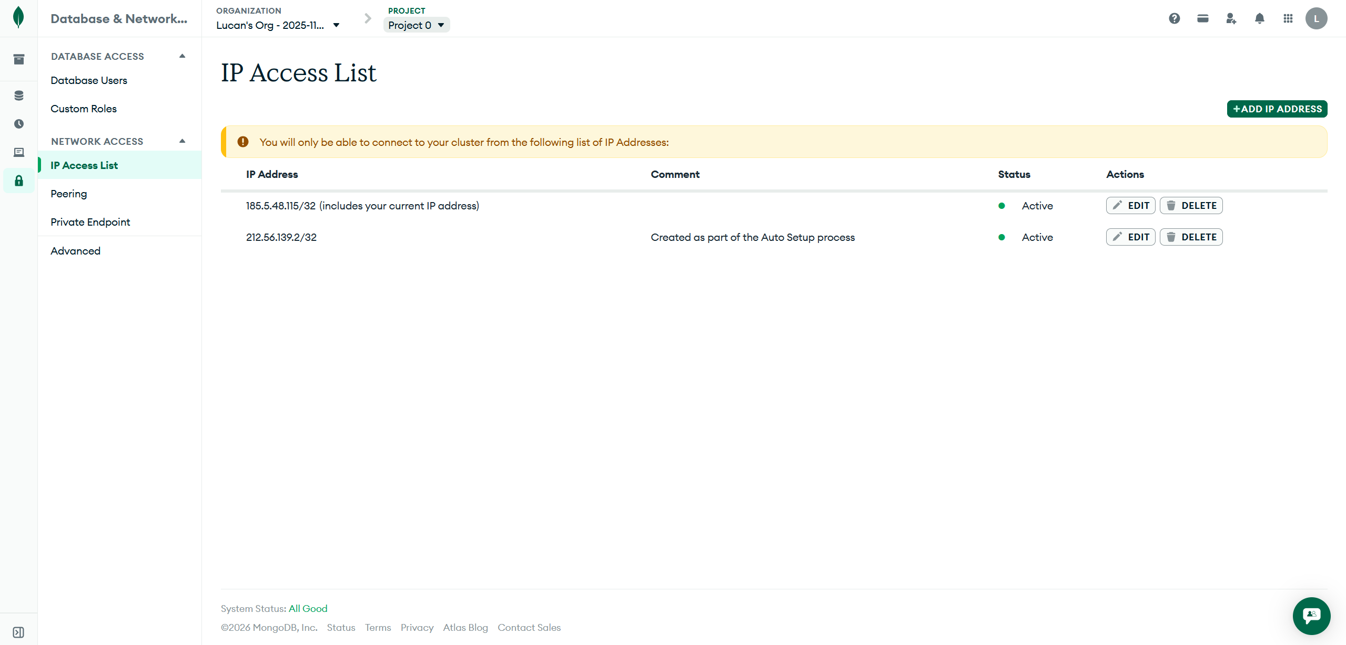
Task 4C: Screenshot showing how you are preventing SQL injection.
