Prediction of Residential Energy Consumption by Household Appliances with Machine Learning
This IoT project aims to create predictive models for forecasting appliance energy consumption. The data used includes temperature and humidity sensor measurements from a wireless network, weather forecasts from an airport station, and energy usage from luminaries.
In this machine learning project, data filtering is required to remove non-predictive parameters and select the best features for prediction. The dataset was collected over a period of 10 minutes for approximately 5 months. The house's temperature and humidity conditions were monitored using a ZigBee wireless sensor network.
Each wireless node transmitted temperature and humidity conditions every 3 minutes. Then, the average of the data was calculated for 10-minute intervals. Energy data was recorded every 10 minutes using "m-bus" energy meters. The weather time from the nearest weather station (Chievres Airport, Belgium) was downloaded from a public dataset from Reliable Prognosis (rp5.ru) and merged with the experimental datasets using the date and time column. Two random variables were included in the dataset to test regression models and filter out non-predictive attributes (parameters).
Our task now is to build a predictive model that can forecast energy consumption based on the collected IoT sensor data. We will be using the R language for this project.
The data can be downloaded from the following link:
https://www.kaggle.com/competitions/appliances-energy-prediction

Data Dictionary
- • Appliances: energy used by household appliances in Wh (watt-hours)
- • Lights: energy used by house lights in Wh
- • T1: temperature in the Kitchen area in Celsius
- • RH_1: humidity in the Kitchen area in %
- • T2: temperature in the Living Room area in Celsius
- • RH_2: humidity in the Living Room area in %
- • T3: temperature in the Laundry area in Celsius
- • RH_3: humidity in the Laundry area in %
- • T4: temperature in the Office area in Celsius
- • RH_4: humidity in the Office area in %
- • T5: temperature in the Bathroom area in Celsius
- • RH_5: humidity in the Bathroom area in %
- • T6: temperature in the Outside area (North side) in Celsius
- • RH_6: humidity in the Outside area (North side) in %
- • T7: temperature in the Ironing Room area in Celsius
- • RH_7: humidity in the Ironing Room area in %
- • T8: temperature in the Children's Room area in Celsius
- • RH_8: humidity in the Children's Room area in %
- • T9: temperature in the Master Bedroom area in Celsius
- • RH_9: humidity in the Master Bedroom area in %
- • To: Local temperature (measured from Chievres Weather Station) in Celsius
- • Pressure: Atmospheric pressure (measured from Chievres Weather Station) in mmHg
- • RH_out: Local humidity (measured from Chievres Weather Station) in %
- • Windspeed: Wind speed (measured from Chievres Weather Station) in m/s
- • Visibility: Visibility (measured from Chievres Weather Station) in km
- • Tdewpoint: Dew Point Temperature or Dew Point (measured from Chievres Weather Station) in Celsius
- • rv1: Non-dimensional Random Variable
- • rv2: Non-dimensional Random Variable
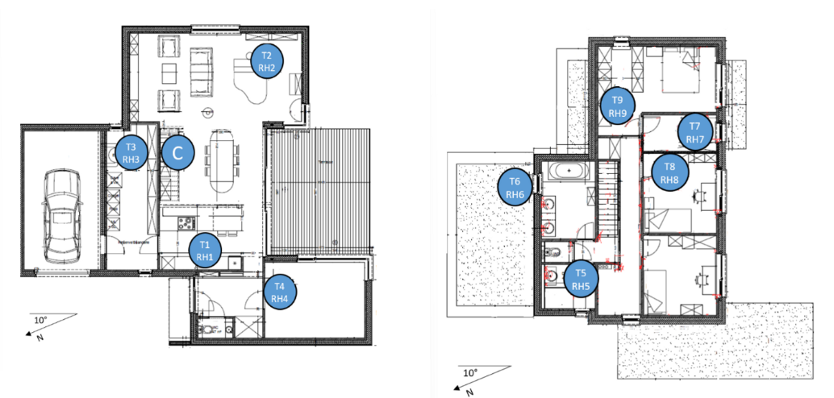

Loading Packages
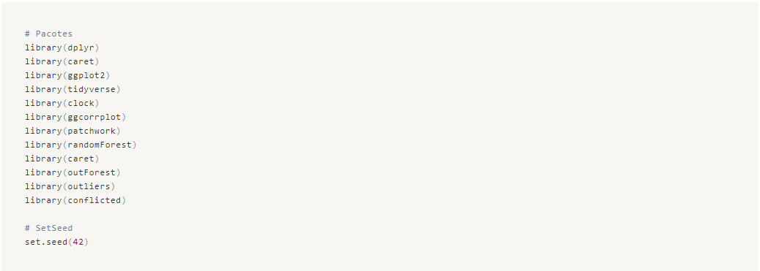

Loading the Data

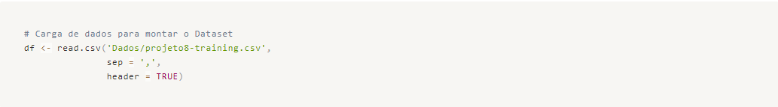

Data Cleaning and Organization

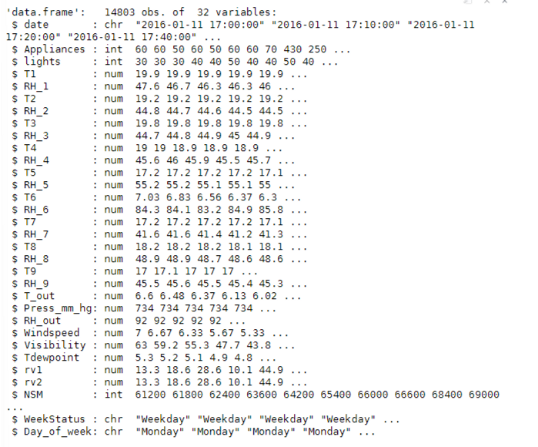

We can observe that we have some variables of type "CHR". The "date" variable should be of the date type so that we can, if necessary later on, break it down into day, month, and year. Therefore, let's change its type at this moment.
For the variables "WeekStatus" and "Day_of_Week", we will analyze their unique values and apply the factor type.
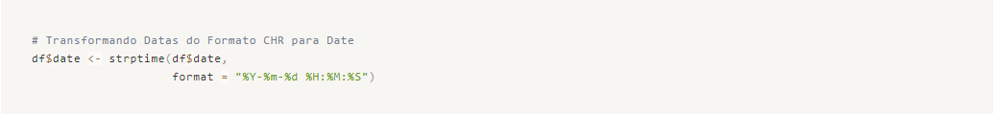
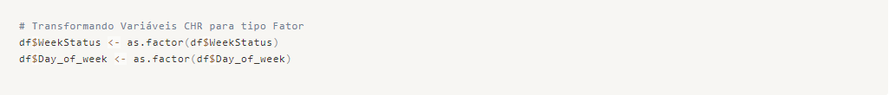
After making the necessary adjustments, let's check for missing data.
Finally, we do not have any missing values in our dataset. To conclude, let's remove the "MSM" column as we do not have a description of what this variable represents, so we will consider it unnecessary.
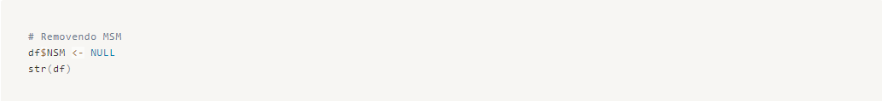
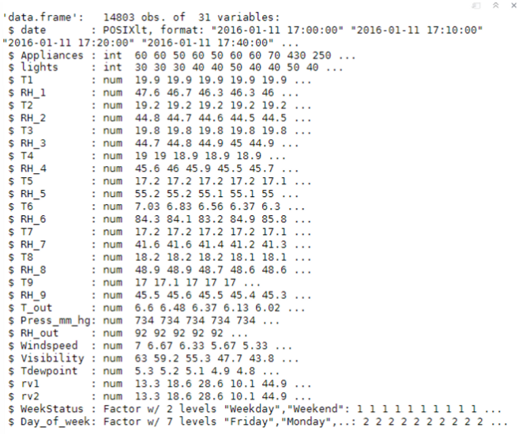

Now we are ready to start the exploratory data analysis!

Exploratory Data Analysis

Let's separate the numerical variables from the categorical variables.
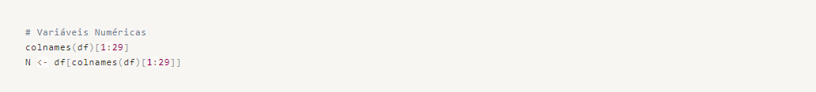
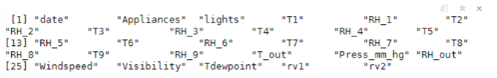
After separating the variables, let's analyze the behavior of each one and identify possible insights.

Numerical Variables
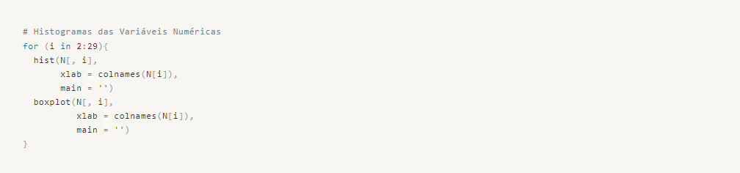
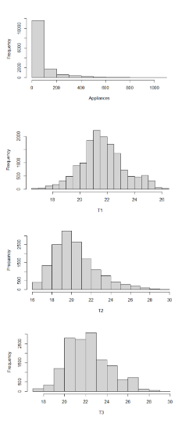
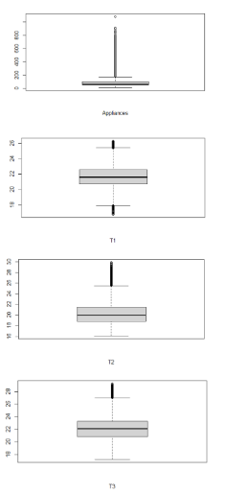

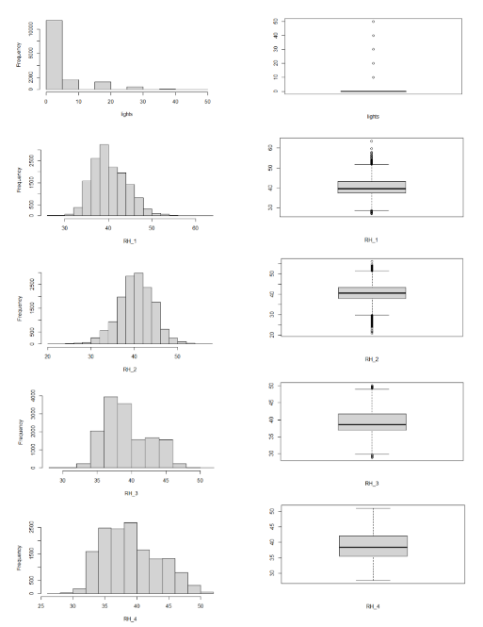
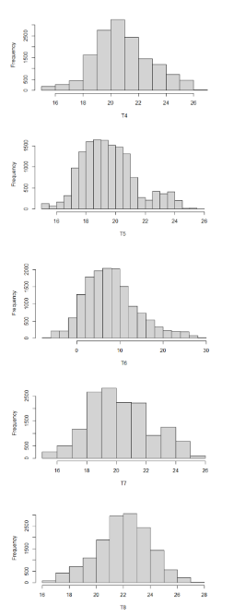
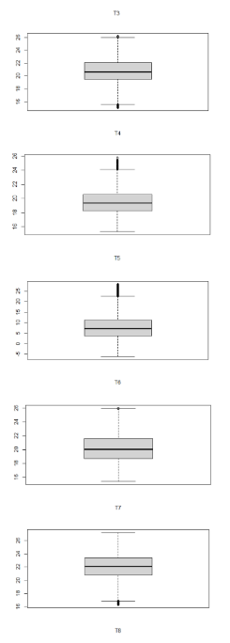

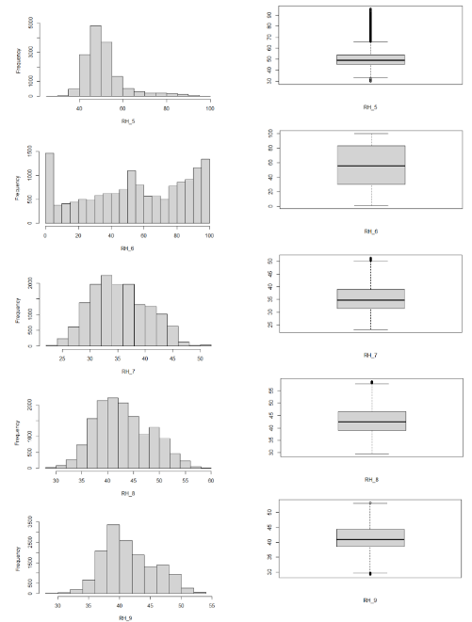
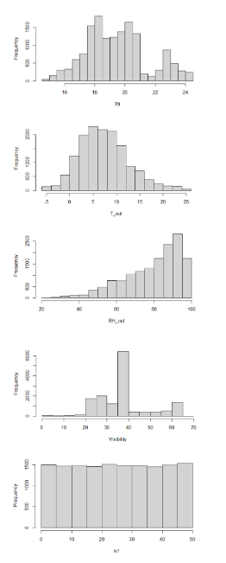
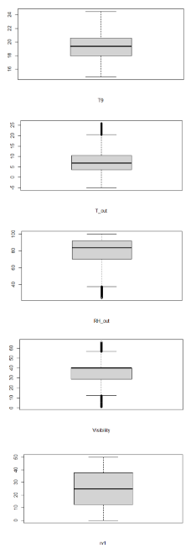
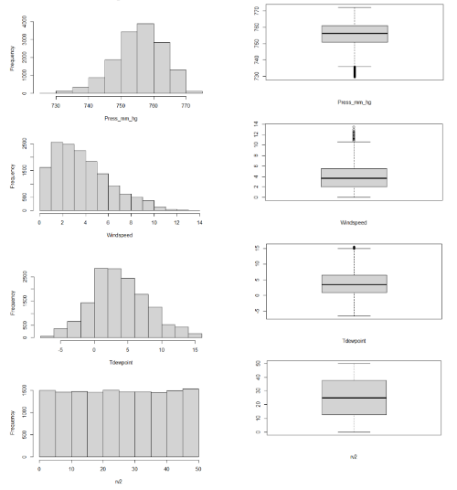
Some interesting observations:
  - The temperature and humidity variables have distributions that are very similar to normal, as their mean and median values are very close. We will not apply a Shapiro test to verify the hypothesis of normality as it is not relevant to the initial results of our predictive modeling.
  - The variables "r1" and "r2" are almost constant within our observations and will clearly be discarded in our selection of important variables.
  - The "lights" variable has a distribution close to normal, but we will further analyze its correlation with the response variable (Appliance) as they are initially competing and independent variables. We will confirm this by examining the correlations.
  - The response variable (Appliance) has a distribution that resembles a normal distribution, but it has some outliers, as do most predictor variables. We will address this issue later.
Let's now examine how the variables correlate with each other.
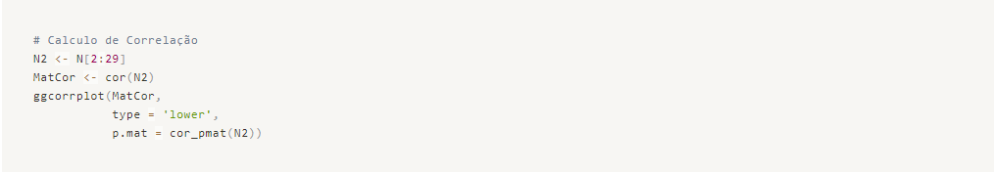
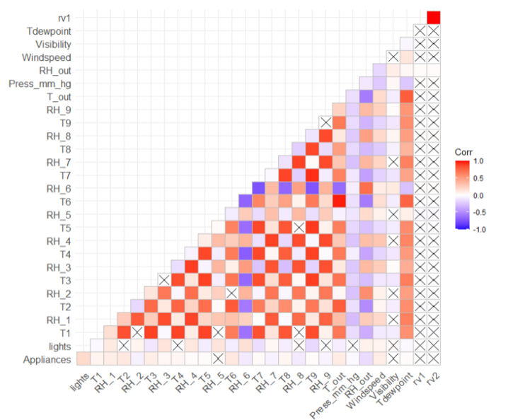

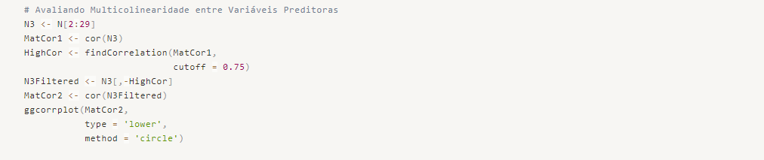
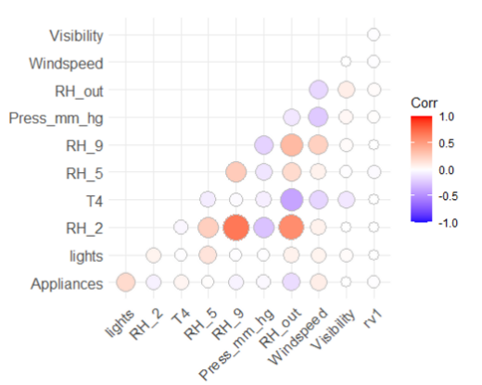
Some points draw our attention:
  - The variables rv1 and rv2 have no correlation with any other variable since, as mentioned before, they are almost constant and were artificially inserted into our data by Kaggle.
  - Our response variable, Appliances, shows some mild positive and negative correlations with some of our variables, indicating that we have the possibility of solving our problem with a linear structured model.
  - The Windspeed variable has some low correlations with the Temperature of the Children's Room, Humidity of the Master Bedroom, Local Humidity, and Atmospheric Pressure. It has little to no correlation with other variables.
  - The temperature of the Living Room has a strong negative influence on Local Humidity, while the humidity of the Living Room has a strong positive influence from Local Humidity, suggesting that it may be an area with ventilation windows.
  - The humidity of the Master Bedroom is positively influenced by Local Humidity.
We notice that the "lights" variable is the only one with a stronger correlation with the response variable.
To conclude our analysis of the numerical variables, let's study how the response variable behaves over time using the "Date" variable.
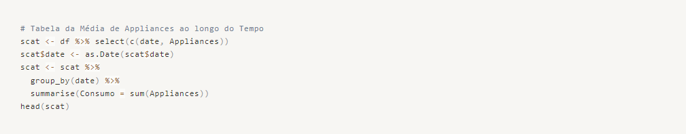
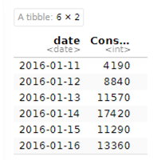

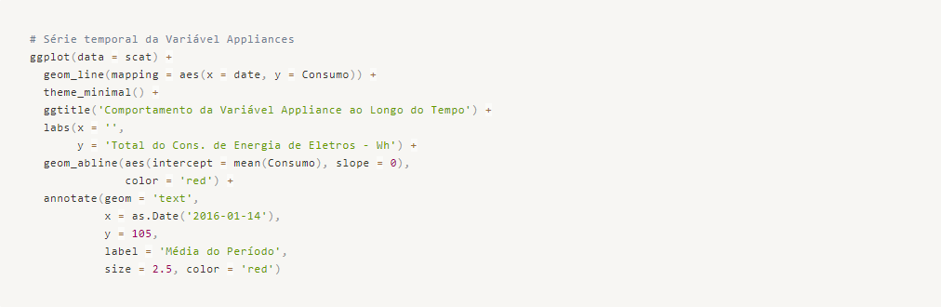
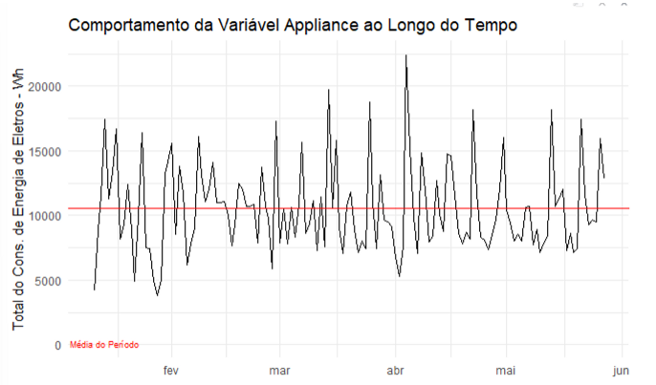
We can point out the following:
  - The highest peak of consumption occurred in April, reaching twice the average for the period.
  - As expected, within the one-month time window, we have significant volatility with minimum values ranging mostly between 75 Wh and 150 Wh. This could be due to some appliances consuming a larger amount of energy but not being used frequently, such as washing machines, dryers, and irons, among others.
Since the Appliances variable behaved differently in April compared to other months, I believe it is worth conducting a time-based analysis on the other variables to identify similar patterns.

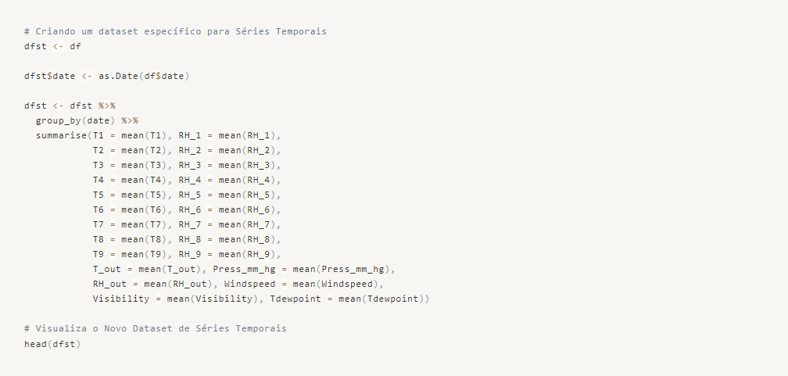
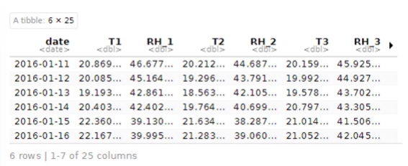

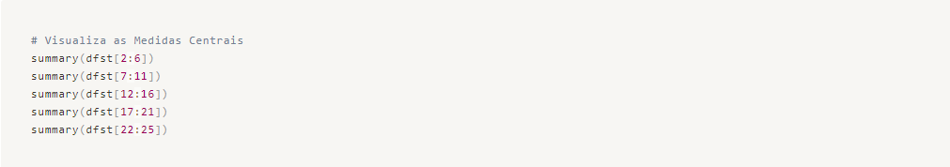
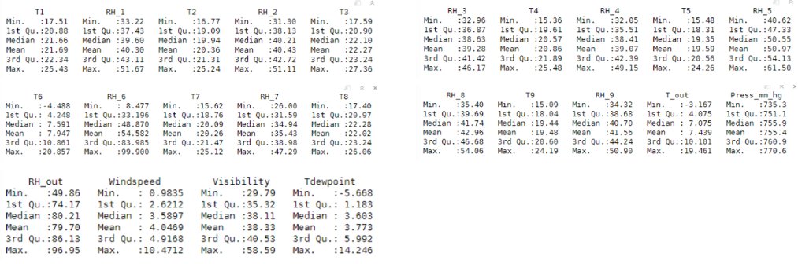
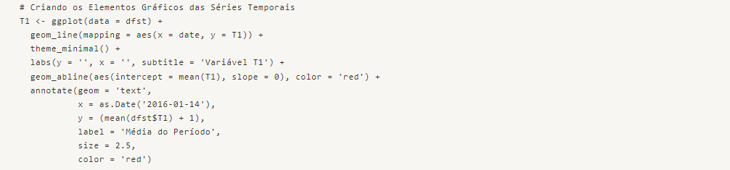
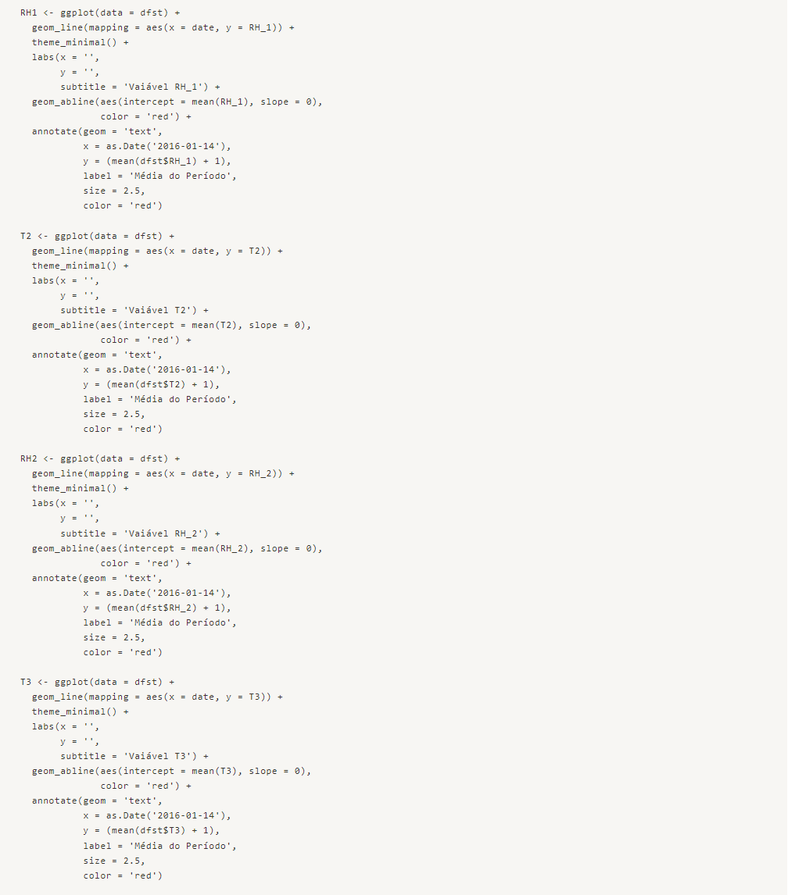

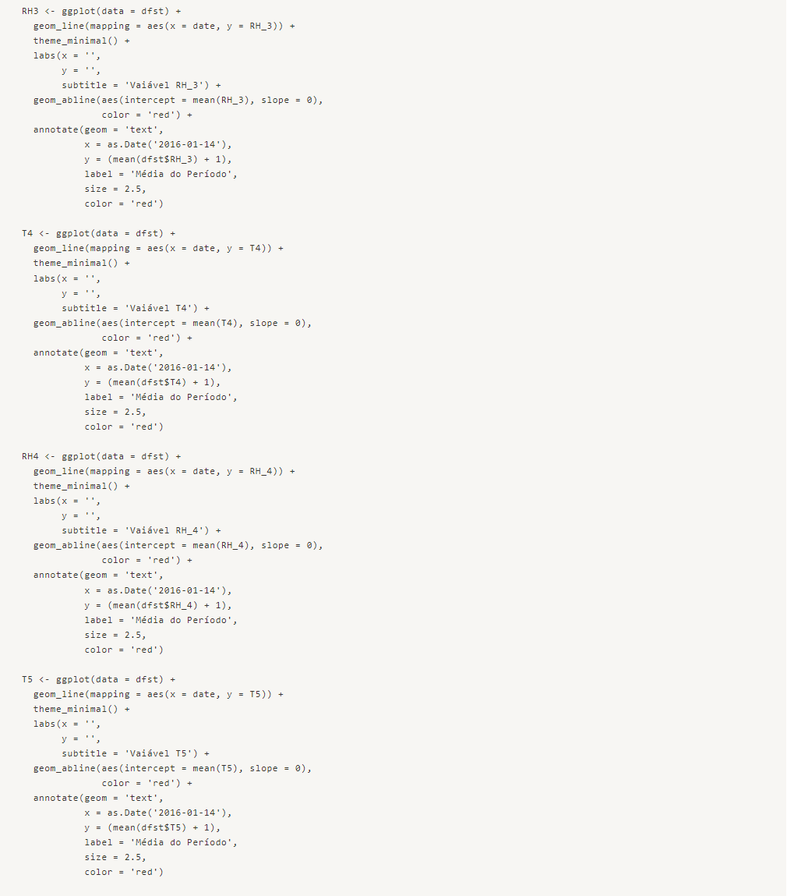

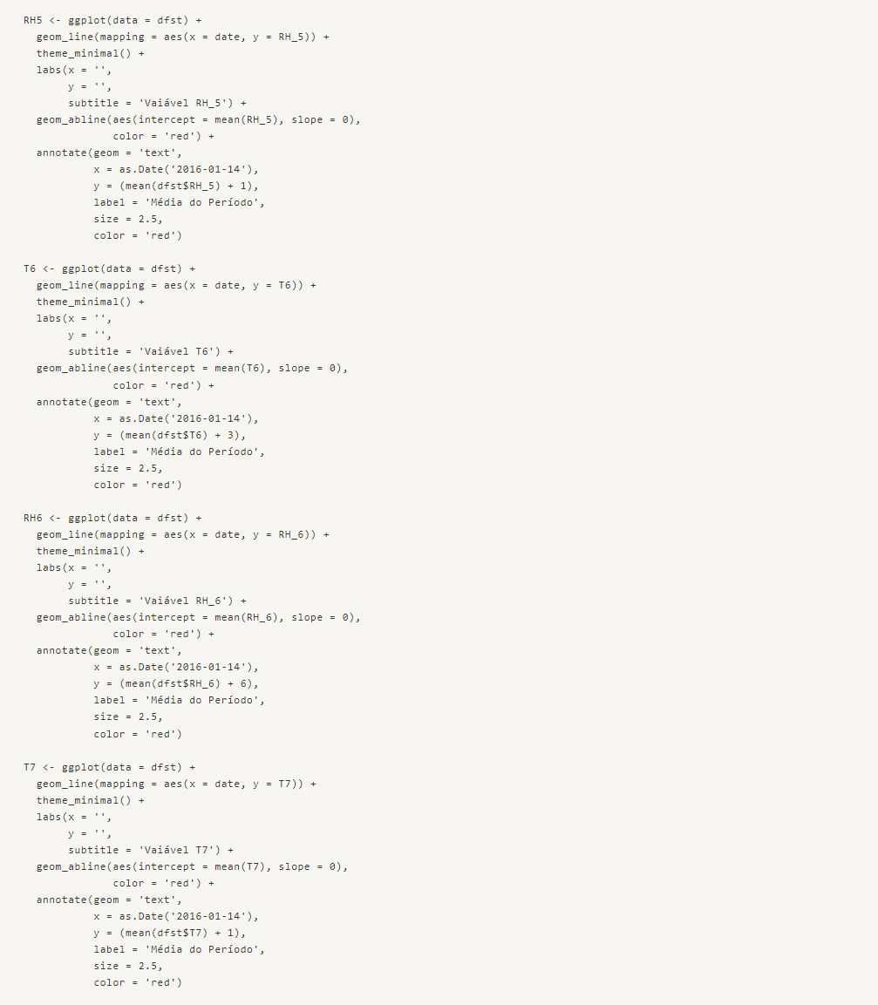

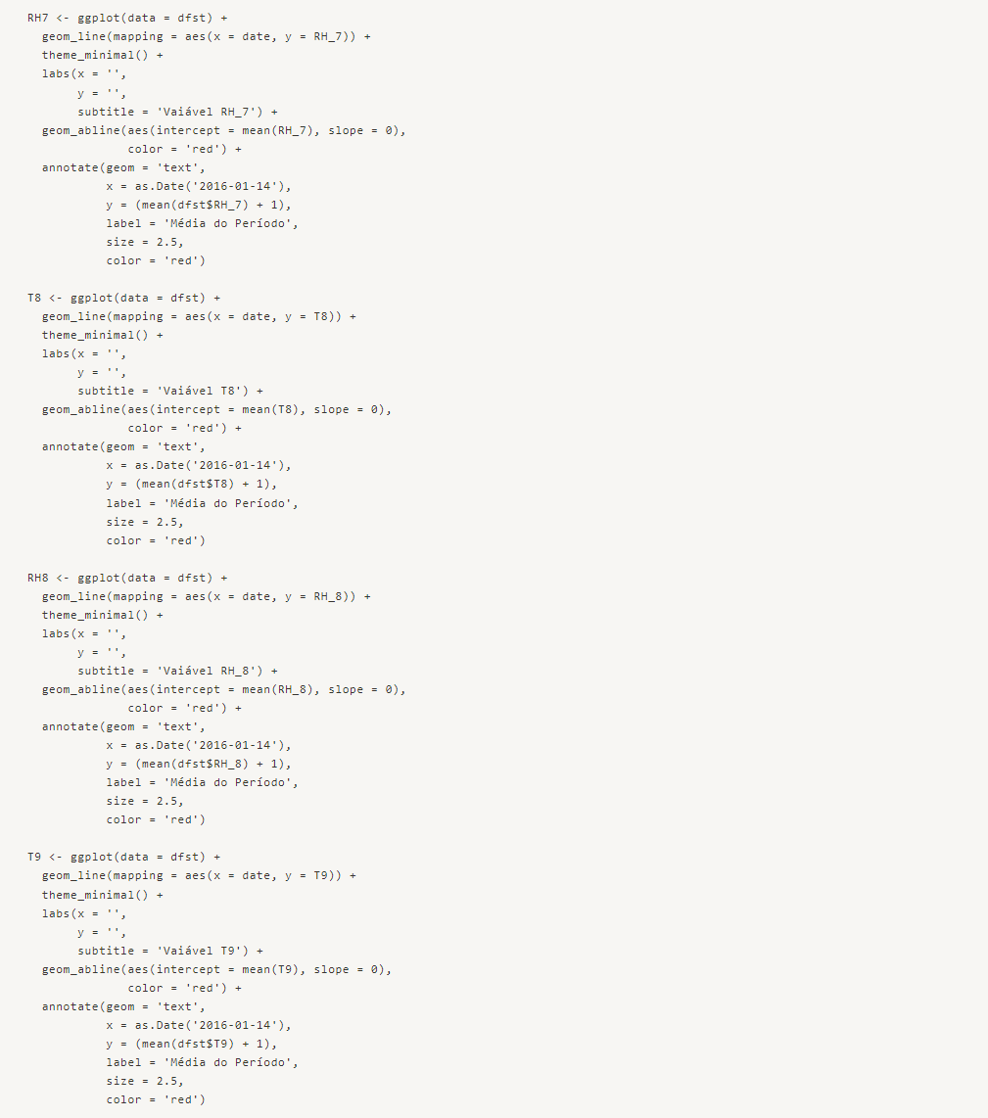

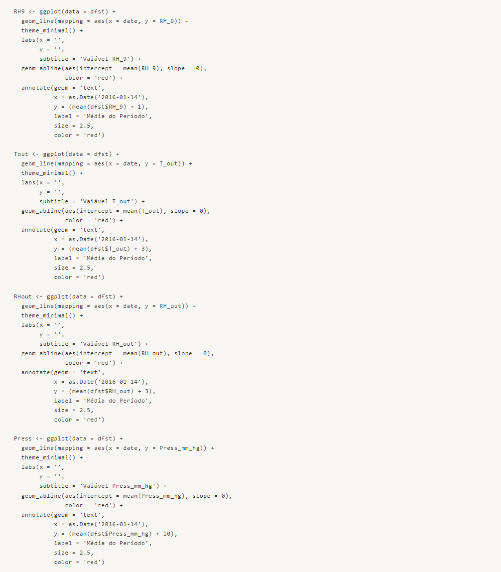

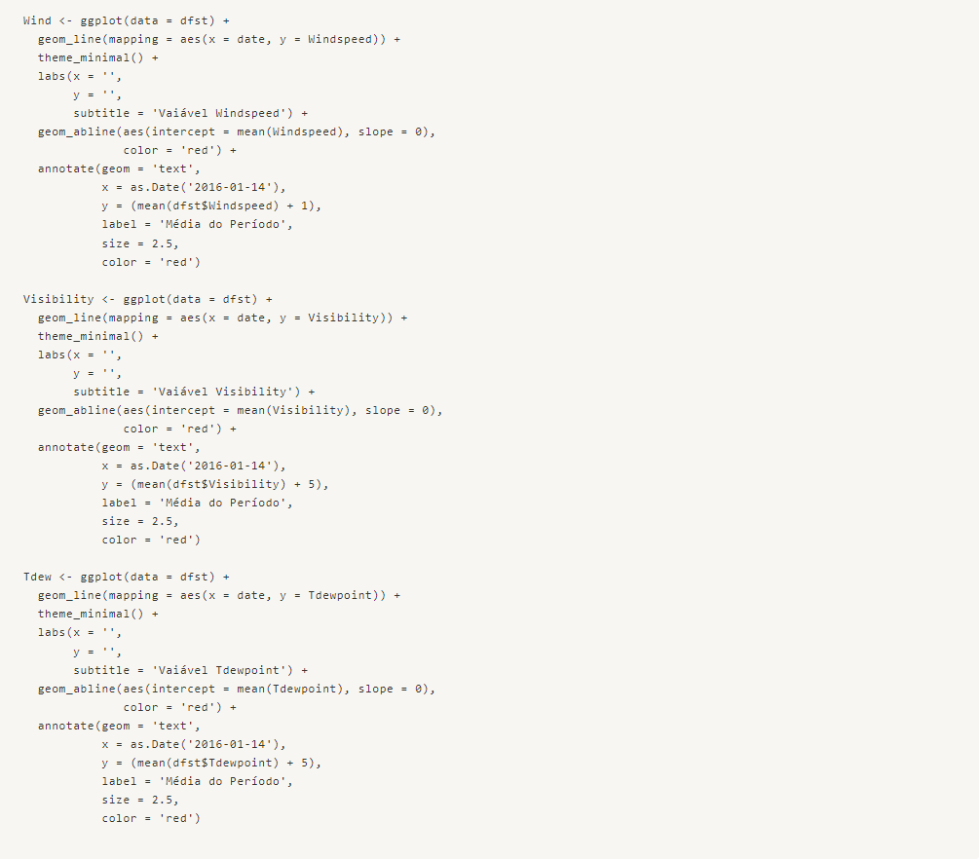
Let's visualize the time series for each region of the house and assess if there is any relationship with time in each case.

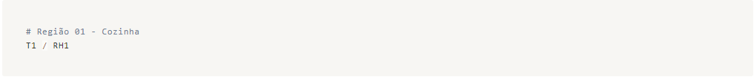

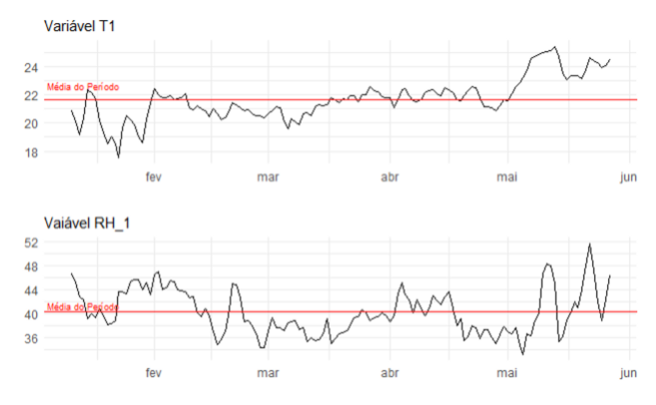

Humidity exhibits higher volatility compared to Temperature, which is plausible considering the rainy season. We can observe a period from May to June with higher and more stable temperatures, but with more volatile humidity ranging between 36% and 52%. Both variables show an upward trend from May to June.
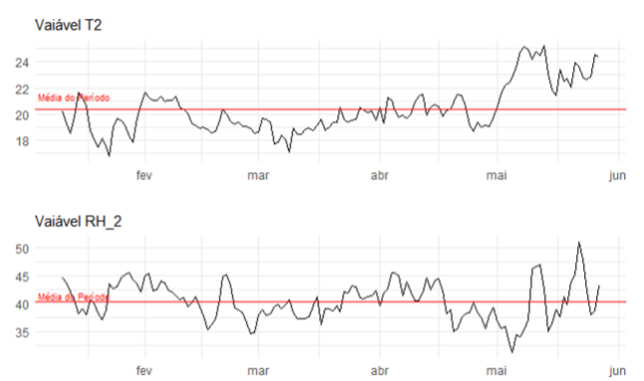

We have a very similar behavior in region 01, with May and June showing an upward trend as well.

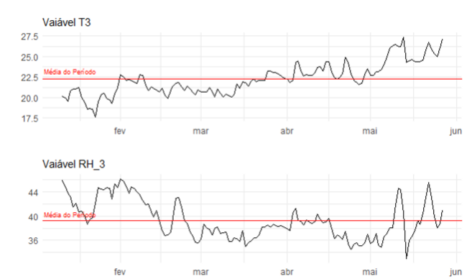

In the Laundry room, we have a slightly different scenario. The temperature shows an upward trend throughout the period, while humidity shows a downward trend. Several factors can explain this behavior, such as exposure to sunlight, morning or afternoon sun, frequent use of appliances that generate heat like washing machines, dryers, and other common equipment. Among the regions analyzed so far, it has the smallest range of humidity values, with lower minimums and maximums.
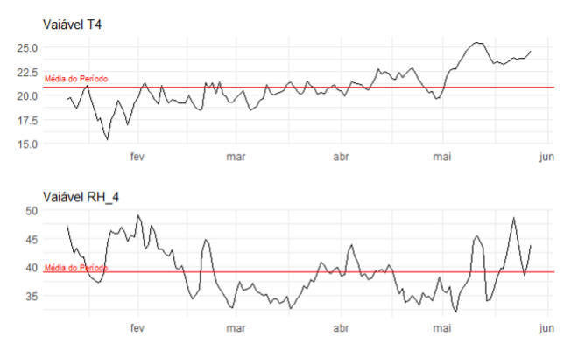

For the Office, we observe a similar behavior to the other regions, with a general downward trend in humidity and an increase in temperature. The May-June period also exhibits a similar pattern to the other regions.
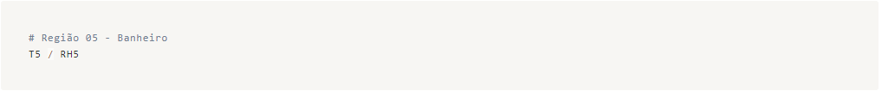
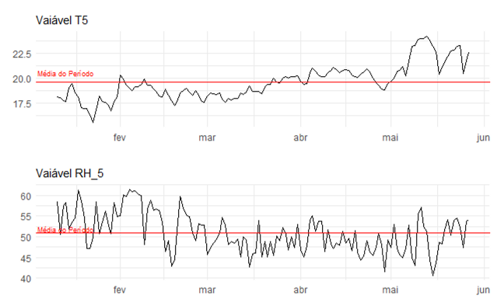

In the Bathroom, we observe larger fluctuations in humidity, which is not uncommon considering its use for activities like bathing. Other than that, we see a behavior similar to the other areas we have studied.
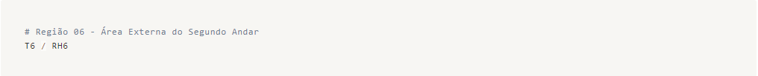
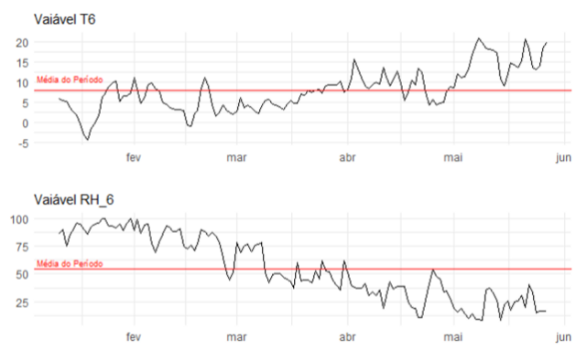

For the Outside area, we observe a different behavior regarding humidity during the May and June period. There is a significant downward trend, while the temperature shows an upward trend similar to the other areas.
The humidity values in this area are generally higher compared to the rest of the house, while the temperatures are much lower.
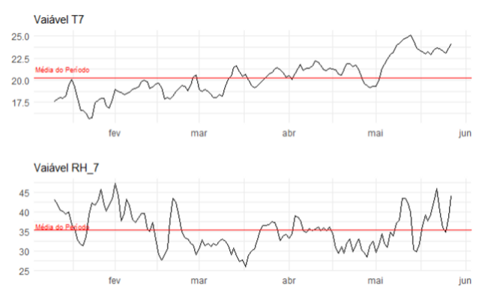

We can observe a rising trend in both humidity and temperature during the May-June period. In the previous periods, the graph shows a downward trend for humidity and an upward trend for temperature.
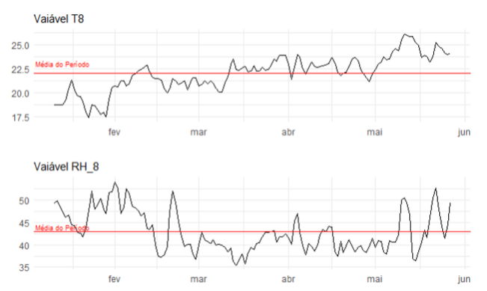

Similar behavior can be observed in the other areas of the house, except for the Outside area (Region 6).
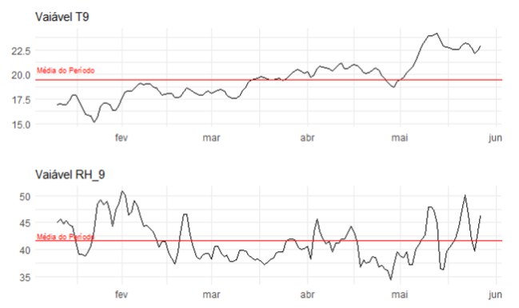

Once again, we see a similar pattern as in the other areas. However, despite the overall upward trend in temperature, the fluctuations in the Master Bedroom are less pronounced compared to the other areas.
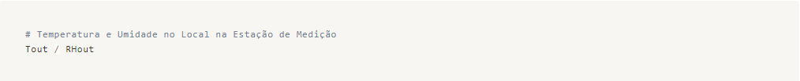
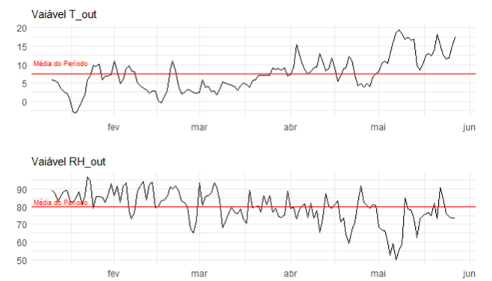

We can observe that the temperatures in the station are much lower than in the house, probably due to heating or the fact that it is a more enclosed area than the outside. On the other hand, the humidity reaches much higher values, with an average of 80%.
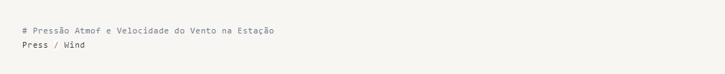
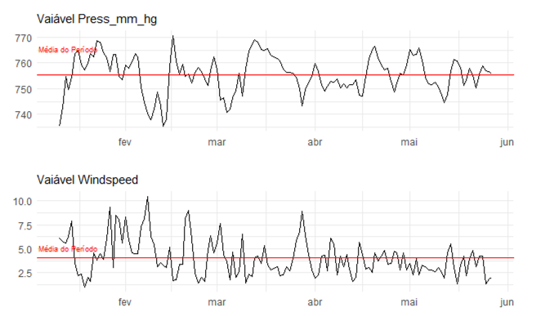

Despite the volatility of the Pressure, we don't have a clear upward or downward trend. The variation is around ± 15 mm Hg, which can be considered relatively constant during the period.
Regarding the Windspeed, we observe a downward trend, which may support some hypotheses regarding the increase in energy consumption by household appliances.
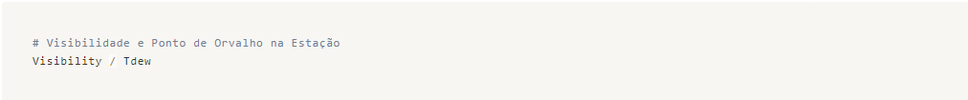
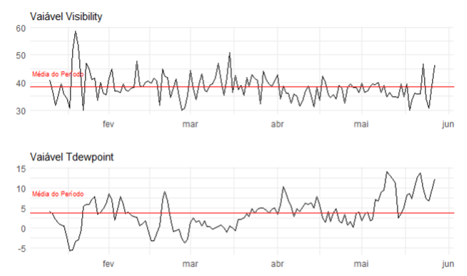

Visibility fluctuates around the average by approximately ± 10 km throughout the period, without any clear upward or downward trend.
The dew point rises as the ambient temperature increases.
Finally, a theory that we can develop, although it would require more information to corroborate, is that from April onwards, the temperature graphs become more positive in relation to their averages. Appliances such as air conditioners, fans, and electric grills are more frequently used. People tend to go out more often, wear more clothes, requiring a higher frequency of using washing machines, dryers, and irons. They also spend more time on personal grooming, increasing the use of hairdryers, straighteners, and so on.
Furthermore, by analyzing people's behavior and researching the Chievre region, we understand that the period from April to June marks the beginning of more pleasant temperatures, which is eagerly awaited by the residents. Consequently, this supports the assumptions we made above. Therefore, the change in climate and season in Chievre can help explain why there is a peak in energy consumption by household appliances in April and a subsequent upward trend.

Categorical Variables

For the categorical variables, we have smaller time windows, such as workdays and weekends, as well as the seven days of the week. We could analyze the behavior of each variable within these time windows, but for our model and understanding of the data, it is not necessary. However, let's study how the variables behave on average during these days.
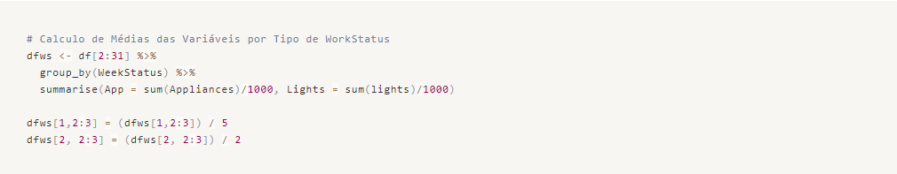
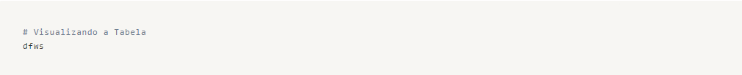
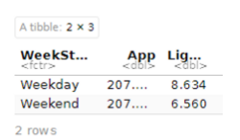

We can clearly see that there is no significantly higher energy consumption in household appliances between weekdays and weekends. However, for the lights, the consumption during the week is higher than on weekends. This is likely due to the cultural habit of leaving lights on when people are away from home.
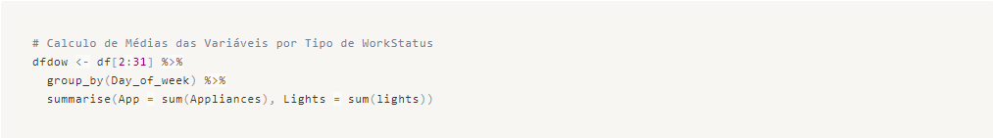
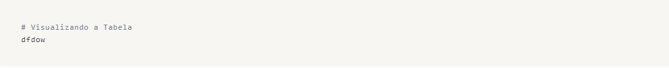
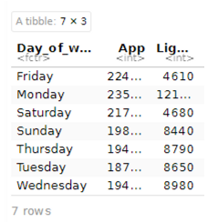

We can observe a pattern in the usage of household appliances, as the highest energy consumption occurs from Friday to Monday. On the other hand, the electricity consumption for lighting is clearly higher on most weekdays, even doubling in some cases.
Interestingly, the energy consumption for lighting is significantly lower on Fridays and Saturdays, about half compared to other days. There is also a peak in consumption on Mondays.

Preprocessing
To prepare our data, we will exclude the time window from the 'date' variable since our objective is not to perform time series predictive modeling. However, we will keep the variables 'WeekStatus' and 'Day_of_Week' as they represent a static window that may have an influence on the target variable. As these variables are categorical, it is important to encode them as factors.
We will also drop the 'lights' variable as it represents energy consumption and is not related to the target variable 'Appliances'.
Furthermore, we need to reduce the dimensionality and apply data standardization to equalize the scales and prevent our model from becoming biased and non-generalizable.
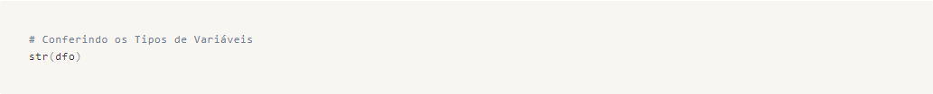
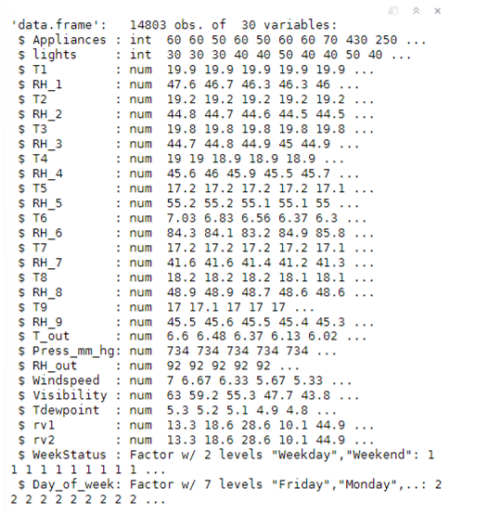

As we can see, the categorical variables are already in factor format, which makes our work easier for label encoding.
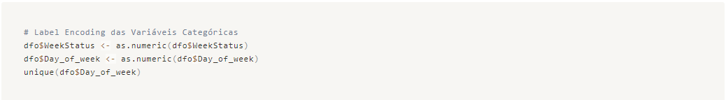
Please note that the week starts with Sunday (Sun), represented by the number 1, followed by the other days of the week in sequence (Mon - 2, Tue - 3, Wed - 4, Thu - 5, Fri - 6, Sat - 7).
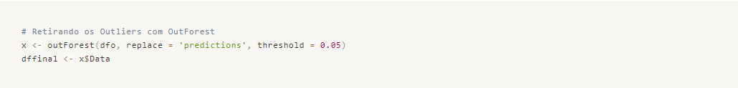
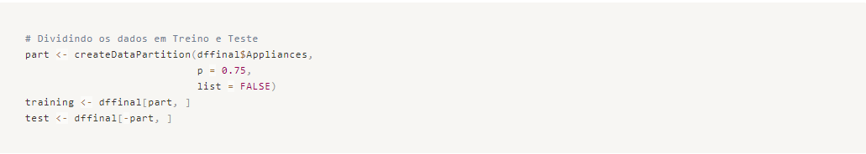
Data divided!
Now we will work on Variable Selection using the Random Forest model. This will help us reduce the dimensionality and complexity of the final model.
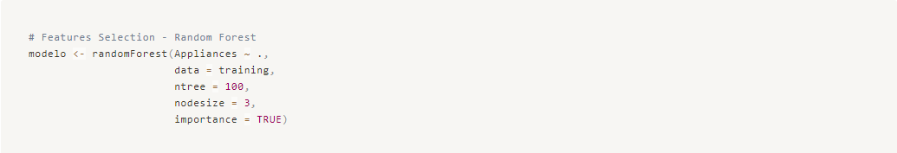
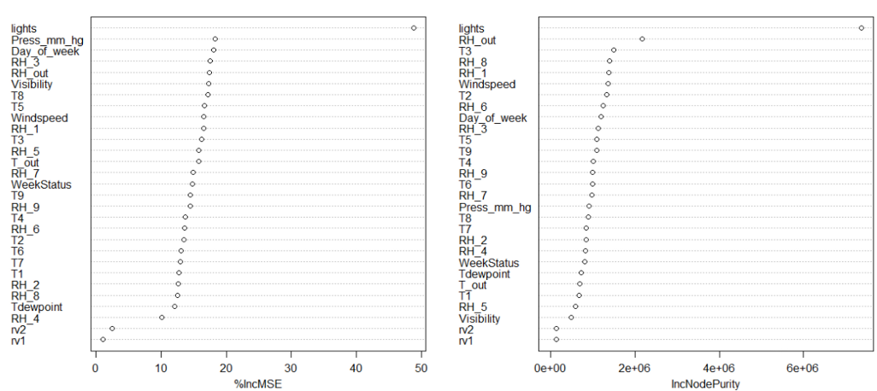
In order to reduce the complexity of our model, we will work with only the top 10 most important variables. This way, our model becomes less complex and more generalizable.
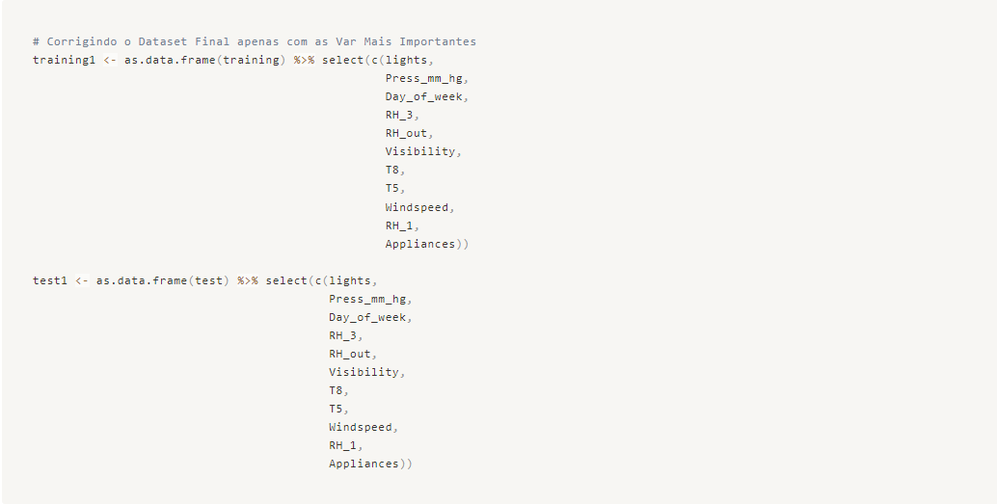

Predictive Modeling
We will use different algorithms to create several versions of models and analyze their performance metrics. Note that we are applying standardization to the predictor variables using the "preProcess" argument within the train function.

Model 00 – Gradient Boosting
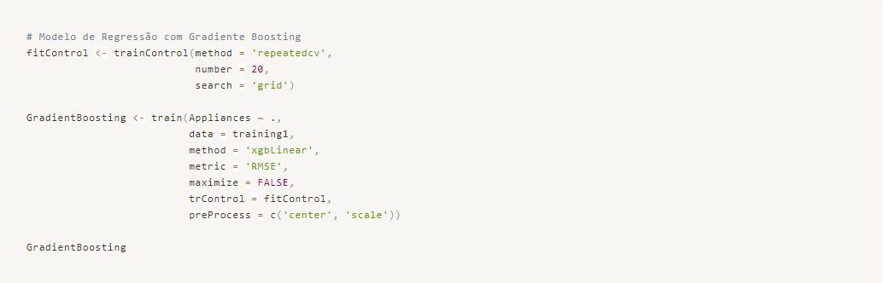

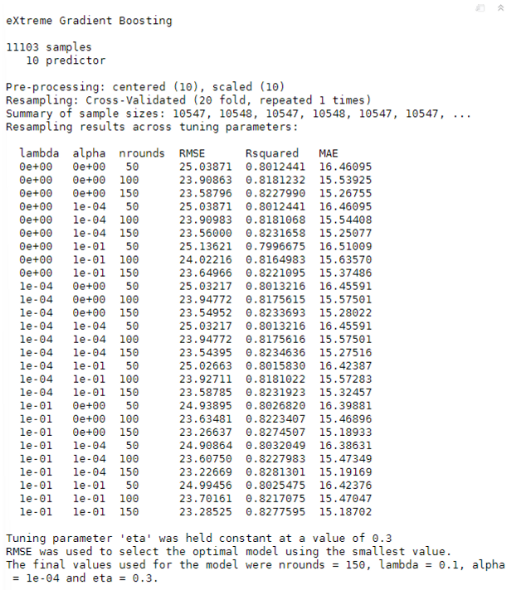

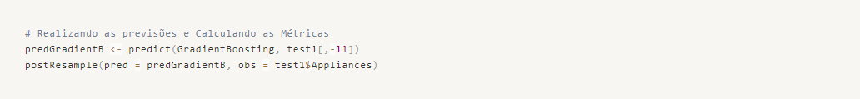

Model 01 – Support Vector Machine (SVM)
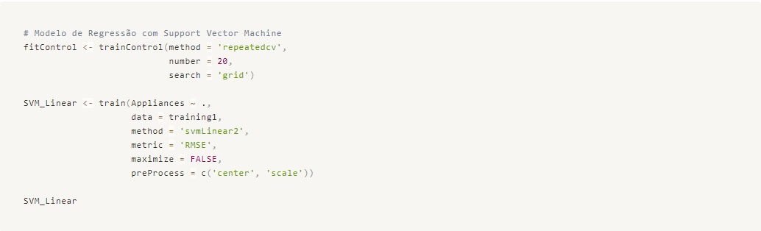
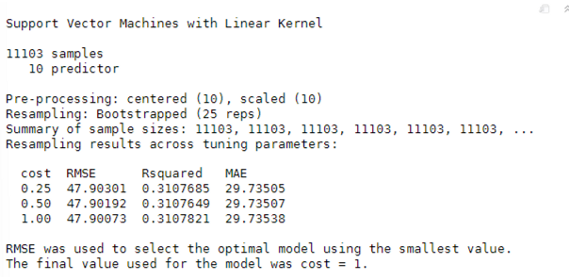

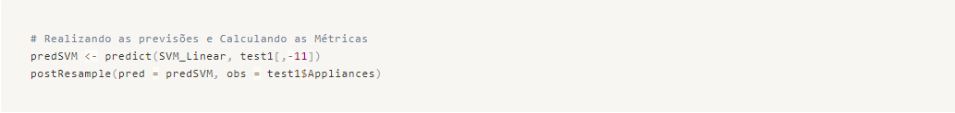

Model 02 – Logistic Regression
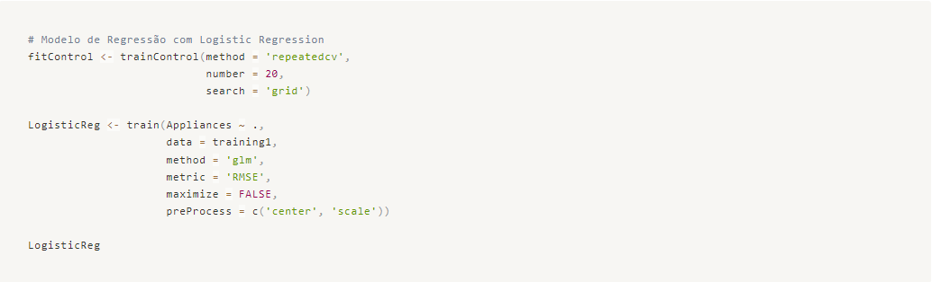
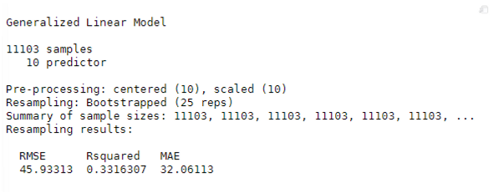

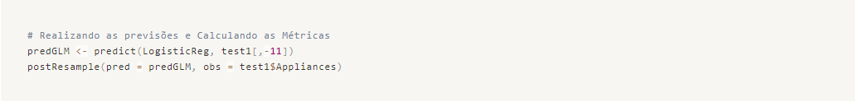

We can see that the eXtreme Gradient Boosting model performed better, as indicated by the lower RMSE and MAE values, and a higher R² value, indicating 82% explainability of the predictor variables with respect to the response variable.
Therefore, let's analyze a graphical comparison between the predicted and actual values for the test data.
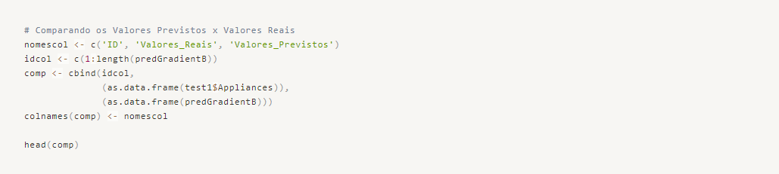
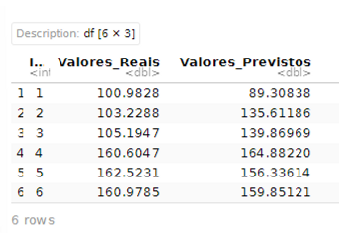

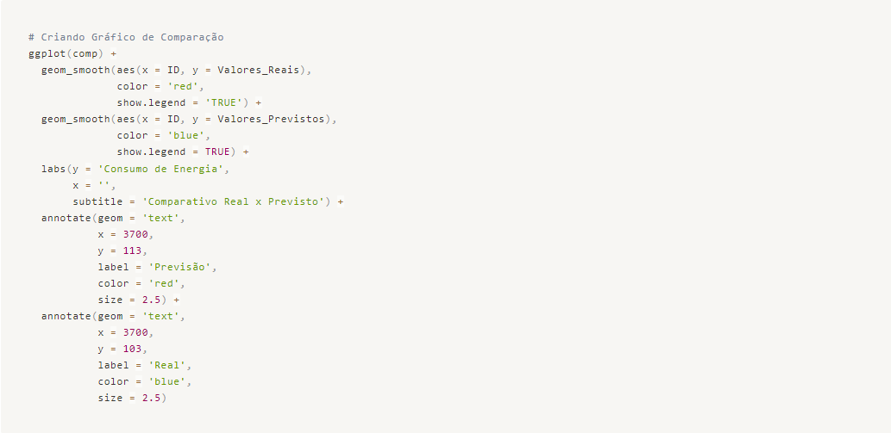
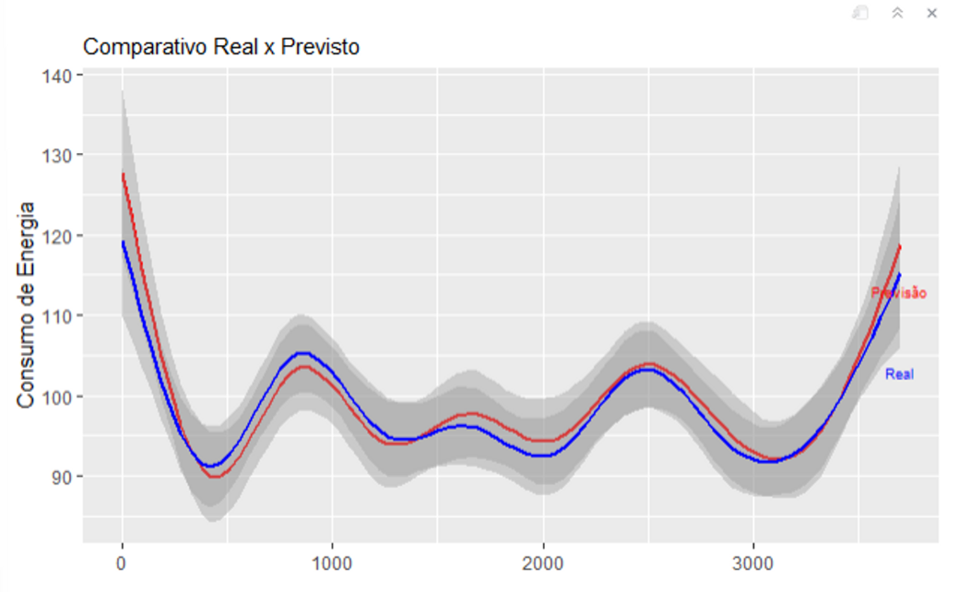

Model Deploy
We conclude our project by deploying the best model and generating predictions using new data. Typically, the data used for deployment does not include the actual values we want to predict. However, in this case, the response variable is present, so we can use it to evaluate how the model performed by comparing the RMSE, R², and MAE metrics between the predicted and actual values.
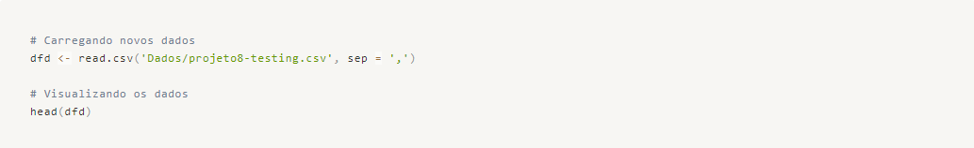
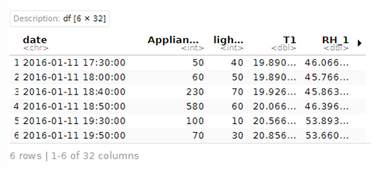

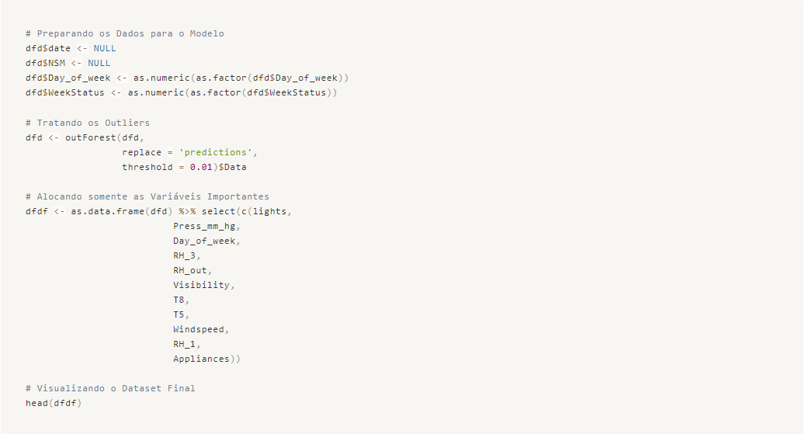
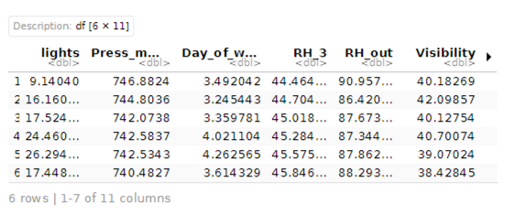

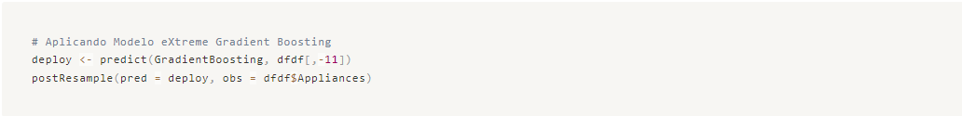

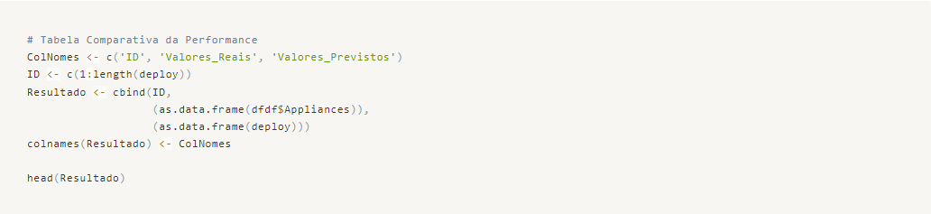
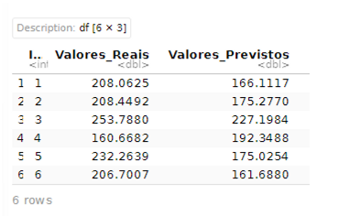

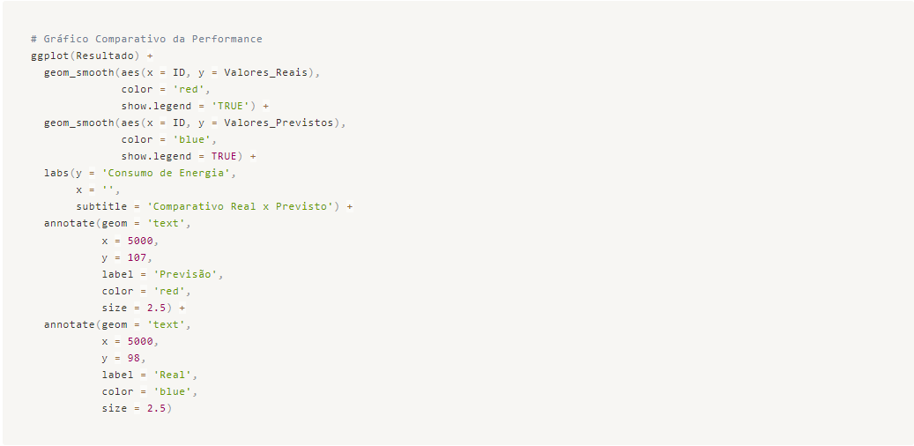
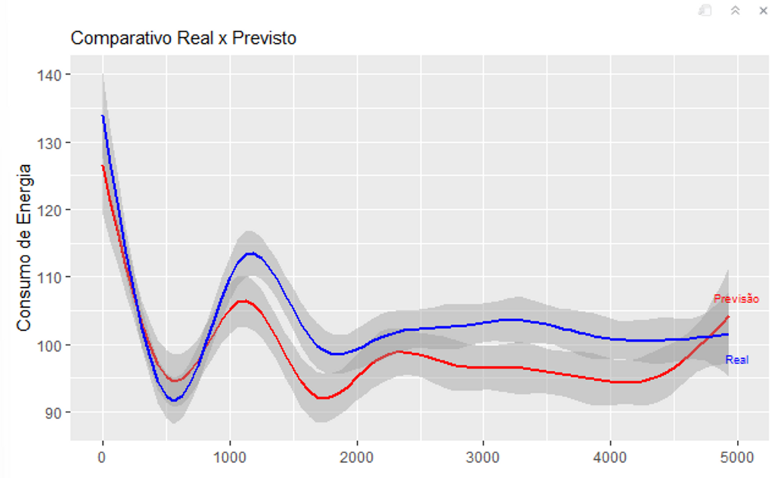
Project Delivered!

