NLP and ML in Medicine for the Classification of Genetic Mutations in Cancerous Tumors
Much has been said in recent years about how precision medicine, specifically genetic testing, will disrupt the treatment of diseases such as cancer. However, this is still only partially happening due to the enormous amount of manual work still required. In this project, we aim to take personalized medicine to its full potential.
Once sequenced, a cancerous tumor can have thousands of genetic mutations. The challenge is to distinguish the mutations that contribute to tumor growth. Currently, the interpretation of genetic mutations is being done manually. This is a time-consuming task where a clinical pathologist has to manually review and classify each genetic mutation based on evidence from text-based clinical literature.
The Memorial Sloan Kettering Cancer Center has provided an expert-annotated knowledge base where world-class researchers and oncologists have manually annotated thousands of mutations. In this project, we will develop a Machine Learning algorithm that, using this knowledge base as a reference, will automatically classify genetic variations.
The complete dataset can be found at:
[https://www.kaggle.com/c/msk-redefining-cancer-treatment/data]

Data Description
There are 9 different classes in which a genetic mutation can be classified.
The training and test data consist of 2 different files. The first one (train/test_variants) provides information about the genetic mutations, while the second one (train/test_text) provides the clinical evidence that experts use to classify the genetic mutations.
The two files are linked by the ID column. For example, the genetic mutation located on the row with ID=15 in the variants file was classified using the clinical evidence from the row with ID=15 in the text file.
To make things more challenging, some of the test data samples were computer-generated to prevent manual labeling. We should ignore the samples that were generated by the computer.

File Details
- training_variants: The descriptions of genetic mutations used for training are separated by commas. The fields are ID (used to link with the evidence dataset), Gene (the gene where the genetic mutation is located), Variation (the amino acid change of this mutation), Class (the class from 1-9 to which the genetic change has been classified).
- training_text: The content of the clinical evidence used to classify the genetic mutations is delimited by double bars (||). The fields are ID (used to link with the variants dataset) and Text (the clinical evidence used to classify the genetic mutations).
- test_variants: The descriptions of genetic mutations used for testing are separated by commas. The fields are ID (used to link with the evidence dataset), Gene (the gene where the genetic mutation is located), Variation (the amino acid change of this mutation).
- test_text: The content of the clinical evidence used to classify the genetic mutations is delimited by double bars (||). The fields are ID (used to link with the variants dataset) and Text (the clinical evidence used to classify the genetic mutations).

Loading the Packages
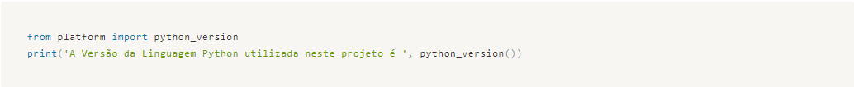

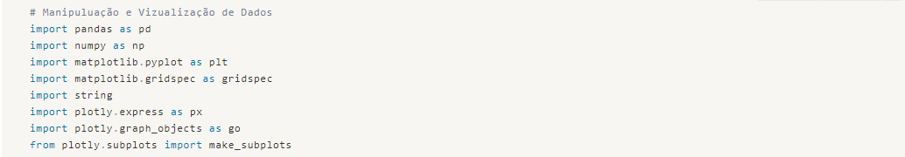

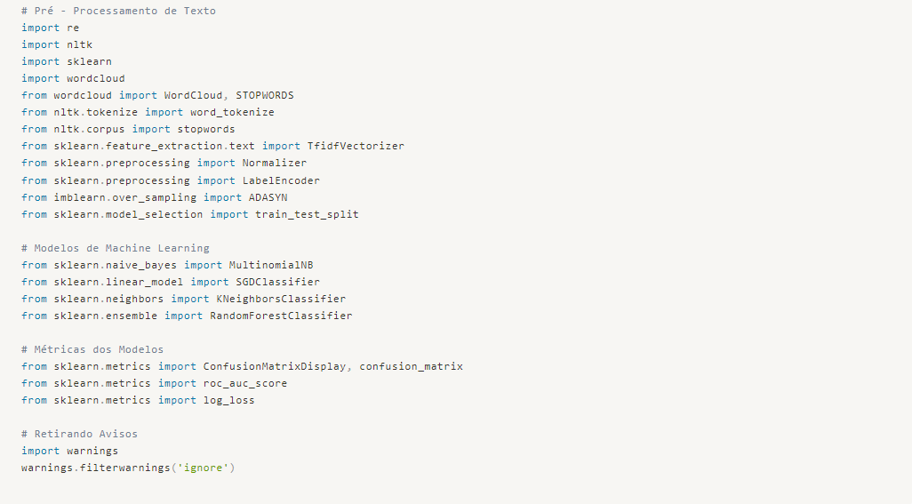
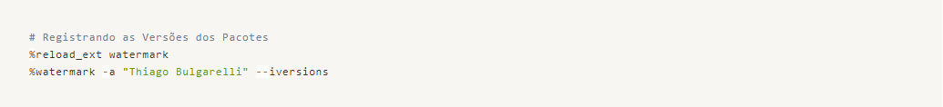
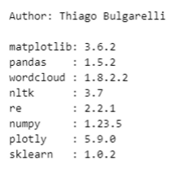

Loading the Data
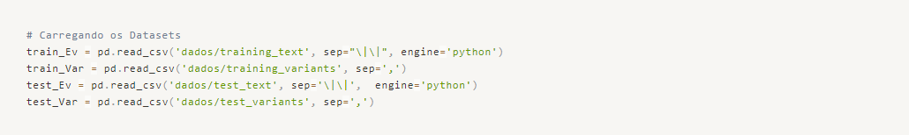

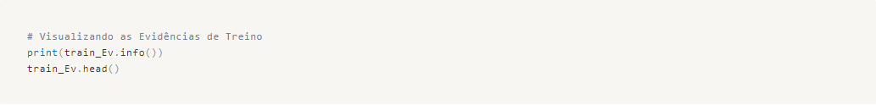
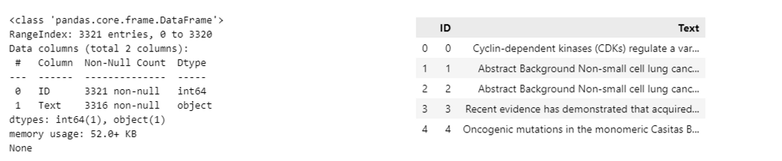
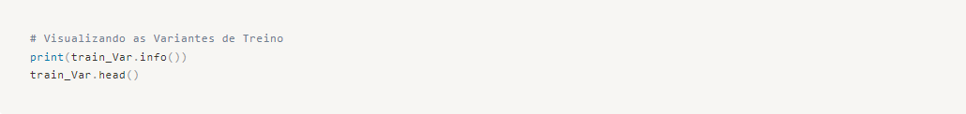
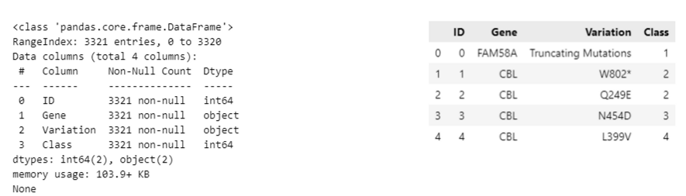
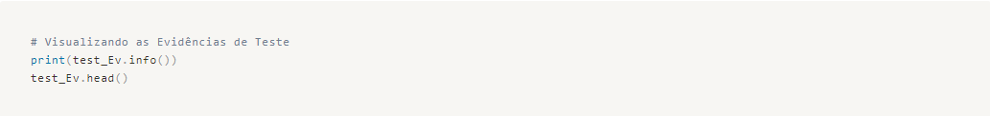
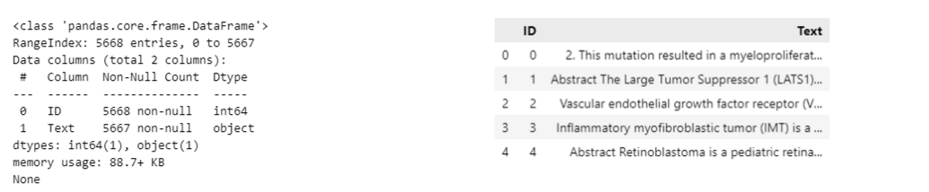
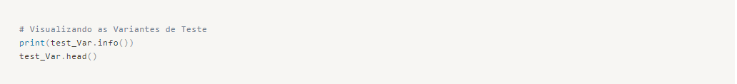
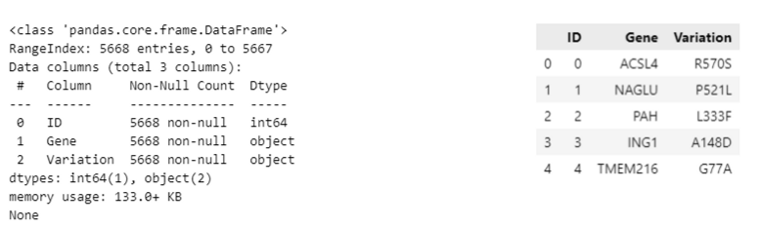

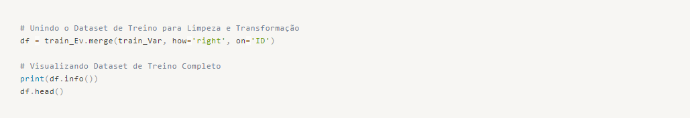
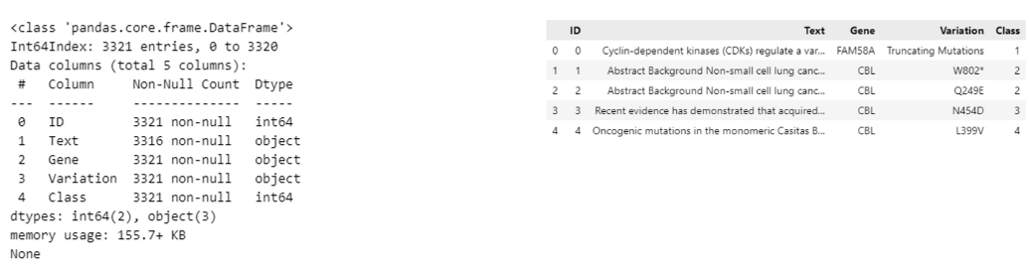
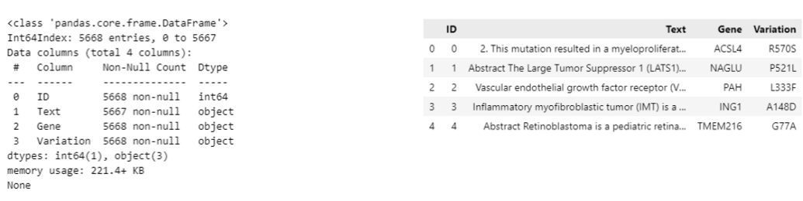
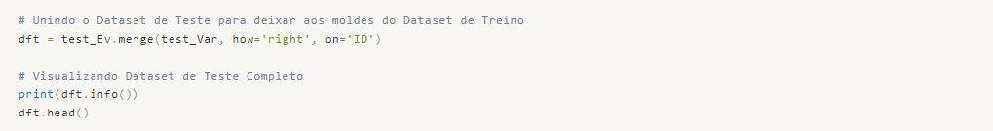

Data Cleaning and Transformation
Let's apply Text Processing techniques to keep only the most important words from each observation, removing special characters or unnecessary punctuation that does not contribute to the understanding of the context.
We will also check for missing data and determine if they need to be replaced or eliminated from our analysis.
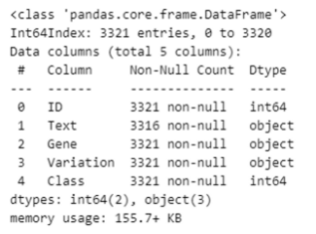

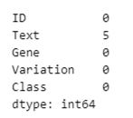

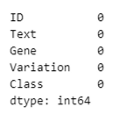
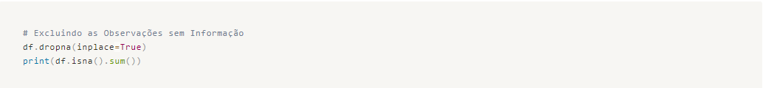

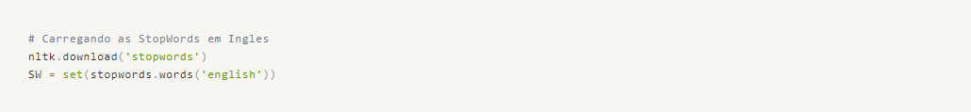

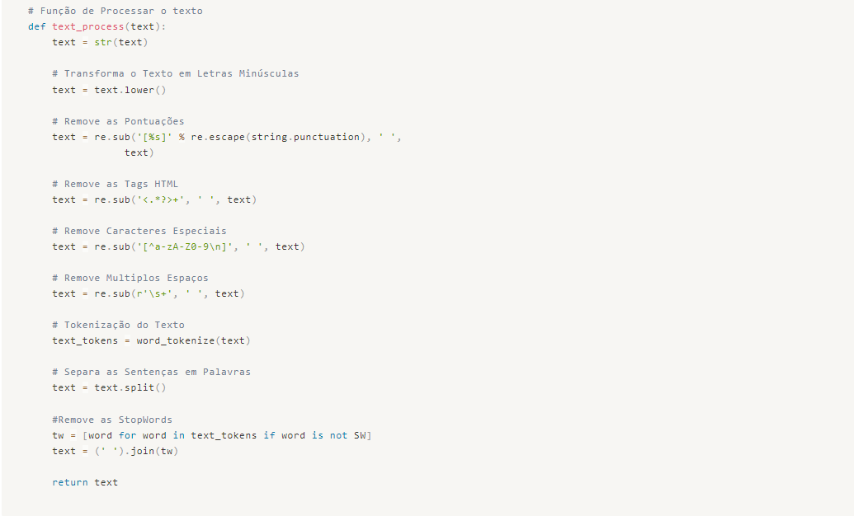
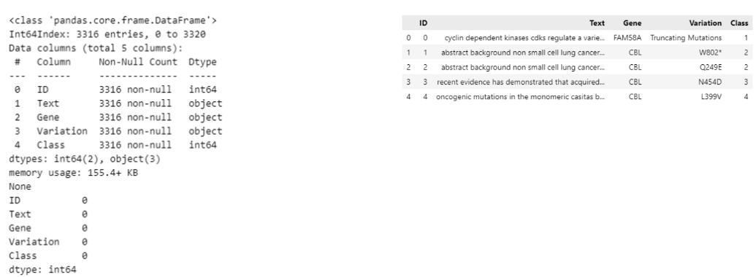
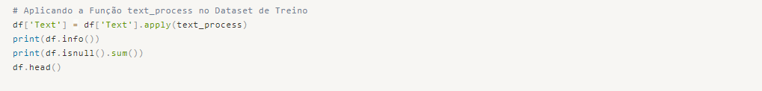

Clean and organized data! We are ready to gain a better understanding of the data and proceed with our analysis.

Exploratory Data Analysis - EDA
Our objective here is to explore the data and uncover hidden insights in the relationships between variables.

Variable Gene
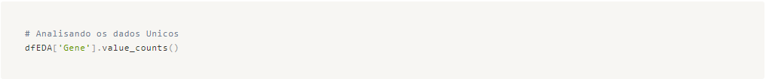
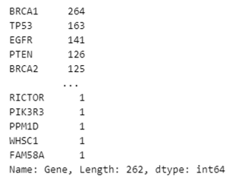

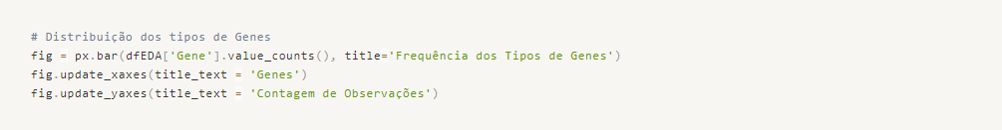

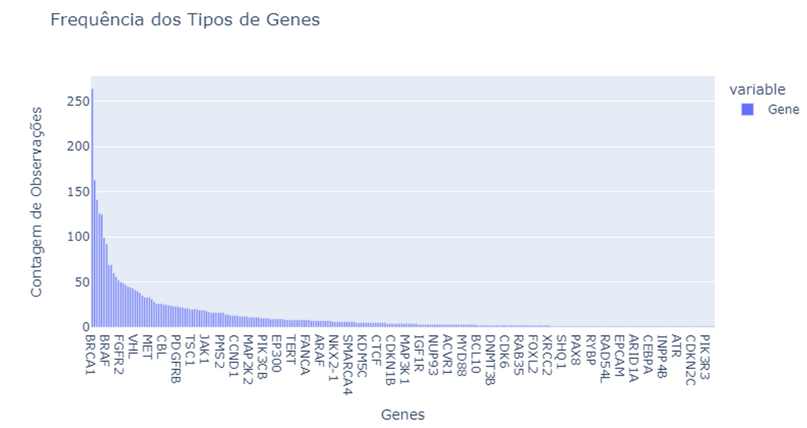
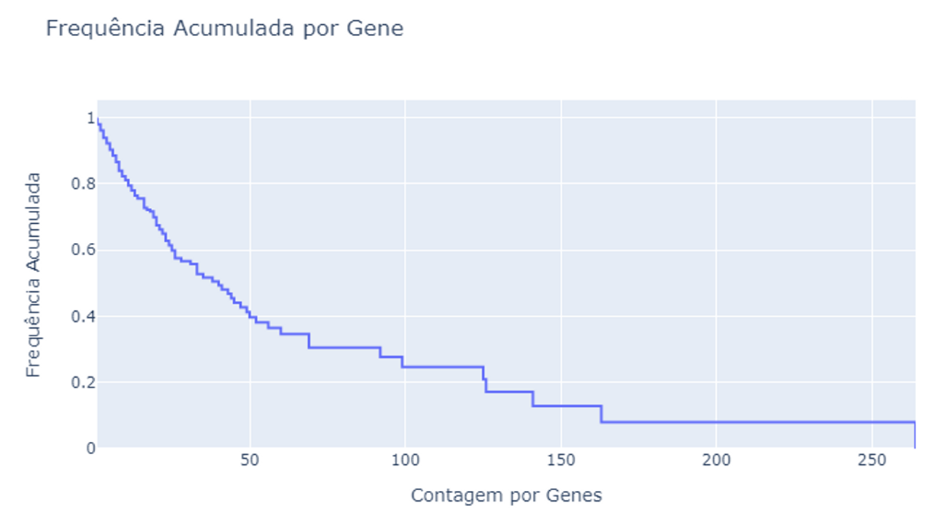
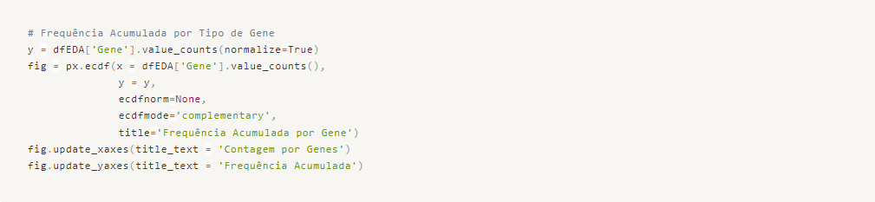
Insight → Based on the provided statement, we can say that the genes with more than 16 occurrences in our dataset account for 75% of the classified cases.

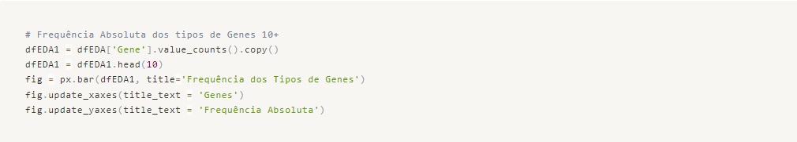
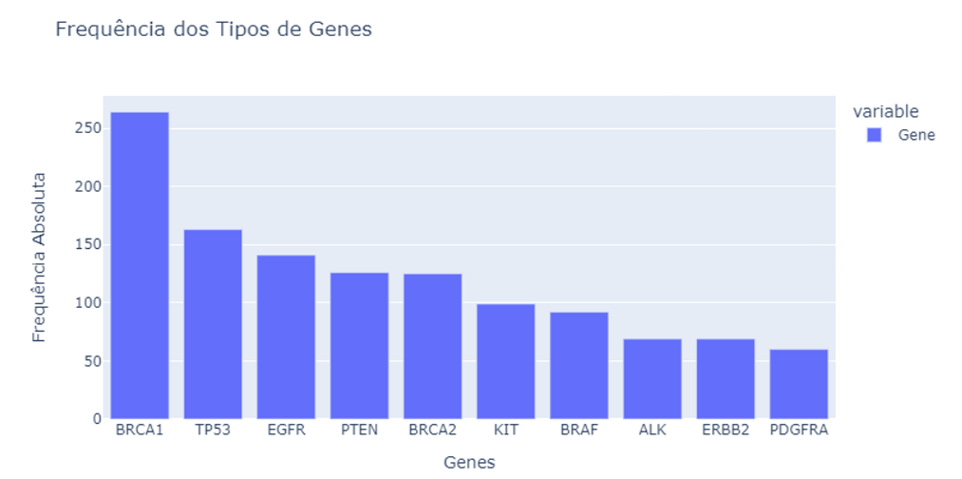
Insight → The most common genes, which are BRCA1, TP53, EGFR, PTEN, BRCA2, KIT, BRAF, ALK, ERBB2, and PDGFRA, account for 34% of our observations.

Variable Variation

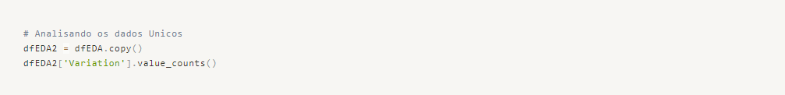

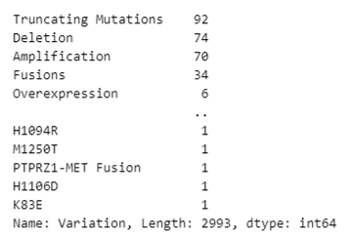

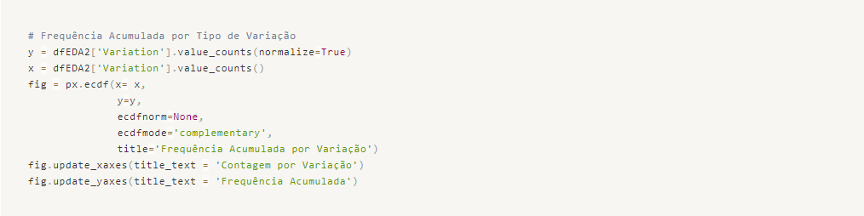
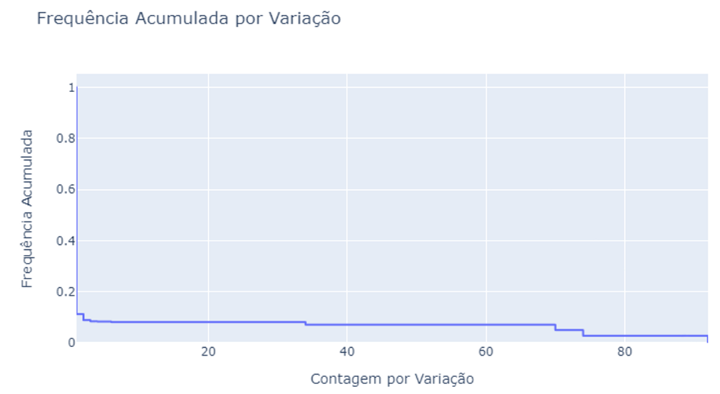

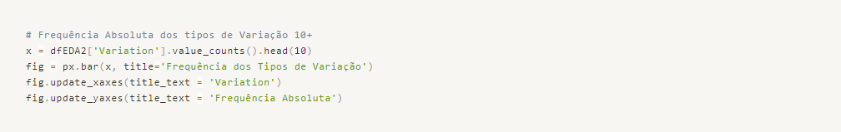
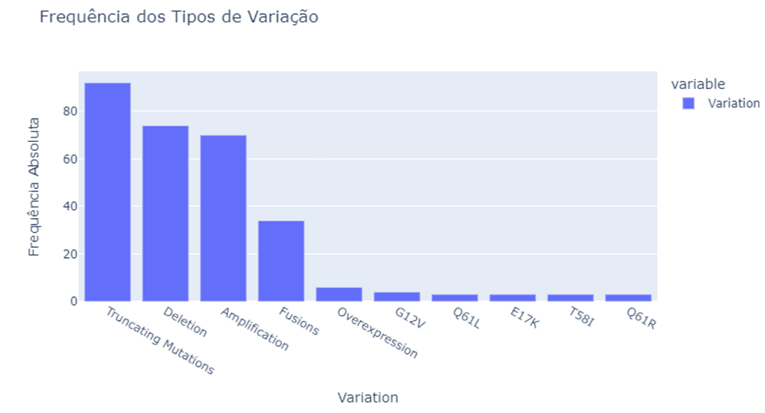
Insight → The most common variations, which are Truncating Mutations, Deletion, Amplification, and Fusions, account for 8% of our observations.
Insight → It is clear that we have almost 1 unique variation for each observation, as we have 2993 different variations for 3316 observations.

Variable Class - Target
To understand the distribution of our response variable, let's examine its distribution and identify if there is a need to balance the classes.
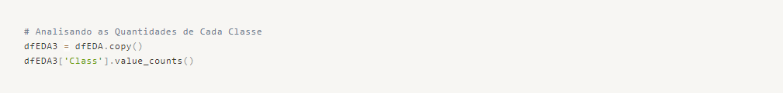

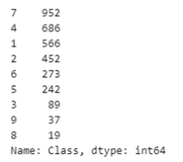

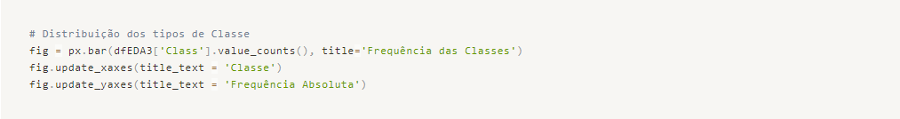
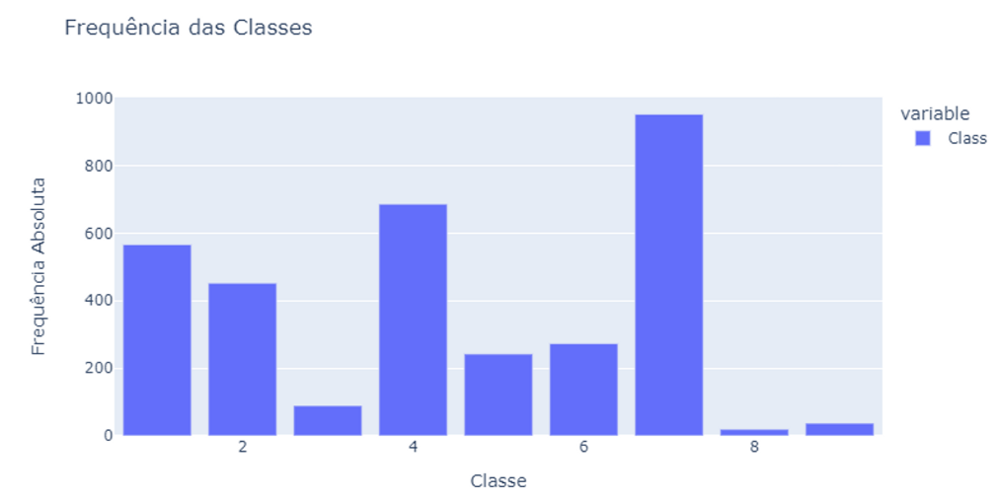
Insight → We can observe that the response variable exhibits a clear class imbalance. Therefore, it is necessary to consider appropriate strategies during the preprocessing stage to address this issue.
Let's further examine the top 5+ types of genes per class to see if there are any distinct patterns or behaviors.
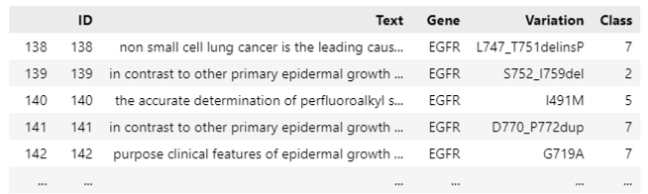
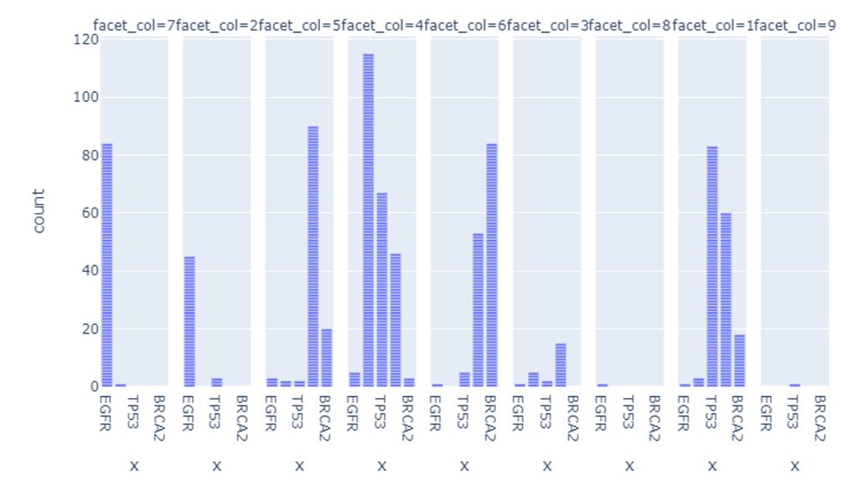
We have a dataset that is quite diluted across the classes, which does not provide us with much information about the data patterns.

Variable Text
Let's focus on observing the "Text" variable for the most frequent genes since the volume of data is too large for our computational capacity. The key is to gain an understanding of the most commonly used terms within the dataset and identify any interesting insights.
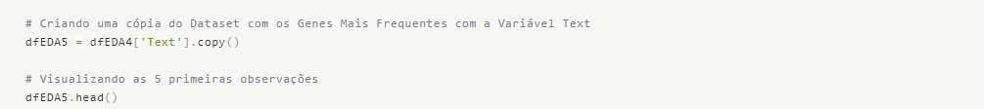
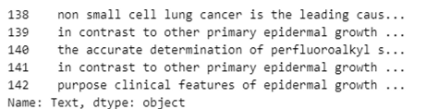

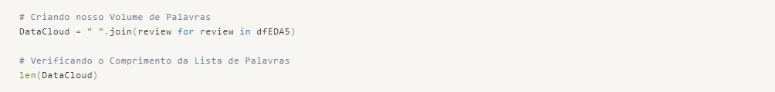
We have 48 million words in our sample.
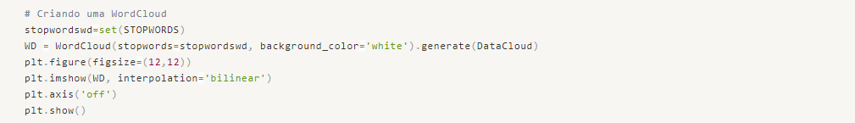
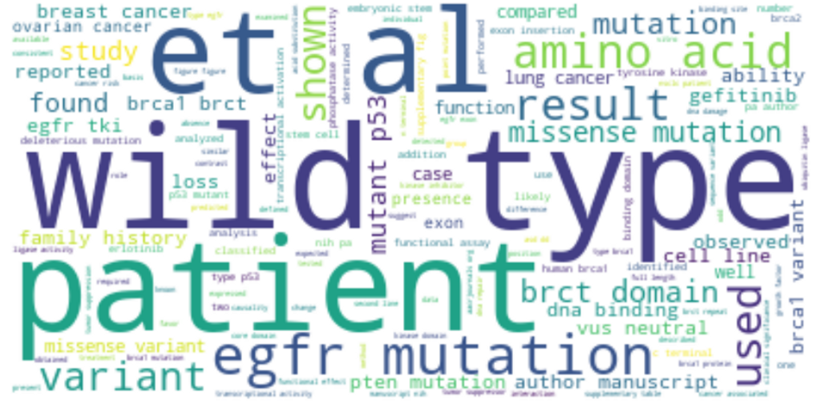
We can identify some highly frequent words such as "mutation," and genes that we have identified based on their frequency, such as "p53," "brca1," "brct," and "egfr." Additionally, there are impactful words such as "patient," "wild-type," "family," and "history."
Given that this is a highly technical and complex text, we acknowledge that our tokenization and stopwords may have some limitations. However, we believe it is sufficient to proceed with our preprocessing and achieve good predictive results. Let's move forward!

Preprocessing and Data Preparation
Let's prepare the data for our predictive modeling.
As we observed during EDA, we have an imbalanced variable "Class" with 9 possible classes. However, since we are working with non-relational data and text variables, it is not feasible to generate synthetic data. Undersampling would also be impractical due to the significant class imbalance. Therefore, we will proceed with the imbalanced response variable and aim to achieve the best possible performance in our machine learning models.
Since the goal of the project is to use literature texts to classify genes and their mutations, we will perform TF-IDF vectorization only on the "Text" variable. After that, we will split the data into training and testing sets. Once these steps are completed, we will be ready to start developing our machine learning models.
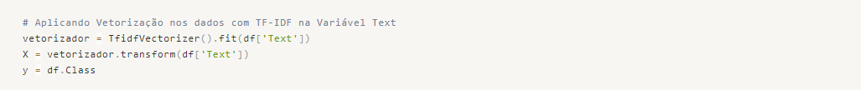
Great! We are all set to start developing our machine learning models. Let's proceed with the model development process!

Machine Learning
Sure! Let's work with the algorithms K-Nearest Neighbors, Random Forest Classifier, Multinomial Naive Bayes, and Stochastic Gradient Descent.
For each model, we will calculate the following metrics:
- Log Loss: The logarithmic loss between the actual and predicted values.
- ROC AUC: The accuracy of the model based on the ROC probability curve.
We will compile the results into a data frame to decide which model to deploy with new data. Let's proceed with model training and evaluation.

Model 00 - K-Nearest Neighbors
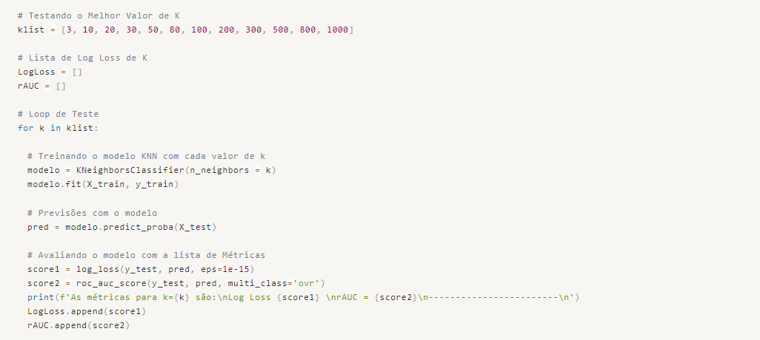
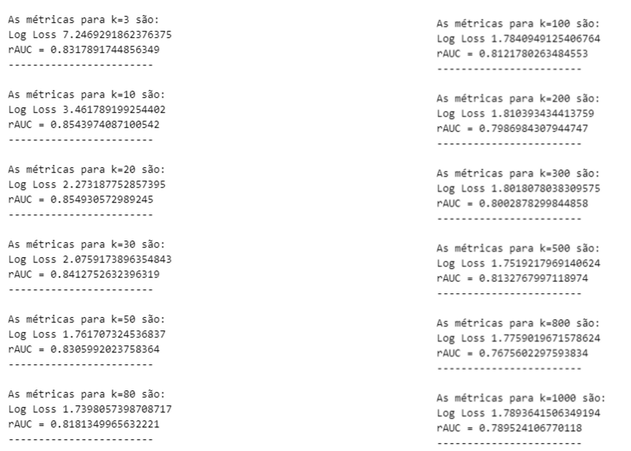
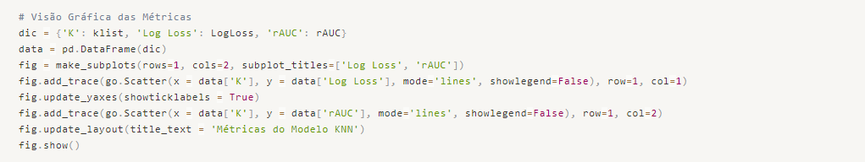
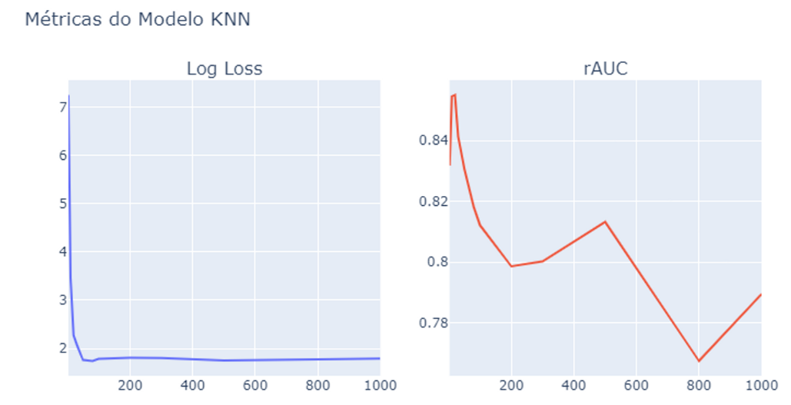
The logarithmic loss (Log Loss) measures how closely the predicted probability aligns with the actual value. In other words, the greater the divergence between the predicted probability and the actual value, the higher the log loss. Therefore, we aim for a lower log loss.
The ROC AUC curve helps determine the model's accuracy level, with a higher value indicating better accuracy.
That being said, you have identified an ideal value of K = 80 for the K-Nearest Neighbors algorithm. We will proceed with training and evaluating the model using this value.

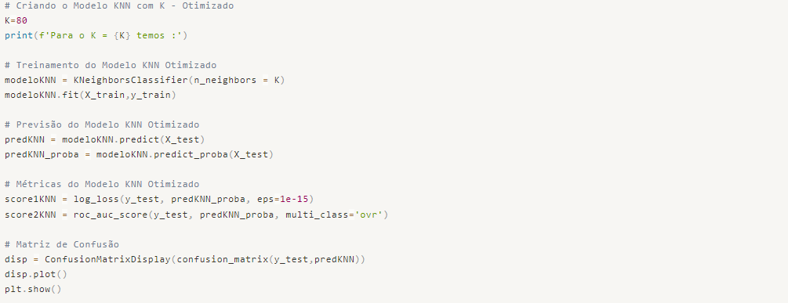

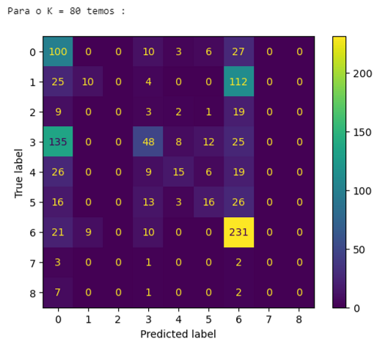

We can observe from the Confusion Matrix that our model is making more accurate predictions for classes 7 and 1. This is due to the imbalanced nature of the output variable, where the model learns more about the classes with higher frequency compared to the classes with lower frequency.
The class imbalance can affect the model's ability to accurately predict minority classes. It is important to address this issue through techniques such as oversampling, undersampling, or using class weights to give more importance to the minority classes during training.
By addressing the class imbalance, we can potentially improve the model's performance in predicting the classes with lower frequency.

Model 01 - Random Forest Classifier
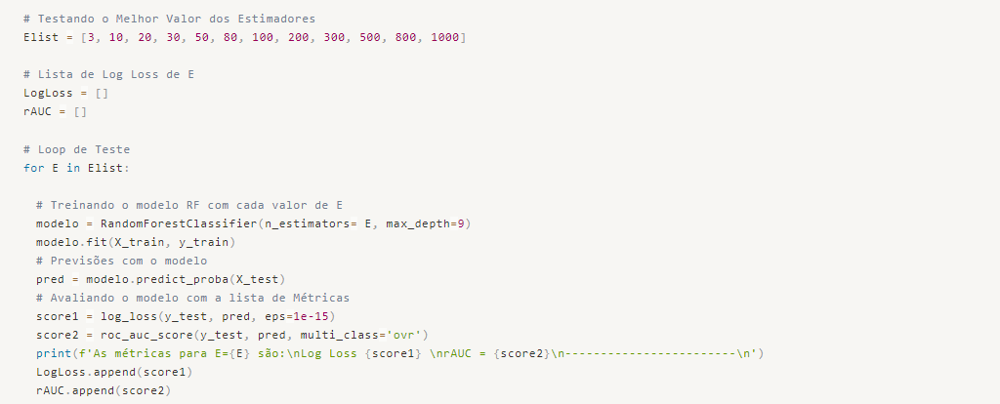
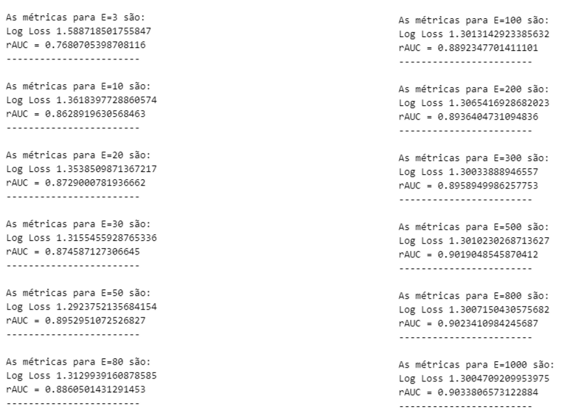

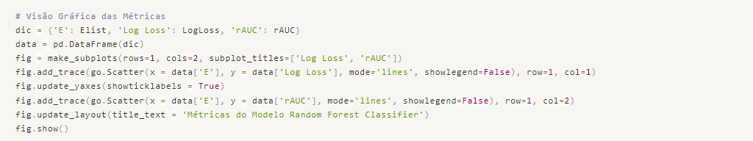
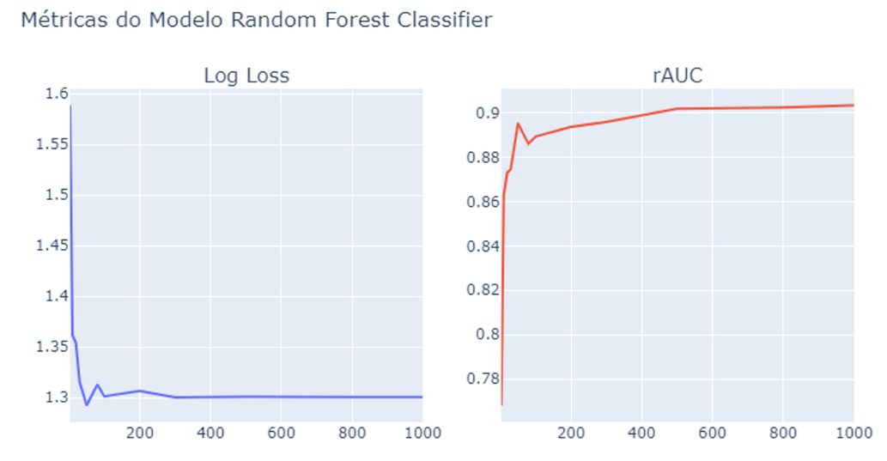
We can conclude that the best value for the number of estimators (E) is 50, as it results in the lowest log loss and a good accuracy of 89.5% with ROC AUC.
By evaluating the model's performance with different values of E, we have determined that E = 50 provides the best balance between log loss and accuracy. This suggests that using 50 estimators in the Random Forest Classifier yields favorable results for our problem.
It's important to note that the choice of the optimal value for the number of estimators may vary depending on the specific dataset and problem at hand. It's always recommended to experiment with different values and evaluate their performance to determine the most suitable value for the given task.
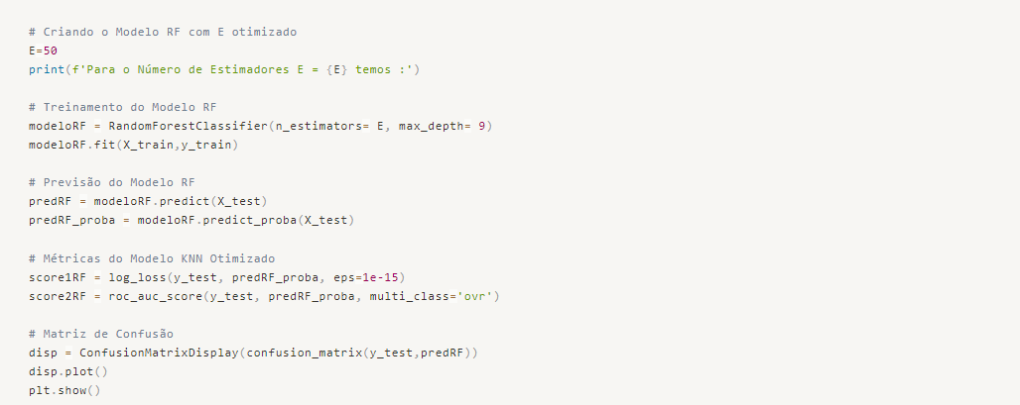
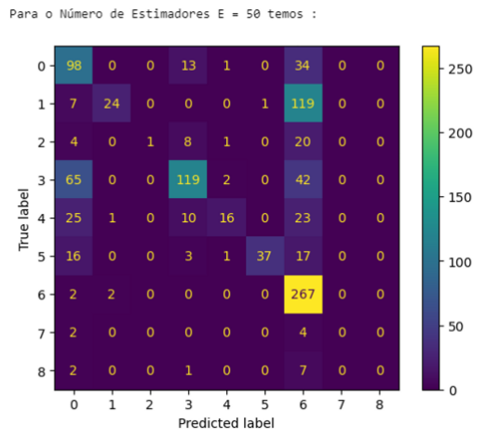

We can observe from the Confusion Matrix that our model is making more accurate predictions for classes 1, 4, 6, and 7 compared to the K-Nearest Neighbors (KNN) model. This indicates an improvement in performance with the Random Forest Classifier.
The Random Forest model is able to capture more complex patterns in the data and make more accurate predictions for multiple classes. This is reflected in the improved performance for certain classes in the Confusion Matrix.

Model 02 - Multinomial Naive Bayes
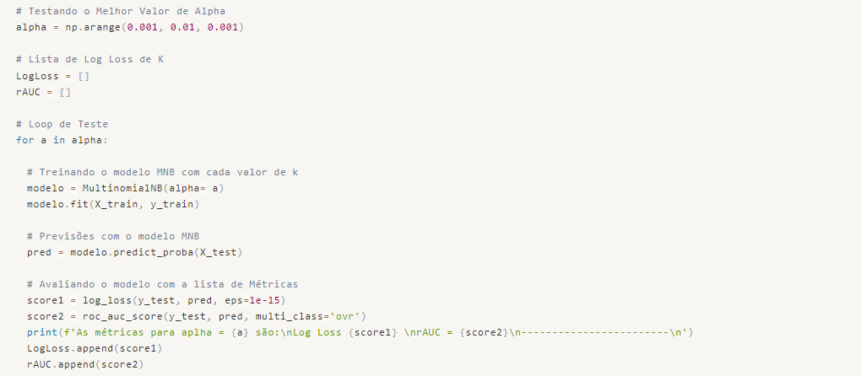
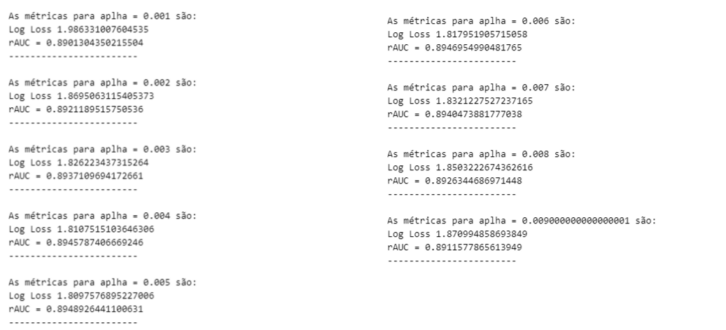
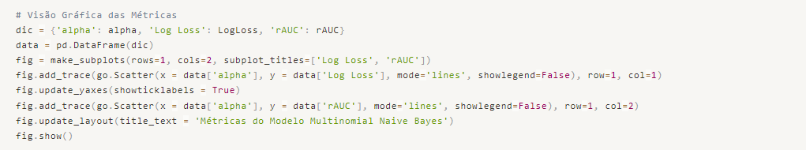

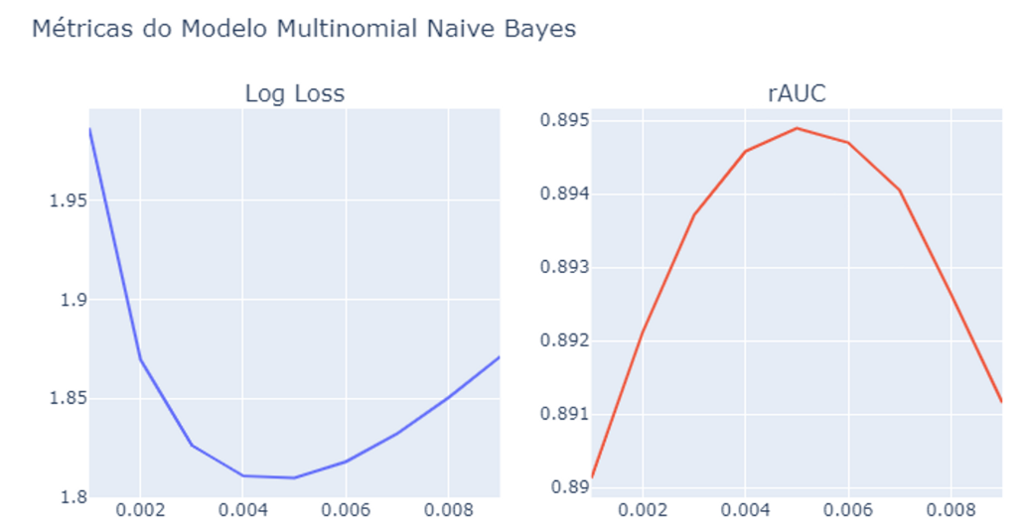
We can conclude that a value of alpha equal to 0.005 is suitable as it results in a log loss of 1.81 and an rAUC of 89.5%.
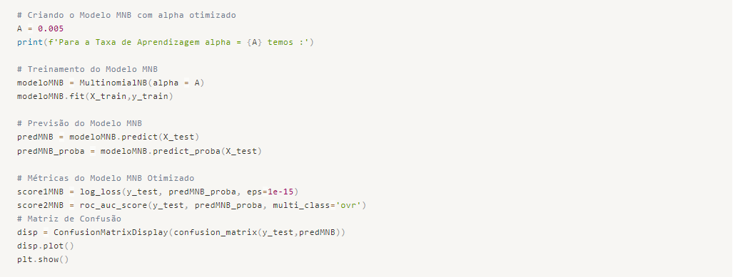
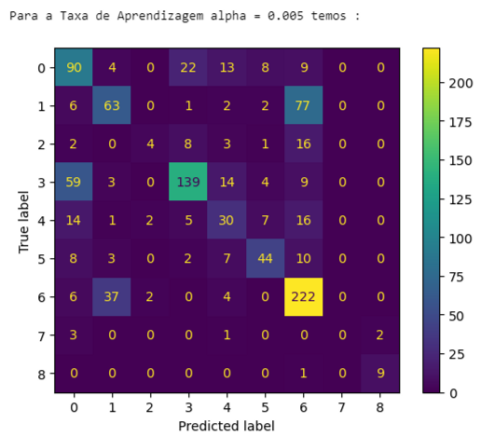

We have made progress in our predictions, achieving more correct predictions and fewer errors for all classes! Although we obtained a higher Log Loss compared to the previous models, we have achieved the highest accuracy so far.
The trade-off between Log Loss and accuracy is a common consideration in machine learning. While a lower Log Loss indicates better probability estimation, a higher accuracy demonstrates the model's ability to make correct predictions overall.
In this case, even though the Log Loss is slightly higher, the improved accuracy suggests that the Stochastic Gradient Descent (SGD) model performs better in terms of overall prediction accuracy.

Model 03 - Stochastic Gradient Descent Classifier
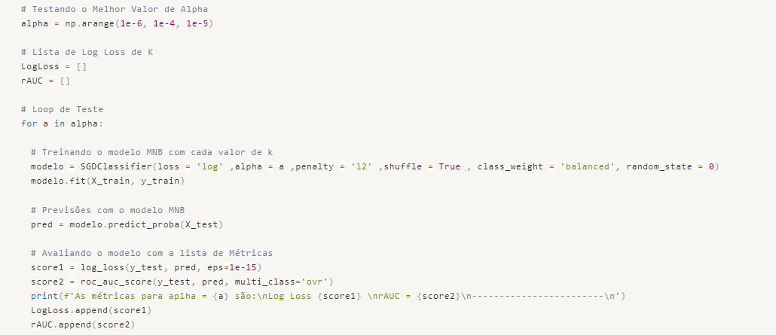
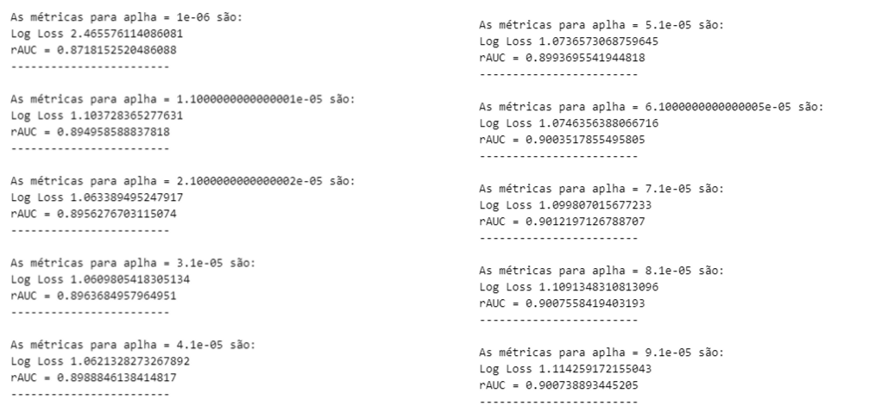
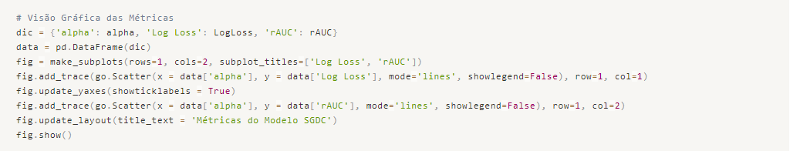
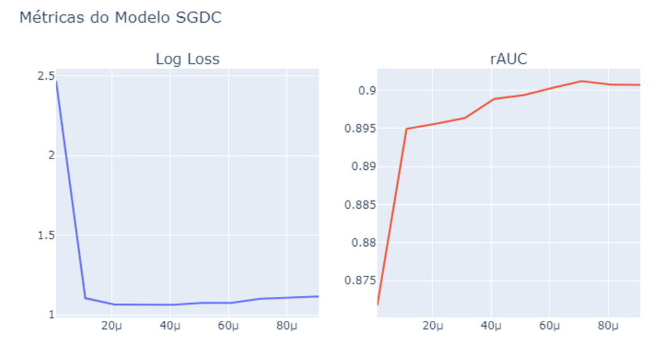
We can determine that the best learning rate alpha is 2.1e-5, which gives us a Log Loss close to 1.06 and an rAUC of 89.5%.
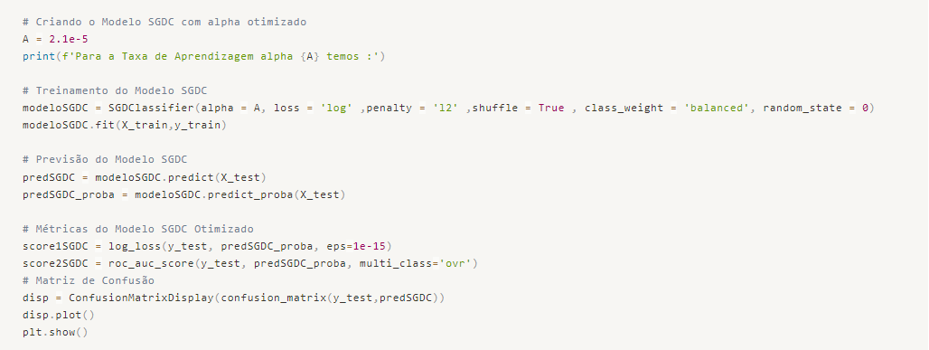

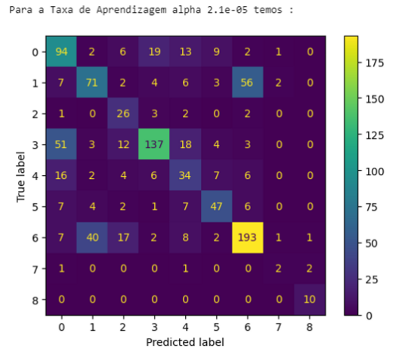

From the Confusion Matrix, we can see that our model made many more correct predictions than incorrect ones in all classes. We also obtained the lowest Log Loss and the highest Accuracy among all the trained models.

Great! With the SGDC model selected as the best model, we can proceed with the classification of new data and deliver the results to our end client. Using the trained SGDC model, we can now make predictions on unseen data by inputting the relevant features (genes, variations) into the model.
Once the predictions are generated, they can be presented to the end client along with any additional information or visualizations that might be useful for interpretation. It's important to communicate the limitations and assumptions of the model to the client to ensure they have a clear understanding of the predicted results.

Model Deploy
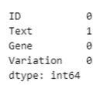

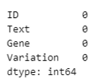

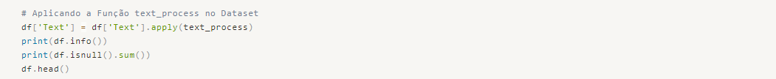
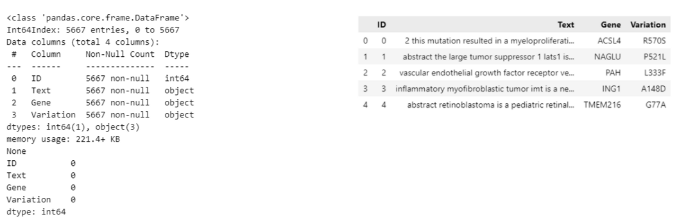

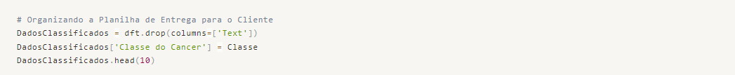
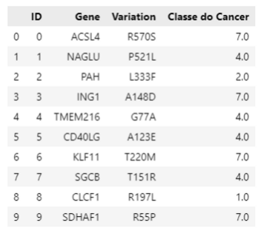

Project Delivered, Happy Client! Let's move on to the next one!!

