Electric Car Energy Consumption Forecast with Machine Learning

Description and Introduction to the Business Problem
"A transportation and logistics company wants to transition its fleet to electric cars in order to reduce costs. Before making the decision, the company would like to forecast the energy consumption of electric cars based on various usage factors and vehicle characteristics.
Using a dataset with publicly available real data, we need to build a machine learning model capable of predicting the energy consumption of electric cars based on various factors, such as the type and number of electric motors, vehicle weight, cargo capacity, and other attributes.
For the construction of this project, we will use the R programming language. The dataset can be found at the following link: https://data.mendeley.com/datasets/tb9yrptydn/2.
This dataset lists all fully electric cars currently available on the market, along with their attributes (properties). The collection does not include data on hybrid cars and electric cars with "range extenders." Hydrogen cars are also not included in the dataset due to the insufficient number of mass-produced models and their different specificities compared to electric vehicles, including different charging methods.
The dataset includes cars that, as of December 2, 2020, could be purchased as new in Poland from authorized dealers, as well as those available for public pr-sale, provided a publicly available price list was available. The list does not include discontinued cars that cannot be purchased as new from an authorized dealer (even if they are not available in stock).
The electric car dataset includes all fully electric cars in the primary market, obtained from official materials (technical specifications and catalogs) provided by car manufacturers licensed to sell cars in Poland. These materials were downloaded from their official websites. If the data provided by the manufacturer was incomplete, the information was supplemented with data from the Auto Catalog SAMAR.
Our task is to build an ML model capable of predicting the energy consumption of electric vehicles."

Data Dictionary
Variable Name | Description
Car Full Name | Full name of the vehicle
Make | Vehicle manufacturer
Model | Vehicle model
Minimal price | Minimum selling price of the vehicle in [US]
Engine power | Power declared by the vehicle's engine manufacturer, measured in [kW]
Maximum torque | Maximum torque of the engine measured in [Nm]
Type of brakes | Type of brake system
Drive type | Type of drive
Battery capacity | Battery capacity in [kWh]
Range | Battery range in [km]
Wheelbase | Wheelbase distance in [cm]
Length | Vehicle length in [cm]
Width | Vehicle width in [cm]
Heigth | Vehicle height in [cm]
Minimal Empty weight | Empty weight measured in [kg]
Permissable gross weight | Maximum allowed weight measured in [kg]
Maximum load capacity | Maximum load capacity measured in [kg]
Number of seats | Number of seats in the vehicle
Number of doors | Number of doors in the vehicle
Tire size | Tire radius size measured in [inches]
Maximum speed | Maximum speed measured in [km/h]
Boot capacity | Trunk capacity measured in [l]
Acceleration 0-100 | Acceleration time from 0 to 100 [s]
Maximum DC charging power | Maximum battery charging capacity measured in [kW]
Mean Energy Consumption [kWh/100 km] | Average battery consumption measured in kWh per 100 km traveled

Packages Used
Using the data from the dataset, our objective is to predict the electricity consumption of the base models and identify important insights and potential improvement opportunities.

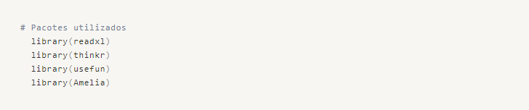
Loading the Data and Adjusting the Dataset
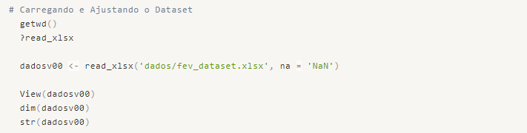
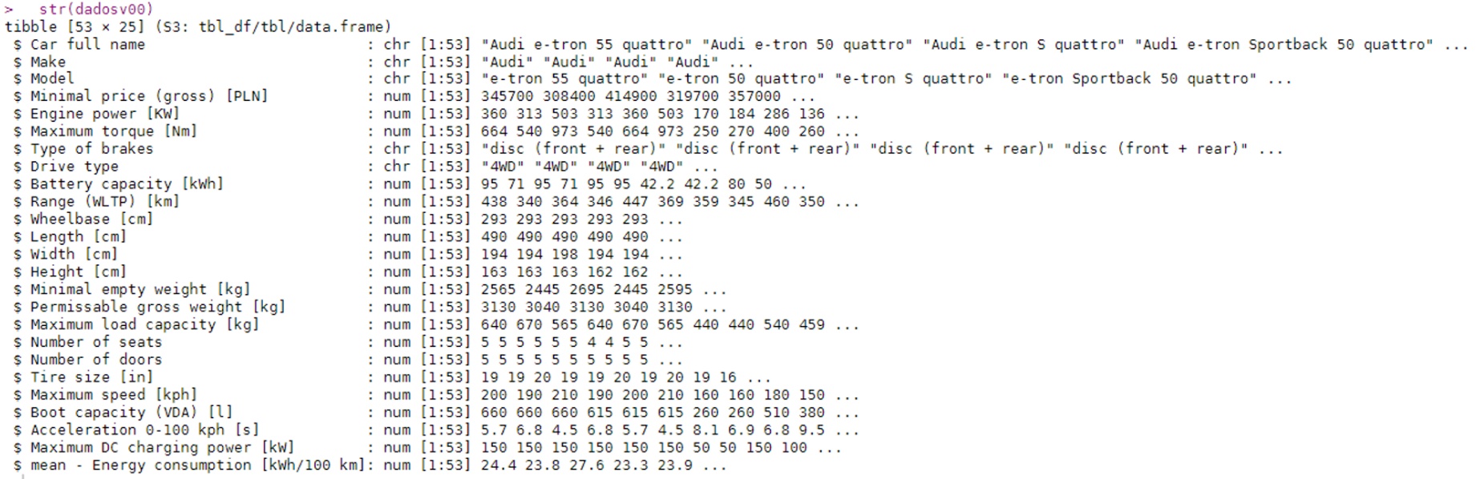
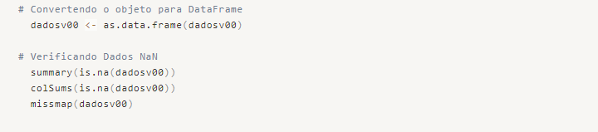
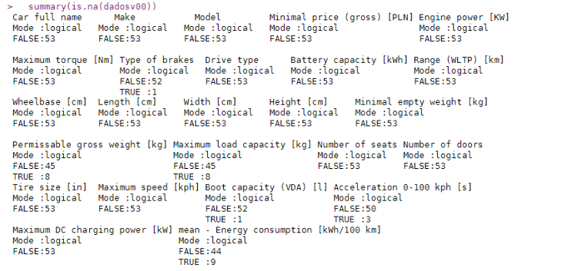
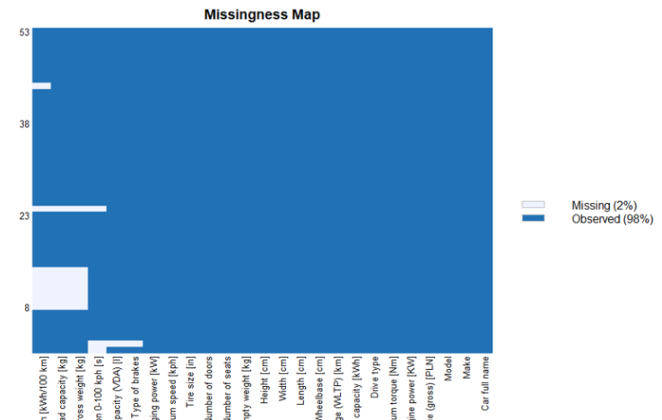
We have some empty rows in the dataset, specifically in the Average Consumption column, which is our target variable. We will simply remove these incomplete data to avoid biasing the prediction error during our predictive modeling. We could have applied some imputation technique, but for now, we will proceed without the incomplete data and see what results we can achieve.
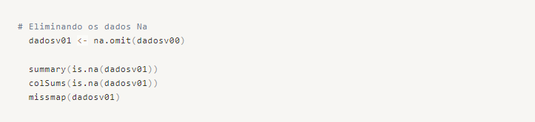
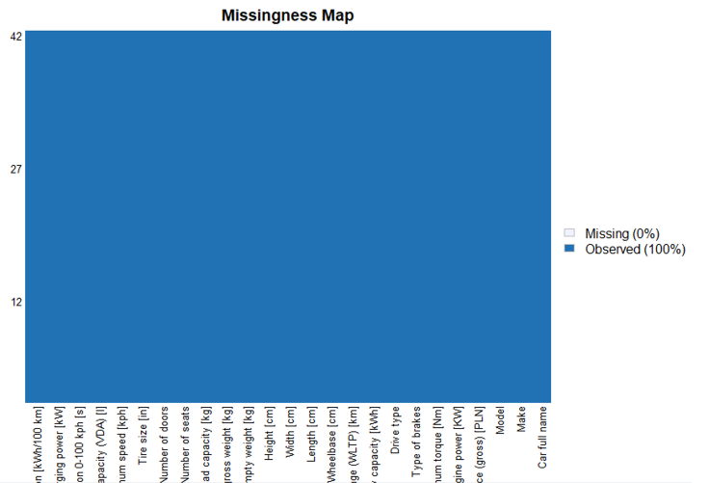
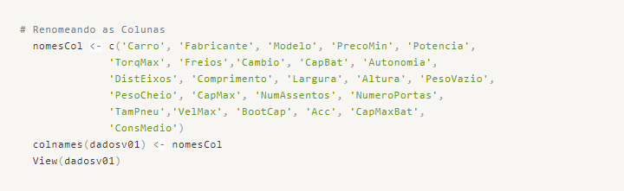
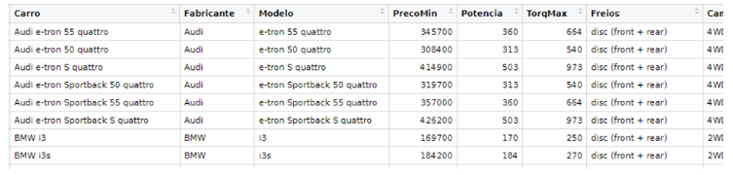

Performing Label Encoding of Categorical Variables
As we intend to create a regression model, we need to identify which categorical variables we will transform into numerical ones.
We have the following categorical variables: Manufacturer, Brakes, and Transmission. We will discard the Model and Car variables as they are not relevant to the analysis of the target variable, as instructed by the business area.
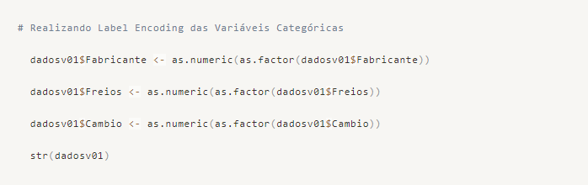

Manufacturer Variable Dictionary
- Audi = 1
- BMW = 2
- Citroen = 3
- DS = 4
- Honda = 5
- Hyundai = 6
- Jaguar = 7
- Kia = 8
- Mazda = 9
- Mercedes-Benz = 10
- Mini = 11
- Nissan = 12
- Opel = 13
- Peugeot = 14
- Porshe = 15
- Renault = 16
- Skoda = 17
- Smart = 18
- Volkswagen = 19

Brake Type Variable Dictionary
- Four-wheel Disc Brakes = 1
- Front Disc Brakes and Rear Drum Brakes = 2

Drive Type Variable Dictionary
- 4WD = 3
- 2WD(rear) = 2
- 2WD(front) = 1

Saving Modified Dataset to Disk
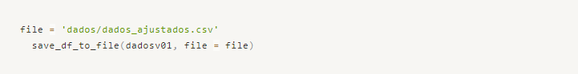
At this point, we are ready to begin our exploratory analysis and prepare our dataset for building the Machine Learning models.

Exploratory Analysis
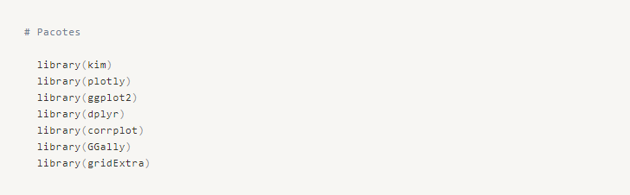
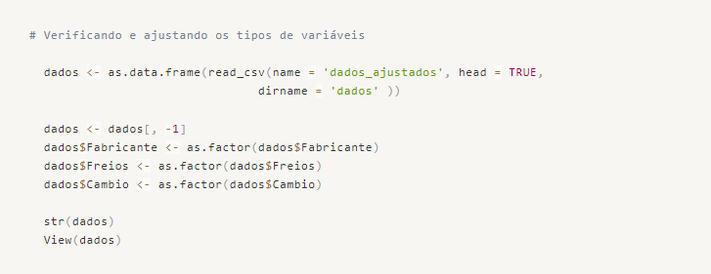
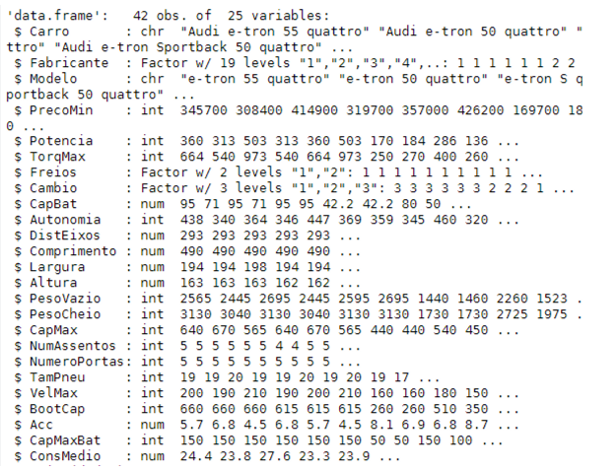

We started our Exploratory Analysis by examining a general summary of the data. However, since we have many variables, it is more practical to analyze them separately: Numerical Variables, Categorical Variables, and the Target Variable.
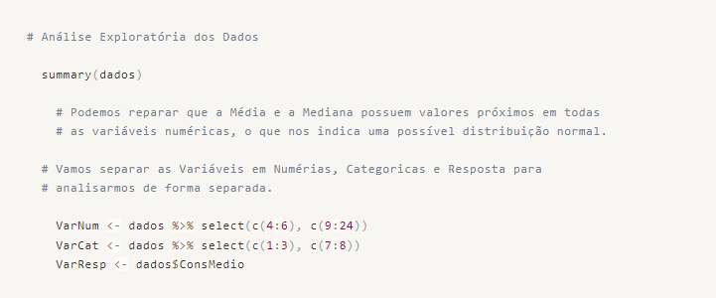

Analysis of the Target Variable
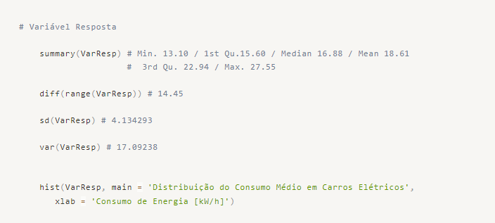
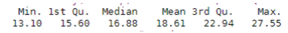

Right from the start, we notice that the median is lower than the mean of the data, indicating that our distribution is right-skewed (positively skewed). This means that the tail of the distribution extends towards higher values.
The maximum range distance is 14.45, as we can verify:
This indicates that the largest difference between the models does not exceed 15 kWh in consumption.
Our standard deviation is 4.13 kWh, and the variance is 17.09.
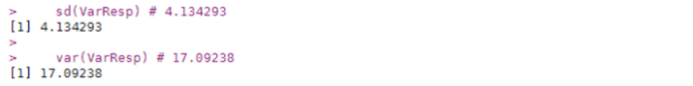
We can observe the issue of Skewness in the histogram below:
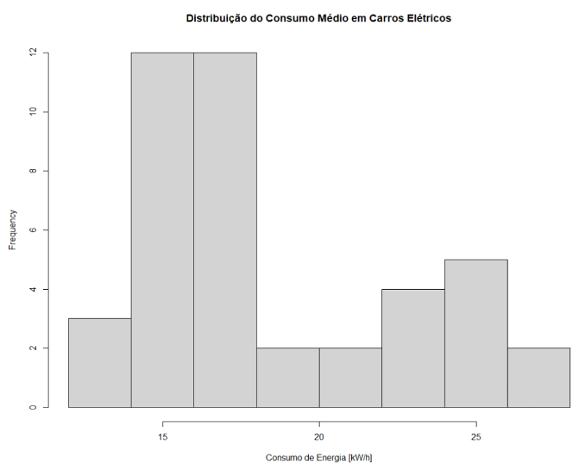
We have some outliers, indicated by values significantly higher than the median of the data. We can further observe this by constructing a boxplot.
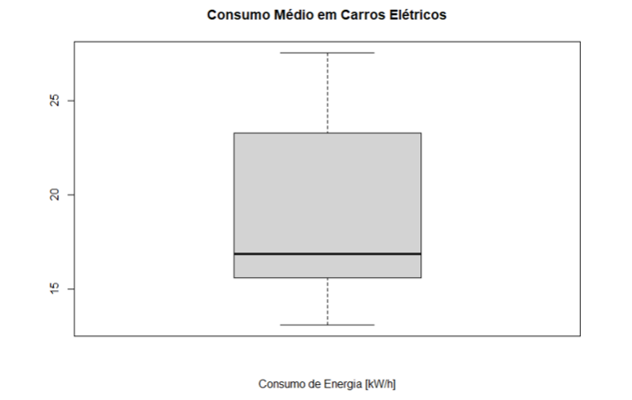

We observe that we do not have any outliers, thus maintaining the data with a reasonable pattern for analysis.
We cannot claim that the data follows a normal distribution, but we can perform a Shapiro test to check for normality in the data distribution.
• H0 → We consider the data to be normally distributed.
• H1 → We cannot consider the data to be normally distributed.
◦ If the p-value is greater than 0.05, we cannot reject H0.
◦ If the p-value is less than 0.05, we reject H0.
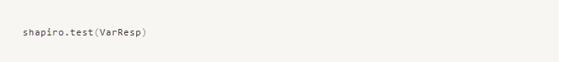
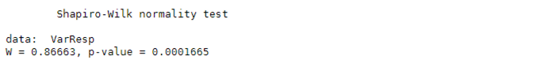
We can observe that the p-value is less than 0.05, indicating that we cannot consider the data of the target variable to follow a normal distribution. Therefore, we reject H0.

Analysis of Numerical Variables
Initially, let's examine a summary of each variable:
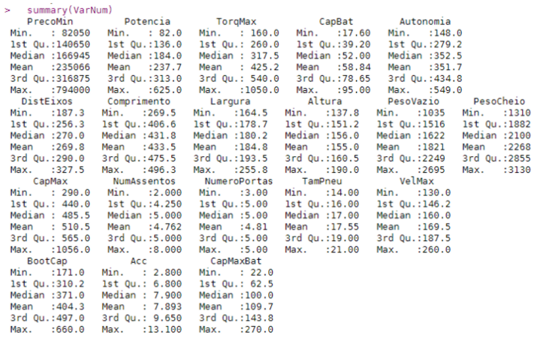
Let's visually analyze a multi-histogram:
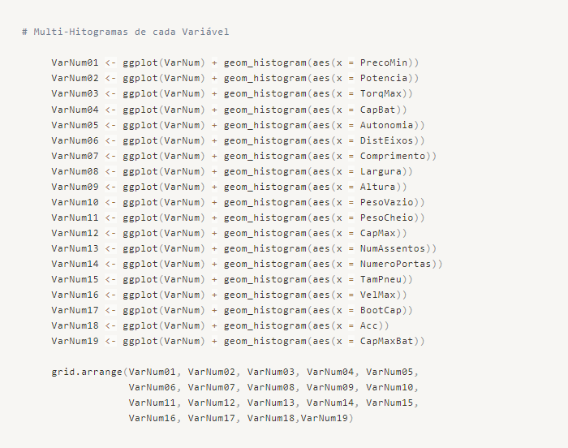
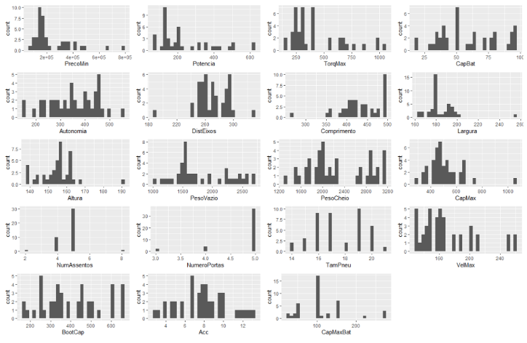
We notice that in our dataset, we have cars from different categories, despite having the same propulsion fuel. Therefore, it is a mixed dataset that does not condition the category of the vehicles. It might be interesting to obtain more data on vehicles and categorize them (label them) so that we can analyze them separately. We can support this statement when we look at extreme data points in Maximum Torque, Engine Power, Minimal Price, Battery Capacity, and Maximum Speed.
Another important point for our analysis is to identify how the variables relate to each other and to the target variable. We will perform a correlation analysis to identify issues such as multicollinearity.
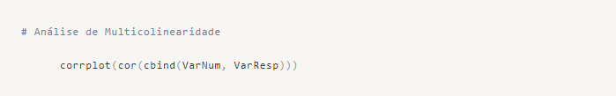
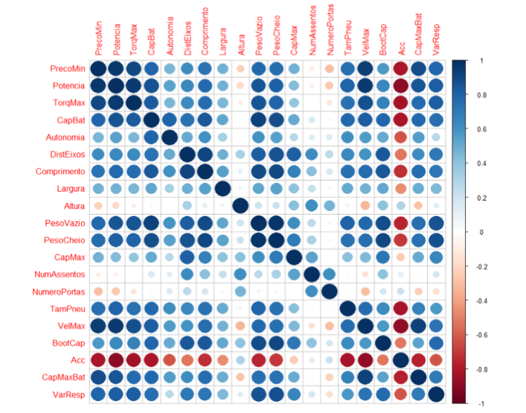
We can identify an excessive correlation between several variables, which can potentially cause confusion during our predictive modeling. Correlations such as Weight/Power and Wheelbase/MaxLoad are relatively obvious from a business standpoint. However, when observing our target variable, we can see high correlations with variables such as Price, Power, Max Torque, Battery Capacity, Empty Weight, Gross Weight, Boot Capacity, and Acceleration. Nonetheless, we will use a linear regression algorithm to help us better select our variables.
To analyze the correlation between variables more effectively, let's create a multivariate plot.
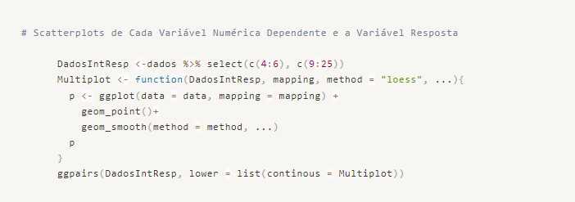
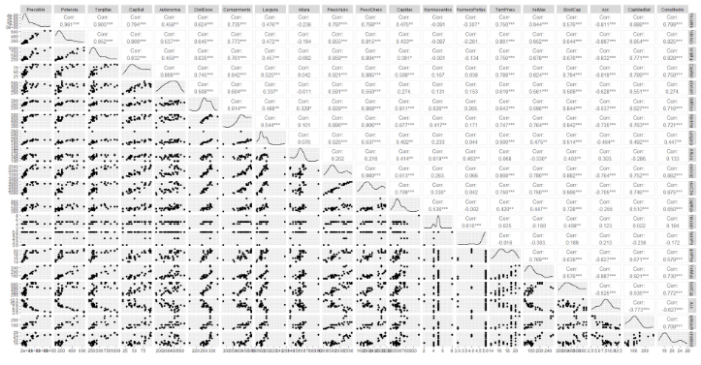

Analysis of Categorical Variables
Let's ignore the manufacturer for now, as it doesn't seem to be relevant since we have 19 manufacturers for 43 observations, which does not provide us with a reasonable sample size to analyze from that perspective.
We will begin by analyzing the proportions of data for each factor in the Brake and Transmission variables.
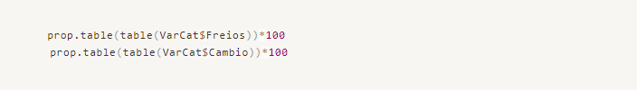
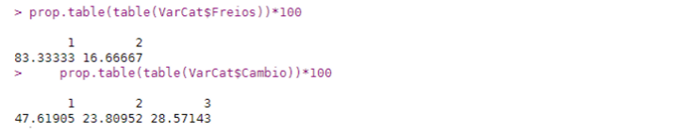
We can see that we have a lot more data for cars with four-wheel disc brakes than for cars with only front disc brakes.
We can also observe a certain balance in the transmission variable, which is better for our predictive model.
Let's analyze the energy consumption for each variable type by calculating the average for each category.
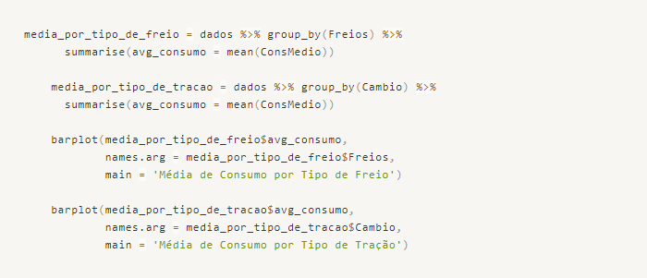
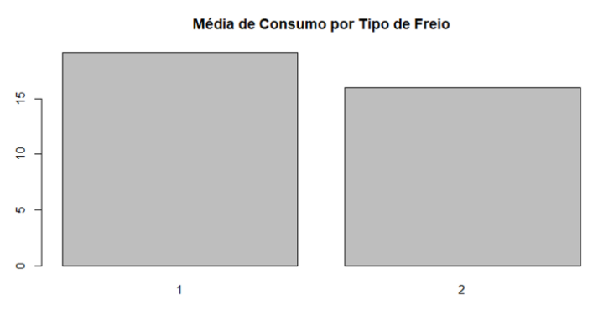
We can clearly see that cars with front and rear disc brakes have higher energy consumption per hour. Here, we are not observing causality, but simply noting the fact that cars with this characteristic, on average, consume more electrical energy.
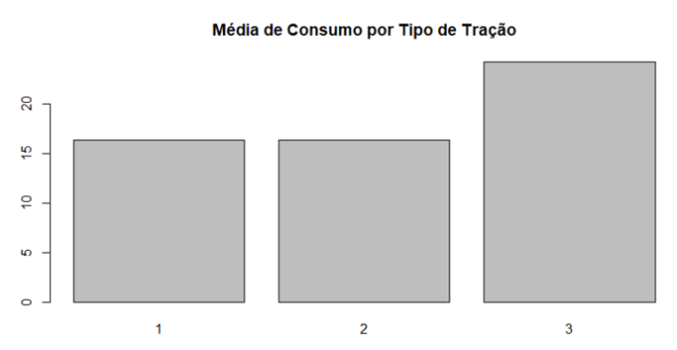
In this variable, we can observe that cars with 4-wheel drive have higher energy consumption. This is directly related to the nature of the 4WD transmission, as it requires energy to be delivered to all four wheels to provide traction, resulting in a higher energy usage compared to just two wheels.
However, an interesting finding is that the average consumption is very similar between cars with front-wheel drive and rear-wheel drive.
We have concluded our Data Exploration phase and are now ready to proceed with the Preparation stage for building the predictive model and addressing the defined business problem.

Data Preprocessing
In this stage, we will apply Feature Selection and determine which variables we will consider for the construction of our Base Model. The rule here is to find a good model efficiency, keeping it as simple as possible.
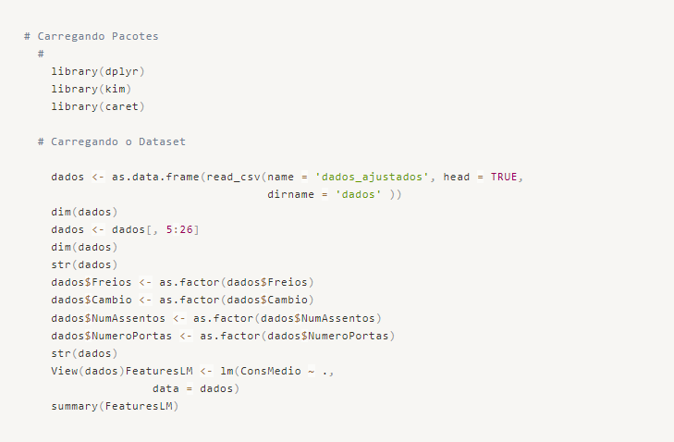

Feature Selection
We will use a simple linear model with all variables to determine which variables are most significant in explaining our target variable.

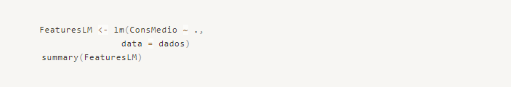
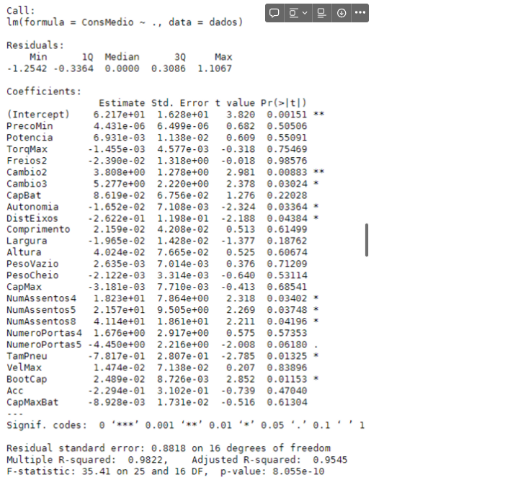
We can see that Range, Transmission, Wheelbase, Number of Seats, Tire Size, and Boot Capacity are statistically significant for our model. The metrics show that with an Adjusted R² of 95.45%, we can conclude that our model can explain 95% of the variability in the mean consumption based on the listed variables.
However, this information may indicate that our model is overfitting, meaning it is overly trained and not very generalizable. Nevertheless, the purpose of this model was solely to identify the most important variables, which it served perfectly.
An important observation we made is that the data is on different scales, which could affect the outcome of the model's identification of the most important variables. Therefore, we redid the model with normalized data. We used a MinMax function to scale all the variables to the same range.
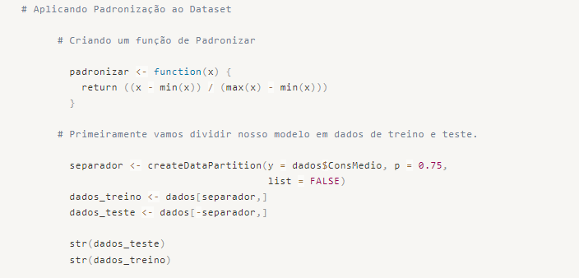
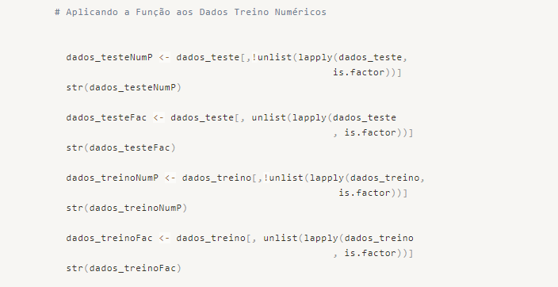
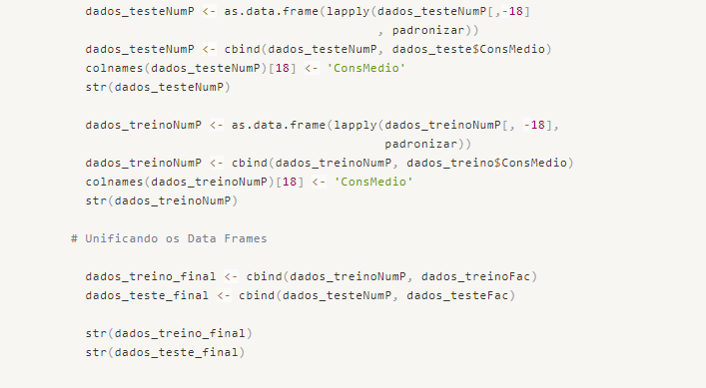
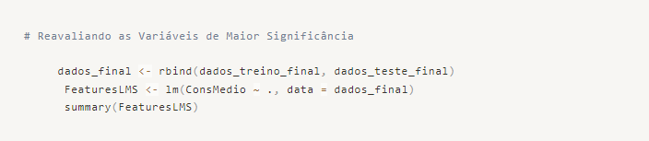
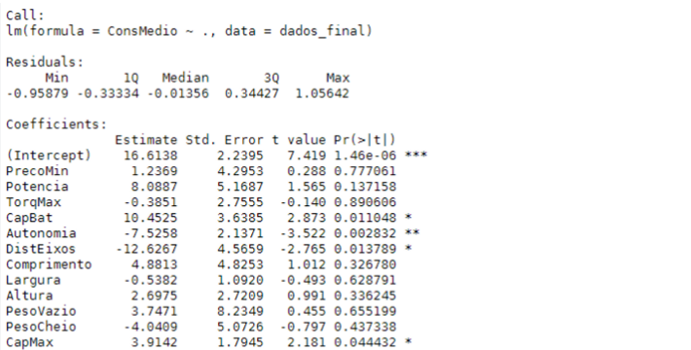
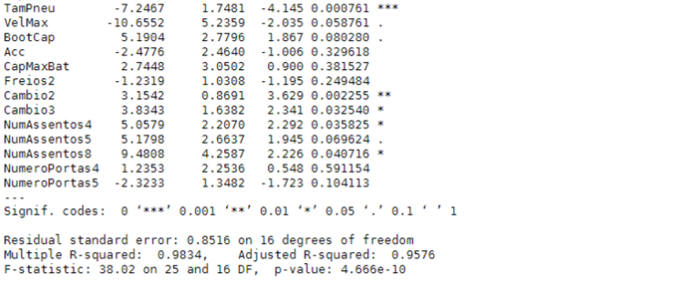
So we have a similar adjusted R² value, but with different variables. Therefore, we will consider the following variables: Battery Capacity, Range, Wheelbase, Maximum Load Capacity, Transmission, and Number of Seats.
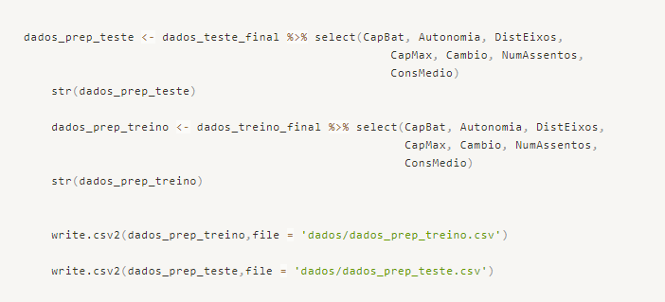

Predictive Modeling
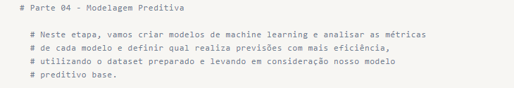
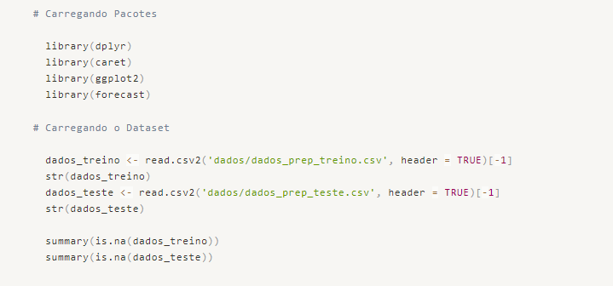

Building the Base Model and Analyzing the Result

Base Model
Let's construct the base model using the lm() function from the base utils package in the R language. This function allows us to fit a linear regression model to our data.
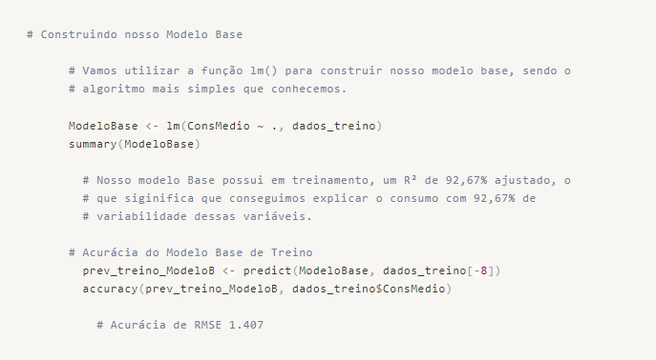

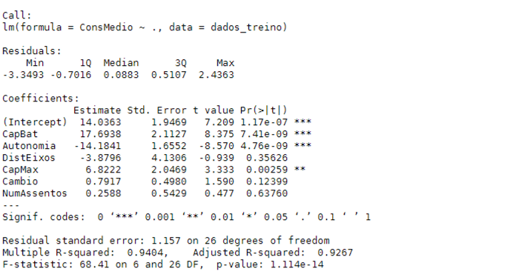
Our base model, in training, has an adjusted R² of 92.67%, indicating that we can explain 92% of the variability in average consumption using the independent variables. This is a good value for the metric, as well as the accuracy of the base training model with an RMSE of 1.027.
Let's make predictions on the test data and analyze the residuals.
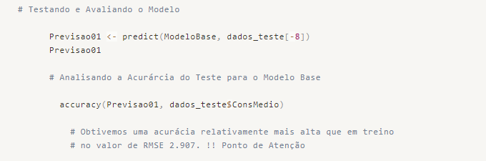

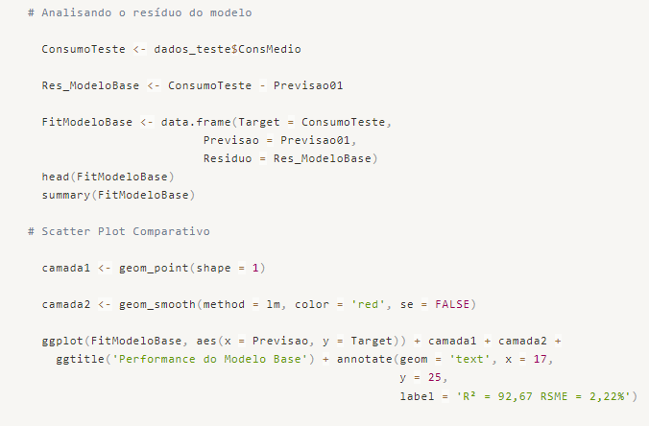
We can see that the residuals have a mean close to zero and a small range between the minimum and maximum values. Let's visualize the regression graphically.
As a result, we have excellent accuracy and few errors compared to the measured results in the test set.
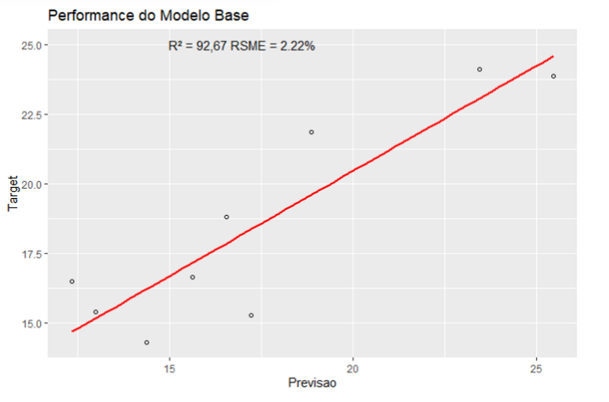

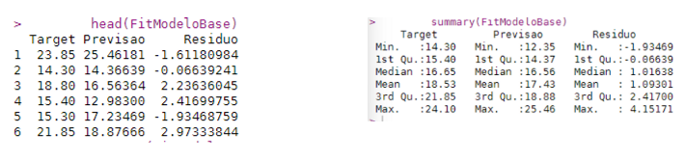

Model V02
For model V02, we will change the algorithm but still use the regression method. We will use the Caret package with the 'lm' method.
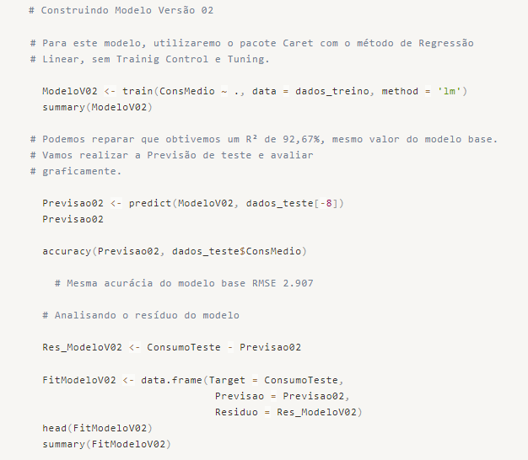
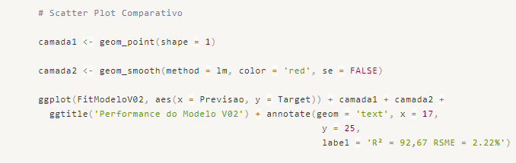
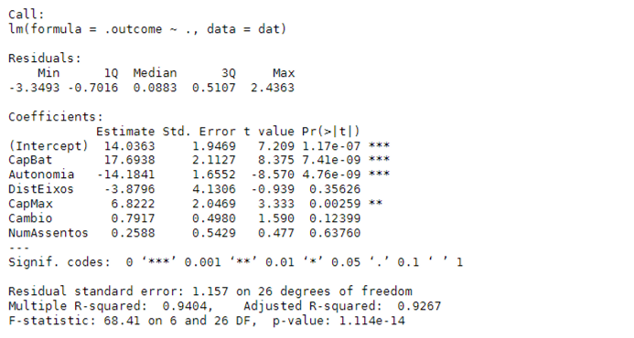
Notice that by simply changing the package, we didn't observe any difference in the results.
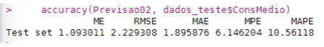

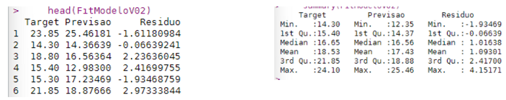
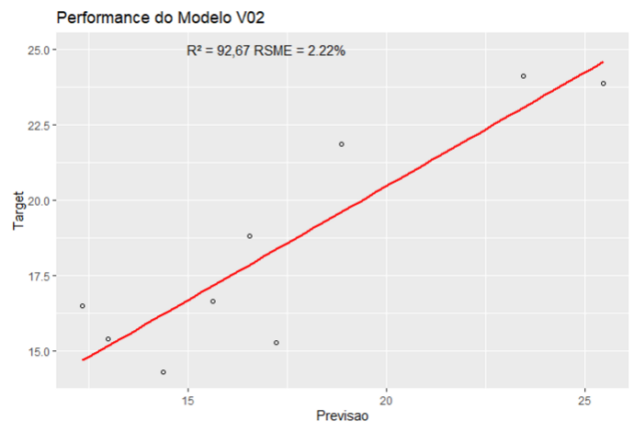

Model V03
For this model, we will change the linear regression method to Boosted Linear Regression.
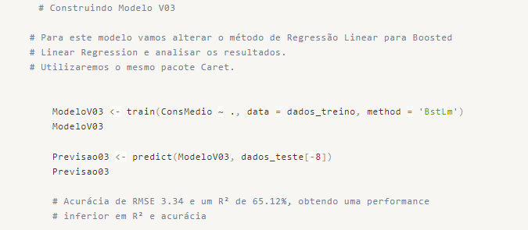
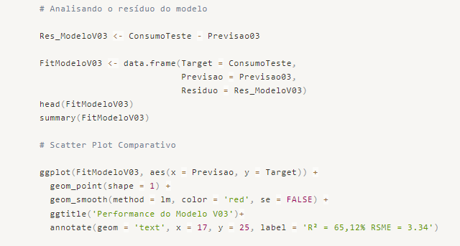
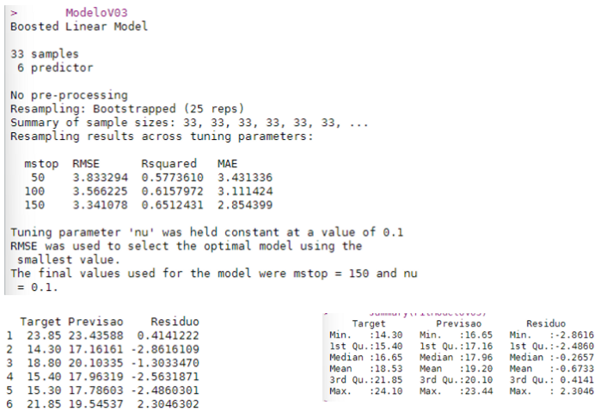

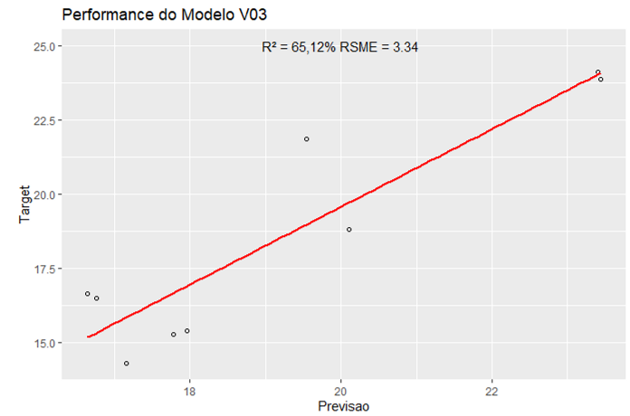

In this model, we achieved an R² of approximately 65.12% with 25 repeated cross-validations. In this method, we performed multiple iterations with smaller samples of the dataset and identified the one with the lowest RMSE and consequently the highest R². However, we obtained a worse result than in our Base Model.

Model V04
For this model, we will use another method from the Caret package called "glmnet".
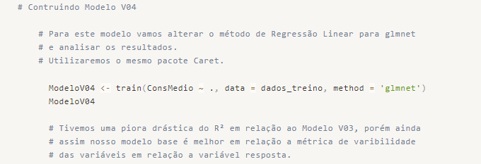
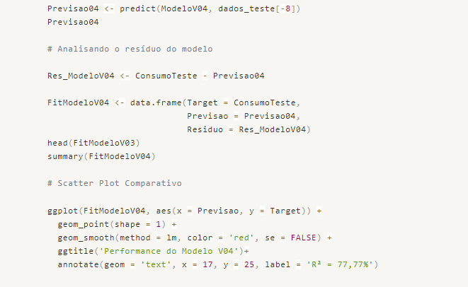
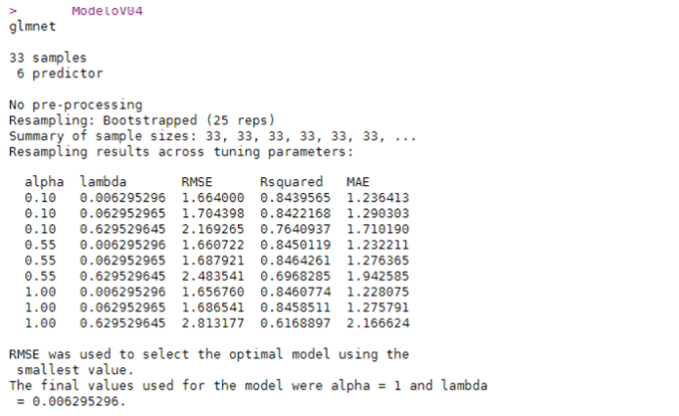

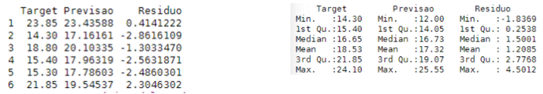
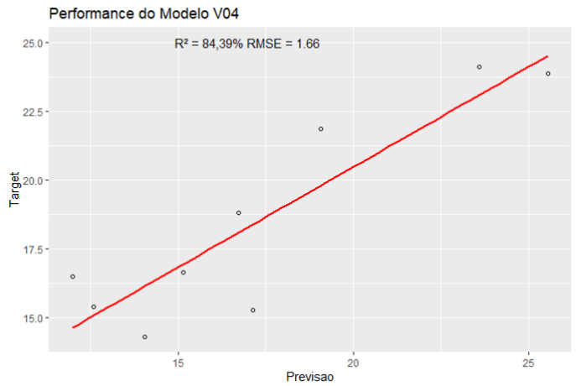
We have achieved an R² of 84.39% in this model, which represents a significant improvement compared to Model V03, although it is still lower than our baseline model. However, the model has a better accuracy of 1.66.

Conclusion
In conclusion, we have completed our work and identified Model V04 as the most suitable for making predictions for the business area. It showed improved performance in terms of metrics and generated residuals compared to previous models.
It is important to note that any new data to be applied to the model's variables must be treated in the same way as during the preprocessing process. This includes removing outliers, handling missing values, and normalizing the data to ensure consistent scaling.
We conclude the project with this report, which includes a description of the script implemented in the R programming language.

