Association Rules and Repurchase Prediction for Online Supermarket using Market Basket Analysis and Machine Learning
Whether you shop with meticulously planned shopping lists or let whims guide your steps, our unique shopping rituals define who we are. Instacart, a grocery ordering and delivery app, aims to make filling your fridge and pantry with your favorite personal items and essentials as easy as can be. After selecting products through the Instacart app, shoppers review your order, do the in-store shopping, and deliver your items right to your doorstep.
The Instacart Data Science Team plays a crucial role in delivering this delightful shopping experience. Currently, they utilize transactional data to develop models that predict which products a user will reorder, which they will try for the first time, or which they will add to their cart during a session. Recently, Instacart made this data openly available, and you can find the download link below.
In this Data Science project, you will use this anonymized data on customer orders over time to predict which previously purchased products will be in a user's next order.
We will be using the R language and Market Basket Analysis packages provided by the language. The dataset download link can be found at:
https://www.kaggle.com/competitions/instacart-market-basket-analysis

Business Problem Details for Instacart
Instacart expects the Machine Learning Community to use the data to test models that predict which products customers will buy again, try for the first time, or add to their cart during their next visit.
Currently, Instacart uses XGBoost, Word2Vec, and Annoy for similar data production, aiming to offer customers "Buy Again" items and recommend others for their new purchases.
These data and the trained algorithm are providing Instacart with a way to revolutionize the shopping experience and discover new products for its customers.
Therefore, our objectives will be:
- Part 1 - Define the Top 10 Business Rules for the Listed Products
- Part 2 - Predictive Modeling to Classify Product Re-purchases

The Data
The provided data is intended for non-commercial purposes and can be downloaded from Kaggle as highlighted.
Let's detail the data dictionary for each file:
- orders.csv
  - order_id → Order Identification
  - user_id → Consumer Identification
  - eval_set → Order Value Class
    - "prior" → Class to define working data and perform exploratory analysis
    - "train" → Class to define model training data
    - "test" → Class for model deployment
  - order_number → Order Number for the Consumer (1 = First Order, n = Sequential Orders)
  - order_dow → Day of the week the order was placed
  - order_hour_of_day → Hour of the day the order was placed
  - days_since_prior → Days since the last order, based on a 30-day scale (NA's for the first order)
- products.csv
  - product_id → Product Identification
  - product_name → Product Name
  - aisle_id → Foreign Key
  - department_id → Foreign Key
- aisles.csv
  - aisle_id → Aisle Identification
  - aisle → Aisle Name
- departments.csv
  - department_id → Department Identifier
  - department → Department Name
- order_products_SET.csv
  - order_id → Foreign Key
  - product_id → Foreign Key
  - add_to_cart_order → Order in which the product was added to the shopping cart
  - reordered → 1 for a product that has been purchased in the past, 0 for first-time purchase

Scripts
We have 3 R scripts for this project:
- Projeto_07-Juncao_Arquivos_Dataset.R → Works on merging all separate datasets into a single loading file.
- Projeto_07-Parte01_Regras_de_Associacao para_Supermercado_Online.Rmd → Exploratory Data Analysis to understand customer behavior regarding products. Here, we provide Association Rules using Market Basket Analysis.
- Projeto_07-Parte02_Previsao_de_Recompra para_Supermercado_Online.Rmd → Data preprocessing and Machine Learning Model Building for repurchase prediction.

Building the Complete Dataset
Our first task is to merge the datasets using their respective primary and foreign keys for each table.
The code used for this task is detailed below.

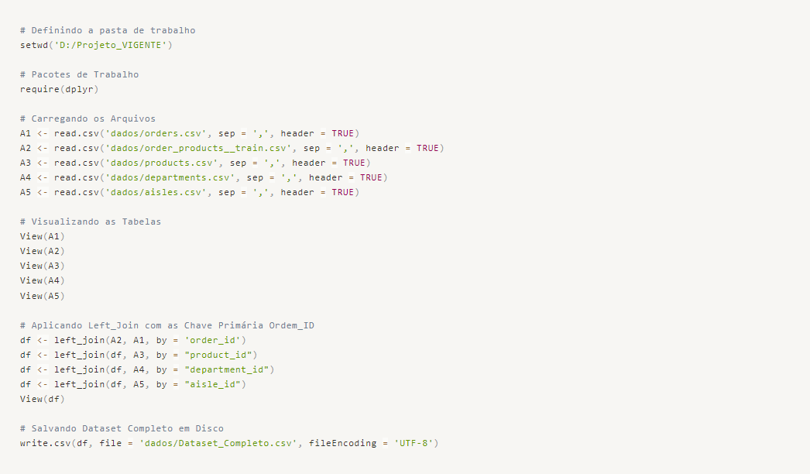
We finish by saving the dataset to disk for future loading.

Part 1 - Association Rules - Market Basket Analysis
We have 1.3 million observations in the complete dataset. We will work with the full dataset for this process. However, for the construction of the predictive model in the second part of the project, we will use a smaller sample of observations due to computational limitations.

Work Packages
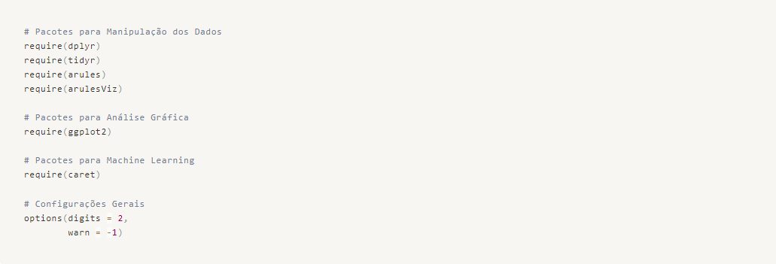

Data Loading
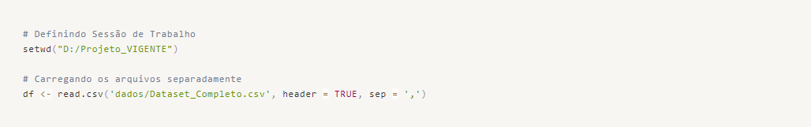

Data Cleaning and Organization
In this step, we will analyze if the data has been loaded correctly, check for any misclassifications of data types, identify missing data, and ensure that the data organization meets our working expectations.
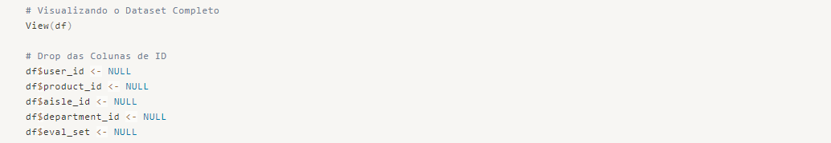
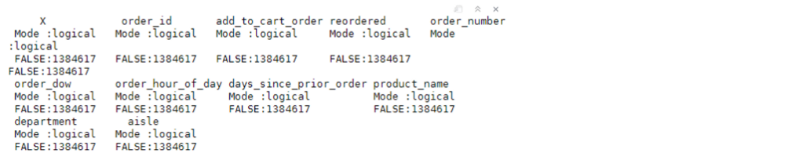
As we can see in the table above, there are no NaN values, so we can proceed with the organization and definition of variable types.
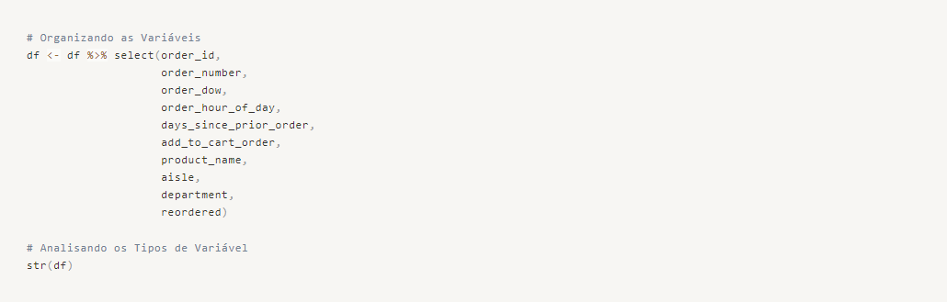
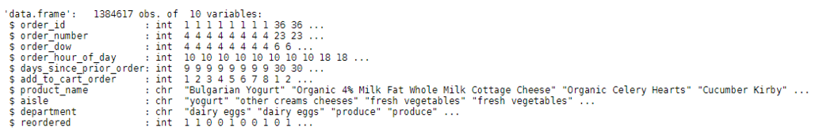
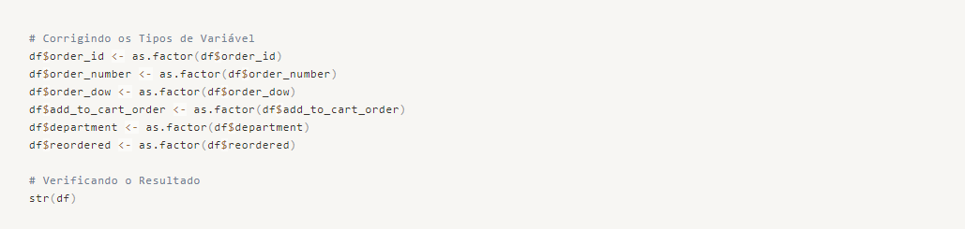
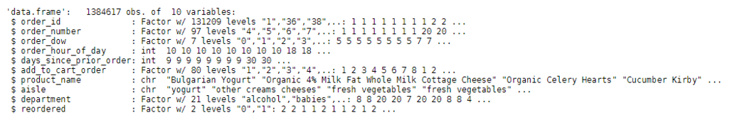
Perfect! We can proceed to Exploratory Data Analysis (EDA).

EDA - Exploratory Data Analysis
First, let's separate the data into numerical and categorical variables. This will allow us to apply specific techniques to each type and gain as much relevant knowledge as possible.
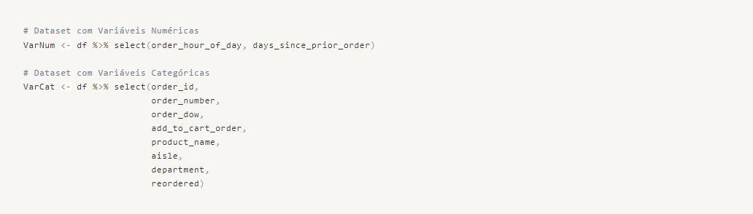

Numerical Variables
We begin by calculating central tendency and position measures.
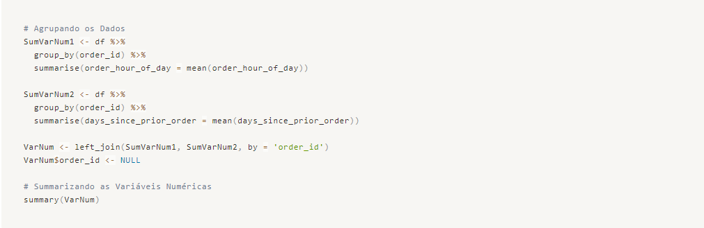
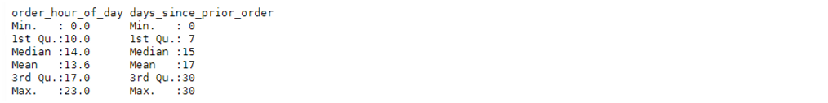
Insight: On average, orders are placed around lunchtime, at around 1:00 PM. There is also a close proximity between the mean and median, indicating a normal distribution for this variable.
Insight: When looking at the days since the first order, we can observe that on average, it takes about 7 days, but the median is close to 11 days. This indicates that we have a large number of data points on the left side of the distribution curve, which pulls the mean below the median.
Let's visualize this information graphically.

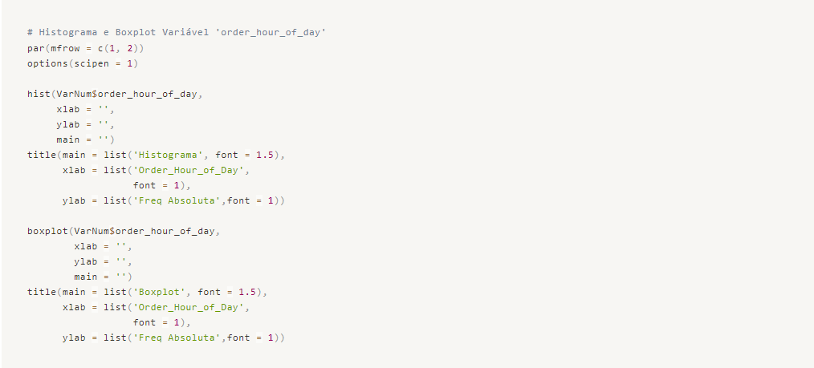
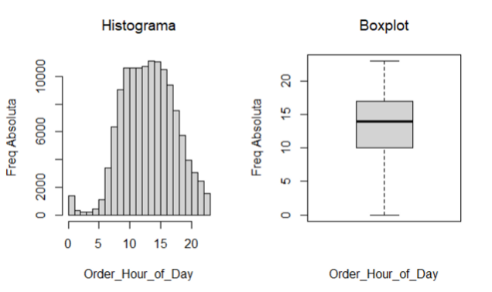

Insight → We can observe that customer purchasing behavior occurs between 9:00 AM and 3:00 PM, where we need greater server capacity to handle the influx of accesses. For marketing and pricing, it's important to develop flash promotions during off-peak hours to relieve congestion during peak hours. At the same time, the infrastructure team should take actions to ensure high throughput during peak hours.
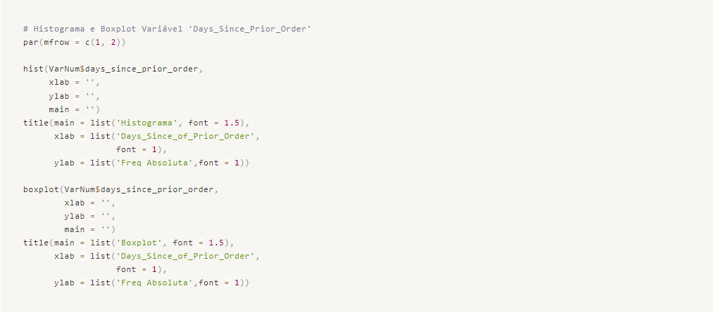
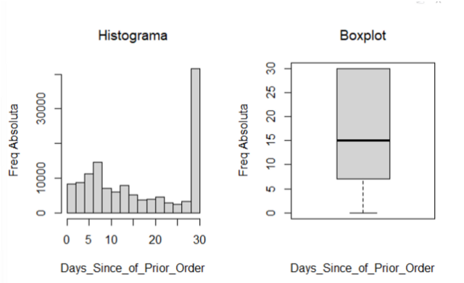

Insight → We have many products with sales occurring after 30 days, which indicates a more monthly consumption behavior, where customers typically make purchases once a month for the most part. However, we can also observe in the same graph that weekly behavior is present, represented by the bars between 1 and 10 days. Creating a flow of promotions or customer engagement to encourage weekly behavior can increase revenue by providing more opportunities to delight customers with additional products they may not have initially planned for.
To conclude our analysis of individual numerical variables, let's visualize the standard deviation.

Categorical Variables
In this step, we will analyze the absolute and relative frequencies of each variable, understanding how many observations occurred in each class within each variable.
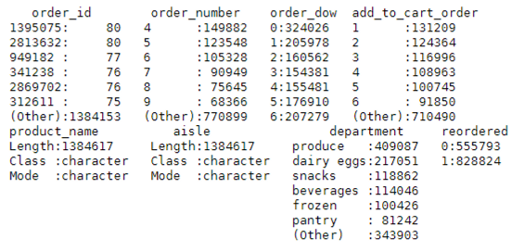

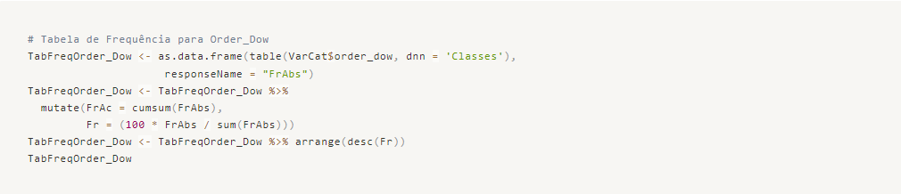
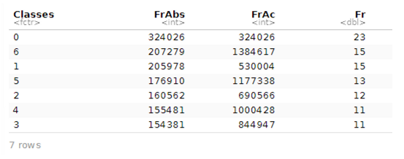

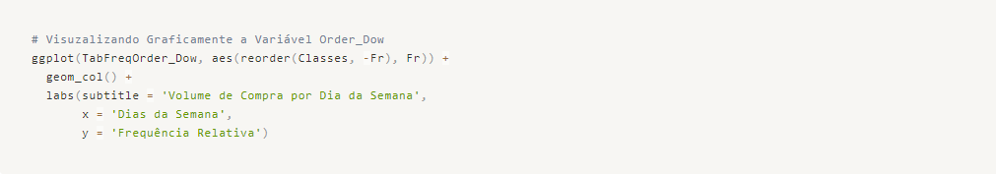
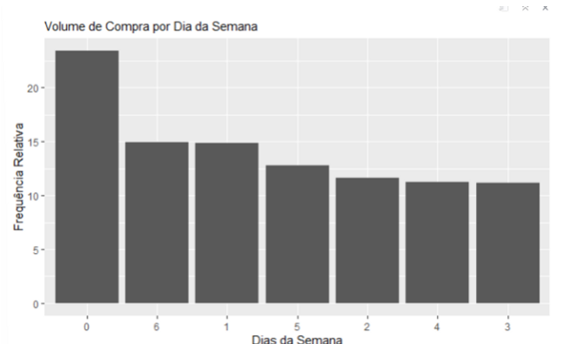

Insight → Clearly, Sunday shows a higher volume of purchases, followed by Saturday and Monday. This may indicate the need to create promotions on the other days of the week to increase order flow.
As we saw in our summarization, the Add_To_Cart_Order variable has over 50% of the observations distributed across 6 classes. Let's visualize this point graphically!
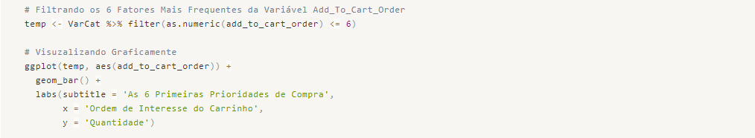
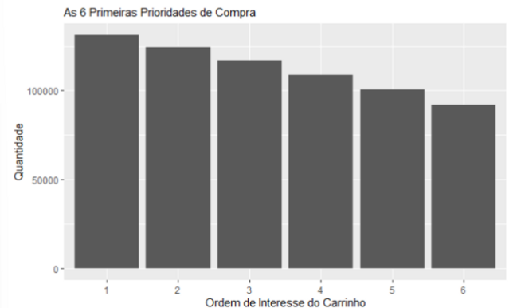

Insight → We can see that 50% of the order volume is concentrated in the first 6 positions of the cart. We can understand that these products are priorities for people, and we should analyze possible opportunities for margin adjustment. We can renegotiate with suppliers and apply higher prices since the demand is evident.
Let's visualize the best-selling products, as well as their departments and aisles.
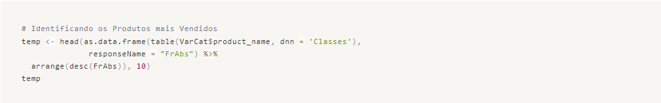
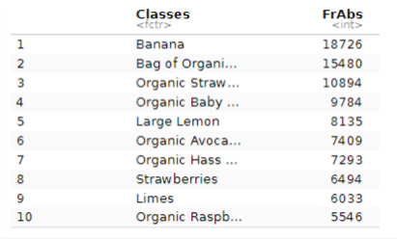

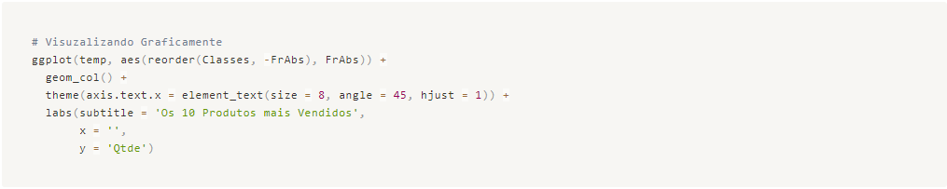
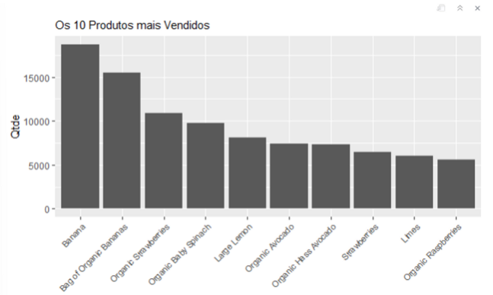

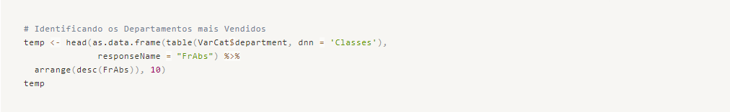
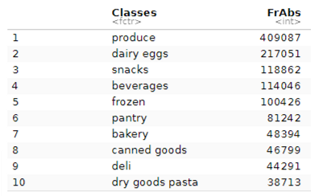

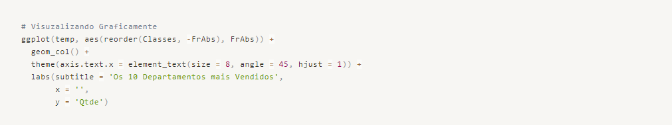
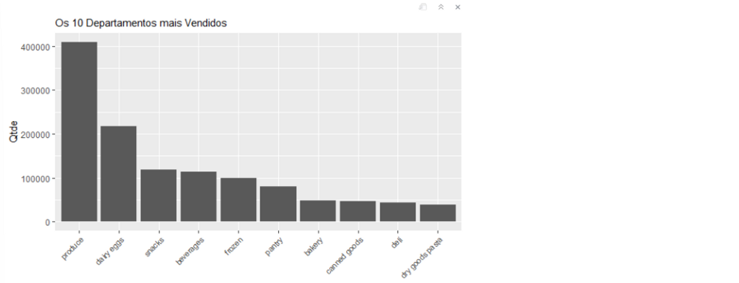

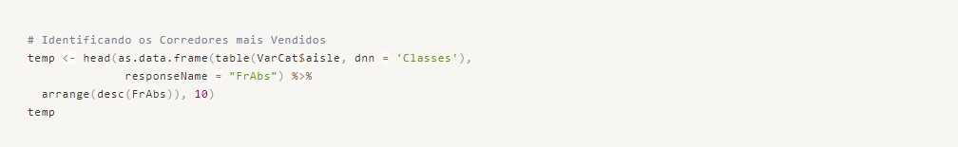
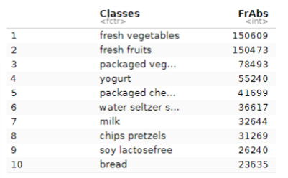

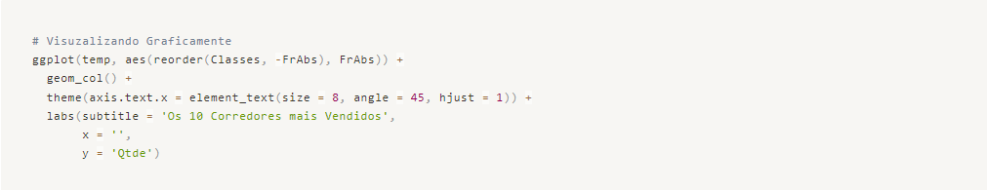
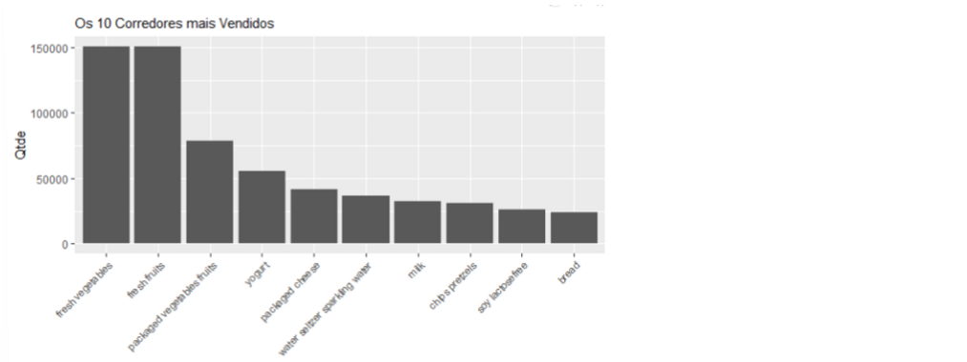

Insight → We have the highest sales volume for Fresh Fruits and Vegetables, with Bananas, Strawberries, Spinach, and Lemons being the top products. An opportunity to expand the product portfolio could be to offer derived products from these fresh items, such as fruit salads, tropical salads, and baked goods.
Let's cross-reference some information and answer some business questions regarding customer behavior.

Targeted Questions
Which Products and Departments are purchased during peak hours of 12:00-14:00?
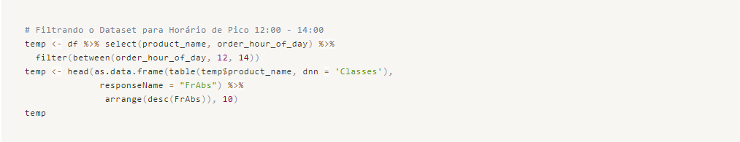
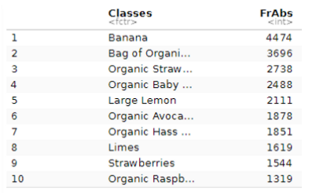

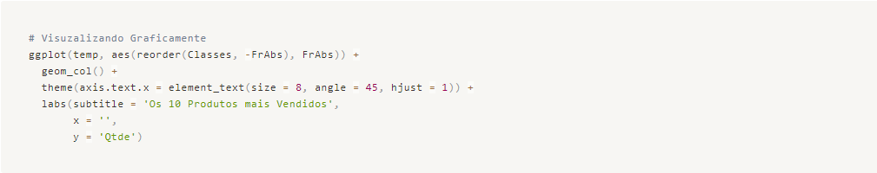
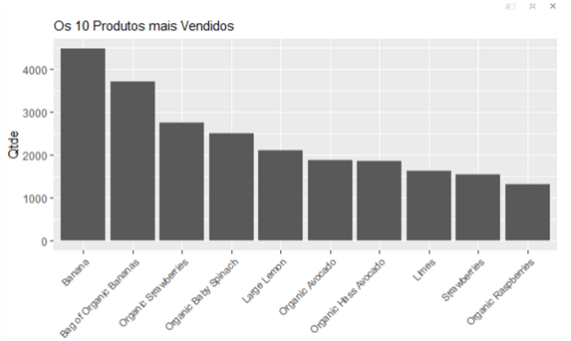

Insight → We can observe that the products we had previously highlighted as sales leaders are repeated, indicating the same consumption pattern.
What are the products in position 1 and position 50 in the cart?
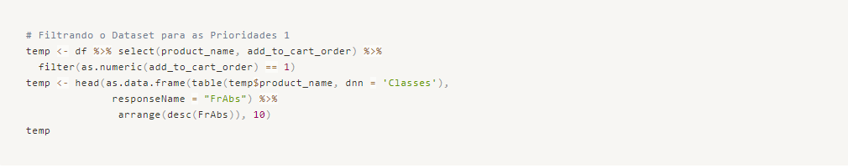
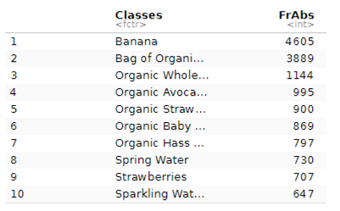

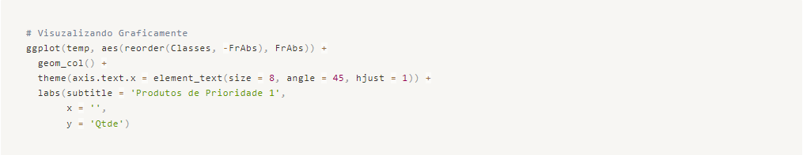
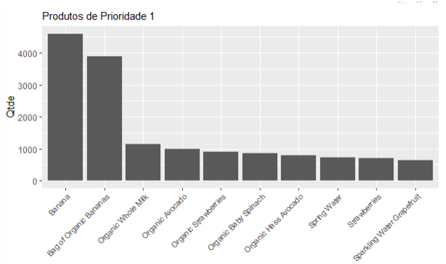

Insight → We would like to highlight to the Marketing and Pricing team that the products in position 1 in the customers' shopping carts are: Banana, Whole Milk, Avocado, Strawberries, and Spinach (all organic, which shows a clear characteristic of customers being concerned about consuming healthier products).
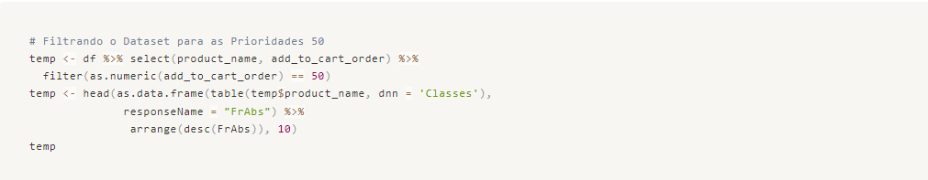
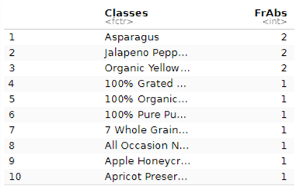

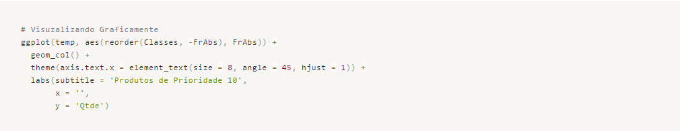
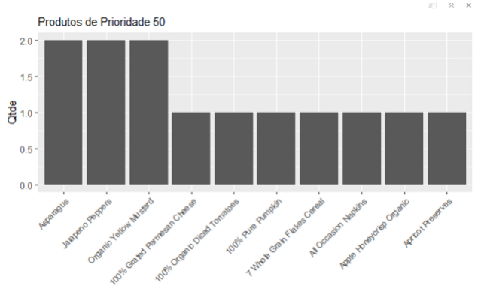

Insight → We can see that for products with lower priority in consumption, we have Asparagus, Peppers, Mustard, Diced Tomatoes, Parmesan Cheese, and Pumpkin. These are more specific products that can be analyzed and possibly reduced in future purchases with suppliers, for example. Finding a balance between stock and purchase price is important.
What are the products and departments with repurchase after 30 days? And after 10 days?
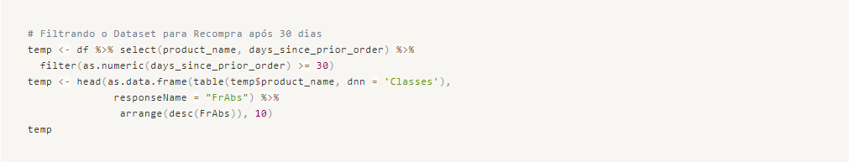
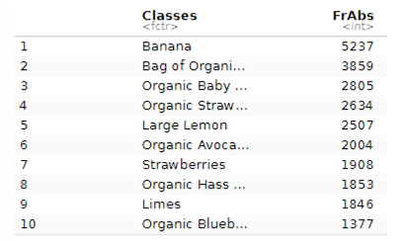

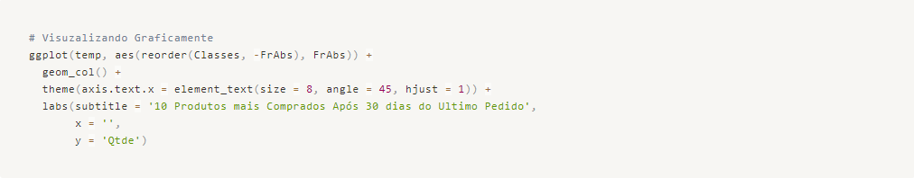
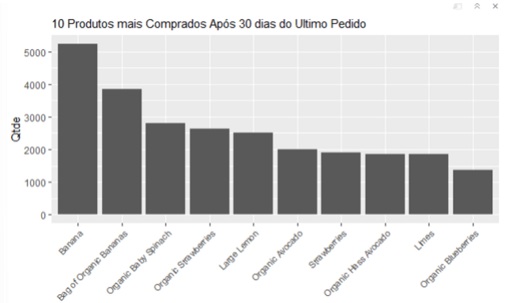

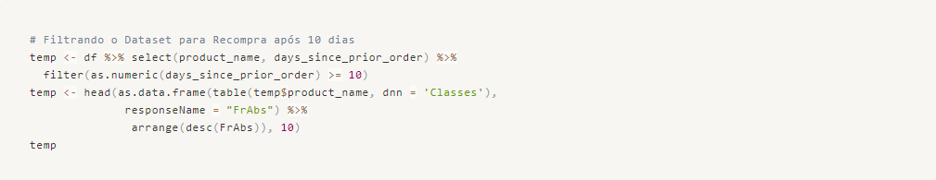
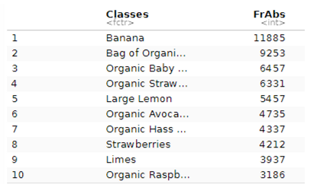

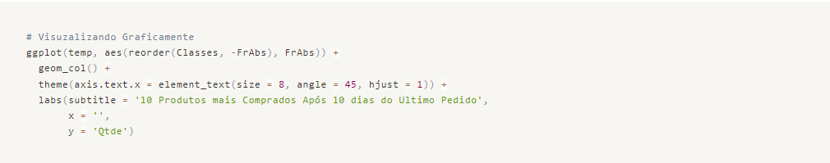
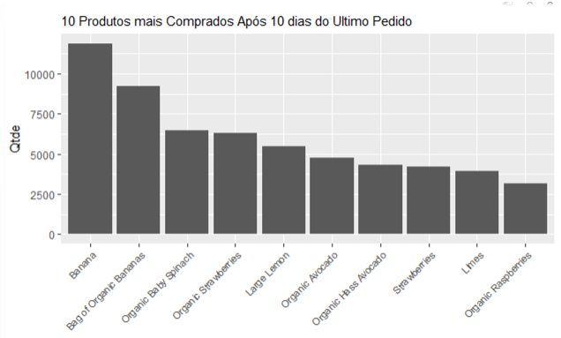

Insights → The products are repeated after 10 and 30 days, confirming the monthly and weekly purchasing behavior of customers as we discussed in another insight.
As we can see, in different scenarios, the products tend to repeat frequently, with Bananas, Organic Bananas, Avocados, and Spinach being recurring products in customers' purchasing behavior.
To conclude our exploratory analysis, let's examine how the numeric variables relate to each other and if there is any correlation among them.
There is virtually no correlation among them. In other words, the time of day does not influence the weekly or monthly purchasing behavior of consumers.
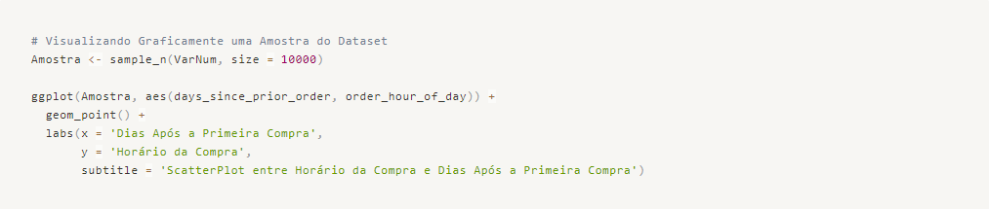
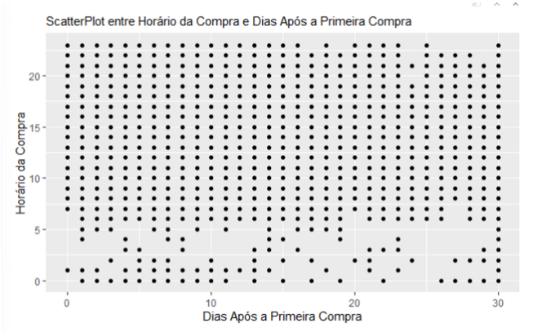

Insight → Once again, we have an opportunity here! If we create more flow and opportunities for good deals for customers at specific times and every 5 days, for example, we would have a more even distribution of sales behavior and could balance purchase orders over time. This would result in a more consistent revenue and smoother inventory control, reducing waste and increasing employee productivity.
We have completed our Exploratory Data Analysis. Let's now proceed with our work on Recommendation Rules using Market Basket Analysis.

Association rules with Market Basket Analysis
To apply association rules, the dataset needs to be prepared as if each row represents a transaction receipt and each column represents an item within the receipt. We will apply 6 items, respecting the order of priority in placing them in the cart, thus representing the customers' preferences in the dataset.

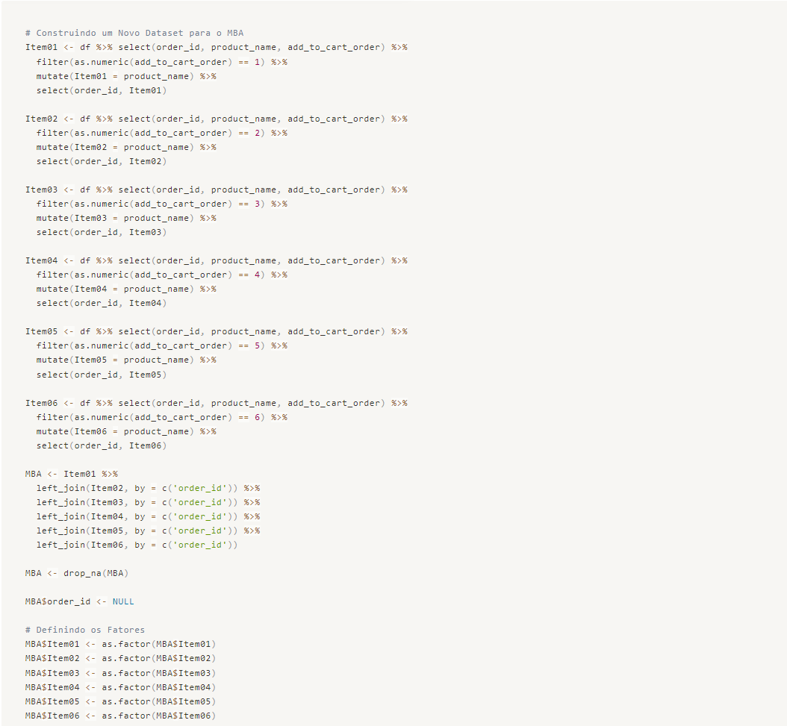
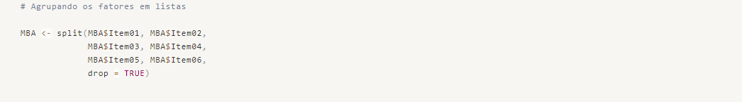
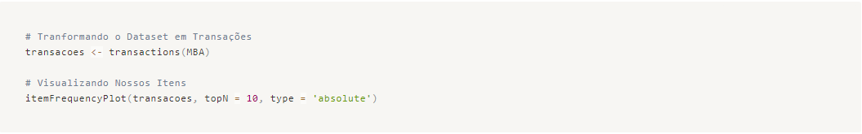
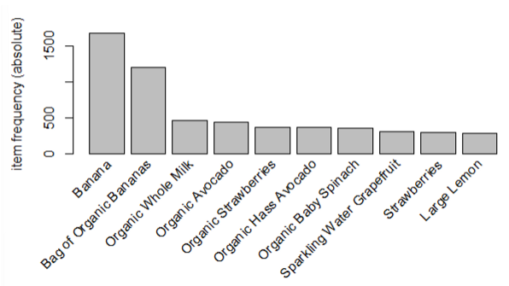

Here we have the most frequent items in the purchase receipts we constructed.
After organizing the dataset to apply MBA, let's identify the Association Rules. Before that, it is important to provide a context for the concepts of Support, Confidence, and Lift.
- Support -> It is the fraction of how often our itemset appears in our entire dataset.
- Confidence -> It is the probability that the rule will hold true for a new transaction with the left-hand side (lhs) items.
- Lift -> It is the ratio of how much the Confidence of the Rule exceeds the expected confidence (predefined by the analyst).
Therefore, let's analyze our top 10 rules with the highest confidence initially.

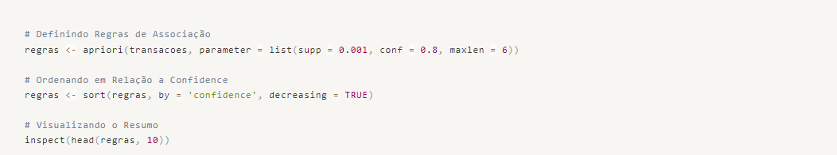
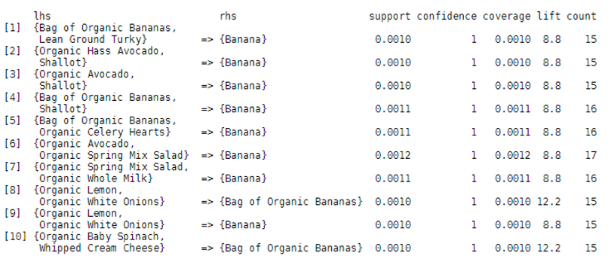
Now we can answer questions such as:
- What do consumers like to buy before purchasing Bananas, considering that Bananas are one of the most purchased products?
- What are consumers likely to buy IF they buy Bananas?
Note that the first question refers to the products on the right-hand side of the association, where when they buy A, they also buy B.
In the second question, we have the products on the left-hand side of the association, where IF we buy A, which product will we likely buy next?
With this information, we can direct not only the visual composition of products on the shelves but also marketing actions to increase sales and foot traffic in physical stores.
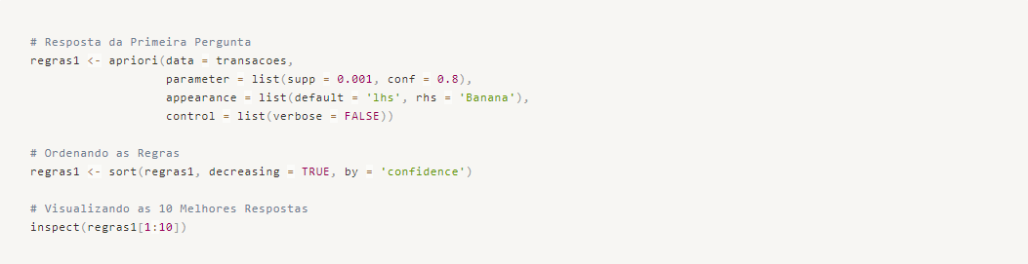
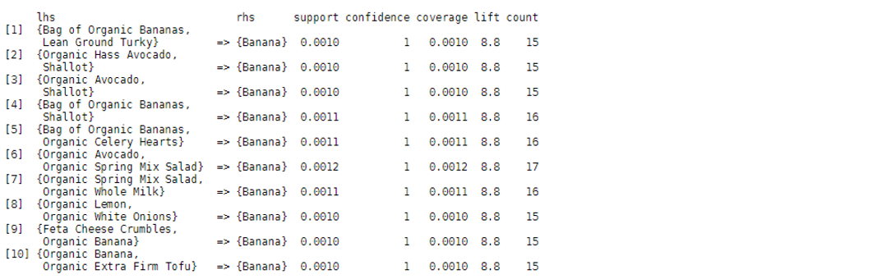

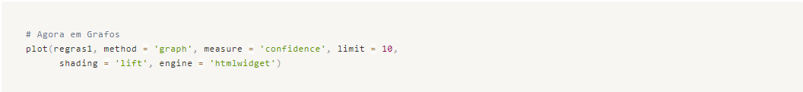
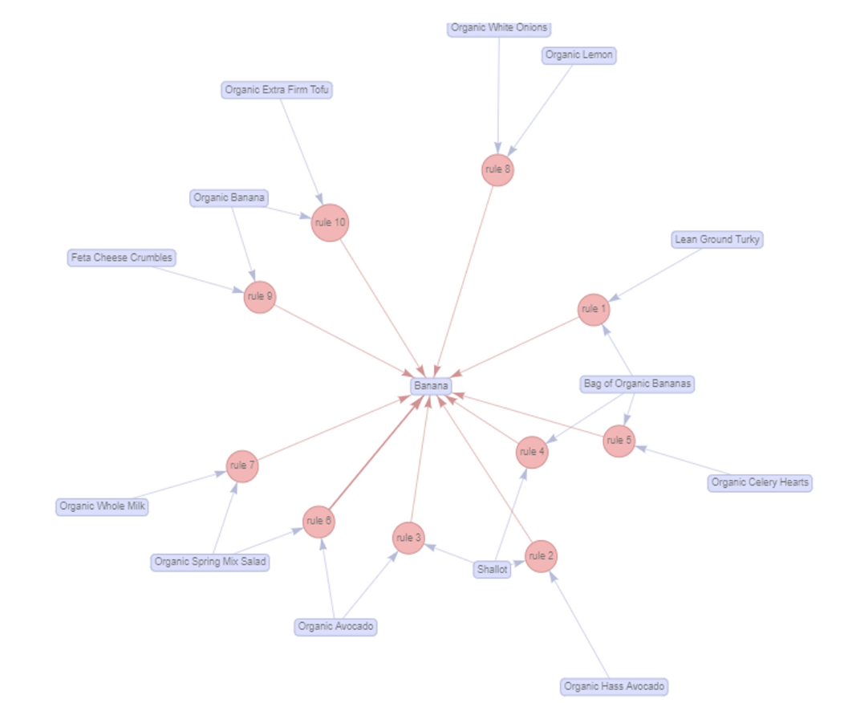
To answer the second question, let's set a minimum confidence of 10% and sort the results in descending order so that we have meaningful research outcomes, considering that confidence tends to be lower in situations where only one product is purchased.
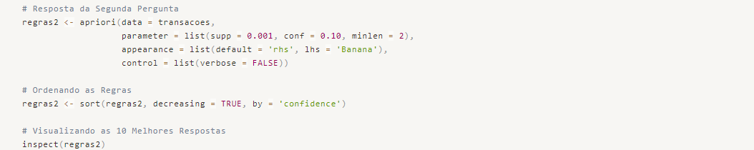
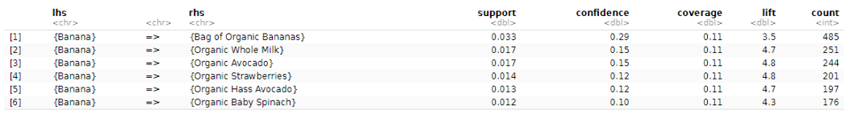
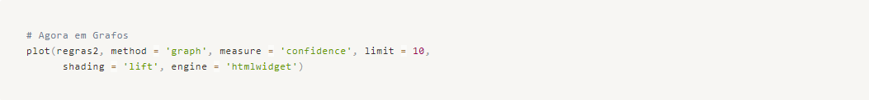
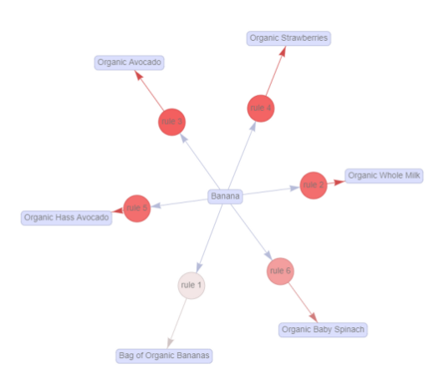

Let's conclude this part of the work, which corresponds to Market Basket Analysis, and from there we will move on to our second business problem, which involves Predictive Modeling for Product Re-purchase.

Part 2 - Predictive Modeling for Product Re-purchase with Machine Learning
We will now work on utilizing Machine Learning to classify an order as a Re-purchase or First Purchase, based on the historical re-purchase data we have. Our goal is to achieve 75% accuracy in our model.

Packages Used
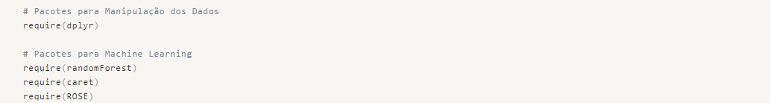

Data Loading
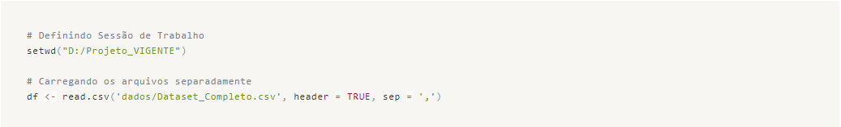

Data Cleaning and Organization:
In this step, we will analyze if the data has been loaded correctly, check for any data type misclassification, missing values, and ensure that the data organization meets our expectations for further analysis.
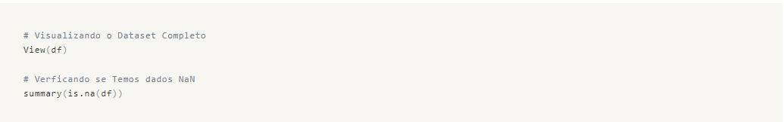
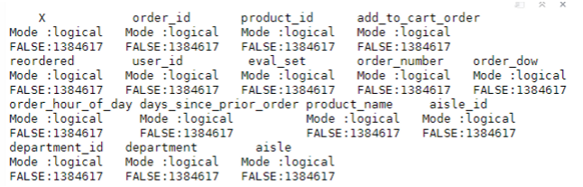

In the table above, we can see that there are no NaN values, so we can proceed with the organization and definition of variable types.
We have decided to remove the "product_name", "department", and "aisle" variables as they are of type CHAR and have many classes, making it challenging to transform them into factors, for example.
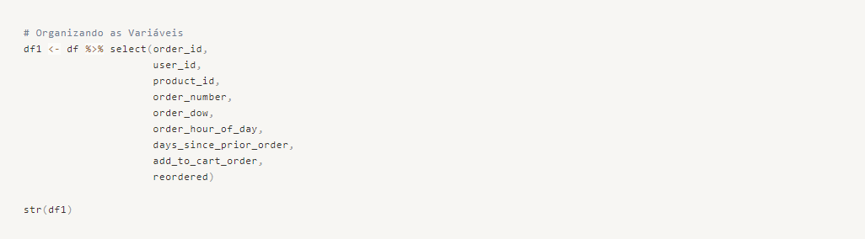
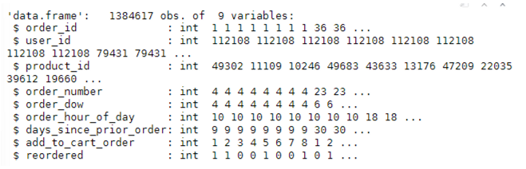

Preprocessing the Data
Let's check if the target variable is balanced.
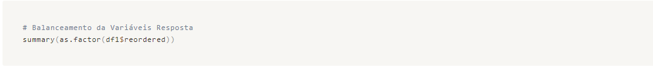

We have class imbalance, which could be addressed using undersampling techniques, considering that we have plenty of data for our application. However, we will keep it as it is and see what results we can obtain.

Feature Engineering
Let's create some new variables by relating repurchase with products and users.
For the product, we will calculate the Absolute Repurchase Frequency and the Repurchase Rate for each product.
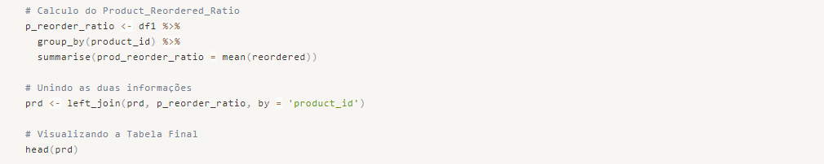
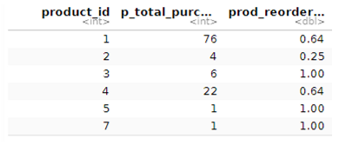

For the user, we will calculate the Number of Orders and the Repurchase Rate per user.
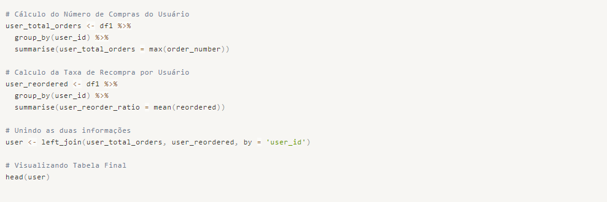
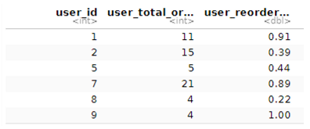

We can also calculate how many different types of products a user has purchased.
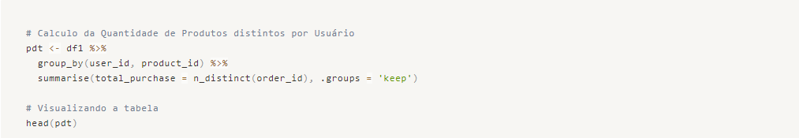
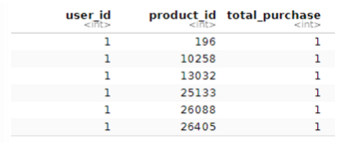

For this sample of data, the user did not repurchase specific products, resulting in a total of 1 purchased product. Therefore, we will not use this variable in the final dataset.
Now, let's merge the datasets by referencing the information using their respective IDs.
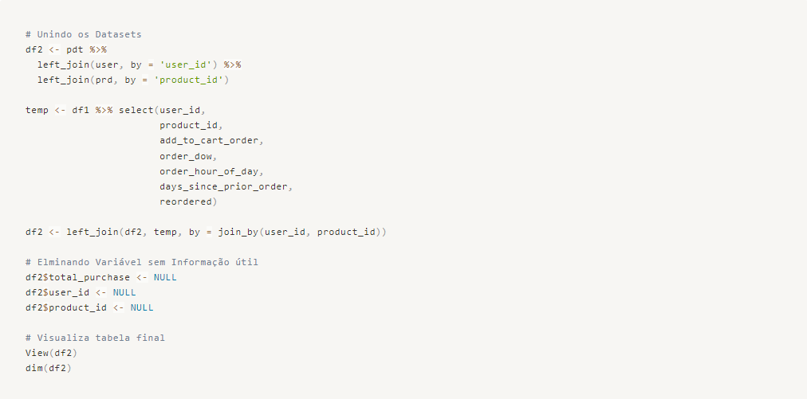
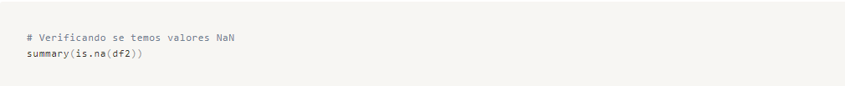

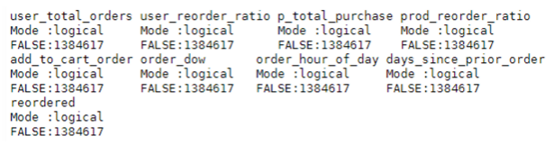

Let's free up the memory consumed so far during the processes, thus keeping our computational capacity more efficient.
Finally, we will use a sample of the data with only 1/3 of the original sample, due to our computational capacity limitation, and apply data standardization to equalize the scales.
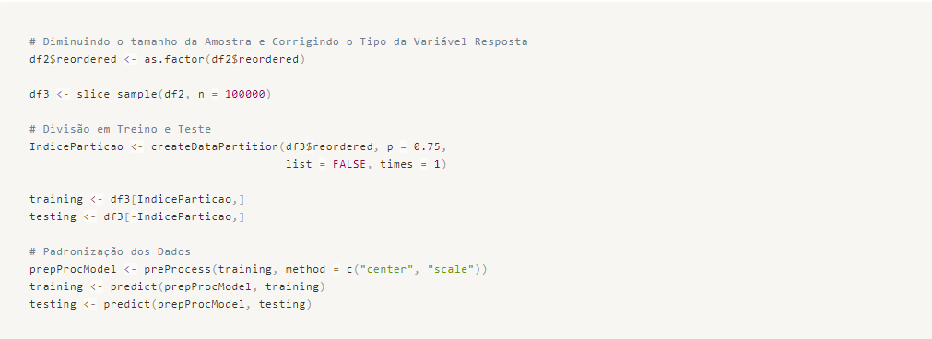

Predictive Modeling - Machine Learning
We will start by building our Base model using the simplest algorithm we know. We will calculate its metrics and then create other more complex models.

Model 00 - Logistic Regression
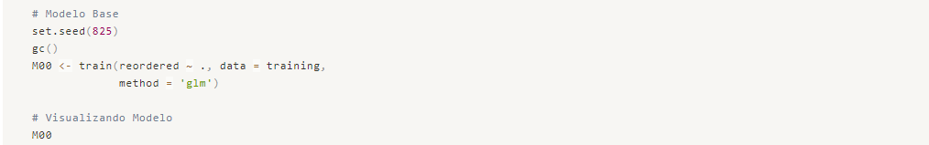
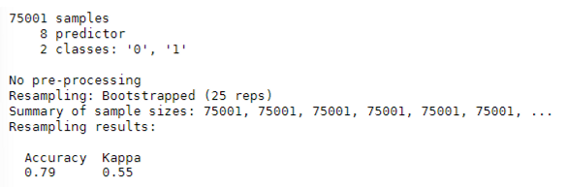

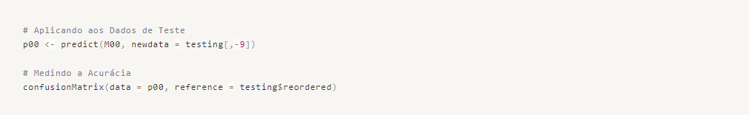
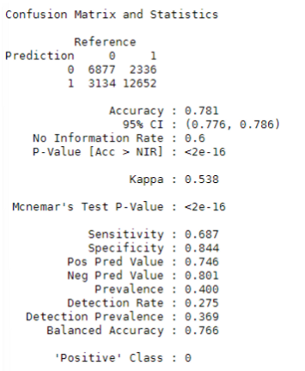

We have an accuracy of 78.1% without optimization.

Model 01 – Random Forest
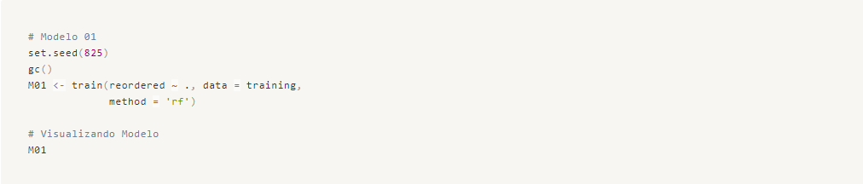

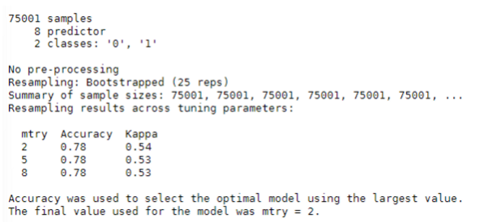

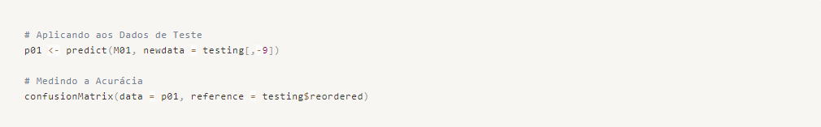
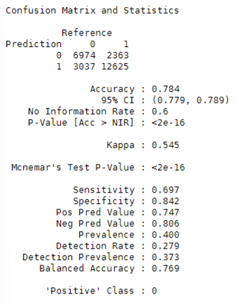

We have an accuracy of 78.4% without making any changes to the model or implementing any training control or tuning techniques.

Model 02 – Boosted Logistic Regression
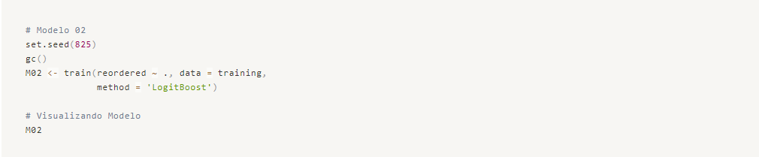
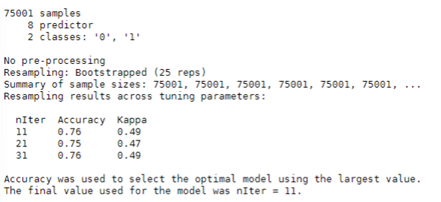

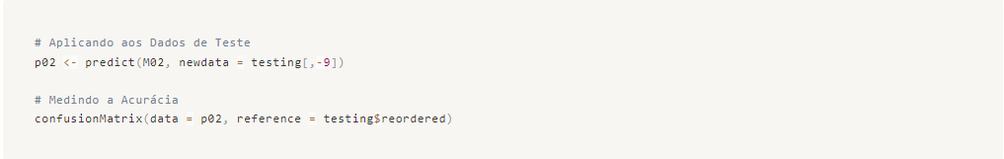
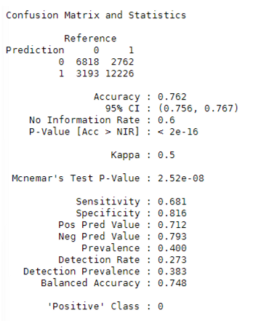

We have an accuracy of 76.2% without making any changes to the model or implementing any training control or tuning techniques.

Model 03 – eXtreme Gradient Boosting
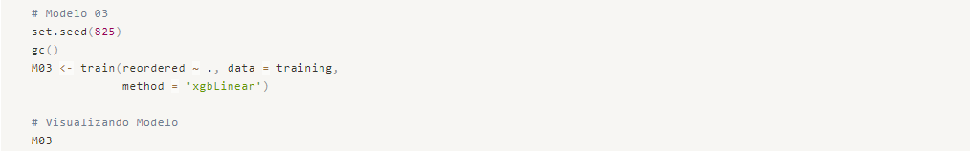

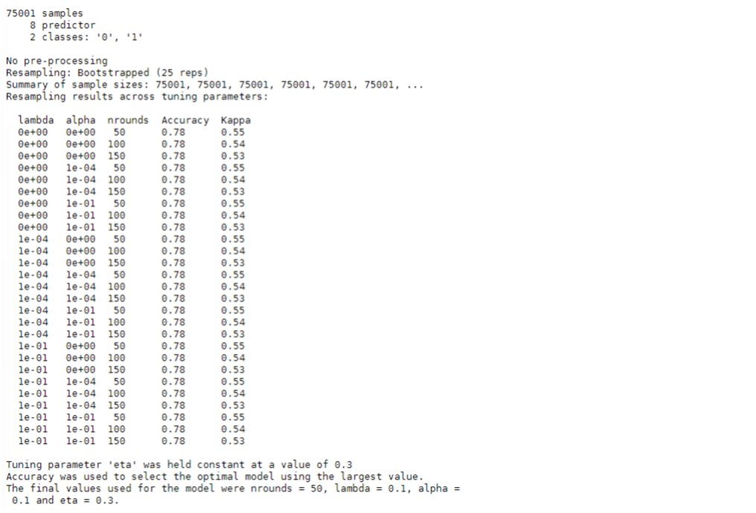

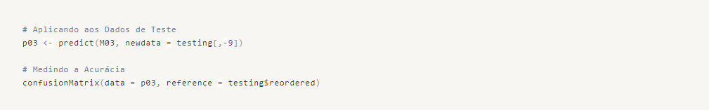
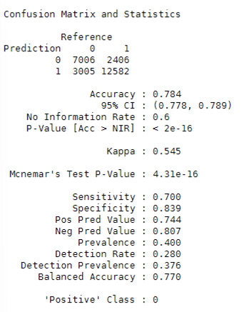

We have an accuracy of 78.4% without making any changes to the model or implementing any training control or tuning techniques.

Model 04 – Stochastic Gradient Boosting
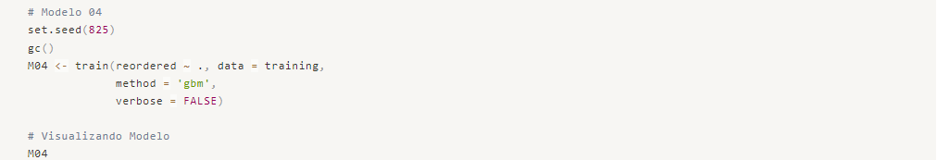
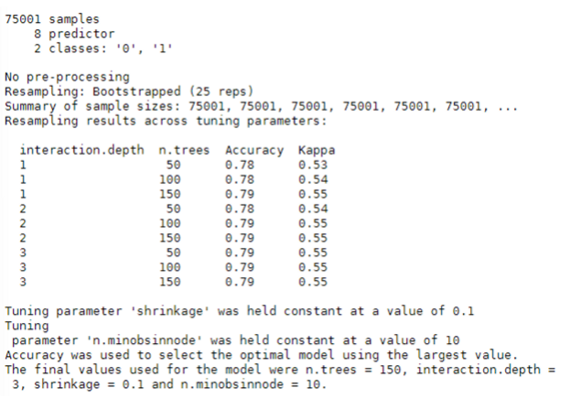

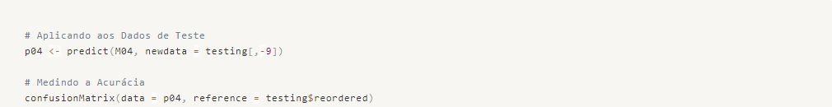
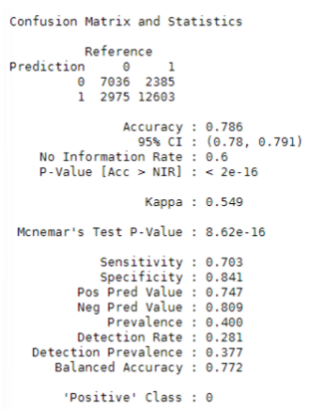

We have an accuracy of 78.6% without making any changes to the model or implementing any training control or tuning techniques. Let's create a Model 05 with hyperparameter optimization and training control to increase the accuracy of our model.

Model 05 – Stochastic Gradient Boosting with Training Control e Tunning Grid
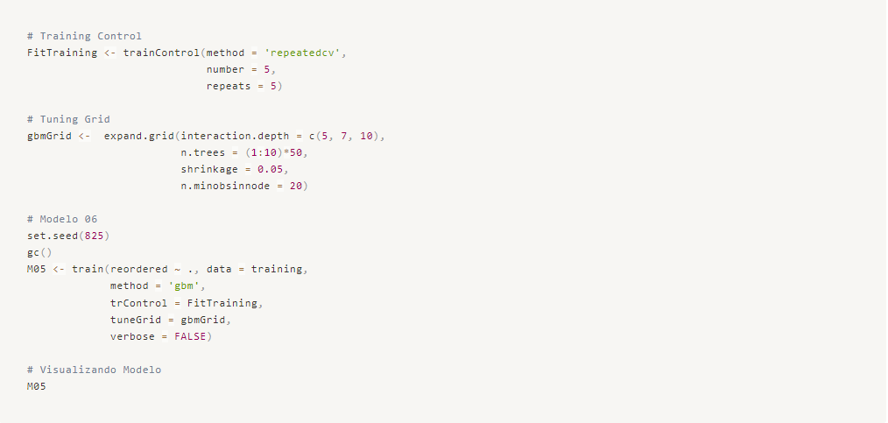
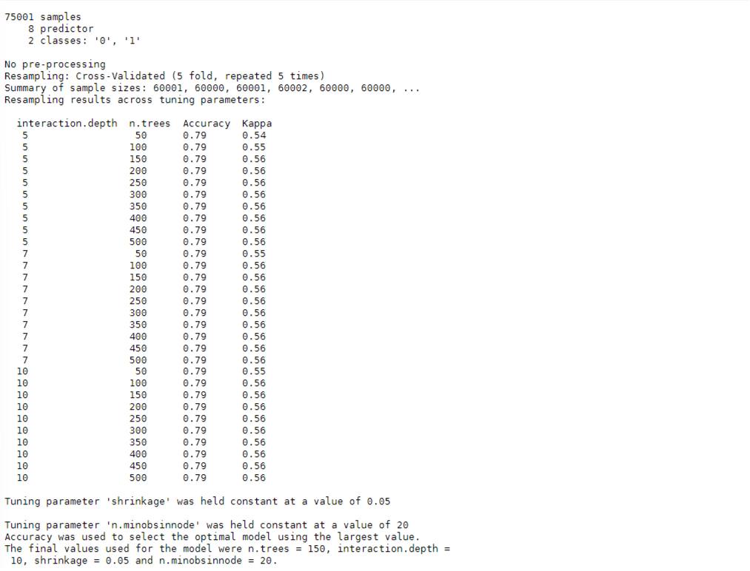

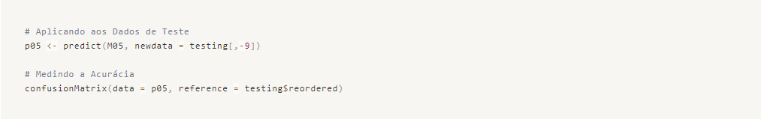
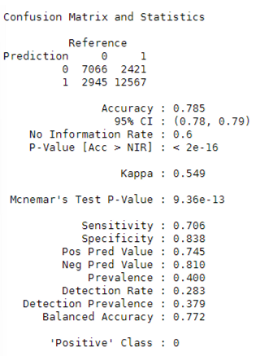

As we can see, even though we applied training control and tuning techniques, the result was the same as the model with standard hyperparameters. Therefore, we will use Model 04 as the final model, which has an accuracy of 78.6%.
We chose this model based on its lower error in predicting Class 0 of the target variable, as observed in the Confusion Matrix.
END!

