Prediction of Fire Extinguisher Efficiency using Machine Learning

Conceptualization and Definition of the Business Problem
The hydrostatic test of the fire extinguisher is a procedure established by the ABNT NBR 12962/2016 standards, which determine that all extinguishers must be tested every five years to identify any leaks and verify the strength of the extinguisher's material.
With that in mind, the hydrostatic test for fire extinguishers can be conducted under low and high pressure, according to these specific standards. The procedure is performed by technical professionals in the field, using specific and appropriate equipment for the test, as accuracy in the results is crucial.
Is it possible to use Machine Learning to predict the performance of a fire extinguisher based on computer simulations and thus add an additional layer of safety to a company's operations? That is the objective of this project.
Using publicly available real data, our challenge is to build a Machine Learning model capable of predicting whether the flame will be extinguished or not when using a fire extinguisher.
The link below contains the data:
https://www.muratkoklu.com/datasets/vtdhnd07.php

Data Dictionary
The dataset was obtained as a result of extinguishing tests on four different fuel flames using a sound wave fire suppression system. The sound wave fire suppression system consists of 4 subwoofers with a total power of 4,000 Watts. There are two amplifiers that allow the sound to reach these subwoofers as amplified.
The power supply of the system and the filter circuit ensure that the sound frequency is properly transmitted to the system located within the control unit. While the computer is used as the frequency source, an anemometer is used to measure the airflow resulting from the sound waves during the flame extinction phase, and a decibel meter is used to measure the sound intensity.
An infrared thermometer is used to measure the temperature of the flame and the fuel can, and a camera is installed to detect the flame extinction time.
A total of 17,442 tests were conducted with this experimental setup. The experiments were planned as follows:
• 3 different liquid fuels and 2 LPG fuels were used to create the flame.
• 5 different sizes of liquid fuel cans were used to achieve different flame sizes.
• Adjustment of half-filled and fully-filled gas was used for the LPG fuel.
During each experiment, the fuel container, positioned 10 cm away, was moved forward up to 190 cm, increasing the distance by 10 cm each time. Along with the fuel container, the anemometer and decibel meter were moved forward in the same dimensions.
Fire extinguishing experiments were conducted with 54 sound waves of different frequencies at each distance and flame size.
Throughout the flame extinction experiments, data obtained from each measuring device were recorded, and a dataset was created. The dataset includes features such as fuel can size representing flame size, fuel type, frequency, decibels, distance, airflow, and flame extinction. Thus, 6 input features and 1 output feature will be used in the model we will construct, initially.
The Status column (flame extinction or non-extinction) can be predicted using the six input features in the dataset. The Status and fuel features are categorical, while other features are numerical.
Our challenge is to build a Machine Learning model capable of predicting, based on new data, whether the flame will be extinguished or not when using a fire extinguisher.
Properties and Descriptions of Liquid Fuels.

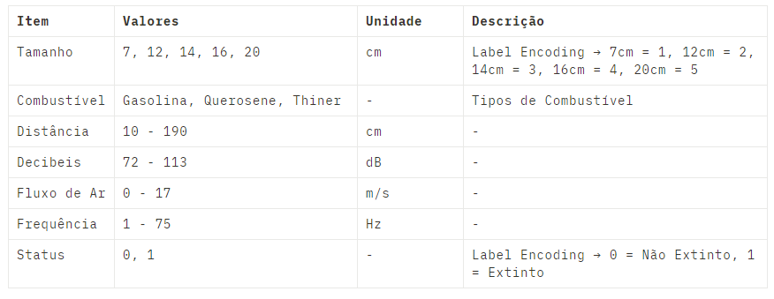
Properties and Description of LPG
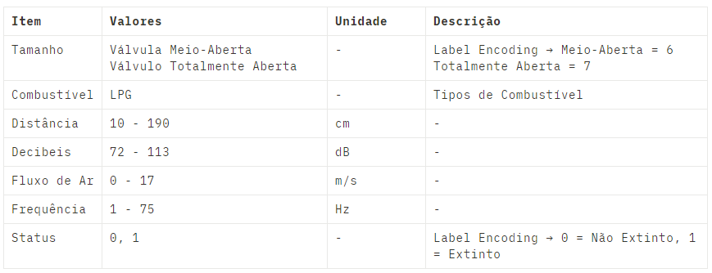

Work Packages
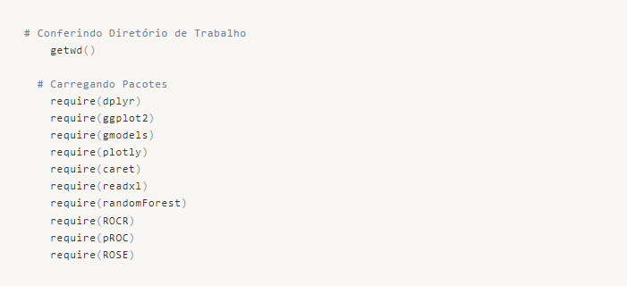

Loading the Data
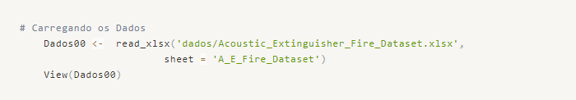
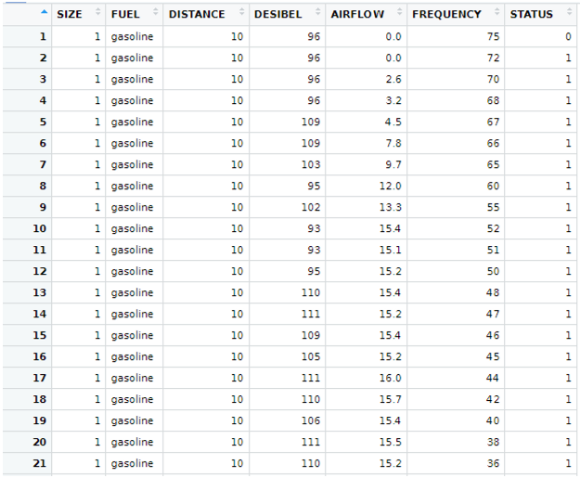
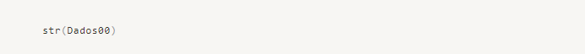
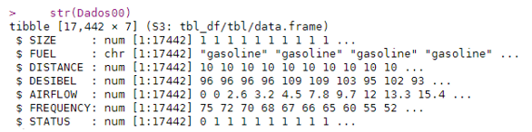

Data Organization and Transformation
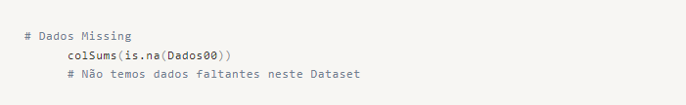
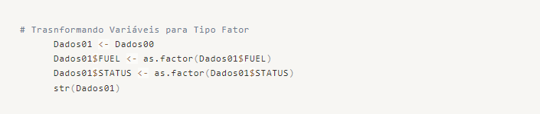
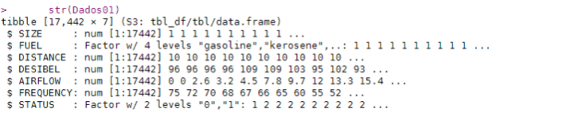
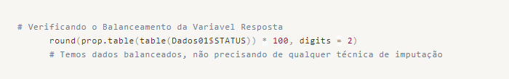
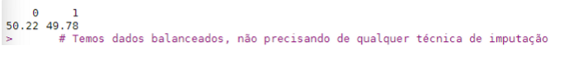

Data Exploration and Analysis

General Exploration

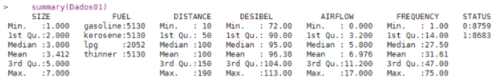
We can observe that the categorical variable STATUS is balanced, containing an equal volume of data for both possible responses.
On the other hand, the categorical variable FUEL has a smaller amount of data for the LPG category. This presents an opportunity for potential model revision if an increase in predictive performance is required.

Analyzing Numeric Variables
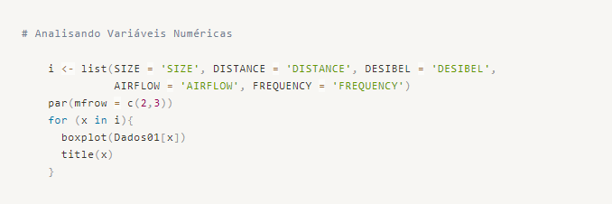
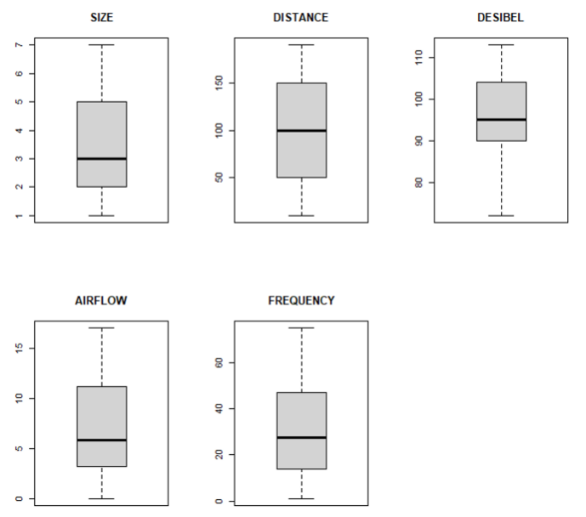
Analyzing the boxplot graphs for each numeric variable, we observe that there are no outlier data points that could negatively impact our predictive model. Therefore, no outlier treatment techniques are required in this case.
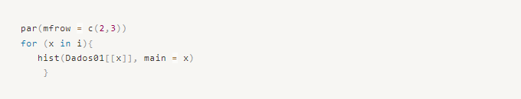
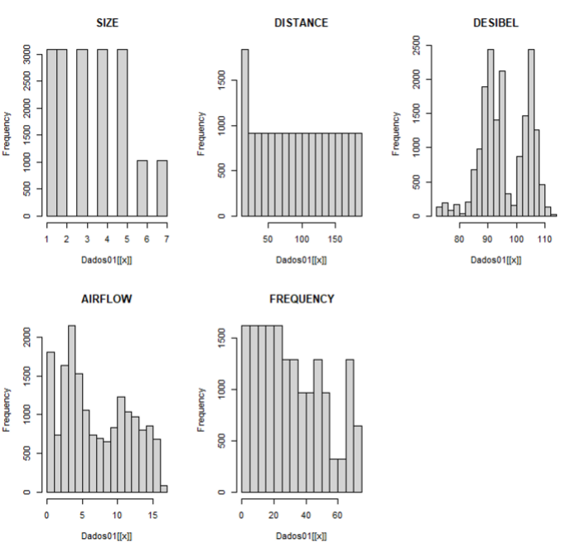
The distribution of the numeric variables does not exhibit a Gaussian pattern. However, if needed to meet the assumptions of a parametric hypothesis test, we could apply techniques to approximate a normal distribution.
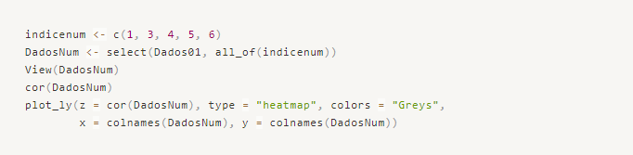
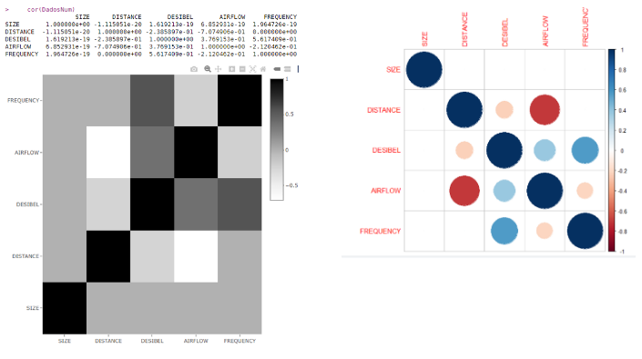
Some variables exhibit a high negative correlation, such as AIRFLOW x DISTANCE, while others show a high positive correlation, such as FREQUENCY x DECIBEL. We may need to remove some variables from the process to avoid multicollinearity and ensure better generalization of the predictive model.
We will address this issue further when defining which variables will be used in the base predictive model.

Analyzing Categorical Variables
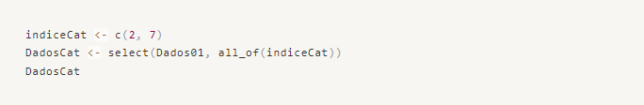
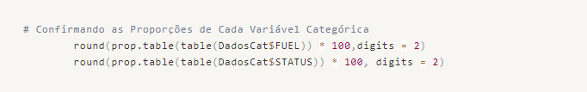
We can ascertain that the variable STATUS (0 -> 50.22%, 1 -> 49.78%) is balanced. However, we can observe that the variable FUEL has fewer experimental observations with LPG (11.76% compared to 29.41% for other fuels).
Let's confirm the balance using a CrossTable:
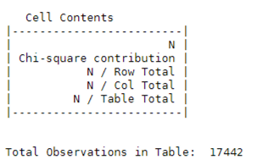

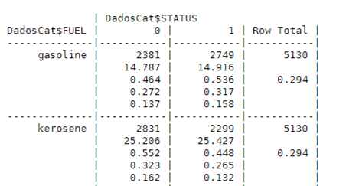

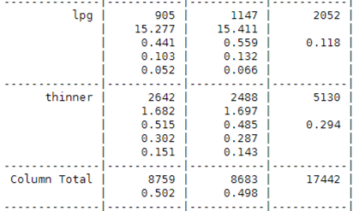

As we mentioned earlier, there is a slight imbalance for the LPG category, but the entire dataset is balanced in terms of relative and absolute frequencies of each category. We can consider another point for possible revision to improve performance, as we could apply imputation techniques to balance the dataset further.

To conclude this stage, let's perform a Chi-square test to check if the two categorical variables exhibit similar dispersion of their data.
Chi-square Test
• Null Hypothesis H0 → There is no relationship between FUEL and STATUS.
• Alternative Hypothesis H1 → FUEL and STATUS are related.
If the p-value is less than 0.05, we reject H0.
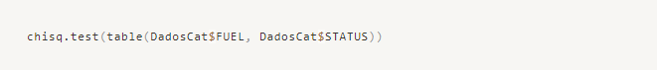

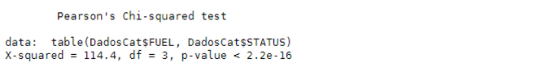

Data Preprocessing

Creating Training and Test Datasets
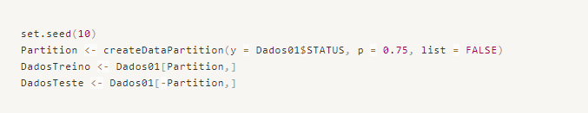

Data Normalization
Since we have data on different scales, we will use the scale() function to ensure that the magnitude of one variable does not have a disproportionate influence on the predictive model.

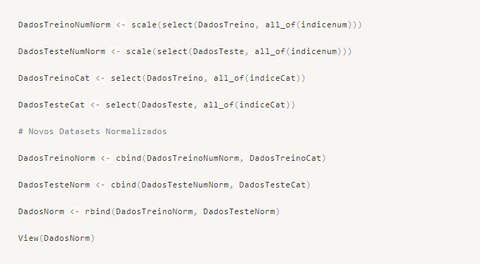

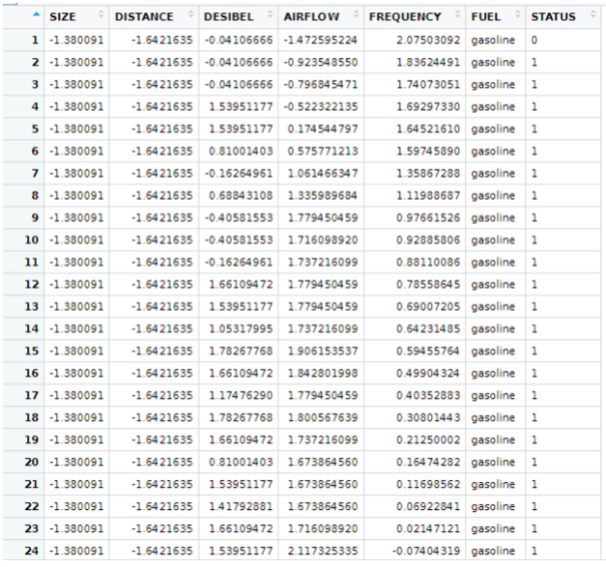

Variables with the Greatest Influence
We will use the Random Forest algorithm to identify the most important variables and simplify our predictive models by reducing dimensionality.
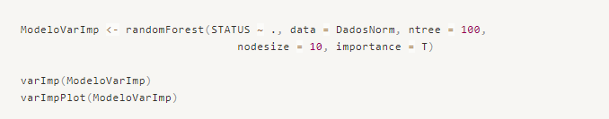
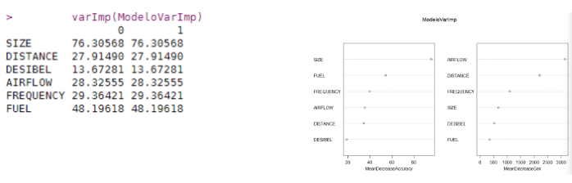
For our initial model, we will use the variables with Mean Accuracy values above 25%. These variables are SIZE, FUEL, FREQUENCY, AIRFLOW, and DISTANCE.

Predictive Modeling

Base Model → Random Forest (CARET)




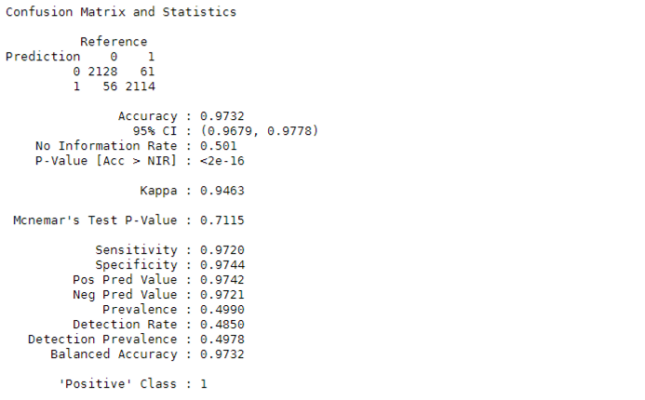
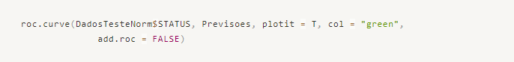
We have achieved an accuracy of 97.3% with the proposed model, which is a highly satisfactory result. This is confirmed by the Accuracy and AUC metrics.
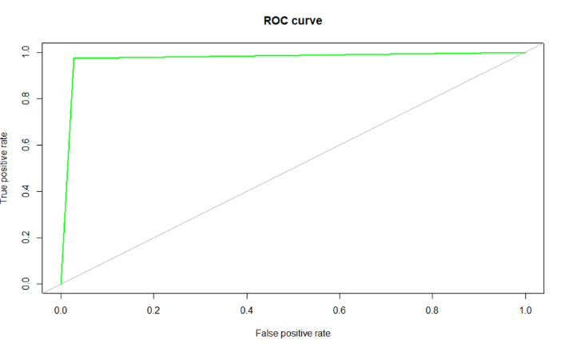

Model 02 → GLM (CARET)
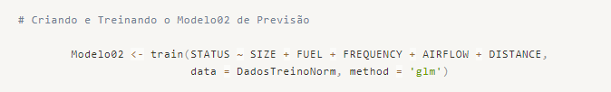


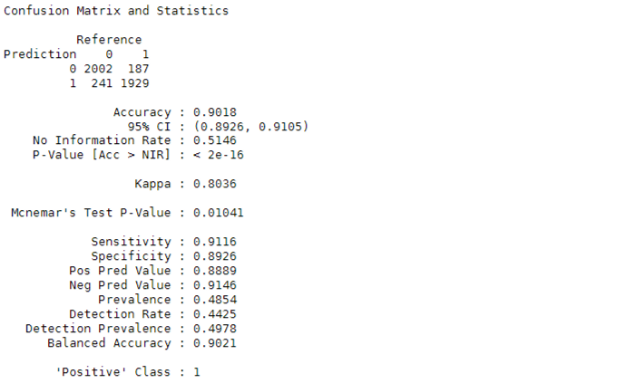
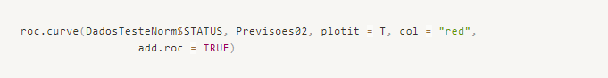
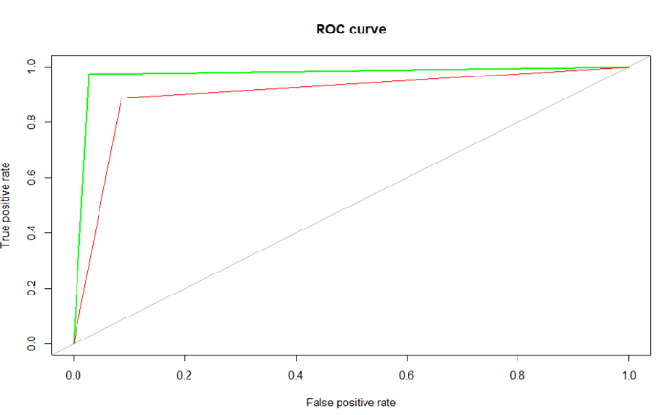
We have achieved an accuracy of 90.18% with the new model, which is lower than the Base Model when comparing the Accuracy and AUC metrics. Let's proceed to build another model, this time using Decision Trees.

Model 03 → Decision Trees (CARET)
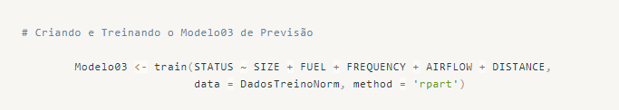




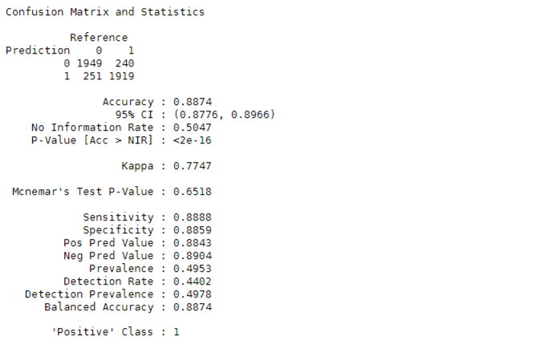
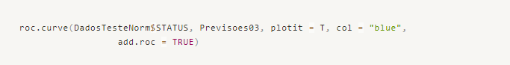
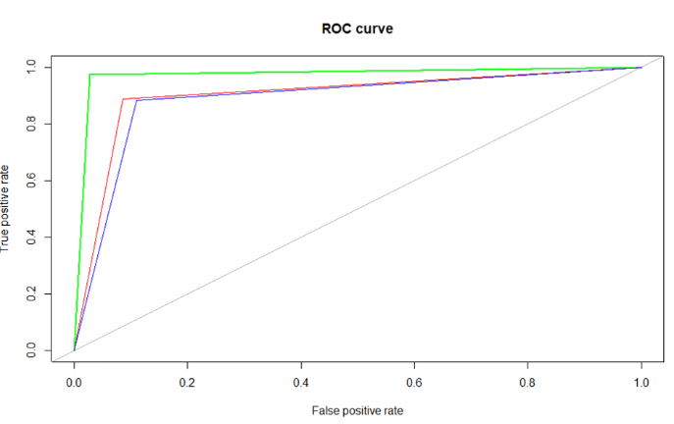
For this model, we achieved a lower accuracy of 88.7% in the predictions

Conclusion
We can conclude that our business problem does not require a very high accuracy, as the intention is to assist in the process of detecting the efficiency of fire extinguishers. Laboratory tests must be performed and repeated through sampling, as required by legislation and regulatory bodies.
Therefore, we need a model that, despite predicting some incorrect data (false positives or false negatives), can provide a generalized predictability to assist in the execution of experimental tests, reducing time, costs, and exposure to risks for the operators.

