Prediction of Customer Satisfaction Level at Santander using Machine Learning

Defining the Business Problem
Customer satisfaction is a critical measure of success. Unsatisfied customers tend to cancel their services and rarely express their dissatisfaction before leaving. On the other hand, satisfied customers become brand advocates. The Santander Bank is seeking assistance in identifying dissatisfied customers early in the relationship. This would enable Santander to take proactive measures to improve the customer experience before it's too late.
In this machine learning project, we will work with hundreds of anonymous features to predict whether a customer is satisfied or dissatisfied with their banking experience. The challenge lies in the unfamiliarity with each variable and the large number of variables available. Our goal is to deliver a list of satisfied and dissatisfied customers to the decision-maker with a model accuracy of 70%. We aim to create a simpler and more generalizable probabilistic model, making it easier for the decision-maker to use the results with clear understanding.
We will utilize the Python programming language and a dataset available on Kaggle, accessible at the following address:
https://www.kaggle.com/c/santander-customer-satisfaction
Please note that the data is provided in two separate files, train.csv and test.csv. Only the train.csv file contains the response variable. Therefore, we will work exclusively with train.csv during the model-building process. We will use the test.csv file to make predictions using the best model identified and provide the results to the decision-maker.

Packages and Versions
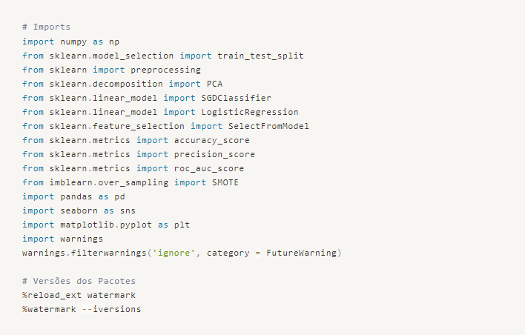
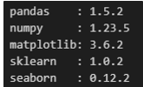

Loading the Datasets
As explained in the problem definition, we will initially work only with the train.csv file.
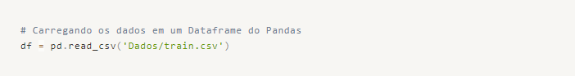

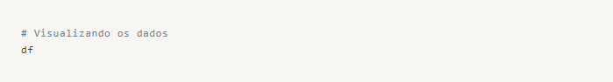
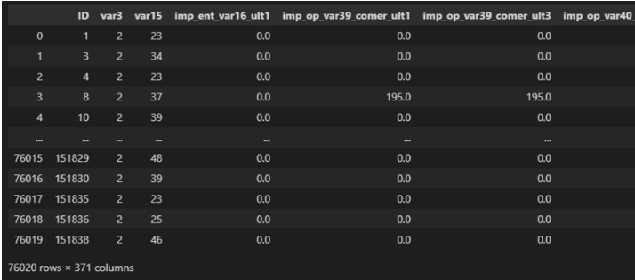
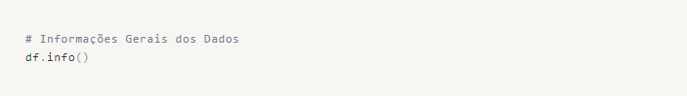
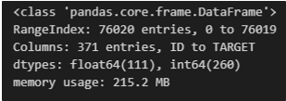

Data Cleaning and Exploratory Analysis
Upon initial inspection of our data, we notice that we have a vast number of variables (370) without descriptions, making it difficult to understand each variable and analyze their behaviors as they are.
Therefore, our initial steps will be to address missing data (NaN) by applying a technique to handle this issue. Subsequently, we will explore two alternatives for dimensionality reduction: Selecting the Most Important Variables and Vectorizing Variables with PCA. Finally, we will create models and compare their performance.
Let's start by checking for missing data and applying a technique to handle it.
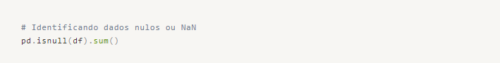
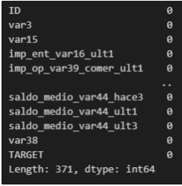

We don't have any missing data, including NaN values, in our working dataset. Let's proceed by renaming the columns to facilitate our visualizations.
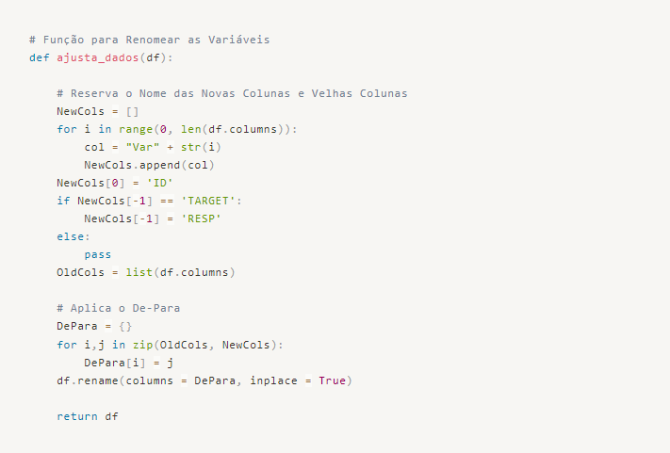
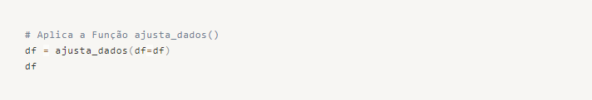
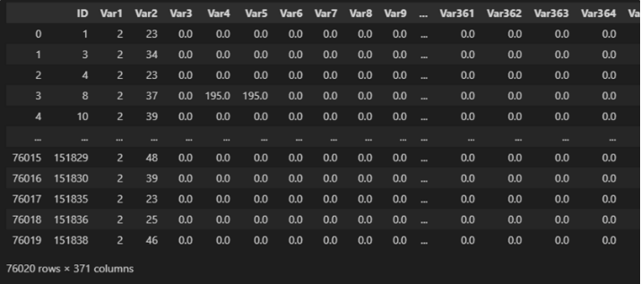
To continue with our work, let's remove the 'ID' variable in a new version of our dataset, as it doesn't provide any statistical information gain.
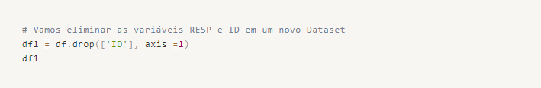
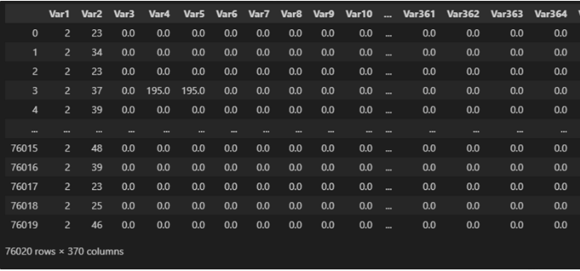

Our dataset is organized and clean. However, since we have a large number of variables and do not know the information that each one represents in relation to the business problem, it is not feasible to study the correlation between variables or analyze central and dispersion statistics. Our next step is to begin reducing the dimensionality before applying predictive modeling.
To conclude, let's examine the target variable and determine its distribution.

We can observe that we have a large number of samples of type 0 (satisfied customers) and very few samples of type 1 (unsatisfied customers). It is quite common to encounter such class imbalance in business problems such as fraud detection or sentiment analysis.
Certainly, addressing the class imbalance issue is an important step in the modeling process. We can explore various techniques such as oversampling the minority class, undersampling the majority class, or using a combination of both. Additionally, we can consider using algorithms specifically designed to handle imbalanced data, such as ensemble methods or cost-sensitive learning.
We can further discuss and implement these techniques to improve the performance of our predictive models.

Work Strategy
As we have identified some challenges in our project, let's outline our strategy to address them:
Different Variable Scales: We will apply a scaling method, such as standardization or normalization, to bring the variables to a similar scale.
Imbalanced Target Variable: We will create two scenarios to tackle the imbalance:
Scenario 1: Initially, we will work with the unbalanced target variable RESP. We will use dimensionality reduction methods based on variable importance, such as feature selection or feature importance. Additionally, we will apply vectorization using PCA to further reduce the dimensionality. We will train different algorithms on the transformed dataset and evaluate their performance using appropriate metrics to determine the best model.
Scenario 2: We will address the class imbalance issue by applying an oversampling technique, specifically SMOTE, to balance the dataset. Then, we will use the same dimensionality reduction techniques as in Scenario 1 and train the algorithms on the transformed dataset. We will compare the performance of these models with those from Scenario 1.
High Number of Variables: Given that we have 369 variables, we will apply dimensionality reduction techniques, as mentioned in Scenarios 1 and 2, to reduce the number of variables and capture the most relevant information.
At the end of the project, we will compare the models developed in both scenarios and determine the best model based on their performance metrics.
By following this strategy, we aim to address the challenges posed by different variable scales, imbalanced target variable, and high dimensionality, and identify the most effective model for predicting customer satisfaction.

Scenario 1 - Imbalanced Dataset + Dimensionality Reduction Techniques
First, we will divide the data into training and testing sets. We will use the Sklearn package for this task.
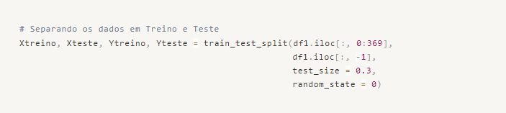
After separating the datasets, we will apply normalization to the training and testing data to equalize the scales of the variables.
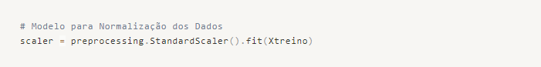
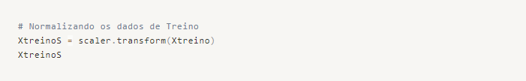
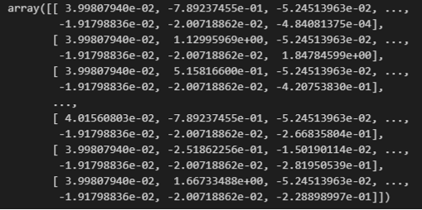

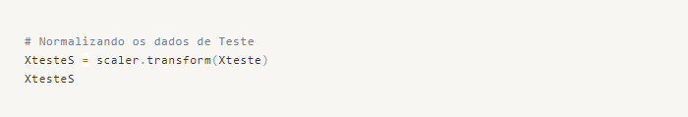
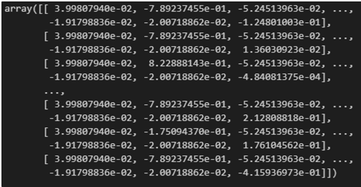

Model 00 - Logistic Regression + Most Important Variables (SelectFromModel - Sklearn)
Datasets with equivalent scales, we can apply our first method of dimensionality reduction. We will apply a Feature Selection based on a Logistic Regression model using SelectFromModel from the Sklearn package.
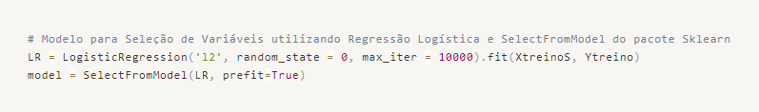
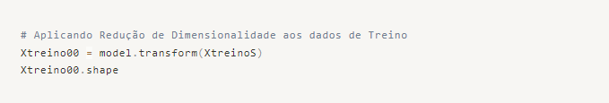

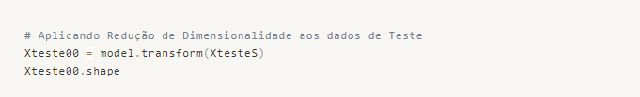

We have arrived at 105 important variables for the classification of our customers. Although we still have a large number of variables, we will apply them to a predictive model and calculate the metrics.
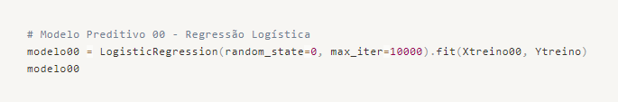
Making predictions with the trained model and evaluating its performance.
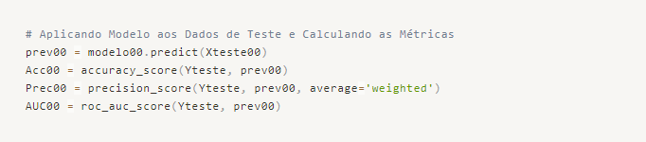
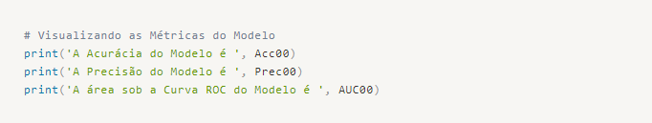
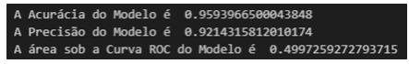

Let's store the results in a table for comparison later.
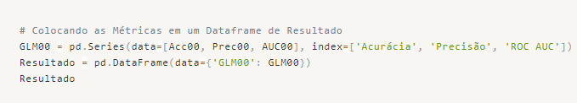
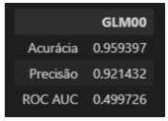

Model 01 - Logistic Regression + PCA
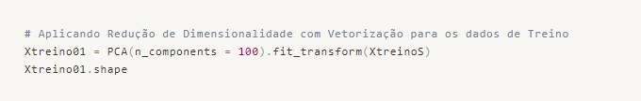
We will work with 100 variables for this model and evaluate its performance.
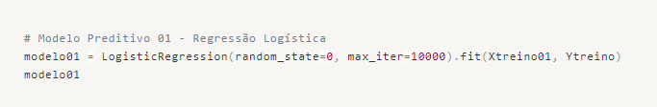
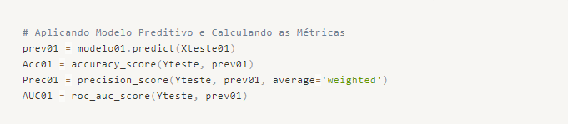
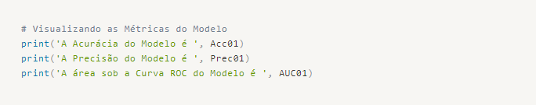
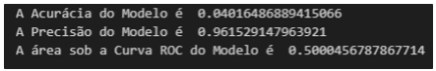

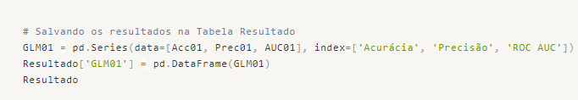
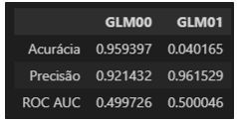

Model 02 - Stochastic Gradient Descent (SGD) + SelectFromModel
For this model, we will use Stochastic Gradient Descent (SGD) and the variable selection we performed with SelectFromModel from Sklearn.
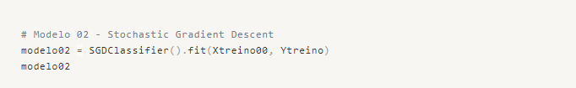
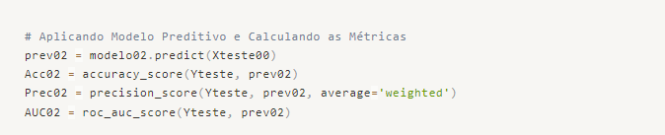
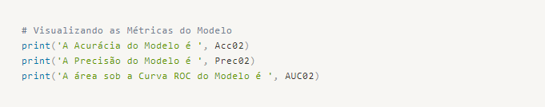
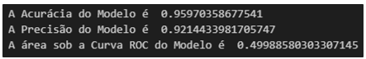

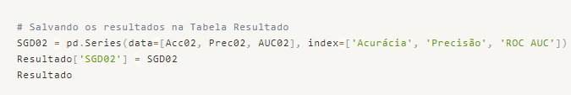

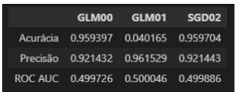

Model 03 - Stochastic Gradient Descent (SGD) + PCA
For this model, we will use Stochastic Gradient Descent (SGD) and apply PCA for dimensionality reduction.
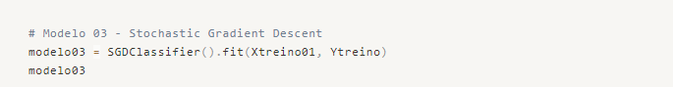

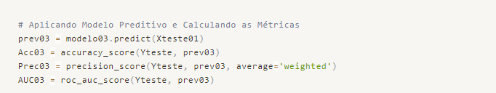
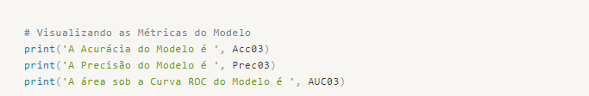
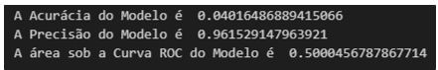

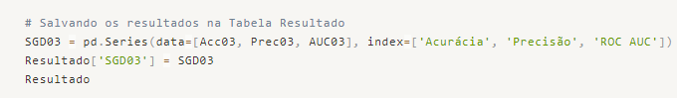

Scenario 2 - Dataset Balancing + Dimensionality Reduction Techniques
For this scenario, we will repeat the algorithms used in Scenario 1, but we will apply a technique to balance the target variable using synthetic data, called Oversampling.
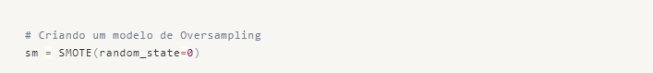
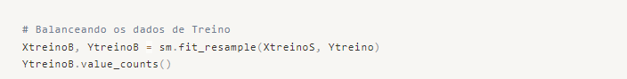

Model 04 - Logistic Regression + SelectFromModel
Now we will repeat the algorithms and techniques used previously, but with our balanced dataset.
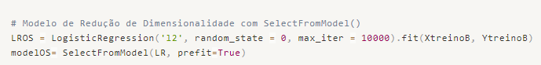
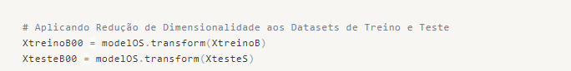
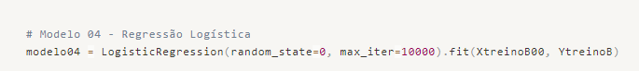
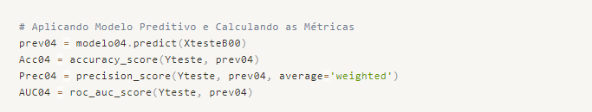
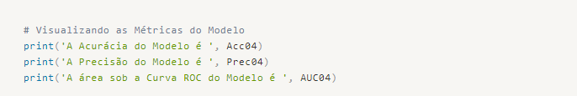
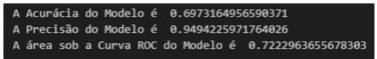

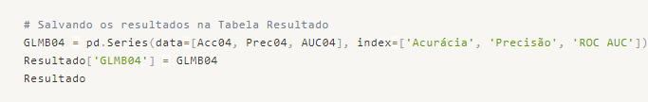
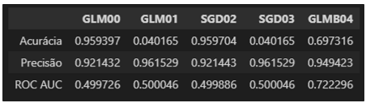

Model 05 - Logistic Regression + PCA
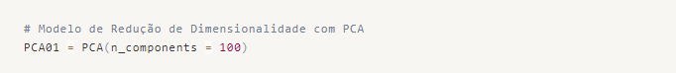
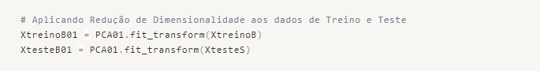
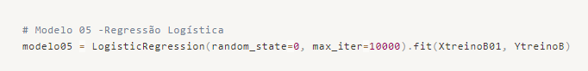
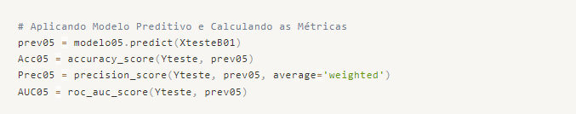
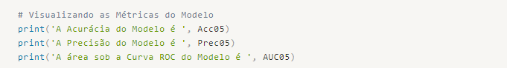

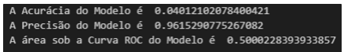

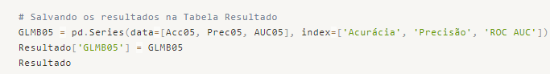
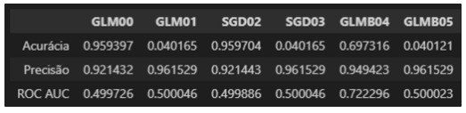

Model 06 - Stochastic Gradient Descent (SGD) + SelectFromModel
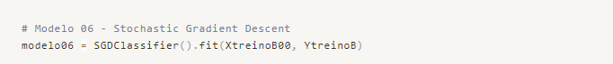
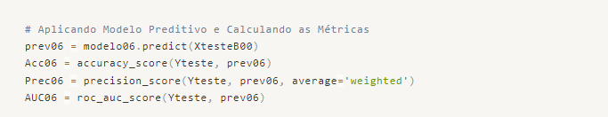
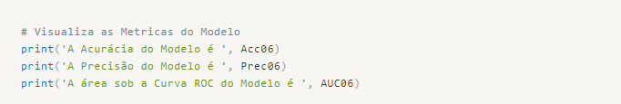
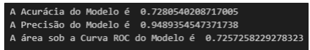

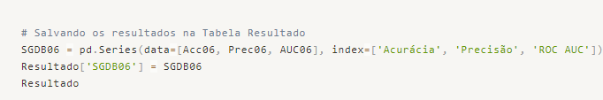
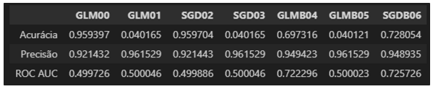

Model 07 - Stochastic Gradient Descent (SGD) + PCA
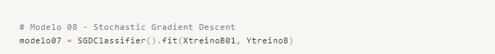
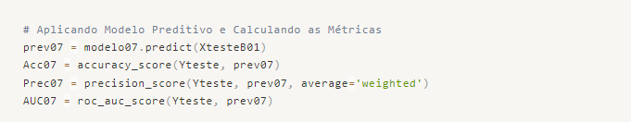
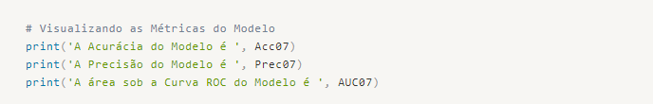
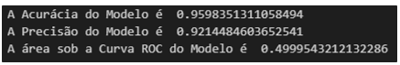

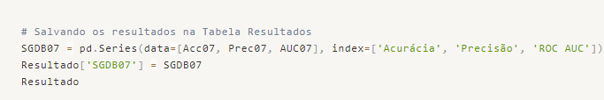

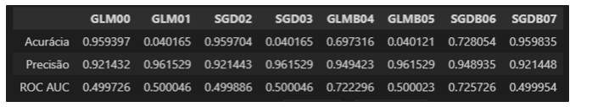

Conclusion and Prediction Delivery
Analyzing the table of model results, we can see that the SGD model, using the balanced dataset with the oversampling technique and applying the dimensionality reduction technique from Sklearn (SelectFromModel), achieved the most balanced performance among the metrics. It obtained an Accuracy of 72.8%, Precision of 94.89%, and ROC AUC of 72.57%.
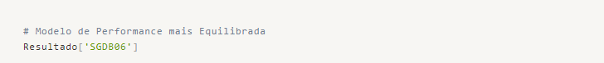
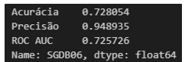

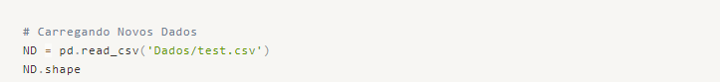

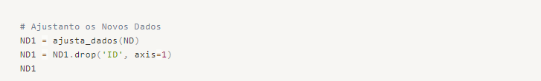
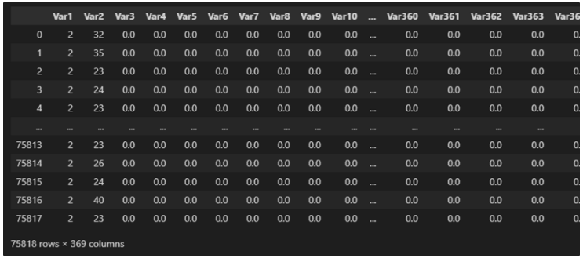
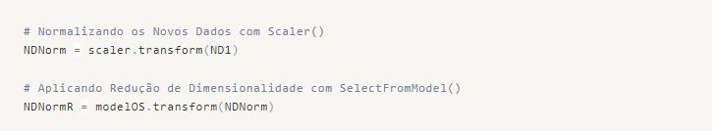
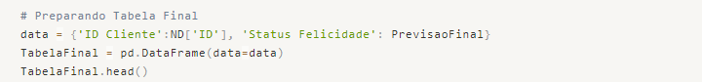
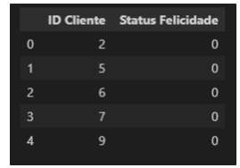

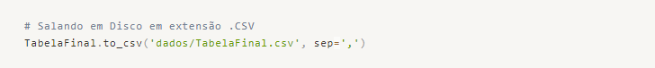
We have completed our work and delivered the PrevisaoFinal table to the client, containing the predictions for the requested examples.

