Predicting CHURN in Telecommunications with Machine Learning

Business Problem Definition
Customer Churn refers to a customer's decision to end a business relationship or the loss of customers. It also represents customer attrition. Customer loyalty and churn rate always add up to 100%. If a company has a loyalty rate of 60%, then the churn rate is 40%. According to the 80/20 customer profitability rule, 20% of customers generate 80% of revenue. Therefore, it is crucial to predict users who are likely to churn and identify the factors that affect customer decisions.
In this project, we will predict Customer Churn in a Telecom Operator. Our task is to create a machine learning model that can predict whether a customer is likely to cancel their plan and the probability of it happening. The dataset header provides a description of the information in each column, which will be detailed in our data dictionary.

Data Dictionary
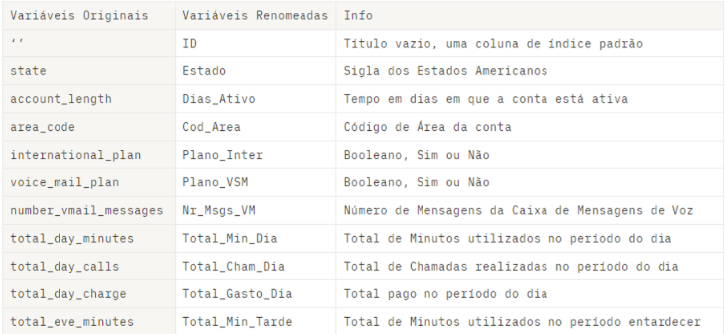

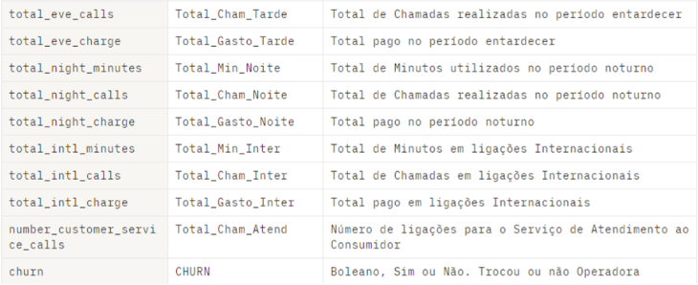

Package and Versions
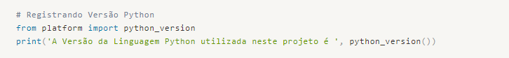
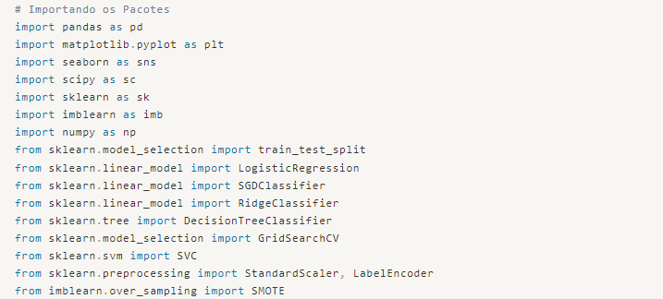
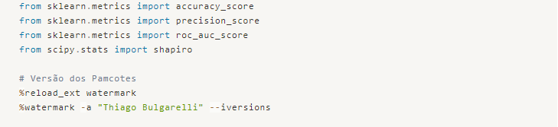
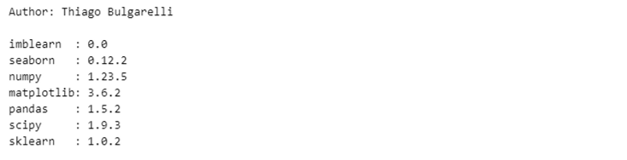

Loading the Data
To load the data, we'll start by combining the training and testing datasets into a single dataset. Then, we'll check the variable types identified by the Python interpreter, look for missing data, and analyze the distribution of the response variable, as we're dealing with a binary classification problem.

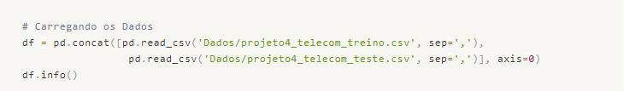
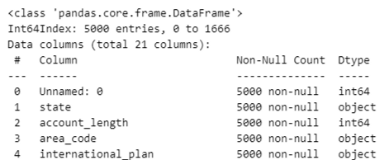

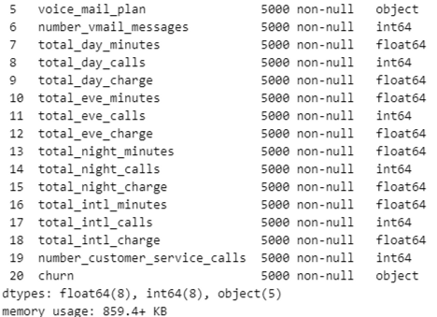

Our interpreter has done a good job identifying the numerical and categorical variables, so we don't need to make any changes at this point. Let's proceed with the organization.
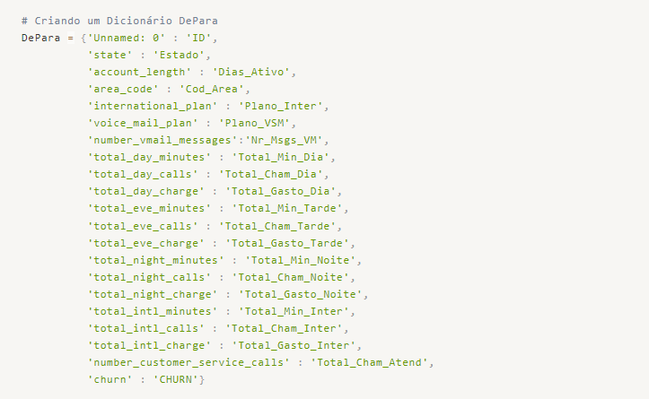
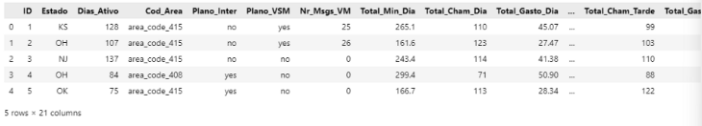
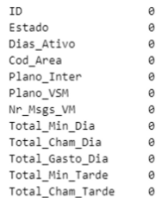
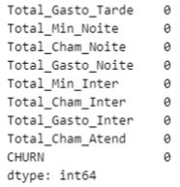

We can see that we have an issue related to the distribution of data in the target variable. We will need to address this issue during the preprocessing stage to avoid having poor performance of the predictive model.

Exploratory Data Analysis (EDA)
Let's start by studying the variables and identify their distributions, key statistical measures, their distributions, and possible correlations between each other and the target variable.

Numeric Variables
Let's start by taking a big picture view of the variables and then study individually those that catch our attention due to their characteristics. The objective here is to better understand each variable and extract possible interesting insights for our business.
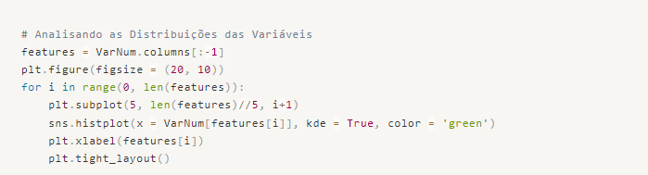
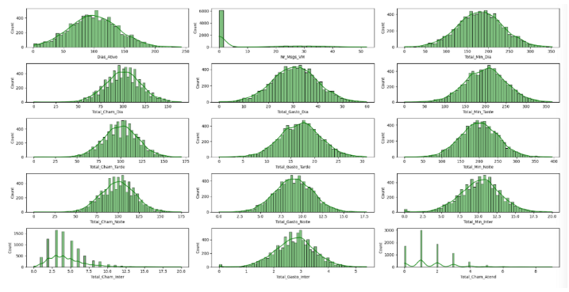
We can observe that the distributions approximate a normal distribution in all variables. We will further investigate this to make statistical assertions.
Insight -> We noticed that the number of Voice Mail Messages is zero for the majority of users, indicating that this service is rarely used. This is likely because people nowadays prefer to send messages through applications rather than traditional telephony services.
Insight -> The number of calls to Customer Service also stands out, with many customers making at least 1 or 2 calls. This could be correlated with customer dissatisfaction.
We will explore these points in more detail when we study the variables individually.
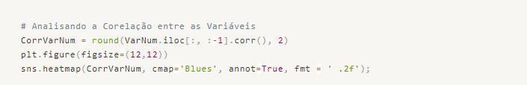
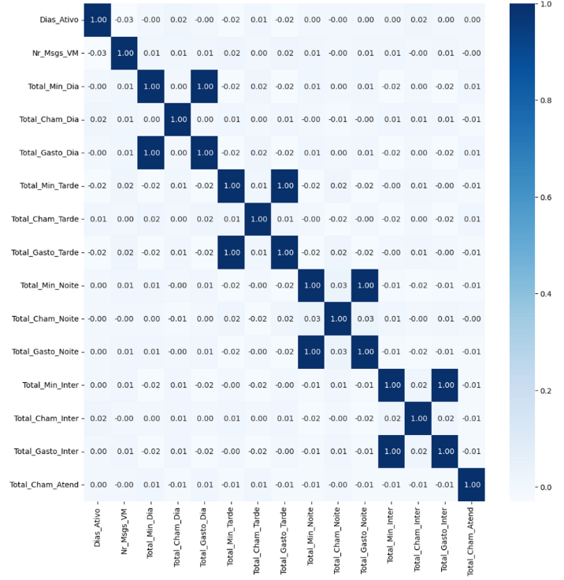

We can see from the heat map that there are variables with multicollinearity (Total_Gasto x Total_Min), meaning they are highly correlated with each other. This occurs because these variables contain similar information and can either be discarded or combined into a single variable. We will address these variables later during the data preprocessing stage. The goal is to retain the information while avoiding duplication, which could bias the learning of our predictive model.

Variable Dias_Ativo
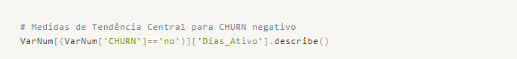
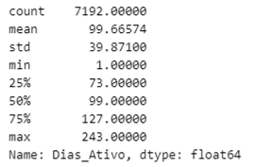

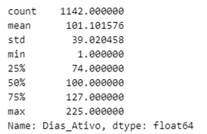

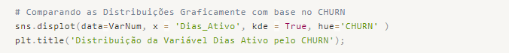
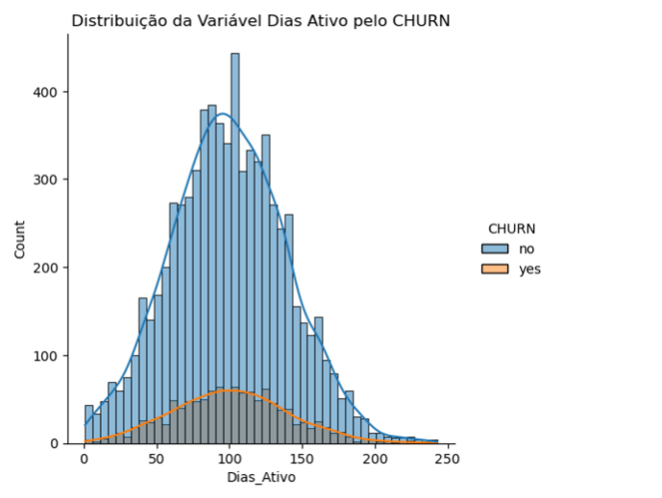
Insight: We have a similar distribution for both customers who remain with the phone plan (negative CHURN) and those who churned (positive CHURN). On average, customers stay with the operator for 100 days, with a maximum of approximately 240 days and a standard deviation of 39 days. It appears that we have a normal distribution for both CHURN situations, as the median is very close to the mean. However, we will verify this information by conducting a non-parametric Shapiro-Wilk test.
Being:
H0 -> The data follows a normal distribution
H1 -> The data does not follow a normal distribution
For the positive CHURN ('yes') situation, we can conclude that the data follows a normal distribution (we fail to reject H0, p-value = 0.067). However, for the negative CHURN situation, we reject H0 (p-value close to 0), indicating that it does not follow a normal distribution.
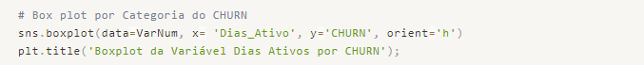
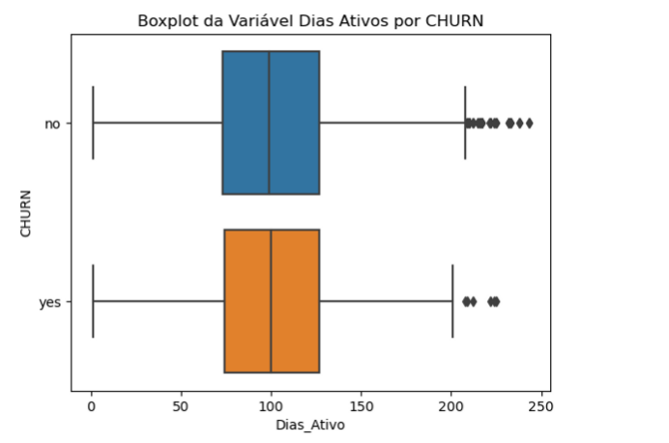

We conclude with the boxplot, which confirms that the median is close to the mean in both cases. However, this is not sufficient to prove the normal distribution according to the hypothesis test.

Variable Nr_Msgs_VM
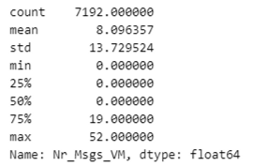

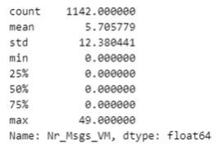

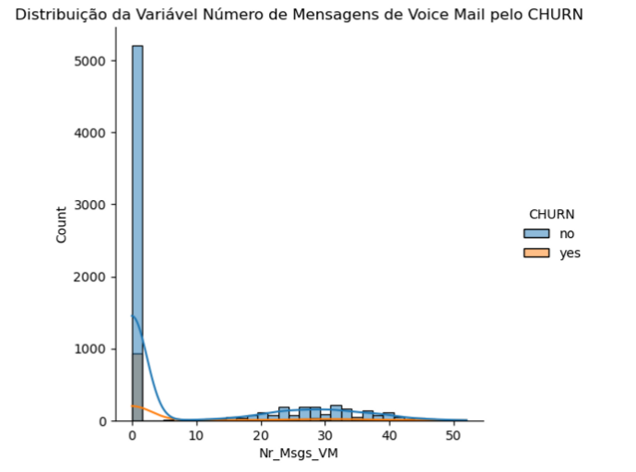
Insight -> It is important to note that in the majority of customers, this service is not utilized. In the case of customers who churned (CHURN = 'yes'), we see that almost 90% of them do not use the service.
Perhaps we can consider reducing the cost of this service and instead offer another service that is more useful to customers.

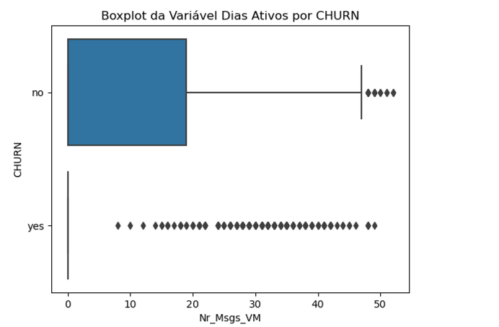
Clearly, we can observe that the median for both categories of CHURN is 0.0, except for a few customers who still use this service.

Variable Total_Dia
Let's analyze the variables related to the time of day, as we have already identified that they are correlated. Let's understand how they behave.

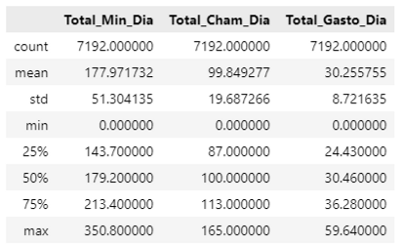

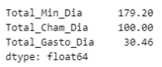

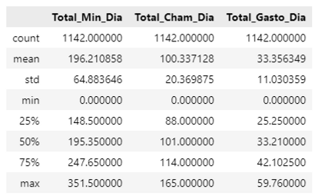

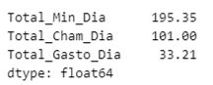

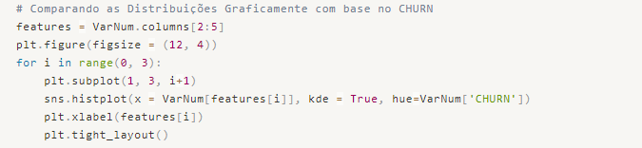
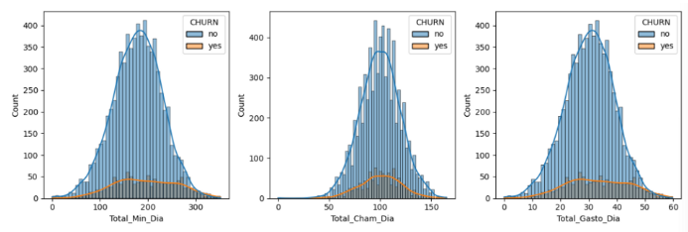
We can observe that the 3 variables have similar behaviors, including when we look at measures of central tendency. When we analyze only the observations with positive CHURN, we can see a negative Kurtosis, indicating a flatter curve with the same amplitude as the observations with negative CHURN.
Let's verify this by calculating the coefficients of Kurtosis and Skewness.
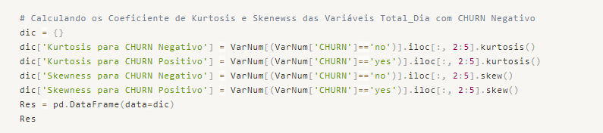
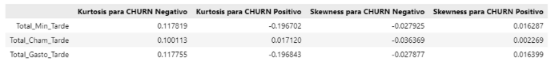
Analyzing the Skewness, we have distributions very close to zero, indicating symmetry. As for the Kurtosis, we observe similar characteristics to the Periodo_do_Dia variable, with distributions close to normal for negative CHURN and slightly flatter for positive CHURN.
Insight -> Finally, similarly to the Total_Day variable, what stands out in the behavior of these variables is that the means and medians are close for both negative and positive CHURN, suggesting that they may have little influence on the customer's decision to stay or leave the company's services.

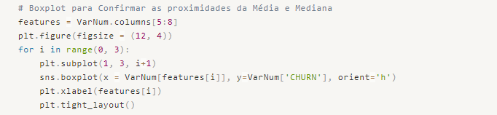
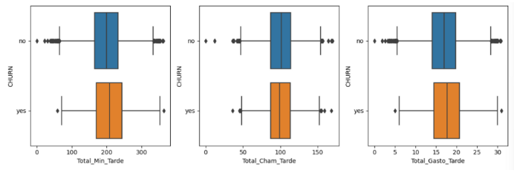

Variable Total_Noite
Let's proceed in the same way as we did with the Day and Evening period variables.

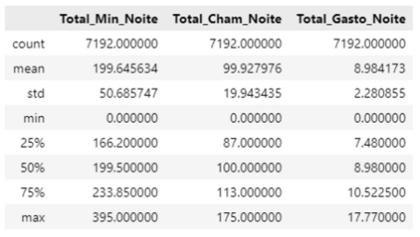

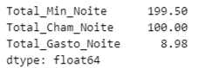

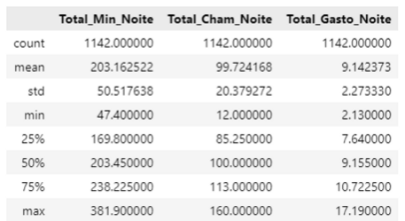

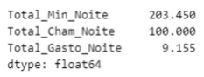

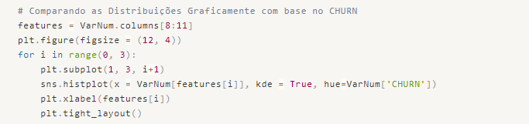
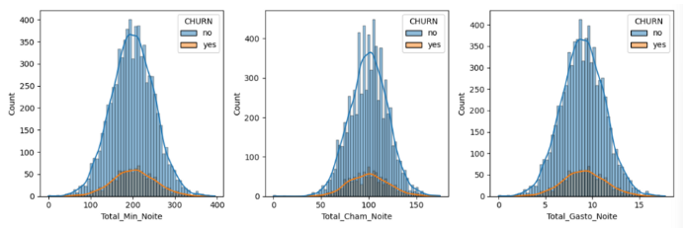
Similar to the variables for the Day and Evening periods, we can observe that the 3 variables exhibit similar behaviors, including measures of central tendency. When we analyze only the observations for positive CHURN, we can see a negative Kurtosis, indicating a flatter curve with the same amplitude as the observations for negative CHURN. Let's verify this by calculating the Kurtosis and Skewness coefficients.
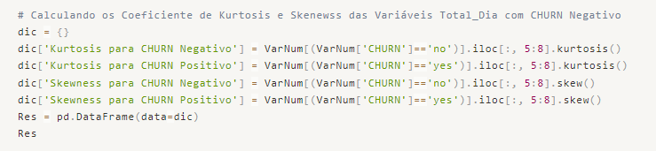
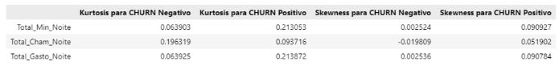
Analyzing the Skewness, we can see distributions that are very close to zero, indicating symmetry. As for the Kurtosis, we observe that all distributions are close to normal, both for negative CHURN and positive CHURN.
Insight -> Finally, similar to the Total_Day and Total_Afternoon variables, what stands out in the behavior of these variables is that the means and medians are close for both negative and positive CHURN. This suggests that these variables may have little influence on the customer's decision to stay or leave the company's services.
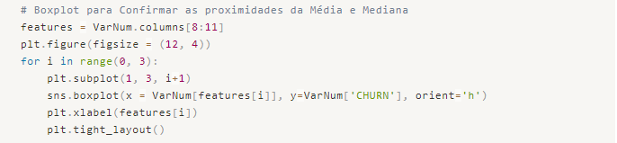
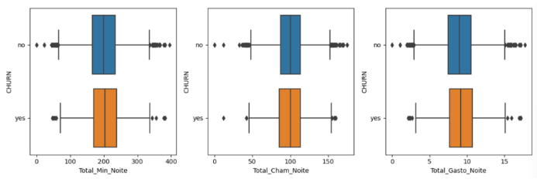

Variable Total_Inter
Let's apply the same analyses to the Day, Afternoon, and Evening periods and examine how International Calls behave.

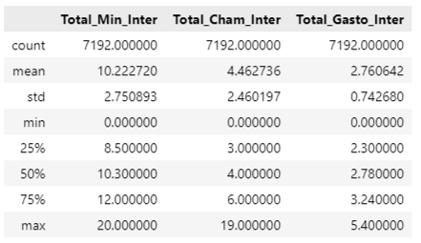

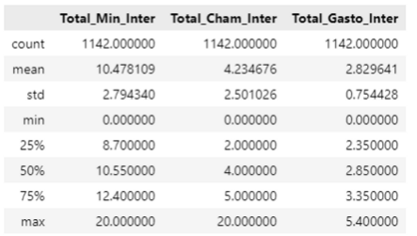

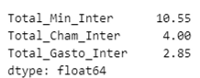

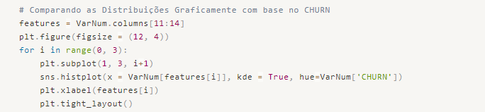
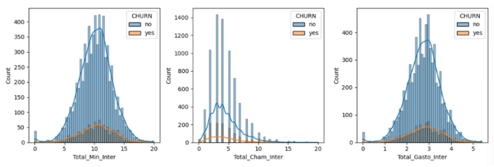
We can observe that the variables Total_Min and Total_Gasto have similar behavior for both Positive and Negative CHURN. As for the variable Total_Cham, we see a discrepancy in the behavior of the graphs, but we will confirm it by calculating the Kurtosis and Skewness coefficients.

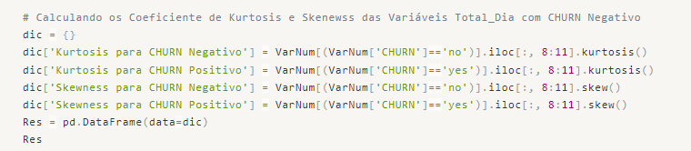
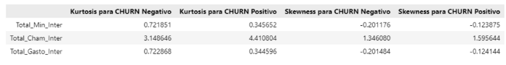
Despite our suspicions regarding the distribution of the Total_Cham variable, the coefficients confirm that they have similar behaviors in both Kurtosis and Skewness, with Kurtosis being slightly higher.
Insight -> Finally, similarly to the variables related to the time periods, what stands out in the behavior of these variables is that the means and medians are close for both CHURN Negative and CHURN Positive. However, one point of attention is the Total_Cham_Inter variable, as the 25th and 75th quartiles for CHURN Positive are shifted downwards compared to CHURN Negative, indicating that it is a less utilized service for those observations, despite the similar median and mean values.

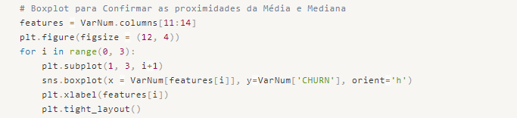
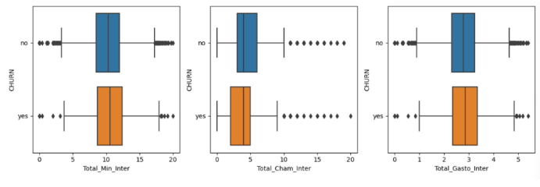

Variable Total_Cham_Atend
This variable may have a strong relationship with the customer's decision-making process. Let's analyze it further!

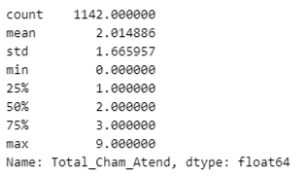

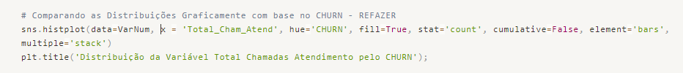
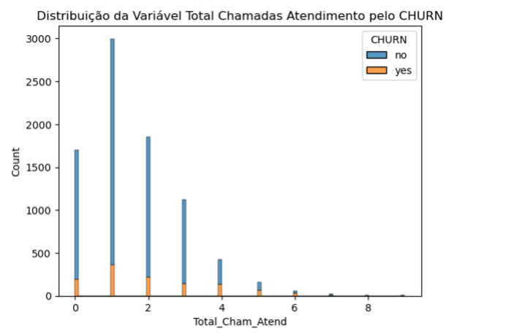
Insight -> Based on the data, we can see that the average number of calls for customers with positive CHURN is 2. For negative CHURN, the average is also around 2, considering that we don't have 1.5 calls. However, the key point here is the Mode, which represents the most frequent value in the variable. It is evident that both positive and negative CHURN cases have a Mode of 1 call. This indicates that this variable alone does not determine a change in the telephony plan. It is quite surprising since it was a business doubt: the more people call customer support (SAC), the more dissatisfaction and, consequently, the higher the positive CHURN.
We have finished analyzing the numerical variables. Now, let's move on to analyzing the categorical variables.

Categorical Variables
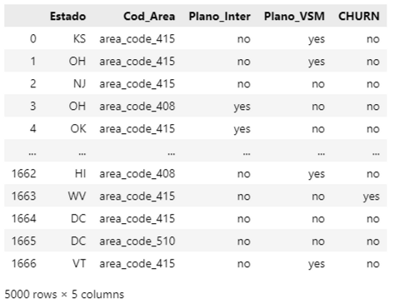

Variable Cod_Area

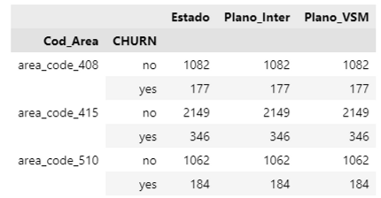

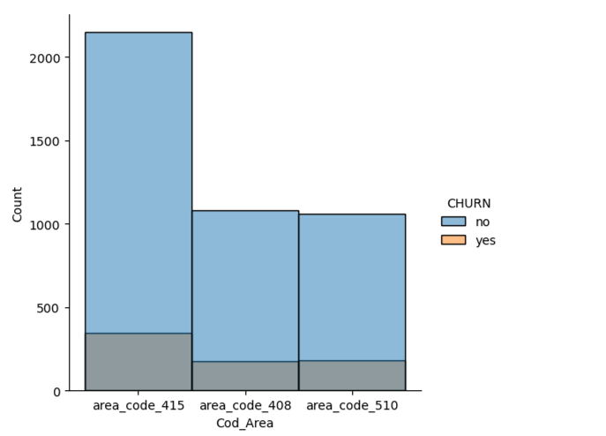
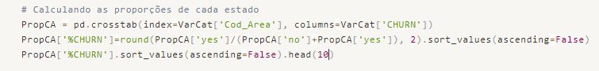
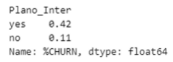

Insights -> For the International Plan variable, we observe that 42% of customers with an International Plan churned, indicating a positive churn. This is an interesting piece of information as it may be one of the reasons why customers become dissatisfied.

Variable Plano_VSM
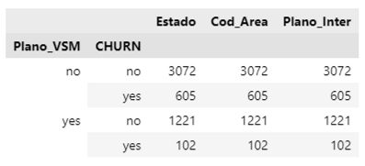

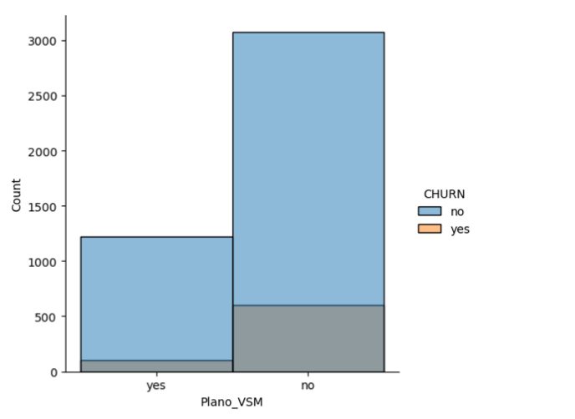
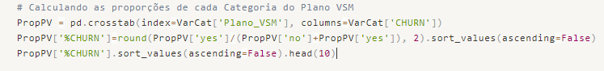
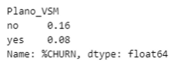

Insight -> For the variable related to the use of Voice Service Messenger, we notice that positive churn does not seem to be related to the Voice Messenger service. We have a 8% positive churn for those who use VSM and 16% for those who do not use the plan.

Data Preprocessing
At this stage, we will start preparing our data for predictive modeling.
The first step is to perform Label Encoding on the Categorical Variables, then apply a technique to balance the number of observations in the target variable. After that, we will split the data into training and testing sets, and finally, we will standardize the data to equalize the scales of each predictor variable.

Feature Engineering
As we identified during the correlation analysis in the exploratory data phase, there is multicollinearity between the variables Total_Min and Total_Gasto. Therefore, we will create a new variable, R$/Min rate, for each period, and then remove the Total_Min and Total_Gasto variables from the modeling dataset.
For the variables related to Plano_Internacional (International Plan), we have a different situation. There is the same multicollinearity between Total_Min and Total_Gasto, but calculating a new variable for R$/min rate will result in NaN values due to division by zero. This is because we have a categorical variable indicating the usage of this type of plan as either "Yes" or "No." Since all these variables are correlated, we will exclude Total_Min and the categorical variable Plano_Inter, and only keep Total_Cham_Inter and Total_Gasto_Inter.
By doing this, we aim to reduce the model's bias, simplify the dimensions, and increase generalization.
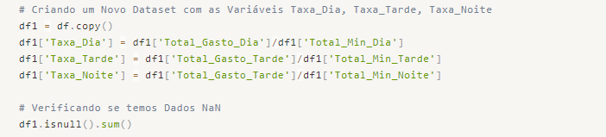
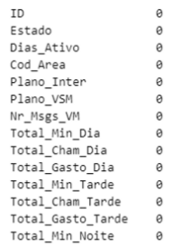
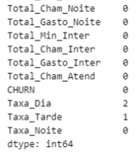

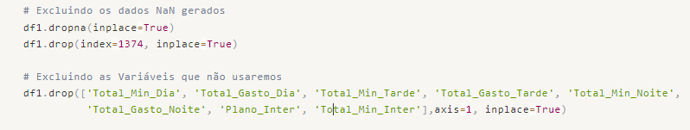
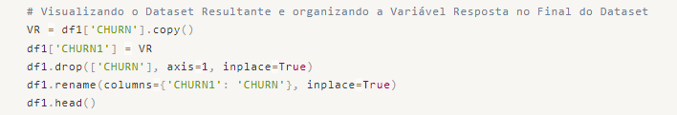
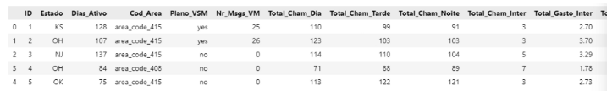

Applying Label Encoding Technique

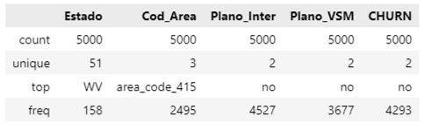

What we can observe is that the State variable has 51 unique values. The Label Encoding technique is not suitable for this case due to the large number of factors that would be created. Applying One-Hot Encoding would also not be ideal as it would introduce 51 additional variables to our project, increasing the complexity of the model.
Another consideration is the geographical representation provided by this variable, which can be represented by the Area Code variable, thus retaining at least one form of geographical information in our modeling. Taking these details into account, we will exclude the use of the State variable and keep the Cod_Area and Plano_VSM variables.
The response variable, CHURN, also needs to undergo Label Encoding, and we will address it accordingly.
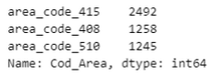

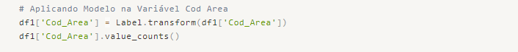

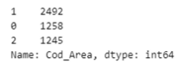

For the Cod_Area variable, we will use Label Encoding as follows:
- area_code_408 -> 0
- area_code_415 -> 1
- area_code_510 -> 2
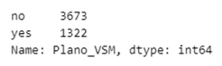

For the Plano_VSM variable, we will use Label Encoding as follows:
- no -> 0
- yes -> 1
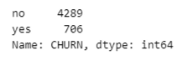

For the CHURN variable, we will use Label Encoding as follows:
- no -> 0
- yes -> 1

Applying Oversampling to the response variable
We will use the oversampling technique to balance our dataset in terms of the number of observations for positive and negative CHURN.
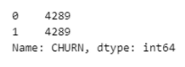

Splitting the data into training and testing sets.
We will split the data into training and testing sets, and then scale each dataset to finalize our preprocessing.
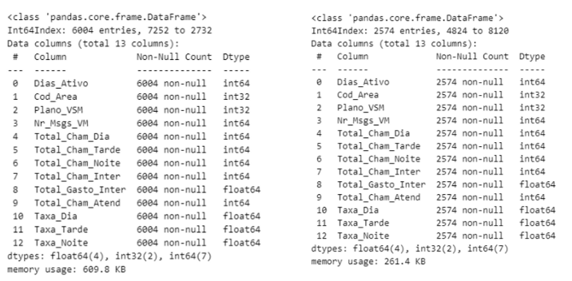
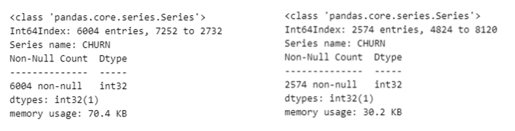

Applying Standardization to the training and testing datasets.
As we observed, the predictor variables have a behavior very close to a Normal Distribution, so using the Z-Score method for Standardization is more appropriate than Normalization in this case.
Preprocessing Completed! Let's proceed with Predictive Modeling...

Machine Learning
In this stage, we will create several models, calculate their respective metrics, and determine which model to use for the final delivery to the client.

Model 00 - Logistic Regression

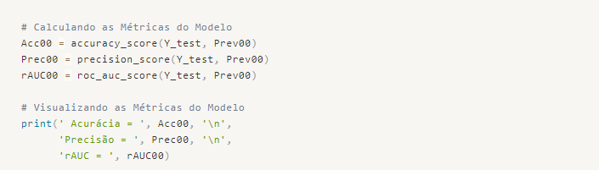
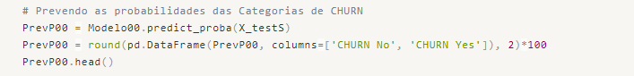
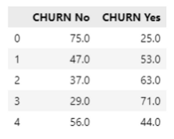

Model 01 - Stochastic Gradient Descent Classifier
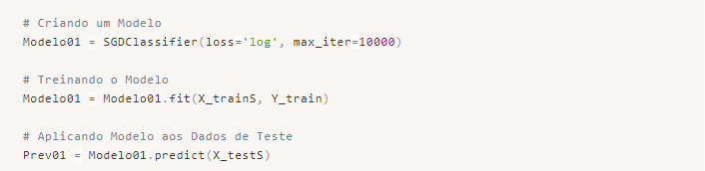
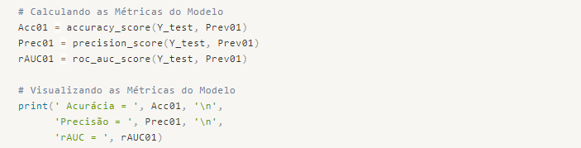

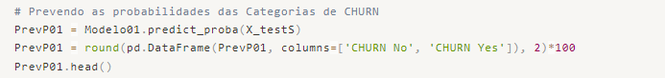
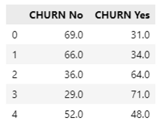

Model 02 - Ridge Classifier
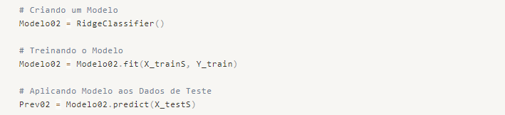

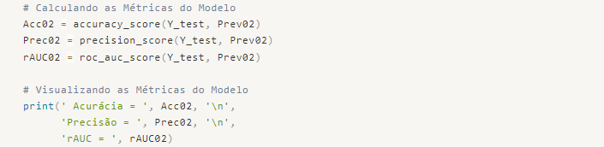

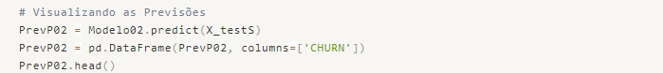
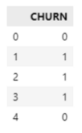

Model 03 - Decision Tree Classifier
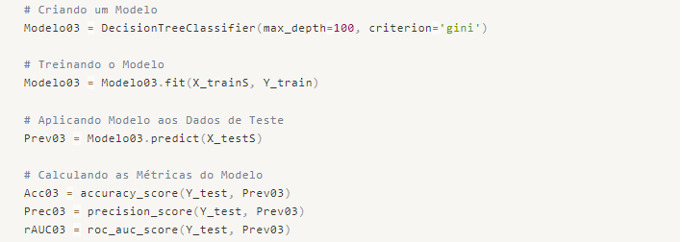

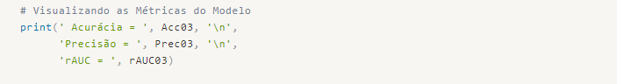

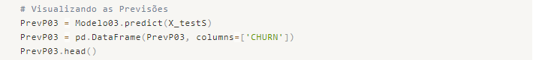
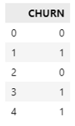

Model 04 - Support Vector Machine
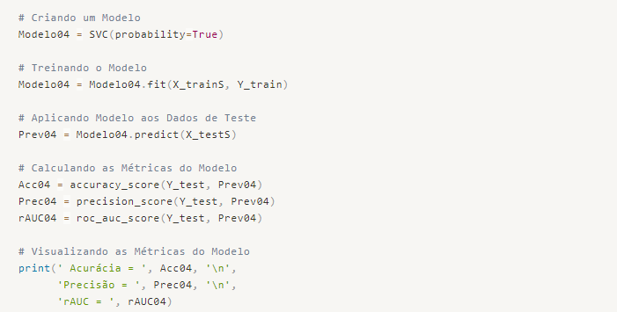
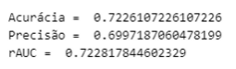

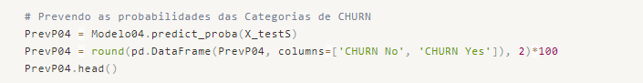
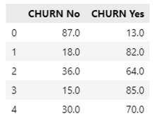

Model 05 - Support Vector Machine with Grid Search (Hyper parameter Optimization)
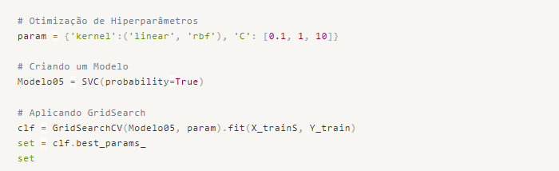

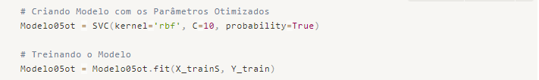
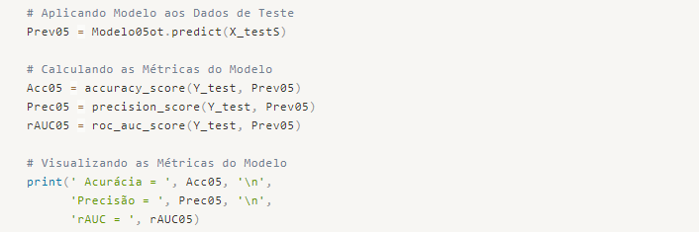

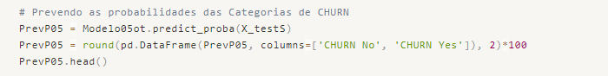
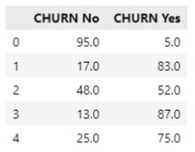

Conclusion
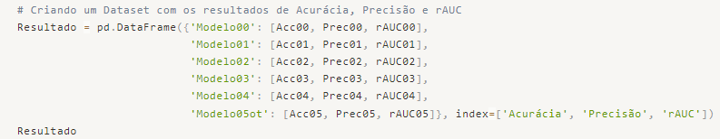
We have finally arrived at several models with different performances. Let's compare them and decide which model to deliver to the decision maker.

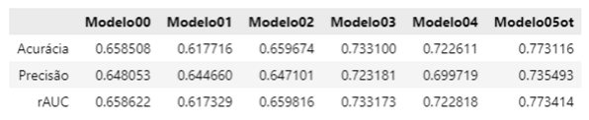
As we can see, Model 05 with the Support Vector Machine algorithm and Hyper parameter Optimization using Grid Search produced the best metrics, as shown in the table below. This will be the model we deliver for predictions on new data as desired by the decision maker.
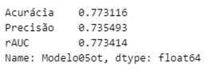

Summary of Insights:
- Low usage of Voice E-mail service among the majority of customers. In the case of customers who switched their phone plans (CHURN "yes"), nearly 90% of them do not use the service. This suggests the possibility of reducing the cost of this service and offering a more useful alternative to customers.
- The time period in which calls are made does not have a direct influence on customer decisions to stay or leave the phone plan. We did not identify any behavioral differences between positive and negative churn.
- Regarding International Calls, what stands out is that the means and medians are similar for both positive and negative churn. However, when looking at the quartiles of the Total International Calls variable, we notice a difference between churn categories, indicating that it is a less utilized service among customers who have left the phone plan, despite the similar median and mean values.
- When it comes to the Total Calls for Customer Service, the key point to note is the mode, which indicates that both positive and negative churn customers have made one call. This suggests that this variable alone does not characterize a phone plan change. It is surprising because there was a business concern that more calls to customer service would lead to higher customer dissatisfaction and, consequently, higher positive churn.
- Although area code 415 has a higher absolute number of positive churn, when considering the number of customers in each area code, we observe that the churn rate is similar across area codes, with a slight superiority of area code 510.
- Certain states stand out with a high churn rate compared to the total number of customers. These states include California, New Jersey, Washington, Texas, Montana, and Maryland, with churn rates above 20%.
- For the International Plan variable, we notice that 42% of customers with an international plan switched their phone plan, indicating positive churn. This is an interesting finding as it may be one of the reasons why customers become dissatisfied, either due to call quality or tariff rates.
- Regarding the variable related to Voice Service Messenger (VSM) usage, positive churn does not seem to be related to VSM. We have an 8% positive churn rate for users of VSM and 16% for non-users of the plan.

