**DOCUMENTATION OF PREPROCESSING DATA**

**I. Data structure:**

* **Original**: Storage of original images
* **Generated_Image**:
  + **001:** Reduced glare directory (section II – first method)
  + **003:** Reduced glare & enhanced contrast directory
* **helper.py**: necessary functions
* **generate.py**: Do generate!
* **show_case.py**: Run after generating to see deeper

**II. Pre-processing data:**

* **First processing method:** Reduce glare (RG) for all images in Original, output images are stored at Generated_Image/001

Include a 4-mixed-filter by 4 steps:

1. First polynomial function (see more at **section II – part 2** in **[v20190404] Reduce Glare - Giảm lóa.pdf**)

2. Gamma correction: *g = 0.75*

3. Second polynomial function

4. Gamma correction: *g = 0.8*

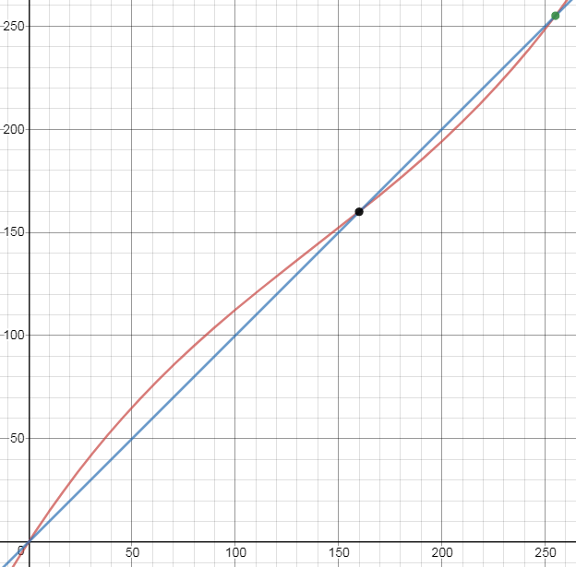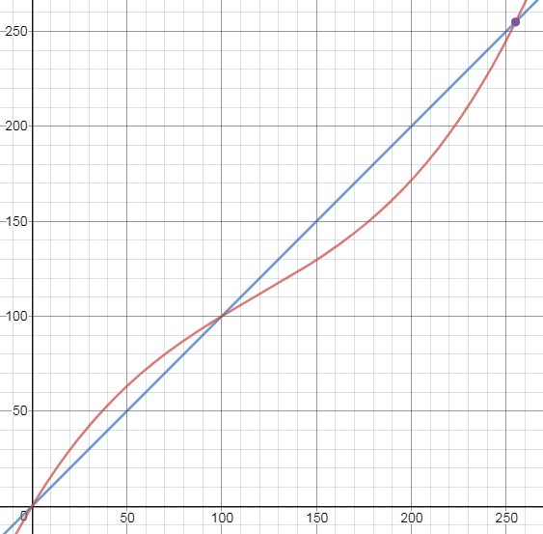

*Left is* ***first polynomial function*** *with threshold = 100.  
Right is* ***second polynomial function*** *with threshold = 160.*

* **Third processing method:** Reduce glare + Enhance contrast (RG + EC) for all images in Original, output images are stored at Generated_Image/003

Mixed 4 steps:

* 1. Reduce glare
  2. Enhance contract: factor = 1.6
  3. Reduce glare
  4. Enhance contract: factor = 1.4