Sure! Here are some ideas and features to enhance your expense tracker project:

### Features to Implement

**User Authentication**

* 1. Allow users to create accounts and log in to access their personal expense data.

**Add/Edit/Delete Transactions**

* 1. Users can add new expenses, edit existing ones, or delete transactions.

**Categorization**

* 1. Allow users to categorize expenses (e.g., food, travel, entertainment) for better tracking.

**Recurring Expenses**

* 1. Implement a feature to set up recurring expenses (e.g., monthly subscriptions).

**Budgeting Tools**

* 1. Enable users to set monthly budgets for different categories and track their progress.

**Data Visualization**

* 1. Use charts or graphs to visualize spending habits over time (e.g., pie charts for category breakdowns).

**Export Data**

* 1. Allow users to export their data as a CSV file for offline analysis.

**Multi-Currency Support**

* 1. If applicable, let users input expenses in different currencies and convert them.

### Technical Considerations

* **Backend**: Use Node.js with Express, or a serverless solution like Firebase, to handle data storage and user authentication.
* **Database**: Consider using MongoDB or PostgreSQL to store user data and transactions.
* **Frontend**: Use React for the user interface, along with libraries like Chart.js for data visualization.

### Project Structure

**Frontend**:

* + Components: Header, ExpenseList, ExpenseItem, AddExpenseForm, Dashboard, etc.
  + Pages: Home, Login, Signup, Dashboard.

**Backend**:

* + API Endpoints:
    - POST /api/expenses to add an expense
    - GET /api/expenses to retrieve expenses
    - PUT /api/expenses/:id to edit an expense
    - DELETE /api/expenses/:id to delete an expense

### Additional Enhancements

* **Mobile Responsiveness**: Ensure the app works well on mobile devices.
* **Dark Mode**: Implement a dark mode for better user experience.
* **Notifications**: Send reminders for upcoming bills or budget limits.

### Learning Resources

* **React Documentation**: For building the frontend.
* **Express Documentation**: For setting up the backend.
* **Chart.js Documentation**: For creating visualizations.

If you have specific questions or need help with any part of this project, feel free to ask!

--------------------------------------------------------------------------------------------------------------------------------------

Here’s a simple UI/UX outline for your expense tracker application. You can use this as a reference to build your design.

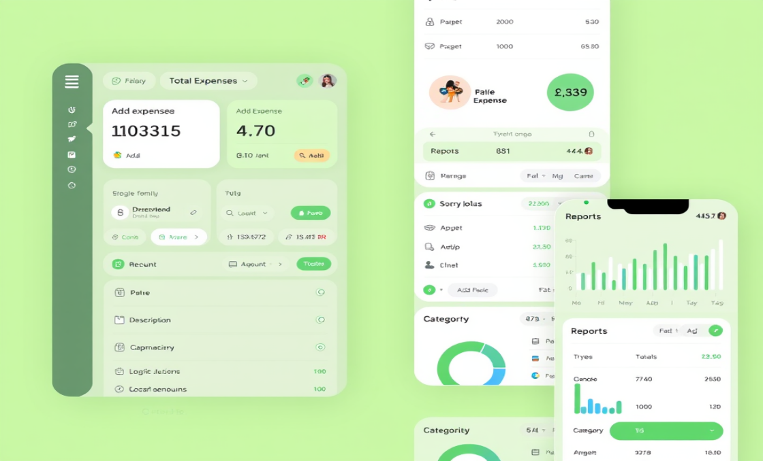

### Expense Tracker UI/UX Outline

#### 1. ****Home / Dashboard****

**Header**

* + App Title: "Expense Tracker"
  + Navigation Links: Home, Add Expense, Reports, Settings

**Main Section**

* + **Total Expenses Display**: Shows total spent this month.
  + **Expense Overview**:
    - * Pie Chart: Illustrating the allocation of expenditures by category.
  + """
  + **Recent Transactions List**: Display the last few transactions with:
    - Date
    - Description
    - Amount
    - Category (with color coding)

**Footer**

* + Links to About, Help, Contact

#### 2. ****Add Expense Page****

* **Form Fields**
  + Description: Text input for the expense description.
  + Amount: Numeric input for the expense amount.
  + Category: Dropdown menu to select a category (Food, Travel, etc.).
  + Date: Date picker for selecting the transaction date.
* **Buttons**
  + Submit: Button to add the expense.  
    Cancel: Button to return to the dashboard.

#### 3. ****Reports Page****

**Filters**

* + Date Range: Start and end date pickers.
  + Category Filter: Dropdown to filter by category.

**Graphs**

* + **Budget Overview**: Visual representation of budget vs. actual spending (e.g., progress bar).
  + Line Graph: Showing expenses over time.

#### 4. ****Settings Page****

**User Profile**

* + Option to update account details (email, password).

**Budget Settings**

* + Set monthly budgets for different categories.

#### 5. ****Mobile Responsiveness****

* Use a responsive grid layout to ensure usability on mobile devices.
* Make buttons large enough for easy tapping.

### Tools for Design

* **Figma / Sketch**: For creating the UI mockups.
* **Adobe XD**: For prototyping and testing the user experience.

### Example Color Scheme

* **Primary Color**: #4CAF50 (Green for positive spending)
* **Secondary Color**: #FF5722 (Red for alerts)
* **Background Color**: #F4F4F4 (Light gray)

Feel free to adjust any part of this outline to better fit your vision! If you need further details or specific components, just let me know!