


BSc in Science in Computing & Multimedia
Year 2, Semester 2, 2024

MobileApp

Module Title: MobileApp
Module Code: BSC2
Assessment Type: Individual Project
Weighting:
Maximal Possible Mark: 100 marks
Submission Date: See Moodle

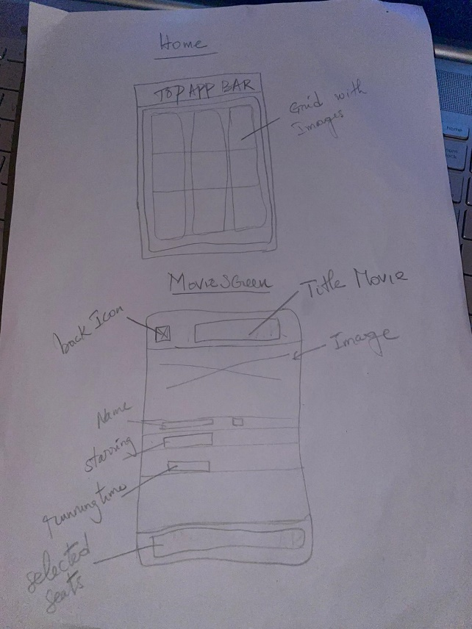

INTRODUCTION

This report explores the creation and execution of a movie screen and seat selection function in accordance with the specifications given in BSC2/Lab 2. The task at hand involves generating a Movie class that follows the format specified in the movie.json file and adding data from other sources to it. It also entails embedding a MovieActivity with a seat selection functionality that includes elements like validation, retention after going back, and seat counting. Along with extra screenshot features, this report will outline the efforts done to meet these objectives.

MOVIE SCREEN IMPLEMENTATION

Movie class structure

It has been asked to create a class called Movie in the project but I called it Screendata instead because, it was easier for me to remember where I stored my data for the screens. Here is a screenshot of my Class called Screendata:

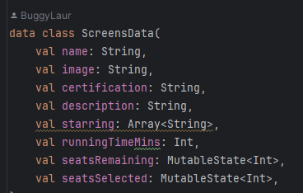

I used Array because I wanted a flexibility storing multiple values since a movie has multiple actors.
I used MutableState to allow reactivity. In jetpack compose, it is commonly use to represent UI-related state, such as the number of selected seats in a movie booking App

2.Data Acquisition and Filling

Instead of creating each class for each movie, I created a list of movies to make my code manageable and scalable. It makes it easier to manipulate the data in the application. It also reduces redundancy and improves efficiency. Here is a screenshot of how I did my list of movies:
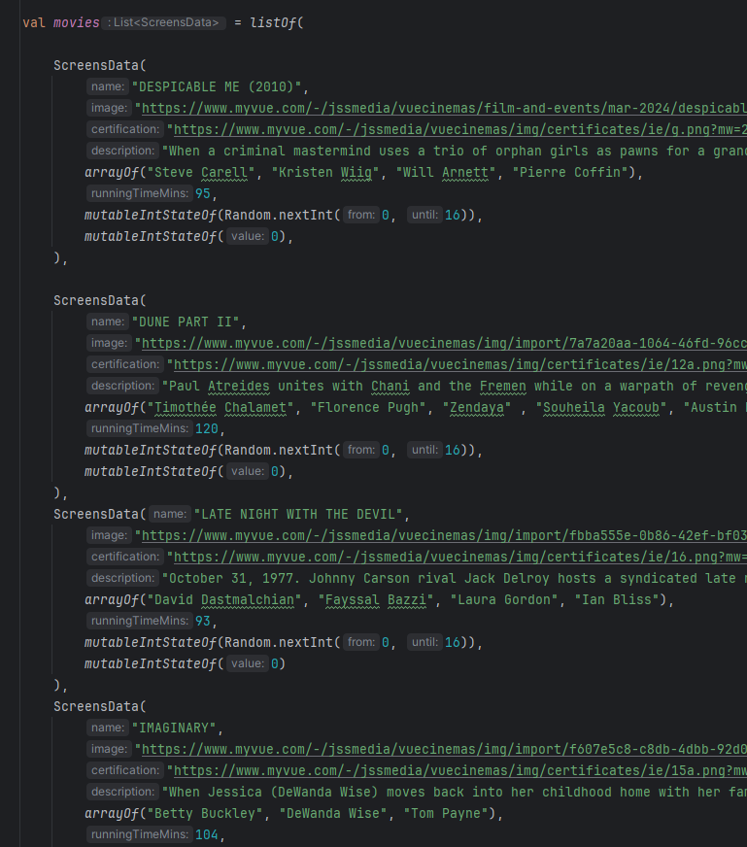
I collected the data form the actual website of view https://www.myvue.com/cinema/dublin/whats-on by just taking links and information of each movie.

3.Randomization of seats

The function mutableIntStateOf(Random.nextInt(0, 16)) produces a random number between 0 (inclusive) and 16 (exclusive). This figure indicates how many seats were initially available on the movie screen. Here, this Random class is used to guarantee that the number of seats available on each movie screen is chosen at random at the beginning.
mutableIntStateOf(0): With a starting value of 0, establishes another mutable state of type Int. This is the initial count of seats that the user has chosen for the movie screen. Initially, there are no seats chosen, so the value is set to 0.

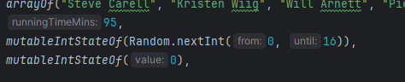

4.Home Screen

Here is my home screen:
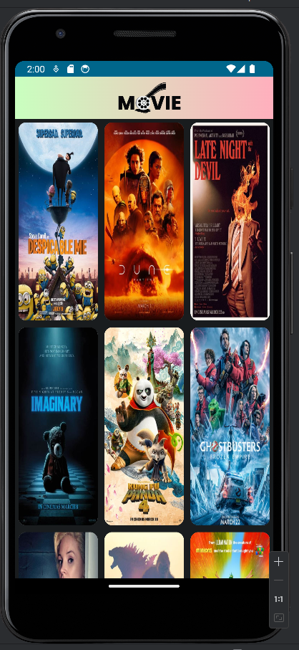
At first I was struggling loading the images on my screen, I didn’t know I had to import and extra library for that so I imported Coil.

For the screen to come in 3 columns, I used LazyverticalGrid(Columns=Gridcells.Fixed(3). Then I used Card to draw attention to the individual items in the grid. With card We can also make each image clickable and interactive. Here is the peace of the code
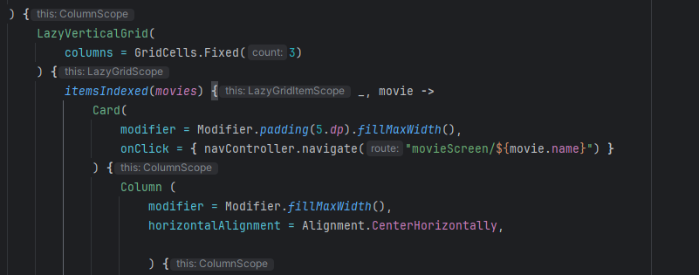

For the Top App Bar, I tried many solid color but they didn’t satisfy me. They were not fancy enough so I decided to use a gradient color. I couldn’t find how to do it on youtube or stack overflow or even Chat gpt for at least an hour, then I remembered that I have Gemini. That helped me a lot:
I created a variable Virgin with two other variables to make the gradient and I put the container transparent.
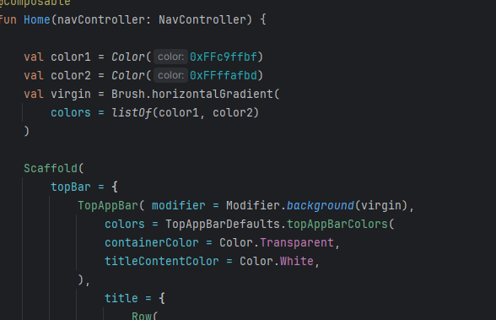

5.Movie Screens

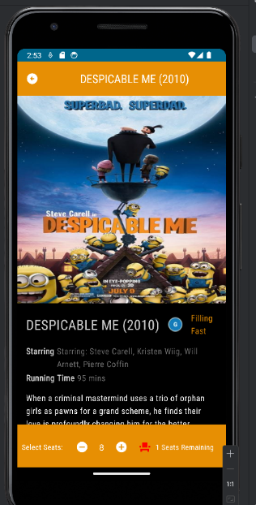

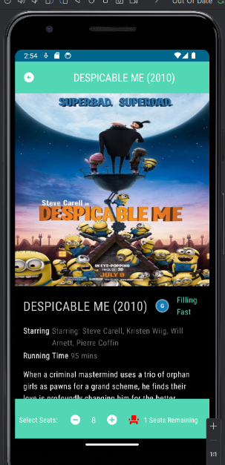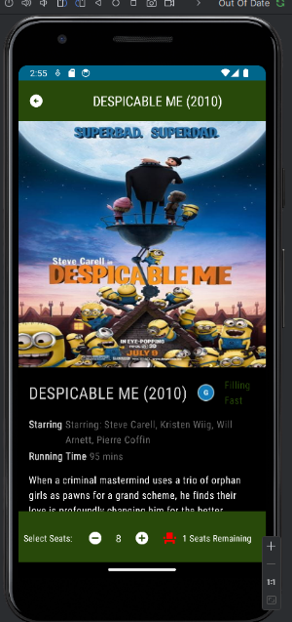

Still, I didn’t want my app to be boring with just a colour each time for all the screens, so I created a random function to generate random colour based on three colours(red,green,blue), so every time you click a screen, it shows different colours on the top, bottom bars and also the Filling fast. Here is the code:
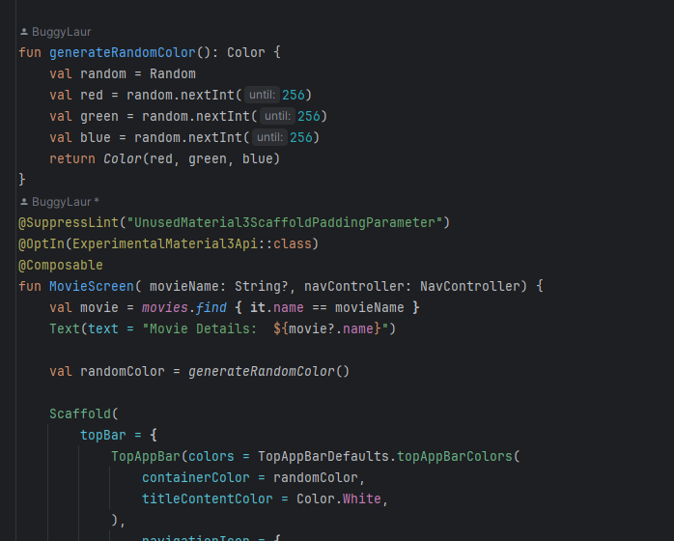
I imported Kotlin.random.Random to generate.

For the Icons +/-/<- , I used a library called

Here is the code for the back icon. It goes to the Appnav Home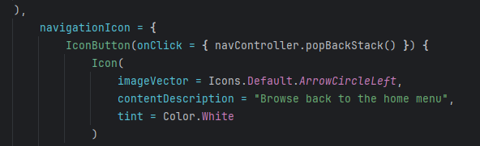
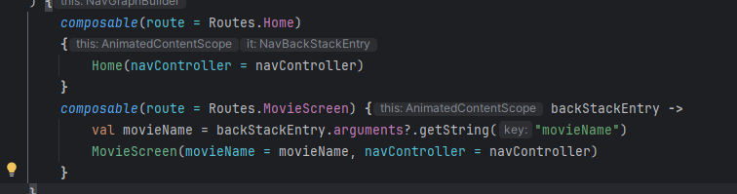

For the interactions between the add icon and the remove, here is the code just explaining how is working. I put 3 conditions :
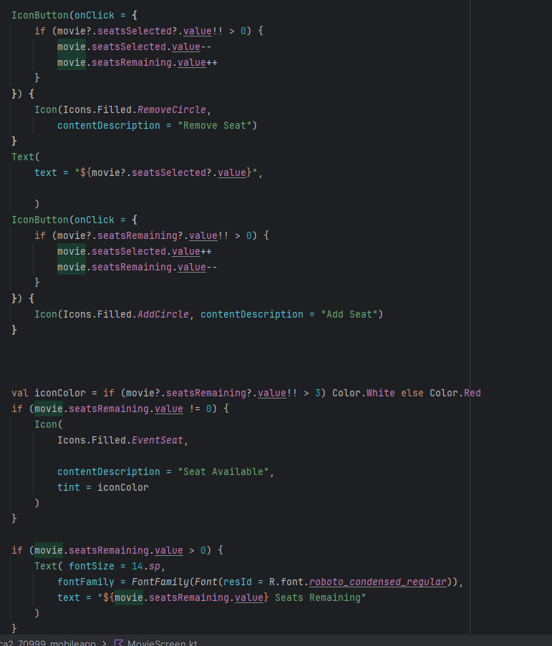

Here is the conditions for the filling fast
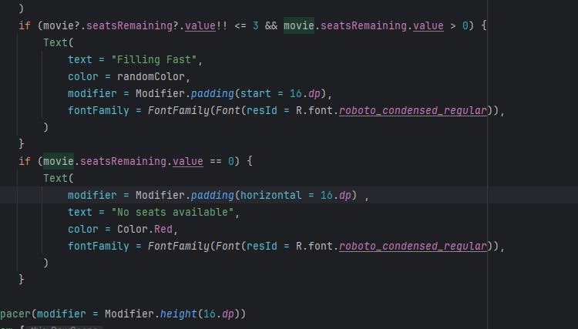

Difficulties I encountered:
- Putting in Roboto font. Even though I imported the library google.font, I still couldn’t put that in Roboto.
To be honest I just wrote lots of thing in the xml files that I found everywhere that I don’t remember why I did it. But it finally worked.
- For the late-night movie screen, When I fill the seat, it shifts down and we don’t see writing like filling fast or no seat available. I think the image is really big for the emulator

