**Mobile Apps 2**

**Assignment Eight**

**Submission Date 09/12/2024**

Percent 10%

**Include all workings and references**

***Section A.***

1. How is Responsiveness achieved in JetPack Compose? (*3 marks*)

Responsivesness in Jetpack compose is achieved through several futures and principles built into its design:

* **Declarative UI paradigm**: Jetpack compose uses a declarative approach, where the UI automatically updates when the underlying data changes.. This eliminates the need to manual manipulate views, making the UI more responsive to state changes. [Jetpack Compose UI App Development Toolkit - Android Developers](https://developer.android.com/compose)

Example:

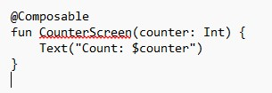

If the counter variable changes, the UI immediately reflects the updated value.

* **State Management**: Compose provides built-in state handling through remember , state, and MutableState. These tools allow seamless and efficient UI updates.

Example:

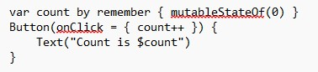

* **Asynchronous and threading Support:** Compose integrates with coroutines to handle asynchronous operations, ensuring responsiveness even during long running tasks.

Example:

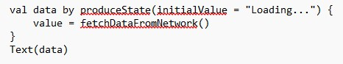

1. Give two real-world examples of where you would use DeepLinking (*2 marks*). [Verify Android App Links - Android Developers](https://developer.android.com/training/app-links/verify-android-applinks)

Deeplinking enables apps to respond to custom URLs or intents, providing users with direct access to soecific parts of the app.

1. Example1: Redirecting Users to a specific product page in an E-Commerce App.

A shopping app might use deepLinking to send usersdirectly to a product page via a marketing email.

* Deep Link URL Example: myshop://product/12345
* Benefit: Users can jump directly to the product instead of navigation from the homepage.

1. Example2: Navigating to a chat Message in a Messaging App

A messaging app could use Deep linking to take users to a specific chat thread from a push notification.

* Deep Link URL Example: chatapp://conversation/67890
* Benefit: Improves user experience by reducing clicks and time taken to access the desired screen.

***Section B.***

1. Using an existing assignment, create and show the workings of a DeepLink (*3.5 marks*)

I am going to use my assignment from BSC2 that I started but couldn’t finish.  
Now it’s working.  
It is a booking system for movies.  
I used deep links form Vue.

1. Create two buttons that will stop and start a specific sound on your app (*1.5 marks*)