OOP-2023-CA1-70999

Explain – with the use of a code fragment – what an abstract class is and how would use it.

A class that lacks a body and is capable of abstract methods—that is, methods that aren't self-instantiating—is referred to be abstract in C#. Abstract classes are meant to be used as foundation classes so that derived classes have a consistent interface and behaviour. This code excerpt illustrates the concept of an abstract class:
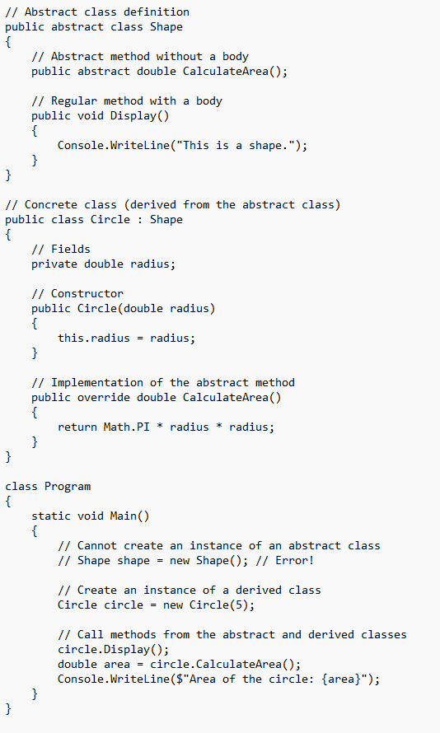
The {Shape} class in this illustration has an abstract function called `CalculateArea()}. The `Circle` class offers an implementation of the abstract method and is derived from `Shape`. The `Main` method shows that although an instance of a derived (concrete) class can be created and used polymorphically through the abstract class's interface, an instance of an abstract class cannot be created directly. Regular (non-abstract) methods with shared implementations across all derived classes can also be present in the abstract class.

