F1 Telemetry System
Technical Report

Course: Distributed Systems / IoT Architectures
Author: Buglione Marco, Rossi Giorgio
Date: May 2026

1. Introduction and Scenario

1.1 Domain Description
Formula 1 is one of the most data-intensive motorsports in the world. A modern F1 car generates approximately 1.5 GB of telemetry data per race weekend, transmitted in real time from the car to the pit wall and, via satellite, to the team's factory. Engineers monitor hundreds of parameters — engine RPM, tire temperatures, fuel levels, brake temperatures, throttle application — to make real-time decisions on strategy, pit stops, and safety.
This project implements a distributed telemetry system that simulates a 10-car, 5-team F1 race at the Monza circuit, collecting and processing sensor data in real time. The system is designed to demonstrate the key principles of distributed IoT architectures: asynchronous publish/subscribe communication, stream processing, persistent storage, and live visualization.

1.2 System Goals
The system pursues the following objectives:
- Simulate realistic sensor data for 10 cars across a multi-lap race at Monza
- Transmit telemetry using MQTT with a hierarchical topic structure
- Process incoming data streams in Node-RED: normalization, classification, event detection, persistence
- Store time-series data in MongoDB with appropriate indexing and retention policies
- Visualize the live race on a web dashboard: circuit map, leaderboard, car states, race events
- Secure race-control command channels with symmetric encryption (AES-256-GCM)

1.3 Race Configuration
Parameter | Value
Circuit | Monza (5.793 km)
Cars | 10 (5 teams × 2 cars each)
Teams | Ferrari, Mercedes, Red Bull, McLaren, Alpine
Race Length | 5 laps (configurable)
Simulation Tick | 250 ms (4 Hz)
Telemetry Frequency | 2–5 Hz per car

2. System Architecture Overview

2.1 Layered Architecture
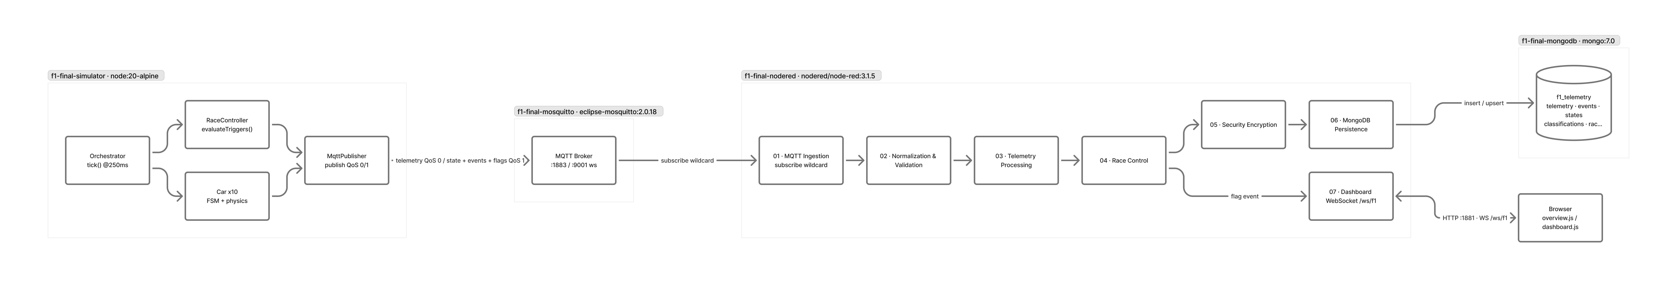
Figure 1 — Component Diagram: system architecture overview
The system is organized into five distinct layers, each with a clearly defined responsibility:
┌─────────────────────────────────────────────────────┐
│ VISUALIZATION LAYER │
│ Web Dashboard (HTML5 + WebSocket) │
├─────────────────────────────────────────────────────┤
│ PROCESSING LAYER │
│ Node-RED (9 flow tabs) │
├─────────────────────────────────────────────────────┤
│ COMMUNICATION LAYER │
│ Eclipse Mosquitto 2.0.18 (MQTT) │
├───────────────────────┬─────────────────────────────┤
│ SIMULATION LAYER │ PERSISTENCE LAYER │
│ Car Simulator (Node) │ MongoDB 7.0 │
└───────────────────────┴─────────────────────────────┘

Simulation Layer — A Node.js process that runs all 10 cars concurrently. Each car has a physics model, a finite state machine (FSM), and publishes telemetry/state/event messages to the MQTT broker at regular intervals.
Communication Layer — Eclipse Mosquitto acts as the central message bus. Publishers (simulator) and subscribers (Node-RED, dashboard) are fully decoupled. The broker enforces QoS policies and manages retained messages.
Processing Layer — Node-RED subscribes to all MQTT topics via wildcards. It normalizes payloads, detects events, computes the live race classification, writes data to MongoDB, and broadcasts aggregated updates to the dashboard via WebSocket.
Persistence Layer — MongoDB stores time-series telemetry and discrete events across five collections. Indices are optimized for the most common queries. A TTL index automatically purges telemetry documents after 30 days.
Visualization Layer — A single-page web application served by Node-RED. It connects via WebSocket and renders the SVG Monza circuit with animated car markers, a live leaderboard, a car state panel, an event log, and a race control indicator.

2.2 Technology Stack
Component | Technology | Version
Car Simulator | Node.js | 18+
MQTT Client | mqtt (npm) | 5.3.5
MongoDB Driver | mongodb (npm) | 6.12.0
Schema Validation | ajv (npm) | 8.20.0
MQTT Broker | Eclipse Mosquitto | 2.0.18
Stream Processing | Node-RED | latest
MongoDB Node | node-red-node-mongodb | 0.2.5
Database | MongoDB | 7.0
Dashboard | HTML5 + Vanilla JS | —
Containerization | Docker Compose | —

2.3 Container Topology
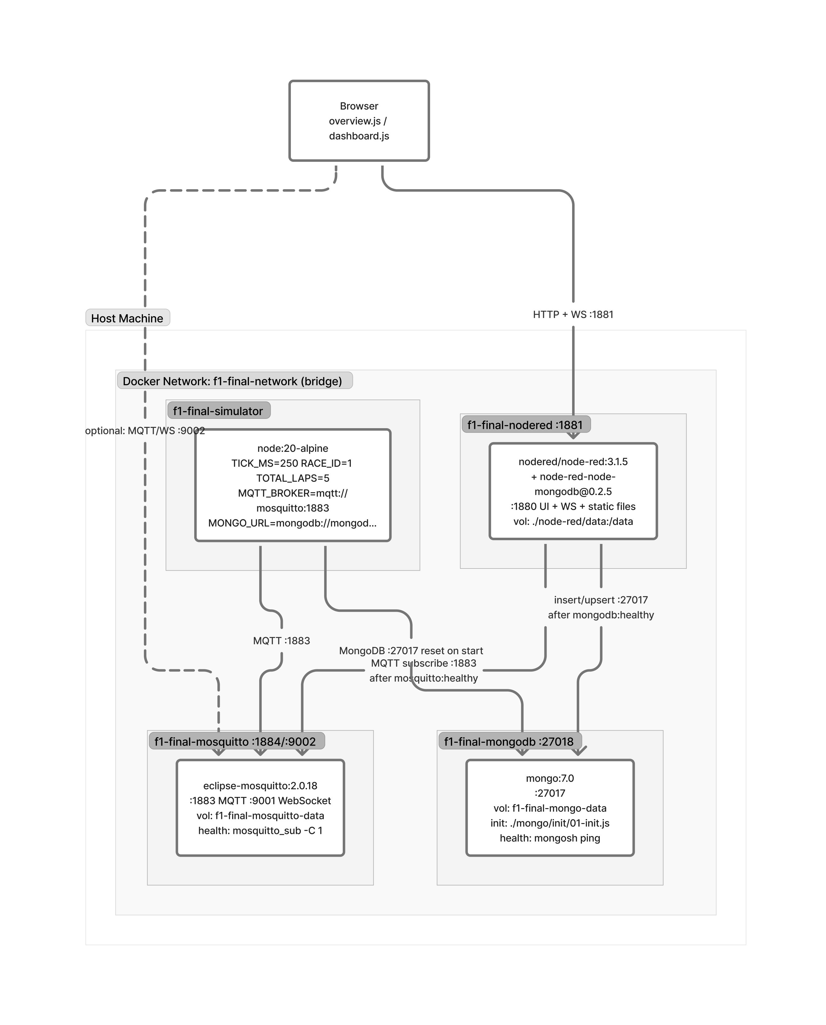
Figure 2 — Deployment Diagram: Docker container topology

All services are orchestrated with Docker Compose. Four containers communicate over a dedicated Docker network (f1-net):
Container | Image | Exposed Ports | Internal Ports
mosquitto | eclipse-mosquitto:2.0.18 | 1883, 9002 | 1883 (MQTT/TCP), 9002 (MQTT/WS)
mongodb | mongo:7.0 | 27017 | 27017
node-red | custom Dockerfile | 1881 | 1881
simulator | custom Dockerfile | — | —

The simulator container connects to Mosquitto and MongoDB by service name (DNS resolution within f1-net). Node-RED connects to both Mosquitto and MongoDB internally and exposes the dashboard and WebSocket on port 1881.

3. Communication Protocol — MQTT

3.1 Protocol Choice
MQTT (Message Queuing Telemetry Transport) is a lightweight publish/subscribe protocol designed for constrained environments and high-latency networks. It was originally developed for pipeline telemetry over satellite links and is now an ISO standard (ISO/IEC 20922:2016).
The choice of MQTT over alternative protocols (HTTP polling, WebSocket streams, AMQP) is justified by:
- Low overhead: binary framing with 2-byte fixed header; suitable for high-frequency sensor data
- Decoupling: publishers and subscribers have no direct knowledge of each other
- QoS levels: three delivery guarantees selectable per message
- Retained messages: broker stores the last message per topic, enabling late-subscriber catch-up
- Hierarchical topics: natural mapping to the race/team/car/sensor hierarchy

3.2 Topic Hierarchy
Topics follow a strict hierarchical naming convention:
f1/simulation/{raceId}/teams/{teamId}/cars/{carId}/telemetry
f1/simulation/{raceId}/teams/{teamId}/cars/{carId}/state
f1/simulation/{raceId}/teams/{teamId}/cars/{carId}/events
f1/simulation/{raceId}/race-control/flags
f1/simulation/{raceId}/race-control/classification
f1/simulation/{raceId}/control/start
f1/simulation/{raceId}/control/stop
f1/simulation/{raceId}/secure/race-control/flags

Segment semantics:
- raceId — numeric identifier for the race session (e.g., 1)
- teamId — lowercase team name (e.g., ferrari, mercedes)
- carId — car number per FIA regulations (e.g., 16, 44)
- Leaf segment — message type: telemetry, state, events, flags, classification

3.3 QoS Policy
Topic | QoS | Retained | Justification
.../telemetry | 0 | No | Sample loss tolerable; next arrives within 500 ms. Throughput priority.
.../state | 1 | Yes | Each state change is semantically significant. Retained for late subscribers.
.../events | 1 | No | Events must not be lost, but no replay needed.
.../flags | 1 | Yes | Race-control commands must be delivered and persisted for reconnects.
.../classification | 1 | Yes | Late-joining dashboard must receive current standings immediately.
.../secure/flags | 1 | No | Encrypted commands; no replay after decryption.

3.4 Payload Schemas
All payloads are JSON objects validated against JSON Schema (Draft 2020-12) in the simulator and Draft-04 in MongoDB validators.
Telemetry payload (16 required fields):
{
"timestamp": "2026-04-27T14:32:10.512Z",
"raceId": 1,
"teamId": "ferrari",
"carId": 16,
"compound": "medium",
"lap": 12,
"trackPos": 0.4731,
"speed": 287.4,
"rpm": 11800,
"gear": 7,
"throttle": 0.92,
"brake": 0.0,
"drs": true,
"tireTemp": { "fl": 102.1, "fr": 99.8, "rl": 105.3, "rr": 104.7 },
"tireWear": { "fl": 0.62, "fr": 0.61, "rl": 0.65, "rr": 0.64 },
"fuel": 38.2,
"state": "RUNNING"
}

4. Simulation Layer

4.1 Architecture
The simulator is a single Node.js process managing all 10 cars. This single-process design was chosen deliberately to avoid the complexity of distributed state synchronization: all cars share the same in-memory race context, track position references, and timing clock.
The main loop (orchestrator.js) fires every 250 ms (configurable via config/default.js). Each tick:
- Calls car.tick(dt) for each active car
- Evaluates race-control triggers (auto-flag logic)
- Publishes telemetry for each car to its MQTT topic

4.2 Physics Model
The Monza circuit is modeled as a trackPos scalar in [0, 1], representing the fractional position along the 5.793 km track. A 31-point speed profile (monza.js) maps each track section to a target speed:
Section | Target Speed | Notes
Main straight (0.0 – 0.08) | 340 km/h | DRS zone 1
Prima Variante (0.08 – 0.12) | 80 km/h | Chicane
Parabolica (0.85 – 1.0) | 145 → 330 km/h | Long corner → straight

At each tick, the physics engine (physics.js) computes:
- Target speed from the track profile, adjusted for compound degradation and active flags
- Actual speed via first-order lag: v += clamp((target - v) * responseRate, -maxBrake, maxAccel)
- Gear selection based on current speed and RPM range (7-speed sequential)
- RPM from speed and gear ratio: rpm = speed / (wheelCircumference * gearRatio) * 60
- Throttle/brake derived from speed delta: positive delta → throttle; negative → brake
- DRS enabled when in a DRS zone and gap to car ahead > 1 second

4.3 Tire and Fuel Model
Tire wear (tire-fuel.js) increases each tick proportionally to speed and current tire temperature:
wearDelta = baseWearRate × speedFactor × tempFactor × dt
tempDelta = (throttle × heatRate + brake × brakeHeatRate - coolRate) × dt
fuelDelta = -baseFuelRate × throttle × dt

Three tire compounds are available: Soft, Medium, Hard — differing in wear rate, heat generation, and optimal temperature window.

4.4 Car Finite State Machine (FSM)

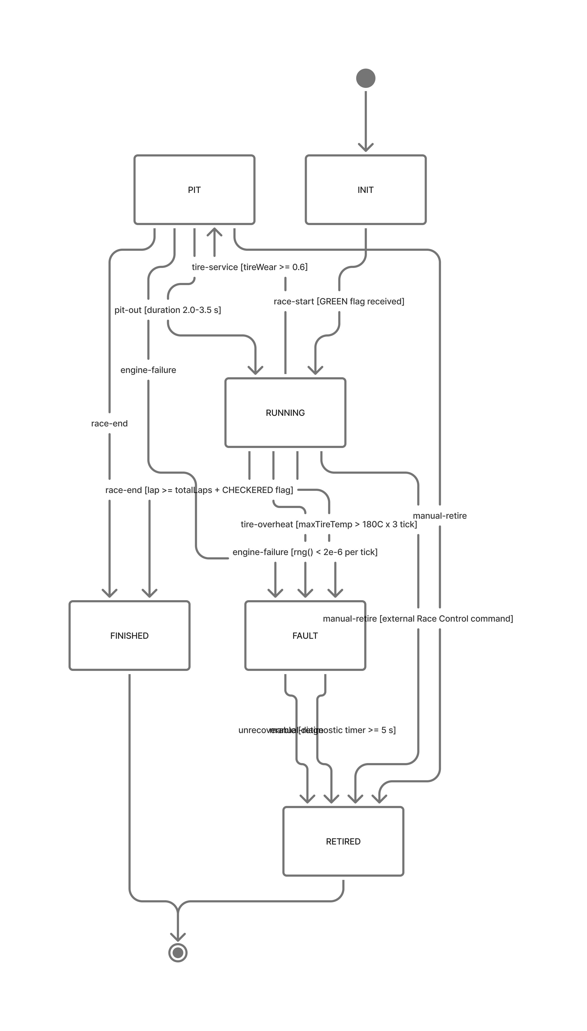
Figure 3 — State Diagram: Car FSM (6 states)

Each car is governed by an FSM with 6 states. Transition table:
From | To | Trigger | Condition
INIT | RUNNING | race-start | GREEN flag received
RUNNING | PIT | tire-service | max(tireWear) ≥ 0.60 AND in pit window
PIT | RUNNING | pit-out | Pit stop timer elapsed (2.0–3.5 s)
RUNNING | FAULT | tire-overheat | max(tireTemp) > 145°C for 8 consecutive ticks
RUNNING/PIT | FAULT | engine-failure | Random probability 1×10⁻⁵ per tick
FAULT | RETIRED | unrecoverable | Fault timer > 5 s
RUNNING/PIT | FINISHED | race-end | lap ≥ totalLaps AND CHECKERED flag active
any | RETIRED | manual-retire | External command via MQTT control topic
any | FAULT | internal-error | Unhandled exception in car.tick()

5. Race Control

5.1 Flag State Machine
The race director manages 6 flag states with a dedicated FSM (flag-state.js):
Flag | Meaning | Effect on Cars
GREEN | Race active | No restrictions
YELLOW | Local hazard | Speed limit in affected sector; DRS disabled
RED | Race suspended | All cars brake to 0 and hold position
CHECKERED | Race ended | Enables FINISHED transition when lap ≥ totalLaps
SC | Safety Car deployed | Global speed limit 140 km/h; gap reduction to SC
VSC | Virtual Safety Car | Global speed limit 120 km/h; uniform speed

5.2 Automatic Trigger Logic
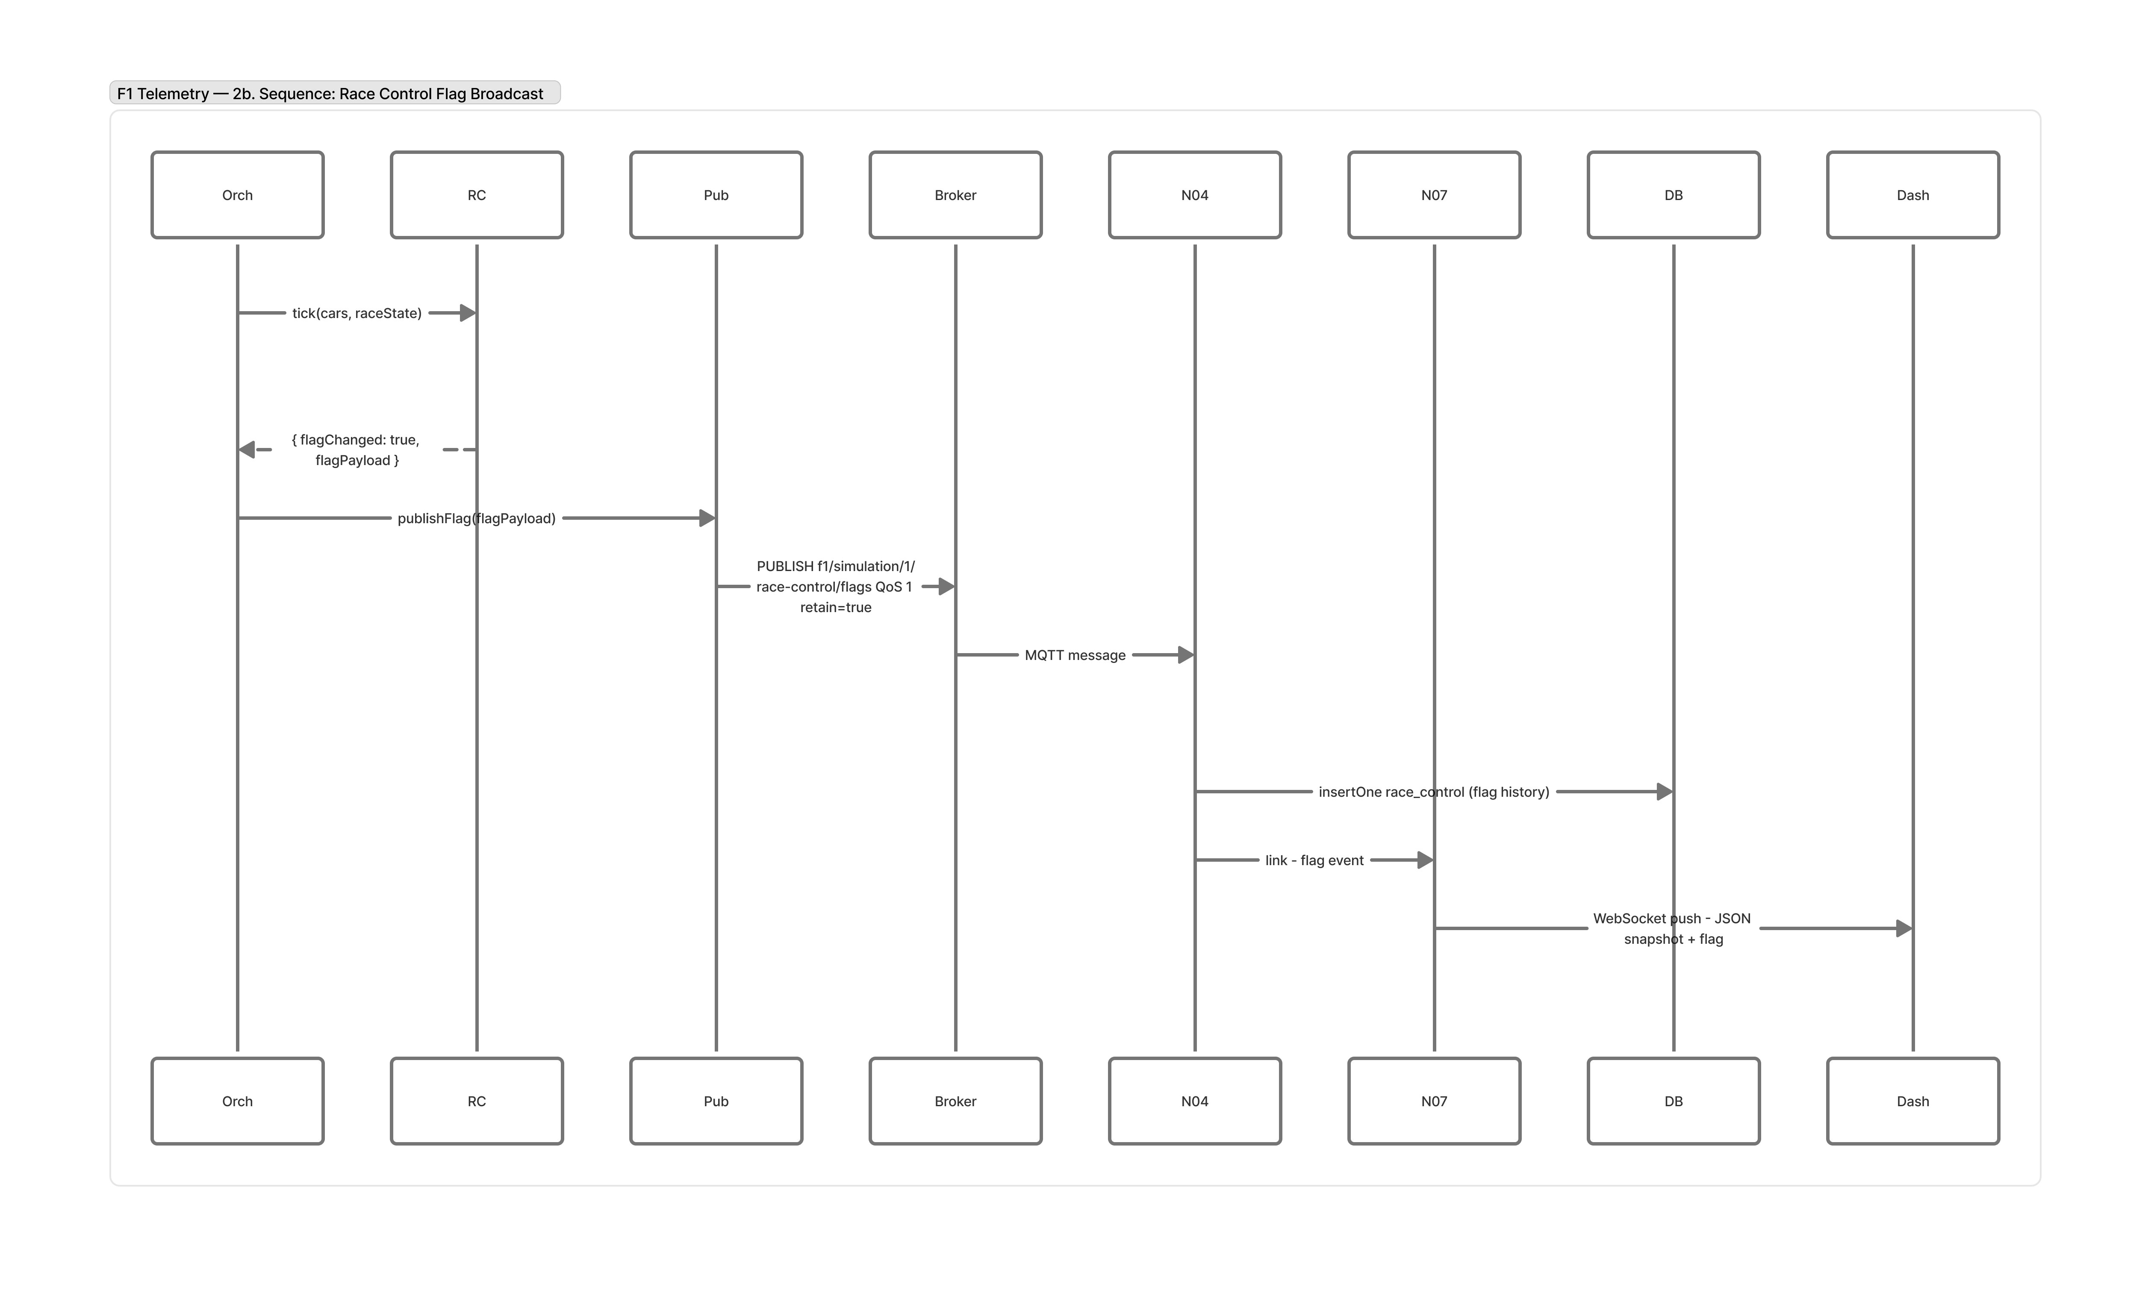
Figure 4 — Sequence Diagram 2b: Race Control Flag Broadcast
The trigger evaluator (triggers.js) runs each orchestrator tick and applies priority-ordered rules:
- CHECKERED — leaderLap ≥ totalLaps (highest priority, ends the race)
- RED FLAG — count(FAULT + RETIRED) ≥ 3 (mass incident threshold)
- SC — New car retirement, probability-based (configurable, default 0%)
- VSC — count(FAULT) ≥ 2 simultaneously (multi-car fault)
- YELLOW — count(FAULT) == 1 (single-car fault, local flag)
- Clearance — Minimum flag duration elapsed AND no cars in FAULT → return to GREEN

6. Processing Layer — Node-RED

6.1 Flow Architecture
Node-RED processes incoming MQTT streams across 9 flow tabs, each with a single responsibility:
Tab | Responsibility
00 – Overview | Documentation, system diagram (comment nodes)
01 – MQTT Ingestion | Subscribe to all topics via wildcard, route by type
02 – Normalization | Parse topic segments, extract metadata, validate payload
03 – Telemetry Processing | Update car context cache, 1 Hz classification, event detection
04 – Race Control | Receive flags, cache in context, broadcast to cars and dashboard
05 – Security / Encryption | AES-256-GCM encrypt/decrypt for secure flag channel
06 – MongoDB Persistence | Batch insert telemetry, upsert states/classifications
07 – Dashboard WebSocket | Emit aggregated updates to browser clients
99 – Error Handling | Catch, log, and surface errors from all flows

6.2 Data Flow (Telemetry Path)
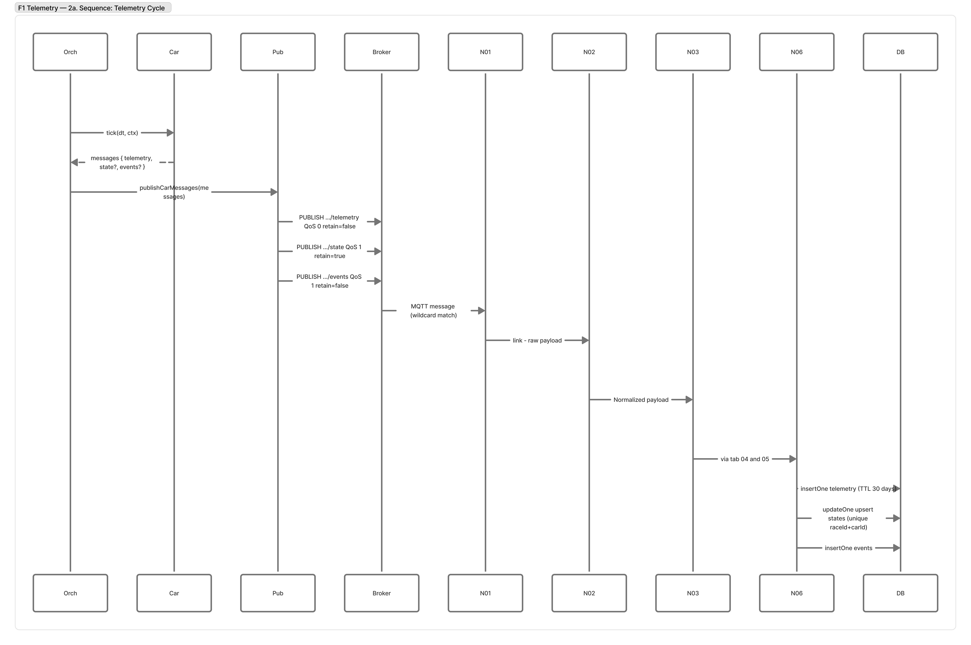
Figure 5 — Sequence Diagram 2a: Telemetry Cycle
MQTT In (wildcard: f1/simulation/+/teams/+/cars/+/telemetry)
|
v
[SF – Parse F1 Topic]
Extract: raceId, teamId, carId, kind from topic string
|
v
[SF – Normalize Document]
Convert timestamp string → Date object
Attach metadata (raceId, teamId, carId)
|
v
[Validate JSON Schema]
Reject invalid payloads → Error Handler
|
├──────────────────────────────────┐
v v
[Car Context Cache] [Event Detector]
Update flow.context: Check anomalies:
race.{id}.cars.{carId} - tireWear > 0.80 → 'warn:tire-critical'
| |
├──────────────────────────────┘
v
[Batch Buffer] → [MongoDB Batch Insert] → [Dashboard WebSocket Envelope]

6.3 Classification Calculation
A 1 Hz ticker computes the live leaderboard from the car context cache:
- Read all car entries from flow.context.race.{raceId}.cars
- Filter cars with telemetry received within the last 2 seconds
- Sort descending by lap, then by trackPos
- Assign positions 1–10
- Compute gap: estimated time between each car and P1 based on speed and track separation
- Publish to f1/simulation/{raceId}/race-control/classification (QoS 1, retained)
- Upsert snapshot in MongoDB classifications collection
- Broadcast to dashboard WebSocket

6.4 Subflows (Reusable)
Subflow | Purpose
SF – Parse F1 Topic | Extracts raceId/teamId/carId/kind from any F1 topic
SF – Normalize Document | Timestamp normalization, metadata injection
SF – MongoDB Batch Insert | Size/time-triggered flush buffer for write efficiency
SF – Upsert by Race Car | Atomic upsert on (raceId, carId) composite key
SF – Dashboard Envelope | Wraps any payload in {type, raceId, ts, data} format

7. Persistence Layer — MongoDB

7.1 Collection Design
MongoDB was selected over a relational database because telemetry data is naturally document-oriented: each telemetry sample is a self-contained JSON object with variable nested fields. Schema-on-read flexibility allows evolving the data model without migrations.
Collection | Content | Write Rate
telemetry | Continuous sensor samples | ~40 docs/s (10 cars × 4 Hz)
states | FSM state transitions | Low (event-driven)
events | Discrete events (pit, fault, flag) | Low (event-driven)
classifications | Leaderboard snapshots | 1 doc/s
race_control | Flag activation history | Very low

7.2 Indexing Strategy
Each collection carries purpose-built indices:
- telemetry: (raceId, carId, timestamp desc) — compound index for per-car time queries
- telemetry: (raceId, lap) — lap-level aggregation (e.g., fastest lap calculation)
- telemetry: (raceId, teamId, carId, lap) — team-level lap analysis
- telemetry: timestamp — TTL index (expireAfterSeconds: 2592000, i.e., 30 days)
- states: (raceId, carId) unique — guarantees one current state per car
- classifications: (raceId) unique — guarantees one current standings snapshot per race

7.3 Schema Validators
MongoDB collection validators enforce payload integrity at the database level, providing a second line of defense after Node-RED validation:
- validationLevel: moderate — existing documents are exempt from re-validation on update (backwards compatibility)
- validationAction: error — invalid new inserts are rejected with an error

7.4 Write Optimization
Raw insert rate for 10 cars at 4 Hz is approximately 40 documents per second. To avoid per-document write amplification, Node-RED buffers telemetry in memory and performs insertMany with ordered: false in batches of 100 documents or on a 1-second timeout. This reduces MongoDB write operations by roughly 50–100×.

8. Visualization Layer — Dashboard

8.1 Components
The dashboard is a single-page HTML5 application served as a static asset from Node-RED on port 1881. It communicates exclusively via WebSocket, receiving a stream of typed update envelopes from Node-RED.
- Circuit Visualization — An SVG rendering of the Monza track (5.793 km). Car markers are color-coded by team (Ferrari: red, Mercedes: cyan, Red Bull: dark blue, McLaren: orange, Alpine: pink).
- Leaderboard — A real-time standings table showing position, car number, driver, team, current lap, and gap to P1. Updated at 1 Hz.
- Car State Panel — A grid of 10 car tiles, each showing live speed, fuel, tire wear, and current state with color coding.
- Race Control Indicator — A banner showing the current active flag with color coding and a reason text string.
- Event Log — A chronological feed (max 80 entries) of discrete race events, color-coded by team.

8.2 Smooth Movement
The simulator publishes telemetry at 4 Hz (250 ms tick), but the browser renders at 60 FPS via requestAnimationFrame. Smooth car movement is achieved through client-side interpolation:
- On each WebSocket message, store the new trackPos and the arrival timestamp
- Compute the animation target position using an exponential moving average of server update intervals
- Each animation frame advances the car along the SVG path proportionally to elapsed time
- The SVG path's getTotalLength() and getPointAtLength() APIs map trackPos to pixel coordinates
const ANIMATION_INTERVAL_EMA_ALPHA = 0.4;
ema = alpha × newInterval + (1 - alpha) × ema;
animationDuration = clamp(ema, 100, 1500); // ms

9. Sensor Heterogeneity
The simulated sensor suite covers both analog (continuous) and digital (discrete) sensor types, reflecting the mixed hardware environment of a real F1 car.

9.1 Analog Sensors (Continuous)
Sensor | Field | Unit | Range | Notes
Speed sensor | speed | km/h | 0 – 360 | Optical encoder on wheel hub
Engine RPM | rpm | rpm | 0 – 16 000 | Crankshaft position sensor
Throttle position | throttle | normalized | 0.0 – 1.0 | Potentiometer on pedal
Brake pressure | brake | normalized | 0.0 – 1.0 | Hydraulic pressure transducer
Tire temperature | tireTemp.{fl,fr,rl,rr} | °C | 60 – 200 | Infrared pyrometer per wheel
Tire wear | tireWear.{fl,fr,rl,rr} | normalized | 0.0 – 1.0 | Model-computed wear scalar
Fuel level | fuel | kg | 0 – 40 | Sprint tank (~38 kg); monotonically decreasing, no refuelling
Track position | trackPos | normalized | 0.0 – 1.0 | GPS + transponder fusion

9.2 Digital Sensors (Discrete / On-Off)
Sensor | Field | Type | Values | Notes
DRS actuator | drs | boolean | true / false | Rear wing flap position
Pit-lane detector | state transition | boolean | pit entry / exit | Pit-lane inductive loop
Sector transponder | embedded in trackPos | enum | S1 / S2 / S3 crossings | Loop at 0.33 and 0.66
Flag detector | flag in race-control | enum | GREEN/YELLOW/RED/SC/VSC/CHECKERED | Marshaling post signal
Gear selector | gear | integer | 0 – 8 | 0 = neutral, 1–7 = forward gears, 8 = reverse

9.3 Mixed-Sensor Processing
- Analog fields — normalized, range-checked, stored as floating-point time series
- Boolean fields — change-detection: only published on state change to reduce bandwidth
- Enum fields (state, gear, flag) — validated against allowed value sets; transitions trigger event detection

10. Security — Encryption

10.1 Threat Model
The primary security concern is unauthorized injection of race-control commands. A compromised dashboard client could publish a fake RED flag, stopping the simulation incorrectly. To mitigate this, the race-control command channel between the dashboard and the broker is protected with symmetric encryption.

10.2 Algorithm and Mode
Parameter | Value | Justification
Algorithm | AES | NIST-approved block cipher; hardware acceleration on all modern CPUs
Mode | GCM (Galois/Counter Mode) | Authenticated encryption: provides confidentiality AND integrity
Key size | 256 bits (32 bytes) | Maximum AES key length; resistant to brute-force
IV (nonce) | 12 bytes | NIST SP 800-38D recommendation for GCM; random per message
Authentication tag | 16 bytes (128 bits) | Detects any ciphertext modification

AES-GCM was selected over CBC or CTR because it combines encryption with a Message Authentication Code (MAC) in a single pass, providing protection against active attackers.

10.3 Key Management
The symmetric key is injected into the Node-RED container via the environment variable F1_TELEMETRY_CRYPTO_KEY_B64. The actual key is stored in a .env file excluded from version control. If the variable is absent or the decoded length is not exactly 32 bytes, the encryption node throws an error and drops the message.

10.4 Protected Topics
Topic | Encrypted | Justification
f1/.../secure/race-control/flags | Yes | Dashboard commands; control signals must be authenticated
f1/.../race-control/flags | No | Simulator-published flags; internal, not user-facing
f1/.../telemetry | No | High throughput; no confidentiality requirement
f1/.../events | No | Informational; no control impact

10.5 Encrypt/Decrypt Flow
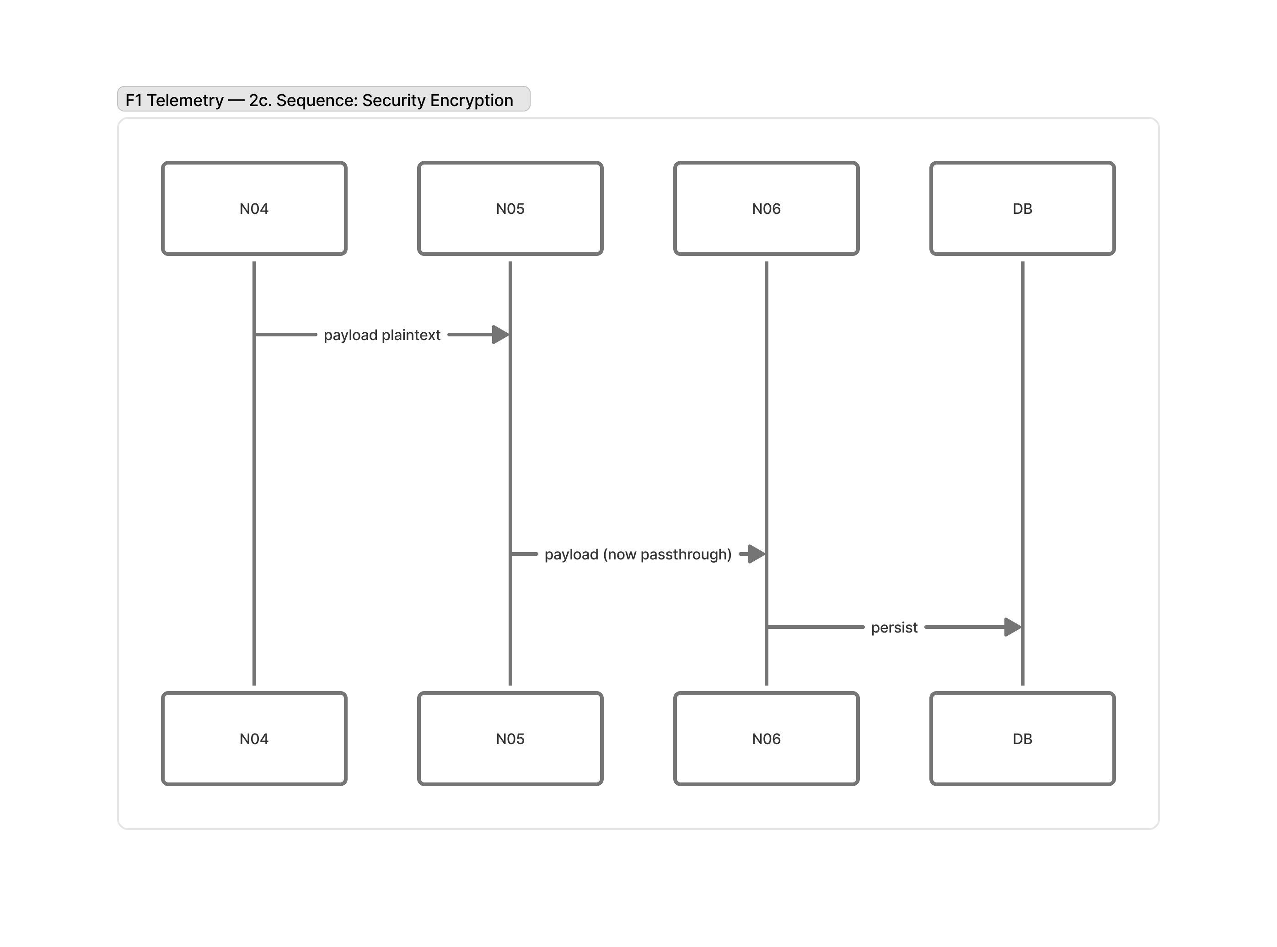
Figure 6 — Sequence Diagram 2c: Security Encryption

Encrypt (dashboard command → broker):
const key = Buffer.from(process.env.F1_TELEMETRY_CRYPTO_KEY_B64, 'base64');
if (!key || key.length !== 32) throw new Error('Invalid crypto key');

const iv = crypto.randomBytes(12);
const cipher = crypto.createCipheriv('aes-256-gcm', key, iv);
const ciphertext = Buffer.concat([cipher.update(plaintext, 'utf8'), cipher.final()]);
const tag = cipher.getAuthTag();

msg.payload = {
iv: iv.toString('base64'),
ciphertext: ciphertext.toString('base64'),
tag: tag.toString('base64')
};

Decrypt (broker → Node-RED internal):
const key = Buffer.from(process.env.F1_TELEMETRY_CRYPTO_KEY_B64, 'base64');
const { iv, ciphertext, tag } = JSON.parse(msg.payload);
const decipher = crypto.createDecipheriv('aes-256-gcm', key, Buffer.from(iv, 'base64'));
decipher.setAuthTag(Buffer.from(tag, 'base64'));
try {
const plaintext = decipher.update(Buffer.from(ciphertext, 'base64'), undefined, 'utf8')
+ decipher.final('utf8');
msg.payload = JSON.parse(plaintext);
} catch (e) {
node.error('Decryption failed — message dropped: ' + e.message);
return null;
}

11. Design Decisions and Justifications

11.1 Single-Process Simulator
Decision: All 10 cars are managed by a single Node.js process with shared in-memory state.
Justification: A multi-process or distributed simulator would require a consensus mechanism for global race state. The single-process design eliminates this complexity entirely. Node.js's event loop handles the 10-car tick sequentially within each 250 ms interval without blocking I/O.

11.2 QoS 0 for Telemetry
Decision: Telemetry messages are published with QoS 0 (fire-and-forget).
Justification: The telemetry stream is continuous at 4 Hz. Loss of a single sample means the next sample arrives within 250 ms — negligible for visualization purposes. For high-frequency sensor data, QoS 0 is the standard industry practice.

11.3 Client-Side Interpolation
Decision: Car movement is smoothed on the browser, not buffered server-side.
Justification: Server-side buffering would introduce a fixed latency equal to the buffer depth. Client-side interpolation produces zero additional latency while absorbing network jitter. The exponential moving average adapts the animation speed to actual network conditions.

11.4 Batch MongoDB Writes
Decision: Telemetry is buffered in Node-RED and inserted in batches.
Justification: Individual insertOne calls at 40 docs/s would generate 40 TCP round-trips per second to MongoDB. insertMany with ordered: false reduces round-trips by 50–100×. The 1-second maximum buffer delay is imperceptible for historical queries.

11.5 Encryption on Control Channel Only
Decision: Only the dashboard-to-broker flag command channel is encrypted.
Justification: Encrypting telemetry streams would add CPU overhead proportional to the message rate (~40 messages/s). Since telemetry is display-only data with no control semantics, encryption provides no meaningful security benefit. The flag channel is the correct and sufficient encryption boundary.

11.6 Node-RED for Stream Processing
Decision: Node-RED was chosen as the stream-processing engine rather than a custom Node.js service.
Justification: Node-RED provides visual flow debugging, built-in MQTT and WebSocket nodes, a context API for in-memory caching, and function nodes with access to the full Node.js crypto module. The flow architecture (9 tabs) also serves as live documentation of the processing pipeline.

11.7 Modular FSM Design
Decision: The FSM (fsm.js), triggers (triggers.js), and flag-state (flag-state.js) modules are pure functions with no I/O side effects.
Justification: Pure modules are inherently unit-testable without mocking I/O. The FSM can be tested by feeding state and trigger inputs and asserting transition outputs. This separation of concerns allows the race-control trigger logic to be modified without touching MQTT publishing or MongoDB persistence code.

12. Conclusions
This project demonstrates a complete IoT telemetry pipeline applied to a Formula 1 race simulation. The system successfully achieves:
- Real-time data acquisition at 4 Hz from 10 concurrent simulated sensors per car
- Scalable communication via MQTT with a hierarchical topic structure and appropriate QoS policies
- Stream processing in Node-RED, including normalization, event detection, live classification, and encrypted command handling
- Persistent storage in MongoDB with time-series indexing, batch writes, and schema validation
- Live visualization with 60 FPS smooth rendering on an SVG circuit map via client-side interpolation
- Heterogeneous sensor modeling covering both analog (continuous) and digital (discrete) sensor types
- Authenticated encryption on the race-control command channel using AES-256-GCM

The architecture follows established IoT patterns: edge simulation, broker-mediated communication, centralized stream processing, and persistent time-series storage. Each design decision was driven by concrete requirements — throughput, latency, testability, or security — and is justified against the alternatives considered.
The system is fully containerized with Docker Compose, requiring a single docker compose up command to launch all services. This makes it reproducible and deployable on any Docker-capable host.

13. Extensibility and Scalability

13.1 Preliminary Note: Simulated Physics vs. Real Sensors
A fundamental distinction must be drawn between this system and a production telemetry deployment. In a real F1 context, sensors broadcast raw measurements regardless of the circuit — the physical car adapts to the track naturally, and the telemetry pipeline simply receives, routes, and stores what the sensors report. Extending such a system to a new circuit requires no changes to the acquisition or processing layers: only the visualization (e.g., a new SVG track map) and optional analytics models need to be updated.
In this system, the situation is more complex because the physics engine must actively simulate the car's behavior on a specific circuit. The Monza speed profile (monza.js) is a hand-crafted 31-point lookup table encoding the target speed at each fraction of the track. Every corner radius, braking zone, and DRS zone is baked into this file. Adding a new circuit — Silverstone, Suzuka, Monaco — requires authoring an equivalent speed profile from scratch, calibrating braking distances, gear selection curves, sector boundaries, and DRS zone coordinates. This is a non-trivial engineering effort, not a configuration change.
This is an intrinsic limitation of physics-based simulation: the model must encode domain knowledge that, in a real deployment, the physical world provides for free.

13.2 Extensibility of the Communication Layer
The MQTT topic structure was designed with extensibility in mind. The {raceId} segment namespaces every message to a specific race session, which means:
- Multiple concurrent races are supported without any broker reconfiguration: a second simulation instance publishes under raceId=2 and Node-RED wildcard subscriptions automatically capture both streams.
- New event types (e.g., a safety-car/position topic or a weather/track-conditions feed) can be added as new leaf topics without breaking existing subscribers, which simply ignore unknown topics.
- New sensor fields can be added to the telemetry JSON payload without breaking consumers, since MongoDB stores documents schema-on-read and Node-RED function nodes access only the fields they explicitly reference.
The main coupling point is the JSON Schema validators: adding a mandatory new field requires updating the schema files in schemas/ and the MongoDB collection validators. Optional fields can be introduced freely.

13.3 Adding a New Circuit
Given the current architecture, introducing a new track involves changes in the following modules:
Module | Change Required | Effort
simulator/src/track/{circuit}.js | Author the speed profile (N-point lookup table), sector boundaries, DRS zones, pit-lane entry/exit offsets | High — requires circuit knowledge and calibration
simulator/config/default.js | Reference the new track module; set totalLaps, lapDistance, pitLaneSpeedLimit | Low
simulator/config/roster.json | Optionally adjust car performance parameters for a different circuit type | Low
node-red/data/public/{circuit}.svg | Provide an SVG of the new track; calibrate the path start offset (TRACK_PATH_START_OFFSET) | Medium — SVG sourcing and path offset tuning
node-red/data/public/dashboard.js | Update the track name label and landmark annotations array | Low
MongoDB / Node-RED flows | No changes required | None

The cleanest extension path would be to abstract the track module into a common interface — { speedAt(trackPos), drsZones, sectors, pitEntry, pitExit } — so that any compliant track module can be loaded by the orchestrator without code changes. The current Monza implementation already exposes this interface informally; formalizing it as a documented contract would reduce the integration effort for new circuits to the authoring task only.

13.4 Adding Weather and Environmental Conditions
The current physics model does not account for weather. Introducing rain, track temperature, or wind would require:
- Rain: a trackGrip scalar (0.4–1.0) that scales the speed profile, increases tire wear rate on slicks, enables wet compound selection, and raises overheat thresholds
- Track temperature: modifies tire warm-up rate and optimal operating window per compound
- Wind: modifies straight-line speed (headwind/tailwind) and aerodynamic balance in high-speed corners
All three parameters could be injected via a new MQTT topic (f1/simulation/{raceId}/conditions/weather) and consumed by the physics engine through the same flag-influence pattern already used for SC and VSC speed limits. The architecture supports this cleanly: the orchestrator already applies flag-derived speed multipliers; a weather multiplier is structurally identical. The effort is in calibrating the physical model, not in the plumbing.

13.5 Scaling the Number of Cars and Teams
The current design has no hard dependency on exactly 10 cars. The roster is defined in config/roster.json as a plain array of { carId, teamId, driverName } objects. Increasing to 20 cars (a hypothetical future regulation) requires only extending the roster file. The MQTT topic structure, Node-RED flows, MongoDB collections, and dashboard layout all adapt dynamically to the number of cars found in the roster at startup.
The main practical constraint is throughput: 20 cars at 4 Hz doubles the MQTT message rate to ~80 messages/s and the MongoDB write rate to ~80 docs/s. Both are well within the capacity of a single Mosquitto broker and a single MongoDB node on commodity hardware. The Node-RED classification ticker (1 Hz, operating on an in-memory cache) is O(n log n) and would show no measurable latency increase for n=20.

13.6 Summary: Design Choices and Their Extensibility Impact
Design Choice | Extensibility Benefit | Extensibility Constraint
MQTT hierarchical topics with {raceId} | Concurrent multi-race support with zero config | New topic types require subscriber updates
JSON payloads with schema validation | Optional fields added freely | Mandatory field additions require schema migration
Pure FSM modules (no I/O) | New states/transitions testable in isolation | FSM changes must be reflected in Node-RED event detection rules
Single-process simulator | Simple shared state, easy to extend roster | Cannot distribute simulation across multiple hosts
Hand-crafted Monza speed profile | High physical realism for Monza | Each new circuit requires equivalent manual authoring effort
Flag-influence pattern for speed modifiers | Weather and new conditions slot in naturally | Each new condition type requires a physics calibration pass
Docker Compose orchestration | One-command deployment on any host | Horizontal scaling requires migration to Kubernetes or Swarm

The overall architecture is well-suited for vertical extensions (new sensors, new event types, new flag conditions, additional cars) with low friction. Horizontal extensions — new circuits, new physical phenomena — carry higher effort due to the inherent complexity of physics simulation, a constraint that does not apply to real-world telemetry systems operating on live sensor feeds.

End of Report

