Hyperparameter Optimization Results

LSTM

Batch Size
Table Lstm Batch Size Results: Epochs = 7 Learning rate = 1e-3
 | Trial 1 | Trial 2 | Trial 3 | Mean | Std
Batch 8 | 1.28000 | 1.27492 | 1.27241 | 1.27423 | 0.00130
Batch 32 | 1.29515 | 1.29638 | 1.29473 | 1.29542 | 0.00070
Batch 128 | 1.38994 | 1.39020 | 1.39178 | 1.39064 | 0.00081

Learning Rate

Table Lstm Learning Rate Results: Epochs = 7 Batch Size= 8
 | Trial 1 | Trial 2 | Trial 3 | Mean | Std
LR 1e-3 | 1.28000 | 1.27492 | 1.27241 | 1.27423 | 0.00130
LR 1e-4 | 1.36924 | 1.37208 | 1.37421 | 1.37184 | 0.00204
LR 1e-5 | 1.67270 | 1.66148 | 1.69396 | 1.67605 | 0.01347

Epoch
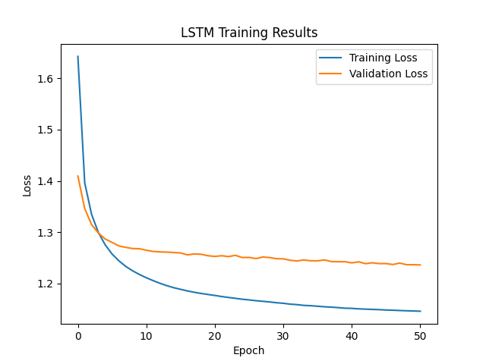

Architectural Hyperparameters
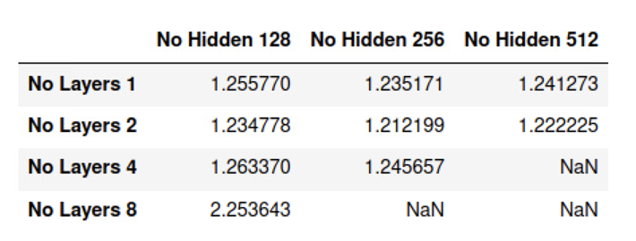

GPT2

Batch Size
Table GPT2 Batch Size Results: Epochs = 1 Learning rate = 1e-4
 | Trial 1 | Trial 2 | Trial 3 | Mean | Std
Batch 2 | 1.02652 | 1.02342 | 1.01925 | 1.02306 | 0.00298
Batch 4 | 0.99265 | 0.99518 | 0.99492 | 0.99425 | 0.00114

Learning Rate
Table GPT2 Learning Rate Results: Epochs = 1 Batch Size= 4
 | Trial 1 | Trial 2 | Trial 3 | Mean | Std
LR 1e-3 | 1.18410 | 1.18445 | 1.18479 | 1.18445 | 0.00028
LR 1e-4 | 0.99265 | 0.99518 | 0.99492 | 0.99425 | 0.00114
LR 1e-5 | 0.99394 | 0.99266 | 0.99290 | 0.99317 | 0.00056

Epoch

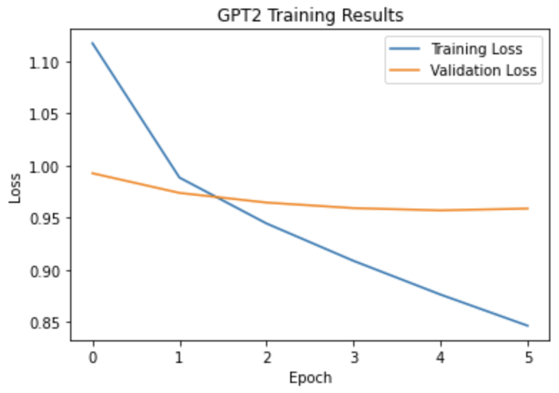

BERT + GPT2

Batch Size
Table BERT + GPT2 Batch Size Results: Epochs = 1 Learning rate = 1e-3
 | Trial 1 | Trial 2 | Trial 3 | Mean | Std
Batch 2 | 1.44759 | 1.41933 | 1.45081 | 1.43924 | 0.01414
Batch 4 | 1.30626 | 1.34169 | 1.31605 | 1.32133 | 0.01494

Learning Rate
Table BERT + GPT2 Learning Rate Results: Epochs = 1 Batch Size= 4
 | Trial 1 | Trial 2 | Trial 3 | Mean | Std
LR 1e-3 | 1.30626 | 1.34169 | 1.31605 | 1.32133 | 0.01494
LR 1e-4 | 1.07407 | 1.07454 | 1.07371 | 1.07411 | 0.00034
LR 1e-5 | 0.99532 | 0.99507 | 0.99509 | 0.99516 | 0.00011

Epoch
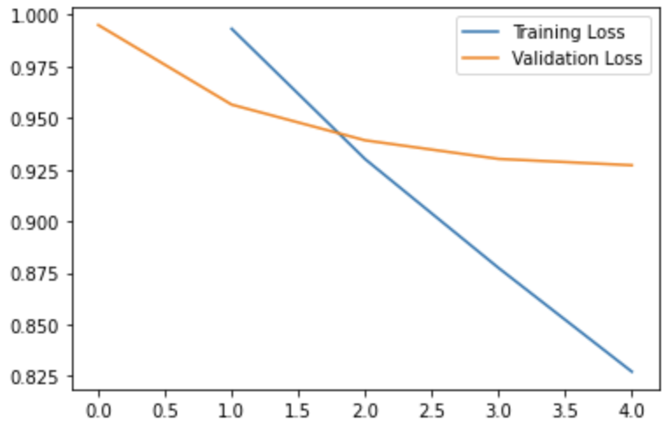

BiLSTM + LSTM

Batch Size
Table BiLSTM + LSTM Batch Size Results: Epochs = 7 Learning rate = 1e-3
 | Trial 1 | Trial 2 | Trial 3 | Mean | Std
Batch 8 | 1.233547 | 1.23193 | 1.23747 | 1.23432 | 0.00285
Batch 32 | 1.24361 | 1.24062 | 1.24810 | 1.24411 | 0.00376
Batch 128 | 1.32438 | 1.31638 | 1.32682 | 1.32253 | 0.00546

Learning Rate
Table BiLSTM + LSTM Learning Rate Results: Epochs = 1 Batch Size= 4
 | Trial 1 | Trial 2 | Trial 3 | Mean | Std
LR 1e-2
LR 1e-3 | 1.233547 | 1.23193 | 1.23747 | 1.23432 | 0.00285
LR 1e-4 | 1.34992 | 1.34450 | 1.34655

Epoch

