* Design and create data warehouse tables schema (design star schema), (use database MySQL, MSSQL, PostgreSQL)

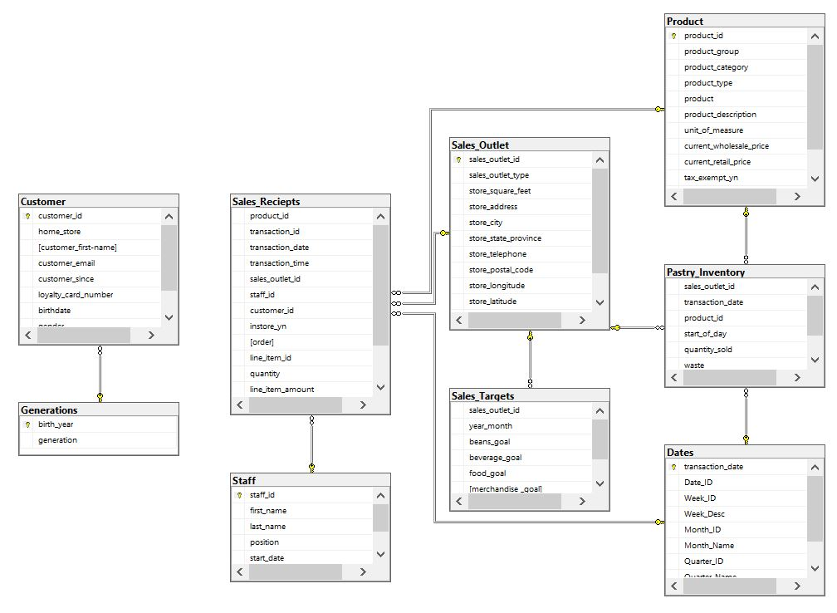

--Customer id values 0, 5000, 8000 in Sales_Reciepts does not exist in Customer table and because of this we can not create foreign key relation between these two tables but we could create this relation on Power BI manually by filtering these customer id’s.

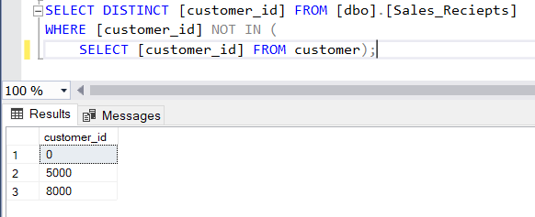

* Design and implement ETL to extract data from CSV into the data warehouse tables (better list the ETL options: nodeJS, SSIS, Talend, Apache NiFi, Informatica)

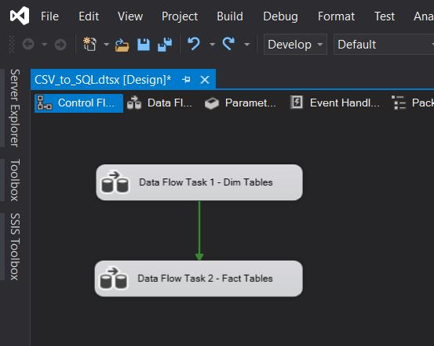

SSIS Workflows Screen Shot

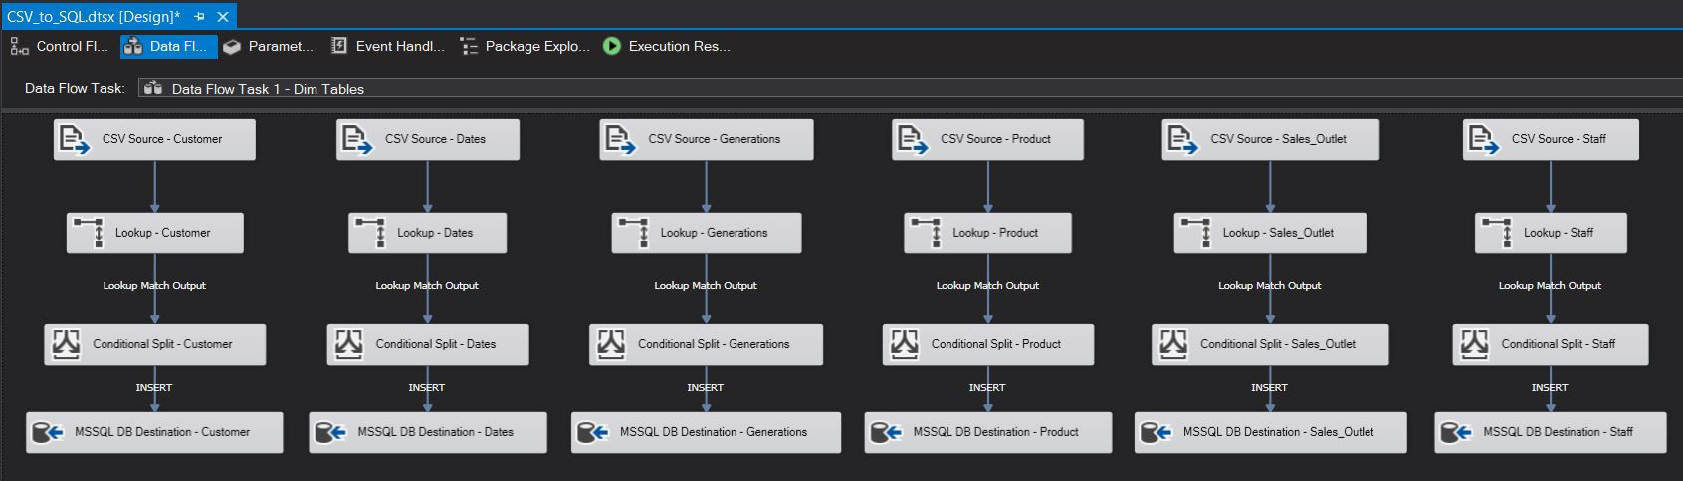

SSIS Load Tasks For Dimension Tables

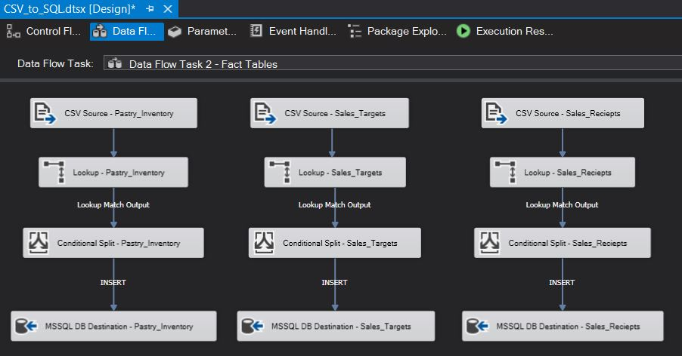

SSIS Load Tasks For Fact Tables

* What are the customers propensity to buy according to their generation?

-- Sold Quantities with Product Group by Generations

SELECT GNR.[generation] AS [Generation], PRD.[product_group] AS [ProductGroup], SUM(SRC.[quantity]) AS [TotalQuantity]

FROM [dbo].[Sales_Reciepts] SRC

INNER JOIN [dbo].[Customer] CST ON CST.[customer_id] = SRC.[customer_id]

LEFT JOIN [dbo].[Generations] GNR ON CST.[birth_year] = GNR.[birth_year]

LEFT JOIN [dbo].[Product] PRD ON SRC.[product_id] = PRD.[product_id]

GROUP BY GNR.[generation], PRD.[product_group]

ORDER BY GNR.[generation]

--We can enrich the relevant data set by expanding this query.

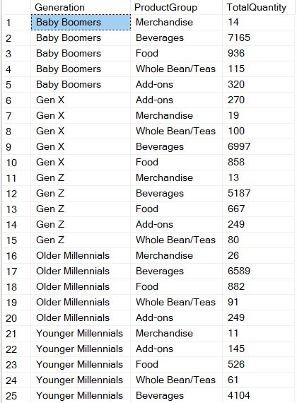

* What is the most 3 seller products according to weeks?

-- TOP 3 Most Seller Products According to Weeks

SELECT [Product], [YearWeek], [TotalQuantity] FROM (

SELECT

ROW_NUMBER() OVER(PARTITION BY CONCAT(DTE.[Year_ID],DTE.[Week_ID]) ORDER BY SUM(SRC.[quantity]) DESC) AS [RowNumber]

,PRD.[product] AS [Product]

,CONCAT(DTE.[Year_ID],DTE.[Week_ID]) AS [YearWeek]

,SUM(SRC.[quantity]) AS [TotalQuantity]

FROM [dbo].[Sales_Reciepts] SRC

INNER JOIN [dbo].[Customer] CST ON CST.[customer_id] = SRC.[customer_id]

LEFT JOIN [dbo].[Product] PRD ON SRC.[product_id] = PRD.[product_id]

LEFT JOIN [dbo].[Dates] DTE ON SRC.[transaction_date] = DTE.[transaction_date]

GROUP BY CONCAT(DTE.[Year_ID],DTE.[Week_ID]), PRD.[product] ) TBL

WHERE [RowNumber] IN (1, 2, 3)

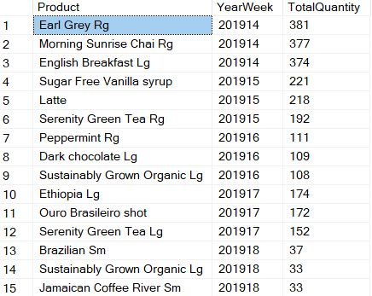

* Implement dashboard for data analysis (on Tableau, Power BI, Qlikview)

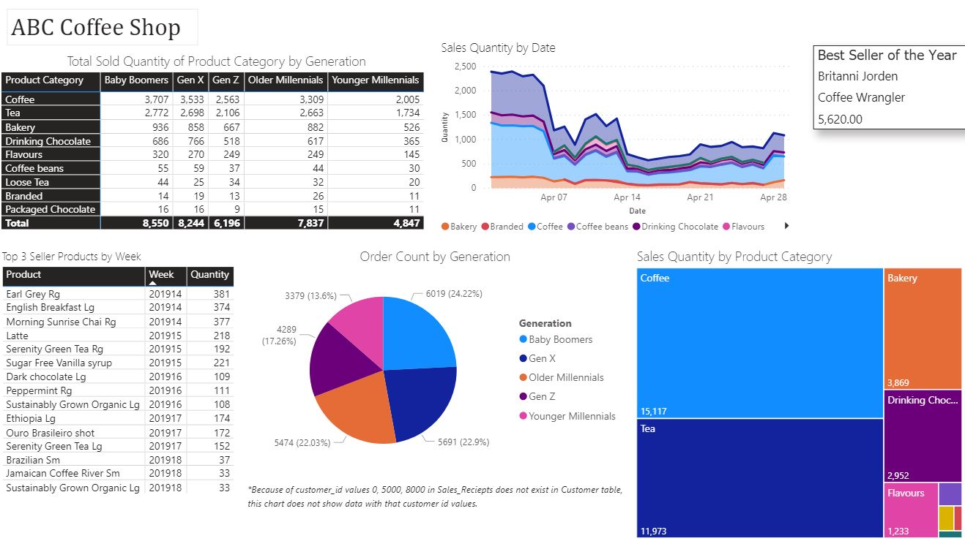

--I don’t have any experience on Power BI, but I learned that I can use it with the Power BI desktop application and tried to create the following reports and graphics with the help of the internet.

* Implement incremental load ETL job that takes new inserted sales in the source (folder contains CSV files) and add only those new sells in the database

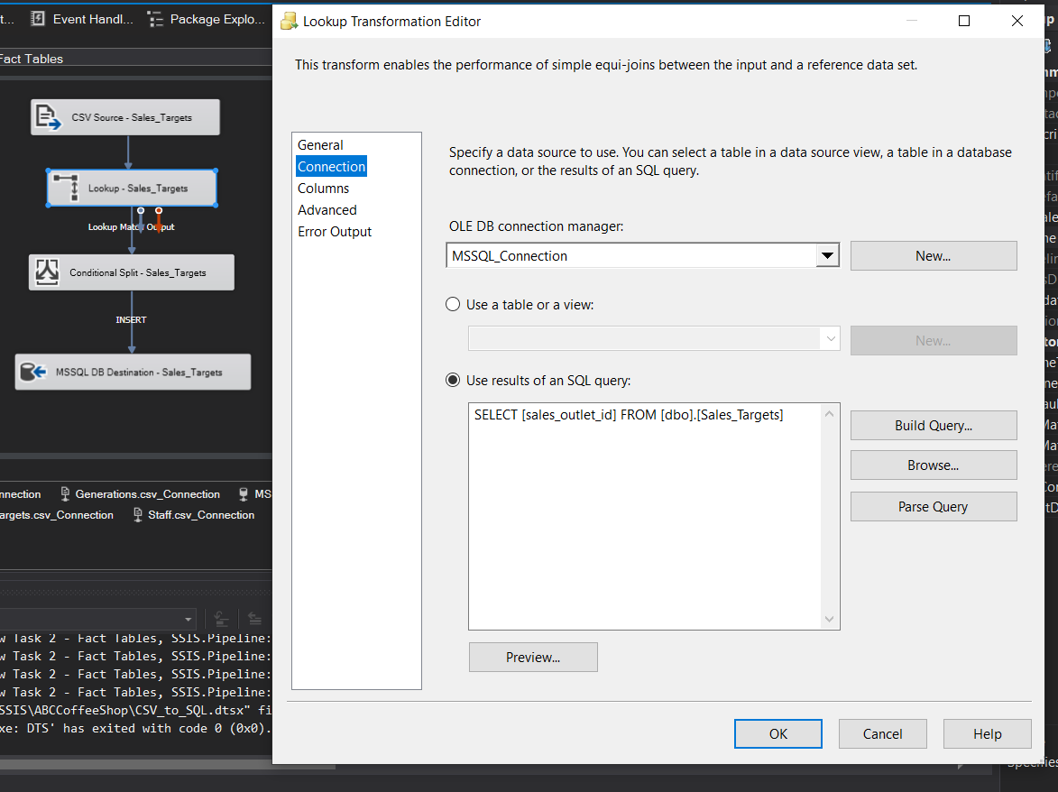

--I don’t have any experience on SSIS, but I learned that, by installing a few setups to my desktop

(vs_community_2019(16.5)__1485245042.1588369637.exe

Microsoft.DataTools.IntegrationServices.exe

en_sql_server_2019_developer_x64_dvd_baea4195.iso

PBIDesktopSetup_x64.exe

SSMS-18.8-Setup-ENU.exe)

I can create the case study environment that consists all applications i need.And as i said,i have no experience on SSIS but i know etl logic and with a little research on SSIS tool, I learned how to prepare tasks.

I have experience on Informatica(10 years) and Qliksense(1 year) but i don’t want to be a tool dependant business intelligence specialist. So, this case study was very useful for me. I hope i can understand the case and solve it as you expect.