# EDA (Exploratory Data Analysis) Workflow

Contents

EDA (Exploratory Data Analysis) Workflow 1

Using the Filed Summary Tool to Create Histograms 2

Picture 1. Change data type with Select tool 3

Picture 2. Field Summary Tool 3

Interactive Charts Box, Bar, Scatter 3

## Using the Filed Summary Tool to Create Histograms

The first step that need to be done to prepare the data for histograms or other visualizations was to change the data type by using “Select” tool (Picture 1. Change data type with Select tool). A useful method to create a overview with a histogram for many columns it’s to use the “Field Summary” Tool. This allows you to see a histogram for every column that you selected in the Configuration part of it. (Picture 2. Field Summary Tool)

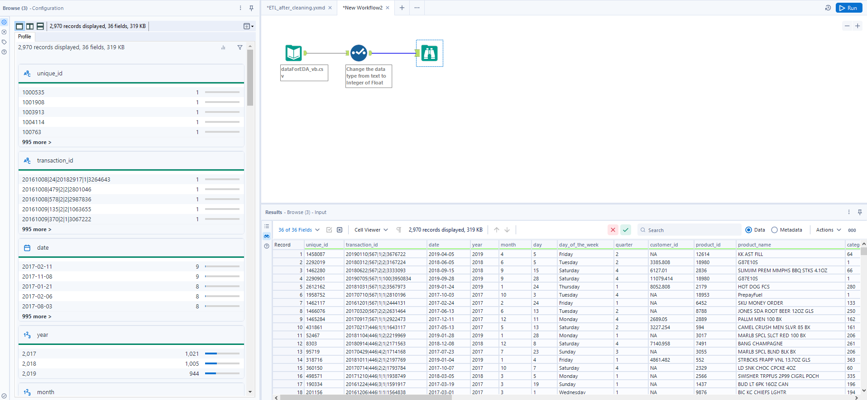

#### Picture 1. Change data type with Select tool

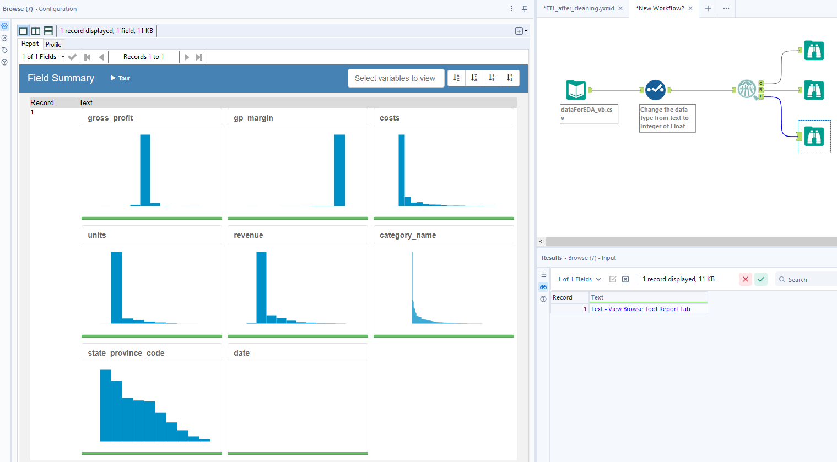

#### Picture 2. Field Summary Tool

## Interactive Charts Box, Bar, Scatter

On Alteryx to create interactive charts need to insert “Interactive Chart” tool from Reporting menu. The next step it’s to configurate the chart (Picture 3. Interactive Chart). After you press the button “Configure Chart”, Alteryx open a new window that offer you, a new environment where could be configure the chart. (Picture 4. Interactive Chart Configuration)

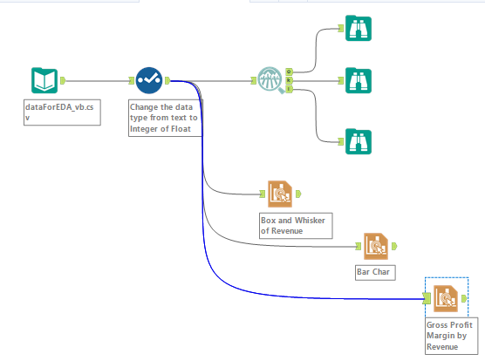

#### Picture 3. Interactive Chart

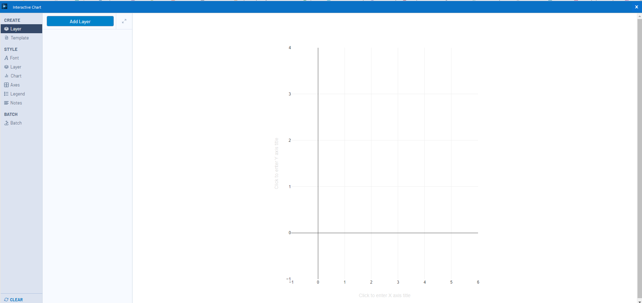

#### Picture 4. Interactive Chart Configuration

To create a Box and Whisker plot first of all was needed to add a new layer from the top of the “Interactive Chart” window. In the layer configuration you could change the name, choose the type of the char (Box and Whisker in our case), orientation (vertical or horizontal), the variable on the X axe, and variable on the Y axe. If you go to the mouse arrow on the chart the application offers you some values that consider to be relevant to see. (Picture 5. Box and Whisker). In the same way it could be create a Bar Chart. (Picture 6. Bar Chart)

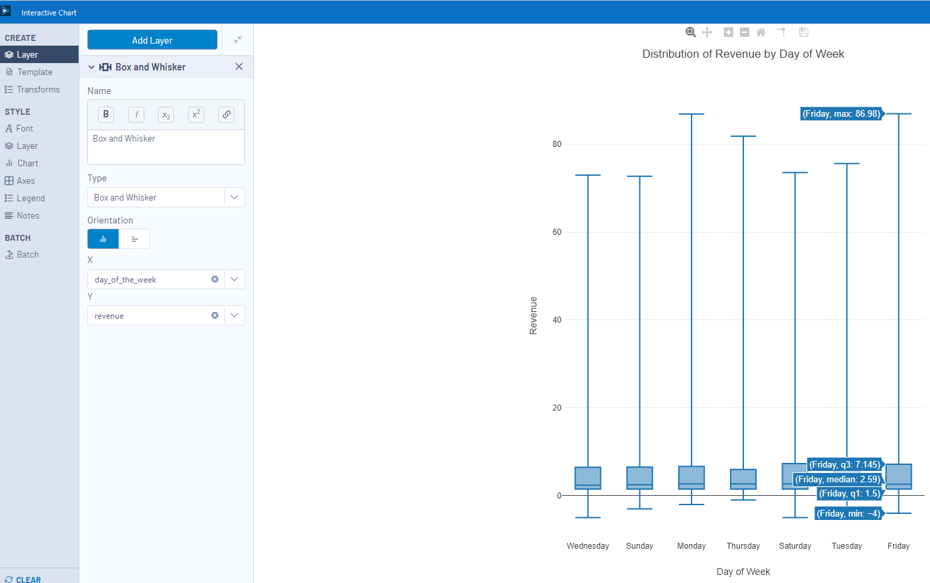

#### Picture 5. Box and Whisker

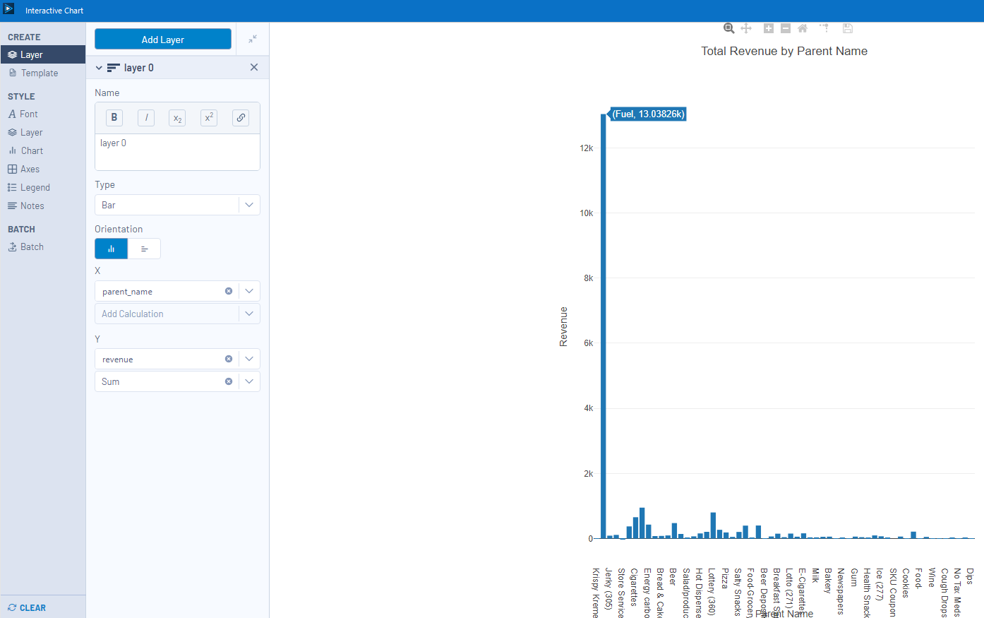

#### Picture 6. Bar Chart

On this type of data set we also could create a Scatter plot to show us the Gross Profit Margin by Revenue for every parent name. For do scatter plot we need to insert a new step of “Interactive Chart” tool. To build the scatter were added on the X axe gp_margin, on the Y column revenue (Picture 7. Scatter Layer), on the *Transforms* tab we *Split* by parent_name to have one color for every parent_name. (Picture 8. Transforms tab)

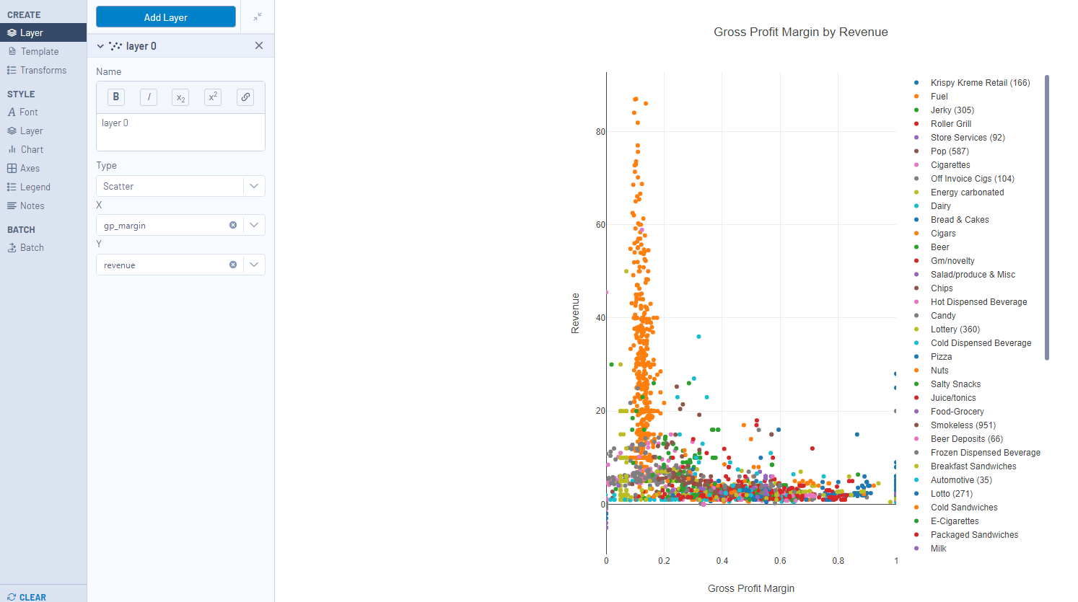

#### Picture 7. Scatter Layer

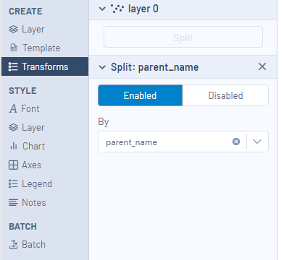

#### Picture 8. Transforms tab

## Summary tables

A good option to visual the data or to prepare to be become an input is to use “Summarize” tool that let you to group by one or many columns, to aggregate data by the group columns. (Picture 9. Summarize tool and configurator, Picture 10. Result of Summarize Tool).

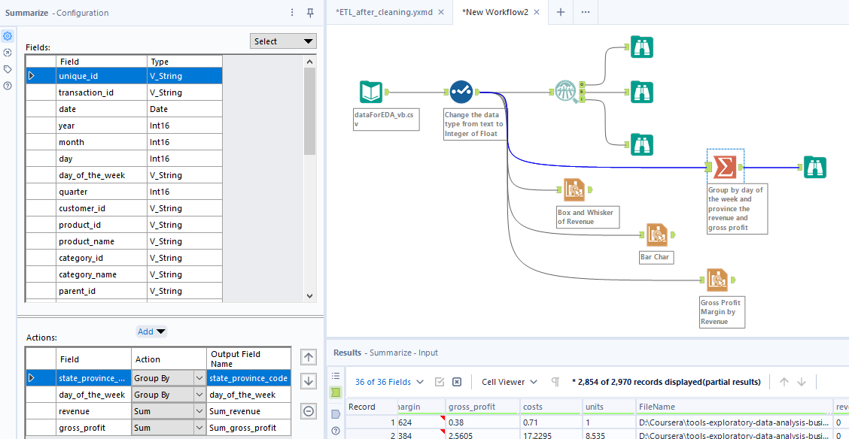

#### Picture 9. Summarize tool and configurator

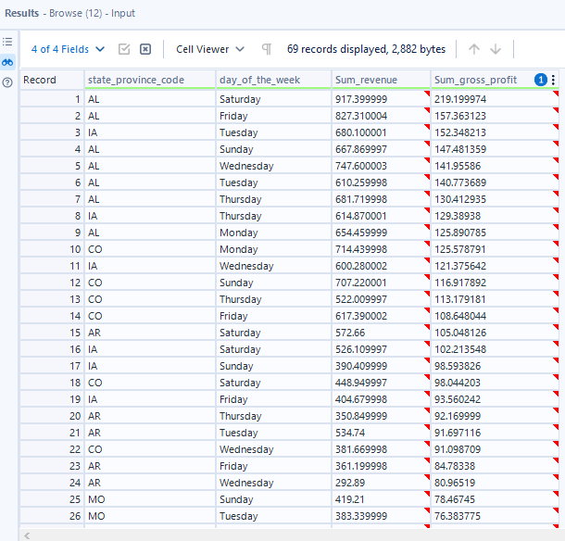

#### Picture 10. Result of Summarize Tool

## Saving Plots and Tables to a Report

To save all the plots and table that were created long this EDA process we need to transform the “Summarize” step into a basic table. After we have the “Summarize” step as a table, all the plots and new table into “Join Multiple” tool that centralize in a single information. The next step is to add them in a layout that could be write in a pdf file with “Render” tool. (Picture 11. Basic Table, Join Multiple, Layout, Render)

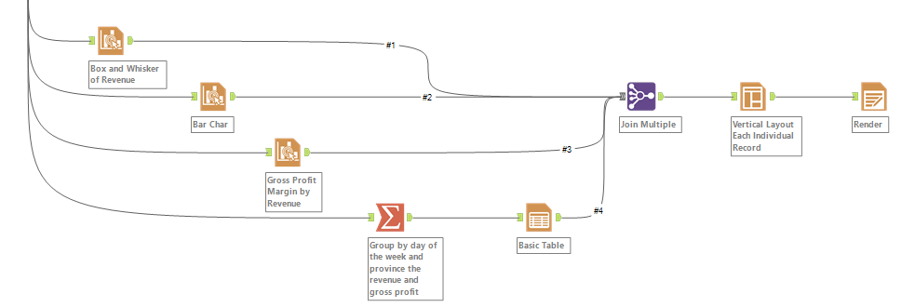

#### Picture 11. Basic Table, Join Multiple, Layout, Render