**AppDev: Assignment #1**

**Name:** Anthony Nadeau - 2058983 **Date:** 09/09/2021

**Course:** AppDev (420-331-VA) **Semester:** Fall 2021

**Section:** 00001 **License:** CC BY 4.0

---------------------------------------------------------------------------------------------------------------------

**Problem-01: Target-Heart-Rate Calculator**

Here is the output for Problem-01:

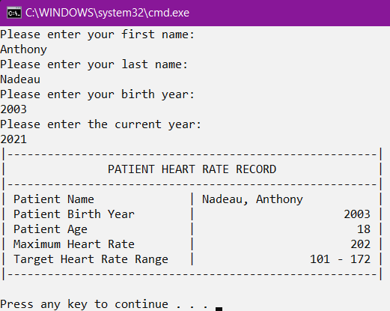

**Problem-02: Computerization of Health Records**

Here is the output for Problem-02:

