**AppDev: Assignment 3**

**Name:** Anthony Nadeau - 2058983 **Date:** 11/11/2021

**Course:** AppDev (420-331-VA) **Semester:** Fall 2021

**Section:** 00001 **License:** CC BY 4.0

---------------------------------------------------------------------------------------------------------------------

Here is the general GUI interface:

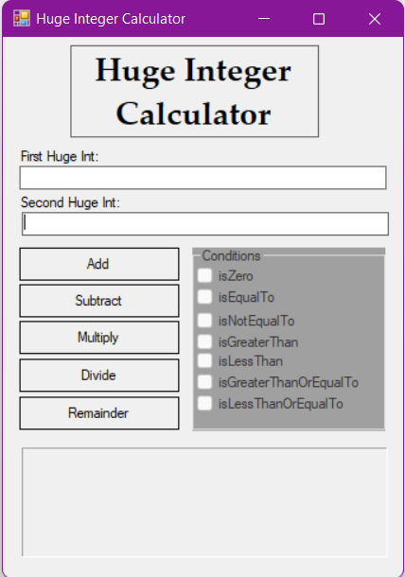

When leaving one or both of the text fields empty and trying to perform an operation, this message box appears:

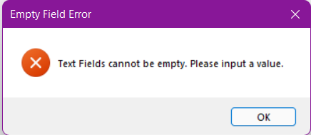

When inputting something that isn’t a number or is a negative number into one of the text fields, this message box appears:

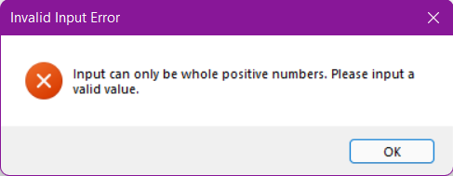

Also, when trying to subtract a larger number from a smaller number, this message box appears:

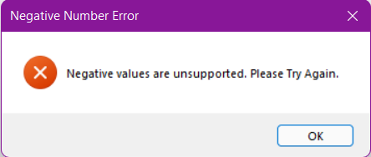

As is shown in the examples on the following pages, the check boxes on the calculator change depending on several factors between the 1st number inputted and the 2nd number inputted.

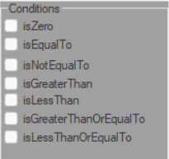

Here are some examples of the Check Boxes and Operations working in the calculator:

Addition:

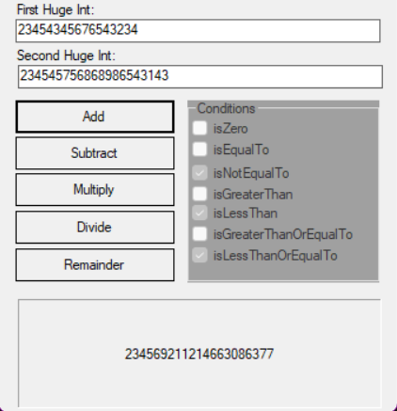

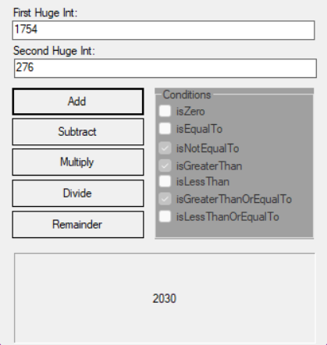

Subtraction:

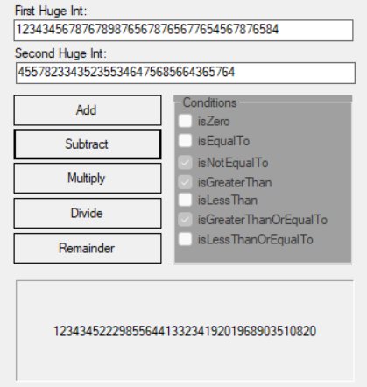

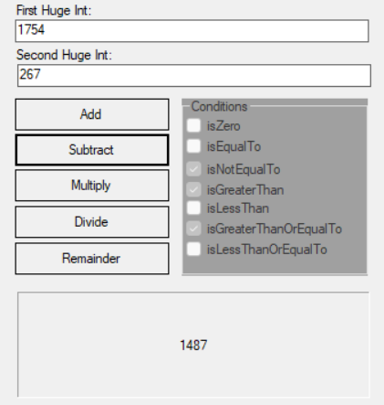

Multiplication:

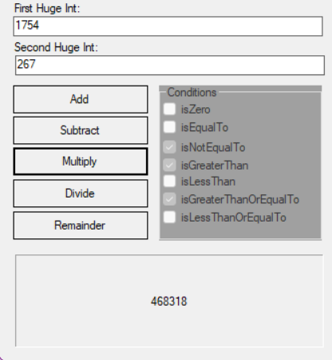

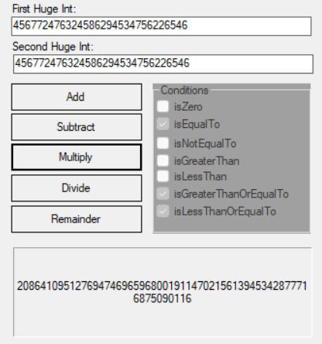

Division:

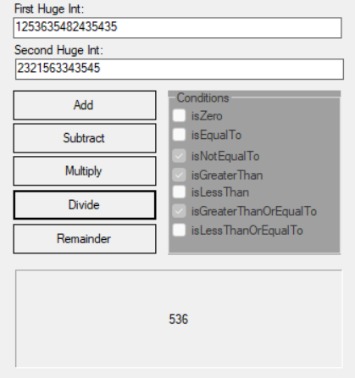

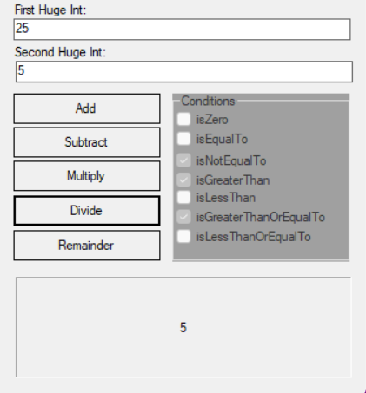

Remainder:

